

**Foundation IGCSE (9 – 1) Revision Pack**

**Mensuration – Compound Areas, Perimeters and Volume (Foundation)**

**Name --------------------------------**

**Questions**

**Q1.**

The diagram shows a quadrilateral *PQRS* on a centimetre grid.

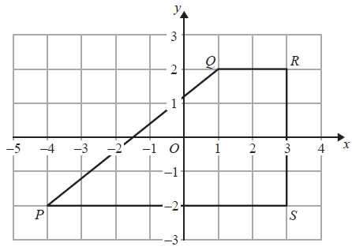

(a)   Write down the coordinates of *R*.

(........................................................... , ...........................................................)

**(1)**

(b)   Write down the coordinates of *P*.

(........................................................... , ...........................................................)

**(1)**

(c)   What is the mathematical name of the quadrilateral *PQRS*?

...........................................................

**(1)**

(d)   Measure the length of the side *PQ*.   
Give your answer in centimetres to 1 decimal place.

........................................................... cm

**(1)**

(e)   Find the perimeter of the quadrilateral *PQRS*.   
Give your answer in centimetres to 1 decimal place.

........................................................... cm

**(2)**

(f)   Work out the area of the quadrilateral *PQRS*.

........................................................... cm2

**(2)**

**(Total for Question is 8 marks)**

**Q2.**

(i)  Write down the mathematical name of this 3-D shape.

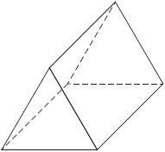

...........................................................

(ii)  How many faces does the shape have?

...........................................................

(iii)  How many vertices does the shape have?

...........................................................

**(Total for question = 3 marks)**

**Q3.**

A circle has radius 9 cm.

(a)  Work out the circumference of the circle.

Give your answer correct to 1 decimal place.

cm

**(2)**

The diagram shows the pentagon *ABCDE*.

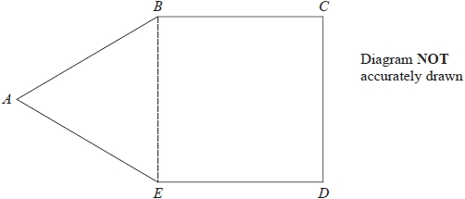

*ABE* is an equilateral triangle.

*BCDE* is a square with area 169 cm2

(b)  Work out the perimeter of *ABCDE*.

cm

**(3)**

**(Total for question = 5 marks)**

**Q4.**

The diagram shows a shape on a centimetre grid.

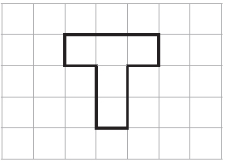

(a) Find the area of the shape.

........................................................... cm2

**(1)**

(b) Find the perimeter of the shape.

........................................................... cm

**(1)**

(c) Shade 60% of the shape.

**(1)**

**(Total for question is 3 marks)**

**Q5.**

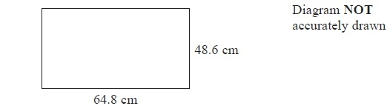

A TV screen is rectangular.

The width of the rectangle is 64.8 cm and the height is 48.6 cm.

(a)  Calculate the area of the rectangle.

Give your answer correct to 3 significant figures.

........................................................... cm2

**(3)**

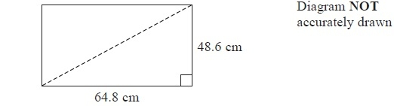

The length of a diagonal of the rectangle gives the 'size' of the TV screen.

(b)  Calculate the 'size' of the TV screen.

........................................................... cm

**(3)**

**(Total for Question is 6 marks)**

**Q6.**

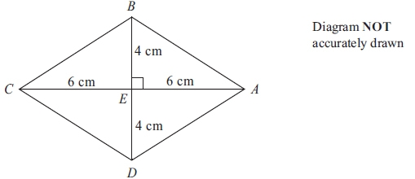

*ABCD* is a rhombus.   
The diagonals *AC* and *BD* cross at the point *E*.   
*AE* = *CE* = 6 cm.   
*BE* = *DE* = 4 cm.   
Angle *AEB* = 90°

(a) Work out the area of the rhombus.

...........................................................cm2

**(3)**

(b) Work out the length of *AB*.   
Give your answer correct to 3 significant figures.

........................................................... cm

**(3)**

**(Total for question is 3 marks)**

**Q7.**

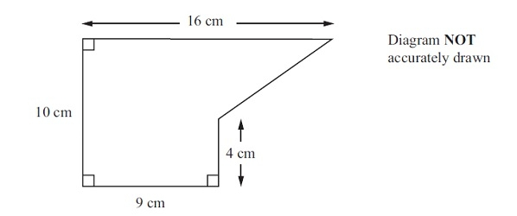

The diagram shows a shape.

Work out the area of the shape.

........................................................... cm2

**(Total for question = 2 marks)**

**Q8.**

The diagram shows a rectangle *PQRS*.   
*PQ* = 14 cm and *QR* = 9 cm.   
The point *A* lies on *PS* so that *PA* = 5 cm.   
The point *B* lies on *SR* so that *BR* = 8 cm.

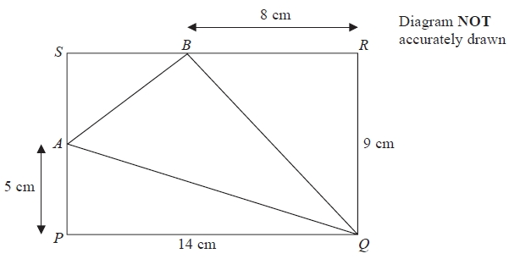

(a)   Work out the area of triangle *AQB*.

........................................................... cm2

**(4)**

(b)   Work out the length of *AQ*.   
Give your answer correct to 3 significant figures.

........................................................... cm

**(3)**

**(Total for Question is 7 marks)**

**Q9.**

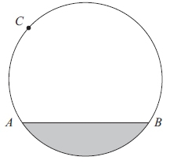

*A*, *B* and *C* are points on a circle.

(a) Write down the mathematical name for

(i) the line *AB*,

...........................................................

(ii) the shaded region.

...........................................................

**(2)**

(b) At the point *C*, draw a tangent to the circle.

**(1)**

**(Total for question = 3 marks)**

**Q10.**

The diagram shows a solid cuboid.

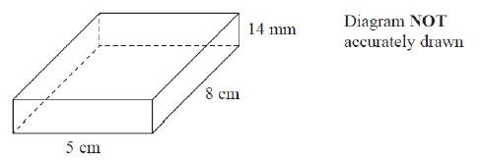

(a)  How many faces has this cuboid?

...........................................................

**(1)**

(b)  How many edges has this cuboid?

...........................................................

**(1)**

The cuboid has width 5 cm, length 8 cm and height 14 mm.

(c)  Work out the volume, in cm3, of the cuboid.

........................................................... cm3

**(3)**

**(Total for question = 5 marks)**

**Q11.**

A steam engine for pulling trains has wheels of diameter 1.5 metres.

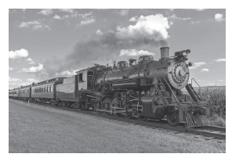

(a)  Calculate the circumference of a wheel.

Give your answer correct to 3 significant figures.

........................................................... m

**(2)**

The steam engine travels 1000 metres along a test track.

(b)  Work out the number of complete turns of a wheel.

...........................................................

**(2)**

**(Total for question = 4 marks)**

**Q12.**

The diagram shows a shape on a centimetre grid.

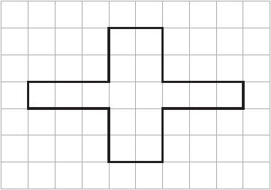

(a)  Find the area of the shape.

........................................................... cm2

**(1)**

(b)  Find the perimeter of the shape.

........................................................... cm

**(1)**

(c)  Write down the order of rotational symmetry of the shape.

...........................................................

**(1)**

(d)  On the shape, draw all the lines of symmetry.

**(2)**

**(Total for question = 5 marks)**

**Q13.**

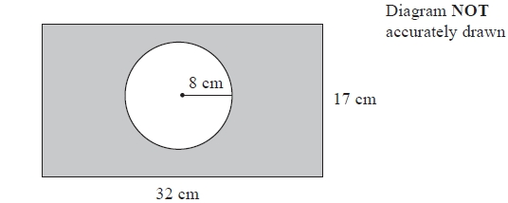

The diagram shows a circle inside a rectangle.

Work out the area of the shaded region.   
Give your answer correct to 3 significant figures.

........................................................... cm2

**(Total for question = 3 marks)**

**Q14.**

Here are two circles.

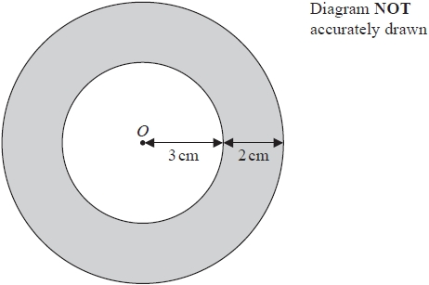

The circles have the same centre *O*.   
The radius of the inner circle is 3 cm.   
The width of the shaded region between the inner circle and outer circle is 2 cm.

Work out the area of the shaded region.   
Give your answer correct to 3 significant figures.

........................................................... cm2

**(Total for question = 3 marks)**

**Q15.**

The diagram shows a circle with centre *O* and radius 6.5cm

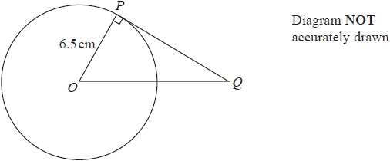

(a)  Work out the area of the circle.   
Give your answer correct to 3 significant figures.

........................................................... cm2

**(2)**

*PQ* is the tangent to the circle at *P*  
*OQ* = 10.5cm

(b)  Work out the length of *PQ*  
Give your answer correct to 3 significant figures.

........................................................... cm

**(3)**

**(Total for question = 5 marks)**

**Q16.**

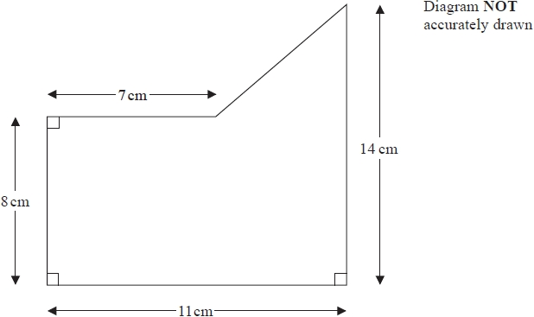

Work out the area of this shape.

...........................................................cm2

**(Total for question = 4 marks)**

**Q17.**

The diagram shows an isosceles triangle.

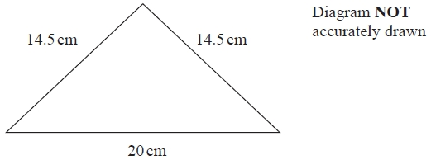

Work out the area of the triangle.

........................................................... cm2

**(Total for question = 4 marks)**

**Q18.**

Here is a rectangle.

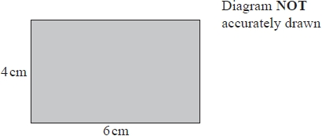

(a)  Work out the area of the rectangle.

...........................................................cm2

**(1)**

Two of these rectangles are placed together without overlapping to make this shaded shape.

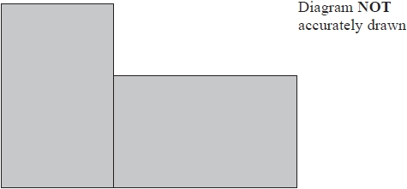

(b)  Work out the perimeter of the shaded shape.

...........................................................cm

**(2)**

**(Total for question = 3 marks)**

**Q19.**

A square hole is cut from a circular piece of card.

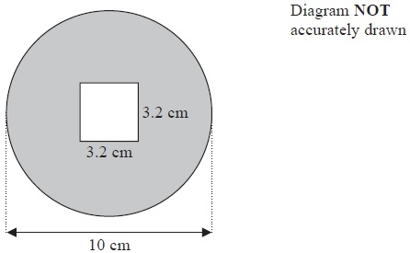

The square has sides of length 3.2 cm.

The diameter of the circular piece of card is 10 cm.

Work out the area of the shaded region.

Give your answer correct to 3 significant figures.

........................................................... cm2

**(Total for Question is 4 marks)**

**Q20.**

The diagram shows a circle inside a rectangle.

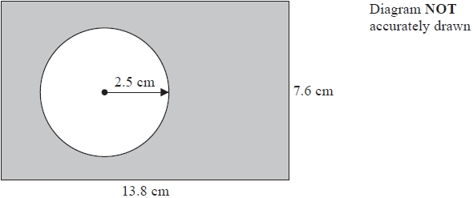

Work out the area of the shaded region.   
Give your answer correct to 3 significant figures.

...........................................................cm2

**(Total for question = 3 marks)**

**Q21.**

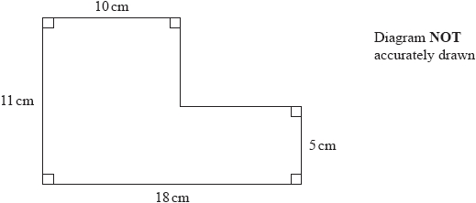

(a)  Work out the area of the shape.

........................................................... cm2

**(3)**

A cuboid has a volume of 360 cm3.   
The cuboid has length 9 cm and width 5 cm.

(b)  Work out the height of the cuboid.

........................................................... cm

**(3)**

**(Total for question = 6 marks)**

**Q22.**

Here is a trapezium *ABCD*.

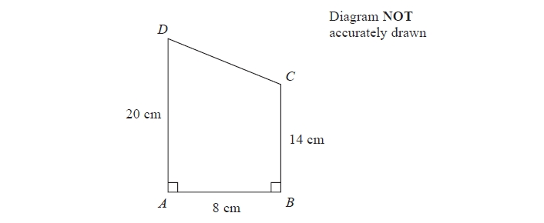

Angle *DAB* = angle *ABC* = 90°

*AD* = 20 cm   
*AB* = 8 cm   
*BC* = 14 cm

(a)  Calculate the area of the trapezium *ABCD*.

.......................................................... cm2

**(2)**

(b)  Calculate the length of *CD*.

.......................................................... cm

**(4)**

**(Total for question = 6 marks)**

**Q23.**

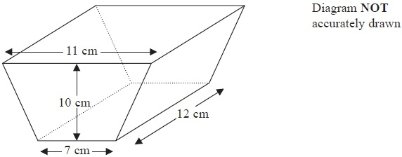

The diagram shows a solid prism.

The cross section of the prism is a trapezium.

The lengths of the parallel sides of the trapezium are 11 cm and 7 cm.

The perpendicular distance between the parallel sides of the trapezium is 10 cm.

The length of the prism is 12 cm.

(a)  How many faces has this prism?

...........................................................

**(1)**

(b)  How many vertices has this prism?

...........................................................

**(1)**

(c)  Work out the area of the trapezium.

........................................................... cm2

**(2)**

(d)  Work out the volume of the prism.

........................................................... cm3

**(2)**

**(Total for Question is 6 marks)**

**Q24.**

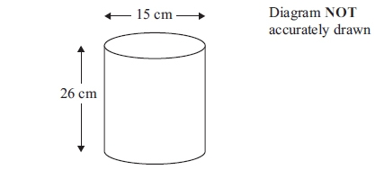

A cylinder has a diameter of 15 cm and a height of 26 cm.

Work out the volume of the cylinder.   
Give your answer correct to 3 significant figures.

........................................................... cm3

**(Total for question is 3 marks)**

**Q25.**

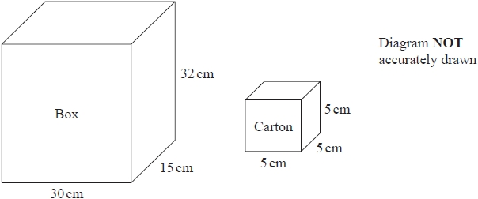

A wooden box measures 30 cm by 15 cm by 32 cm.   
The box has a lid.

A carton measures 5 cm by 5 cm by 5 cm.

James has 110 cartons.   
He wants to put all these cartons in the box and be able to shut the lid.

Can James put all 110 cartons in the box and shut the lid?   
Show your working clearly.

**(Total for question = 3 marks)**

**Q26.**

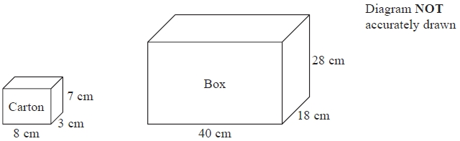

A carton measures 8 cm by 3 cm by 7 cm.   
Cartons are packed into boxes.   
A box measures 40 cm by 18 cm by 28 cm.

Work out the number of cartons that can completely fill one box.

...........................................................

**(Total for question = 3 marks)**

**Q27.**

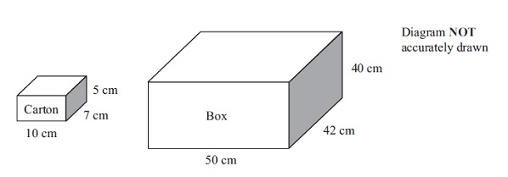

A carton measures 10 cm by 7 cm by 5 cm.  
 Cartons are packed into boxes.  
 A box measures 50 cm by 42 cm by 40 cm.

Work out the number of cartons needed to fill completely one box.

...........................................................

**(Total for question = 3 marks)**

**Q28.**

The diagram shows a cuboid and a triangular prism.

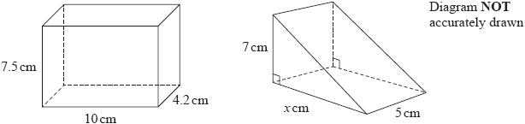

The volume of the cuboid is equal to the volume of the triangular prism.

Work out the value of *x*.

...........................................................

**(Total for question = 4 marks)**

**Q29.**

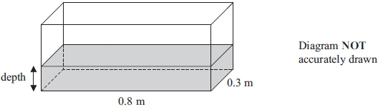

A fish tank is in the shape of a cuboid.  
 The length of the fish tank is 0.8 m and the width is 0.3 m.  
 The volume of water in the fish tank is 108 litres.

1 m3 = 1000 litres.  
 Work out the depth of the water in the fish tank.

............................................................m

**(Total for question = 3 marks)**

**Q30.**

The diagram shows a solid prism.

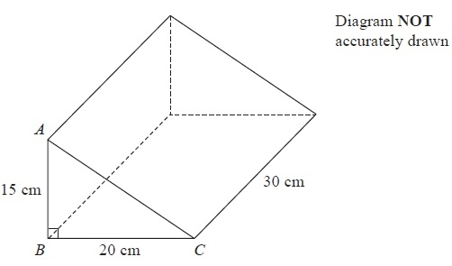

(a)  (i)  How many vertices has the prism?

...........................................................

(ii)  How many edges has the prism?

...........................................................

**(2)**

*AB* = 15 cm, *BC* = 20 cm and angle *ABC* = 90°

(b)  Work out the area of triangle *ABC*.

........................................................... cm2

**(2)**

The length of the prism is 30 cm.

(c)  Work out the volume of the prism.

........................................................... cm3

**(2)**

**(Total for Question is 6 marks)**

**Mark Scheme**

Q1.

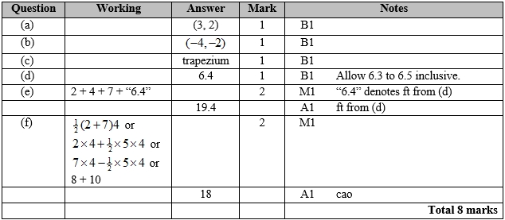

**Q2.**

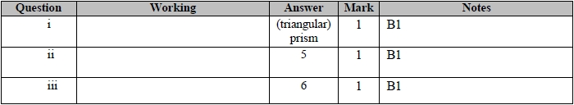

**Q3.**

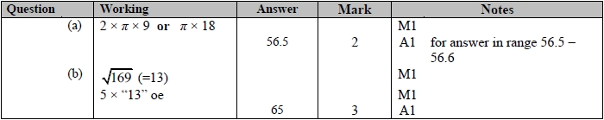

**Q4.**

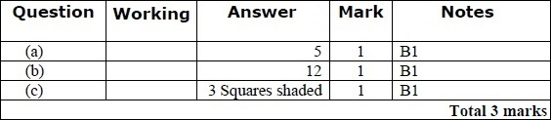

**Q5.**

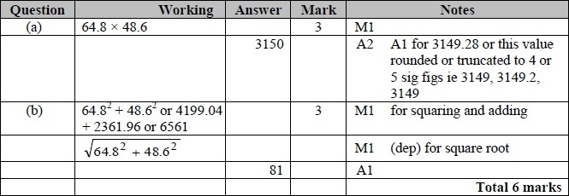

**Q6.**

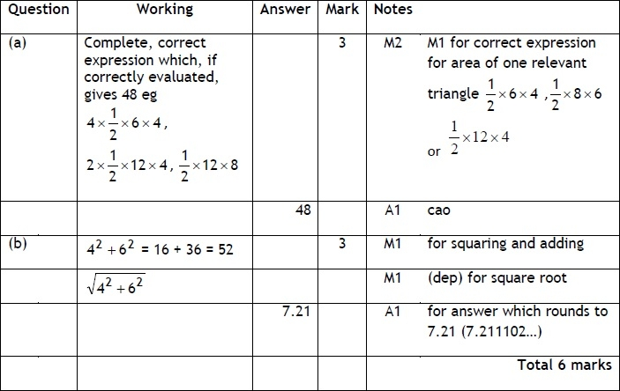

**Q7.**

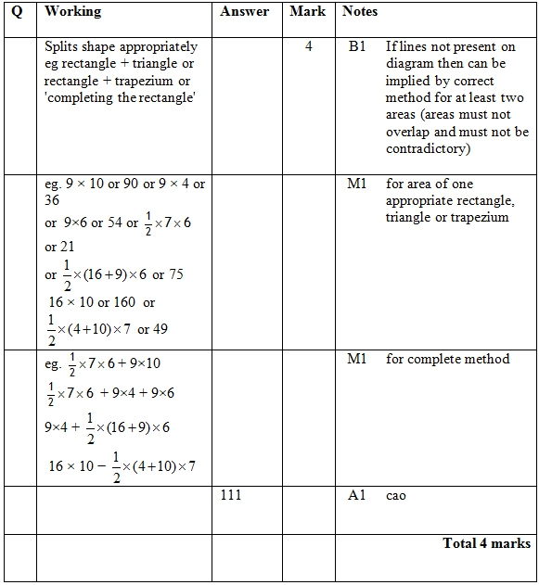

**Q8.**

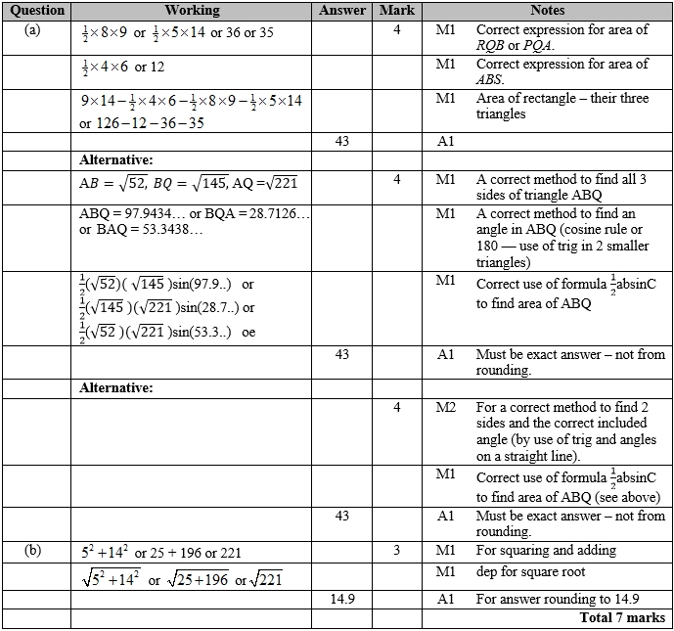

**Q9.**

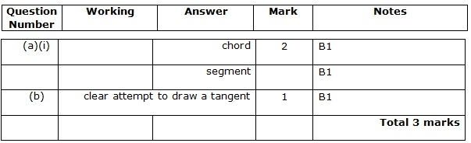

**Q10.**

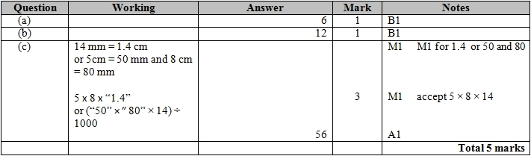

**Q11.**

For all questions, the correct answer, unless clearly obtained by an incorrect method, should be taken to imply a correct method.

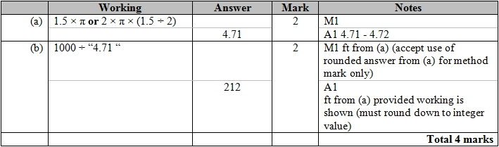

**Q12.**

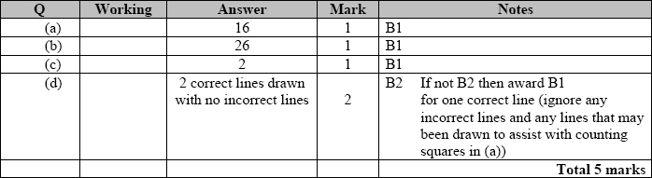

**Q13.**

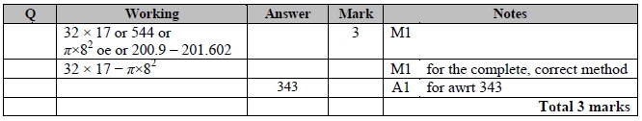

**Q14.**

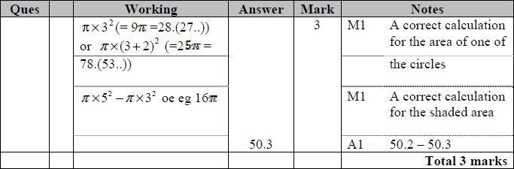

**Q15.**

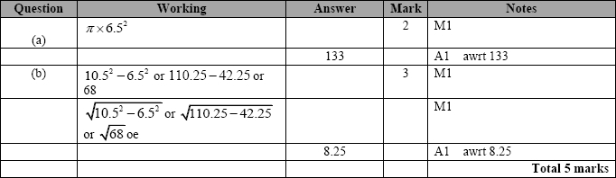

**Q16.**

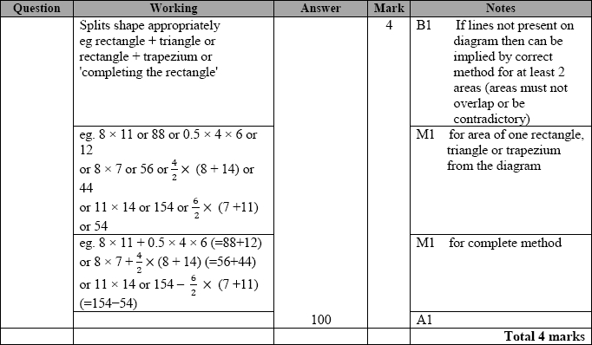

**Q17.**

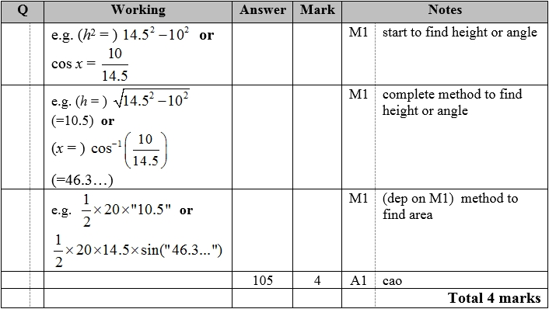

**Q18.**

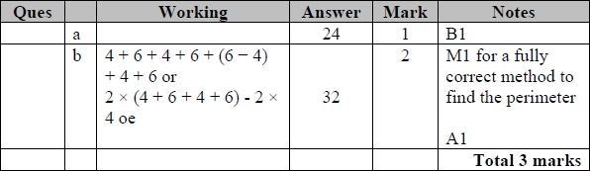

**Q19.**

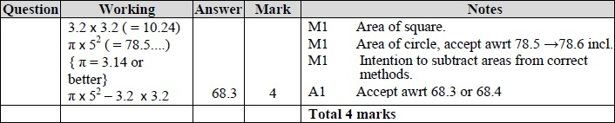

**Q20.**

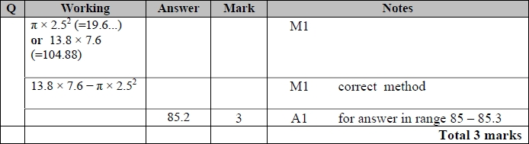

**Q21.**

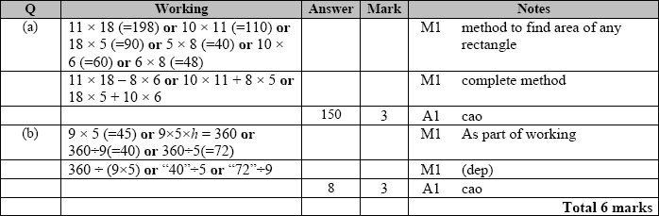

**Q22.**

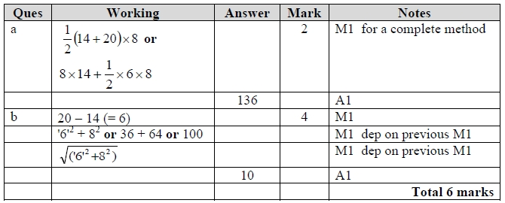

**Q23.**

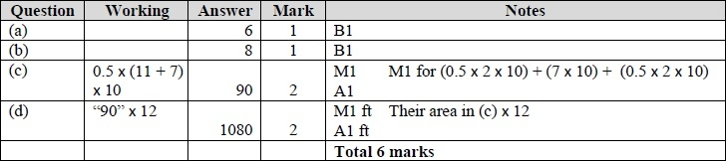

**Q24.**

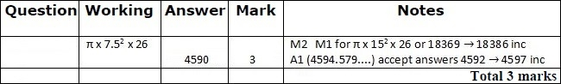

**Q25.**

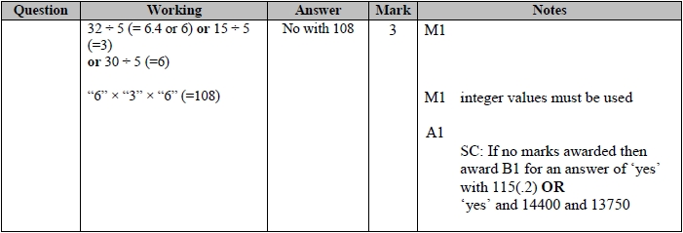

**Q26.**

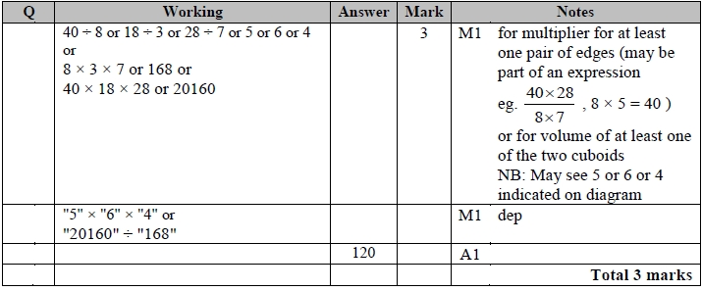

**Q27.**

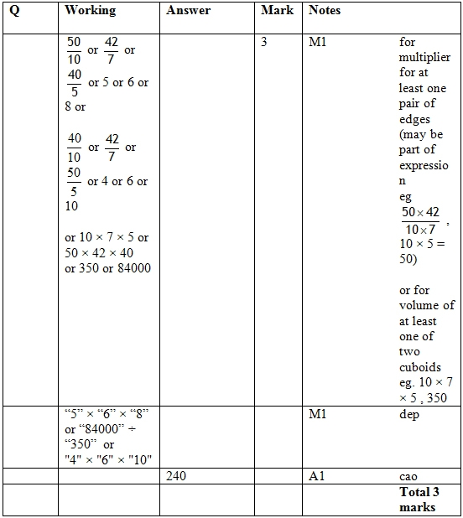

**Q28.**

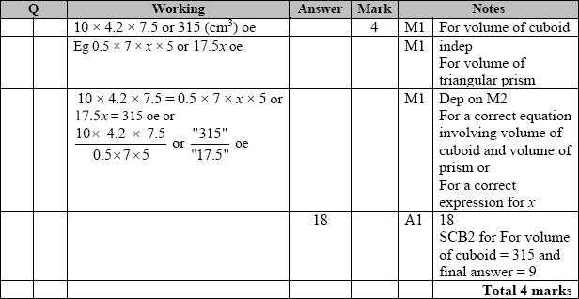

**Q29.**

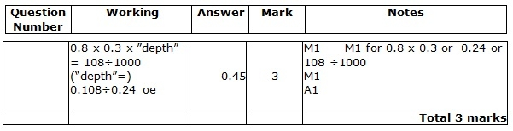

**Q30.**

