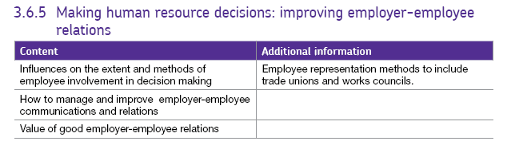3.6.5 Employer – employee relations

# Effective Employer/Employee Relations

Employer-employee relations refers to the involvement and communication between employees and management. Employees are an important asset in many businesses especially where they have customer –facing roles and so it is important for the management to look after them although methods of doing this differ greatly between businesses.

Some firms have received poor ratings from their employees when asked about this conditions of work and this can damage the firm’s reputation.

<https://www.telegraph.co.uk/business/2017/07/04/10-worst-companies-work-uk-according-employees/>

<https://www.glassdoor.co.uk/Award/Best-Places-to-Work-UK-LST_KQ0,22.htm>

## Image result for employee relationsMethods of employee representation

Methods of employee representation might include: works councils and trade unions. Most employers seek to co-operate with employees to resolve conflicts. Sometimes this is through Trade unions but can also be internal to the firm. Some firms have their own systems and set up various meeting, committees, representatives etc. to allow workers to voice their opinions and have a say in the running of the firm such as:

* Work councils – where workers gather together to discuss plans and put forward ideas.
* Employee shareholders – expected to make employees feel that their work is directly affecting the value of their shares thereby improving productivity.
* Autonomous work groups – groups with a similar mission to the work councils, but without management involvement.

There are also other organisations which can advise businesses as shown overleaf.

## 

## The role of Trade Unions and ACAS [**Trade-union-membership-statistical-bulletin-2019**](https://assets.publishing.service.gov.uk/government/uploads/system/uploads/attachment_data/file/887740/Trade-union-membership-2019-statistical-bulletin.pdf)

Trade unions are groups which employees can join to strengthen their position at work by representing them and negotiating for them.

Over time, unions have become an integral part of business life in the majority of developed countries although in many places there is less need for them as workers are more aware of their rights and firms can experience very bad publicity if they break the rules. Workers are also protected by the law enforced by the Government through inspectors such as The Health and Safety Executive.

The role of unions nowadays is 2-fold

– to help bring about change

* to protect workers

The biggest unions in the UK are [UNISON](https://www.unison.org.uk/) and ASLEF, which represent public sector (Government employed) workers but there are many other unions such as the [RMT](https://www.rmt.org.uk/home/) and the [NASUWT](https://www.nasuwt.org.uk/), [GMB video](https://youtu.be/8QgDbRjp6mg)

## Industrial action.

If the Trade Union and the employer fail to reach an agreement, they can ask ACAS (see below) to intervene and mediate to find a decision acceptable to both parties.

Both employers and employees can act to change a situation if they are not happy, this may be formal e.g. a complaint, or may be informal.

* Employees - Trade Unions, work to rule, strike
* Employers - Threats of job cuts, lack of overtime, and no pay rise or changes in conditions

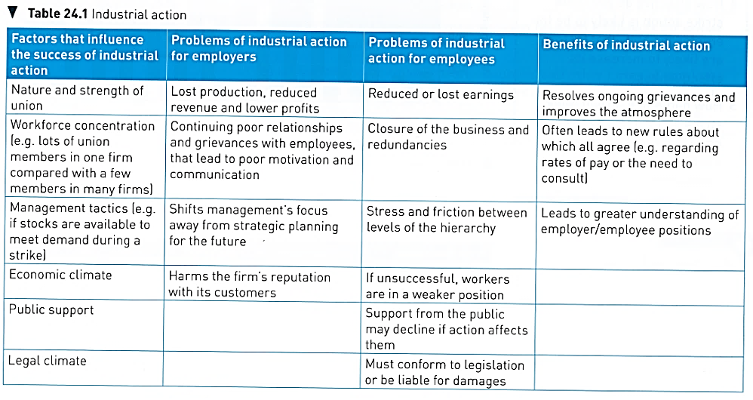If staff are unhappy the union will help them to take this industrial action. They will try to negotiate with employers in an industrial dispute and will support workers to take action if their dispute can’t be resolved. However, there are strengths and weaknesses to all these approaches.

## Methods of conflict resolution (conciliation and arbitration).

If, for whatever reason conflict has arisen, then there are various ways in which it can be dealt with. These are often run through Trade Unions or a third party involvement. A conflict between workers and employers is referred to as an **Industrial Dispute**.

1. Negotiation - where the 2 parties sit down together and discuss how the problem has arisen and how it could be solved.

## [**The role of ACAS.**](http://www.acas.org.uk/index.aspx?articleid=1461)

2. Arbitration - Where the parties involved sit down with a mediator / 3rd Party who helps them to reach an agreement. ACAS - the Advisory, Conciliation and Arbitration service is usually the third party involved here. This is an independent organisation made up of industrial specialists who mediate between the parties.

3. Conciliation – Both parties give some ground in order for agreement to be reached. This is also often done through ACAS.

# Improving communication and relations.

There are lots of approaches which firms can use to have positive relations with workers.

## Collective approaches to relations.

These include collective bargaining and quality circles as well as working parties or discussion groups.

**Collective bargaining** is usually carried out by a union or similar on behalf of the employees, this is good as the employer only has to deal with one set of people and not negotiate individually with each person, also, unions are in a stronger position as they represent so many people.

**Quality circles** involve people from different levels sitting down together and discussing what should be done next. This allows input from all levels rather than from the top down.

## Individual approaches to relations

Can often be more difficult as people want to negotiate their own deals.

## What choices face managers?

Manager have to make many difficult choices which may change employees pay and conditions, for example they may have to look at whether they need to employ full-time, salaried staff or to have more temporary, part-time or subcontracted work, they may even want to have some staff on zero hours’ contracts where they have not guaranteed hours of employment. This is not illegal but can be seen as unethical.

Because pay is so important to employees, making changes can lead to demotivation and higher staff turnover before industrial action takes place, this would lower productivity and therefore raise average costs.

There is a lot of research to show that talking to staff and keeping them informed about any likely changes can help to prevent many of the problems which can arise.

## Relationship between communication and motivation

There are several different systems for communicating within a firm. Some involve a degree of hierarchy while others rely on the participation of all workers to maintain their effectiveness. The method used will depend on:

- the size of the firm - the type of ownership - the nature of the industry

- the available capital - the nature of the workforce.

- formality: is it recognised by the management e.g. Memos, reports, minutes or written warnings.

- informality: is it information passed down on "the grapevine." This can both help and hinder management - gossip is dangerous.

It is important to keep workers informed through formal methods otherwise the grapevine may do more harm than good. Some firms with good labour relations can ask unions for help with organising change / encouraging workers to see it positively.

## Effect of poor morale on communication and vice versa

If workers are disenchanted, they will be less productive as they are unhappy in their work. Efficiency, quality and productivity may suffer along with customer service.

### Importance of feedback

If workers are informed what is happening and what changes will be made as a results of their communicated opinions, they are more likely to be willing to make changes. Similarly, if workers are not happy with changes and they do not make this clear, then the managers will not know that they have to make further alterations.

## Barriers to effective communication

These are factors which can prevent communication between levels of the hierarchy from being effective.

* Attitudes of staff and employers
* Intermediaries – people who pass the thoughts on managers to workers etc. – frequently from an outside organisation e.g. Trade Union
* Lack of common language – workers not understanding the language of management and what some terms mean e.g. delayering
* Management ignoring the comments of workers.
* Sense of purpose – for example if workers do not know why something is happening.

These factors can all feed into **resistance to change** where staff are not working with management to move the firm forward.