**3.3.7 Optical isomerism**

**AS Link:**

**3.3.1 – Introduction to organic chemistry**

**3.1.3 – Bonding (shapes of molecules)**

**3.3.4 – Alkenes (isomerism)**

**3.3.5 – Alcohols (nomenclature)**

**Isomerism**

* **Structural**
  + *Chain or branched* – different arrangements of the carbon skeleton
  + *Position* – functional group in a different position on the carbon skeleton
  + *Functional group* – different functional group
* **Stereoisomerism**
  + *E-Z* – groups arranged differently in space around the C=C bond
  + Optical - new

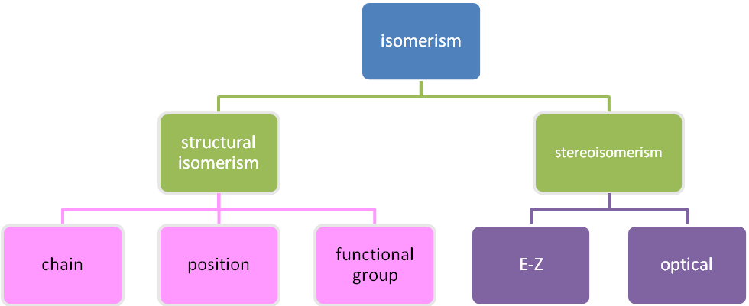

Structural – **same molecular formula but different structure**

***Definition***: **Structural isomers** are compounds with the same molecular formula but different structures

**Chain isomerism** *–* ***2 or more ways of arranging carbon skeleton***

E.g. C4H10 CH3CH2CH2CH3 CH3CH(CH3)CH3

butane 2-methylpropane

C4H9OH CH3CH2CH2CH2OH CH3CH(CH3)CH2CH2OH

butan-1-ol 2-methylpropan-1-ol

**Position isomerism** *–* ***functional groups join carbon skeleton at different positions***

E.g. CH3CH2CH2Br 1-bromopropane CH3CHBrCH3 2-bromopropane

E.g. CH2=CHCH2CH3 but-1-ene CH2CH=CH2CH3 but-2-ene

**Functional group isomerism** *–* ***different functional groups***

E.g. C6H12 CH3CH2CH2CH2CH=CH2

cyclohexene hex-1-ene

E.g. C3H6O CH3CH2CHO CH3COCH3

propanal propanone

Stereoisomers isomers **– different arrangement of the bonds in space**

***Definition***: **Stereoisomers** are compounds which have the same structural formula but the bond or atoms are arranged differently in space

**E-Z Isomerism**

They have **two groups attached to each carbon across the double bond**. There is **restricted rotation** around the **C=C bond**. The isomers can have different physical properties, such as melting point or polarity. The substituents may either be on the **same side** of the bond (***Z***) or **opposite** **sides** (***E***).

|  |  |  |
| --- | --- | --- |
|  |  |  |
| Restricted rotation | *E* – entgegen (opposite)  lower boiling point  less polar | *Z* – zusammen (together)  slightly higher boiling point  more polar |

***Sheet: Isomerism notes***

***Sheet: Isomerism – Task 1***

**Optical isomers**

These occur when there are **four different substituents attached to one carbon atom**. This carbon is described as **chiral** (from the Greek word ‘kheir’ meaning ‘handed’). This gives **two** possible **arrangements** of the groups attached to this carbon so **two isomers** are formed that are **mirror images**. The molecules are **asymmetrical**. They can’t be superimposed just like a pair of hands.

|  |  |  |
| --- | --- | --- |
|  |  | *Enantiomers*  *From the Greek ‘enantios’ meaning ‘opposite’* |

These isomers are called **enantiomers** or **optical** **isomers**.

***Definition***: **Enantiomers** are pairs of optical isomers

***Demo: Models with mirror***

**Chirality**

Optical isomers are said to be **chiral** and the two isomers are called **enantiomers** (a pair of optical isomers). The two molecules cannot be superimposed on each other. They possess an **asymmetrical carbon atom**, this carbon is said to be **chiral**, and is often shown with an **asterisk**. A chiral molecule can be identified because it contains at least **one carbon with 4 different groups** attached to it.

***Definition***: **Chiral molecule** cannot be superimposed on its’ mirror image

***Video clip: Breaking bad***

Drawing optical isomers

* Locate chiral carbon
* Draw one enantiomer as a tetrahedral
  + chiral carbon in the centre
  + different groups in a tetrahedral shape – use structural formula
* Draw the mirror image – imagine a mirror between them

**Example: CGP171**

2-hydroxypropanoic acid

|  |  |
| --- | --- |
|  |  |

butan-2-ol

|  |  |
| --- | --- |
|  |  |

***Sheet: Isomerism – Task 2***

**Optical activity**

|  |  |
| --- | --- |
| Light consists of vibrating electrical and magnetic fields. |  |

It has waves **vibrating in all directions**. If the light is **passed** **through** a **polar filter**   
(or polaroid) all the vibrations are cut out so it can **only produce light vibrating in one plane** only i.e. **polarised light**. It will be either **vertically** or **horizontally polarised**.

|  |  |
| --- | --- |
|  |  |

Enantiomers have the **same physical properties** **except** their **effect on the plane of plane-polarised light** and so are said to be **optically-active**. Their **chemical properties** are **identical** **except** in reactions with **other** **optically active substances**.

Pairs of molecules like this are called **optical isomers** because they differ in the way they **rotate the plane of polarised light**:

***Definition***: **Optical isomers** (enantiomers) are stereoisomers which **rotate** plane-polarised light **equally** but in **opposite directions**

Racemates

***Definition***: **Racemate** is a mixture containing equal amounts of both enantiomers

A **racemate** or **racemic mixture** contains **equal quantities** of **each enantiomer**.

Therefore a racemate will be **optically inactive** because the **effect** of each isomer on the **rotation** of plane-polarised light **cancels** each other out since it will be **rotated equally** in **opposite directions**.

Measuring optical rotation

Optical rotation can be measured using a **polarimeter**:

* **Pass polarised light** through **2 solutions** of the same concentration each containing a different optical isomer of the same substance.
* One solution will **rotate** the plane of polarisation **clockwise**, this is the (**+**) isomer.
* The other will **rotate** the plane of polarisation **anticlockwise**, this is the (**-**) isomer

|  |  |
| --- | --- |
|  | 1. Light source 2. Unpolarised light 3. Polariser 4. Polarised light 5. Sample tube  6. Specific rotation 30° 7. Movable analyser 8. Observer |

The 2 solutions are **enantiomers** and will **rotate** the **plane of light**:

* clockwise (+) or D (Latin; *dextrorotatory* = clockwise) or R (Latin; *rectus* = right handed)
* anticlockwise (-) or L (Latin; *laevorotatory* = anti-clockwise) or S (Latin; *sinister* = left handed)

|  |  |  |
| --- | --- | --- |
|  |  |  |

***Demo: Optical activity of sugars***

**Optical isomers**

There are many naturally occurring molecules with a **chiral carbon** but only exist in nature as **single enantiomers.**

Amino acids

With the exception of glycine, the simplest, which has 2 hydrogen atoms attached to the central carbon all **α-amino acids** can exist as **optical isomers**.

**Example**: 2-aminopropanoic acid (alanine) CH3C*H(NH2) COOH

|  |  |
| --- | --- |
|  |  |

In **nature**, only **one optical isomer occurs** (e.g. all natural amino acids will rotate polarised light to the left); this is because they need to be **stereospecific**, particularly for an enzyme’s active site.

Lactic acid

**2-hydroxypropanoic acid**, commonly called **lactic acid** has a **chiral centre**. In some biological situations just one enantiomer is produced and in others a **racemate** is formed.

|  |  |
| --- | --- |
| **(+/-)** mixture is **found** in **sour milk** | **(+)** enantiomer is formed during the **contraction of muscles** leading to cramp if it isn’t removed by the body |
|  |  |

Carvone

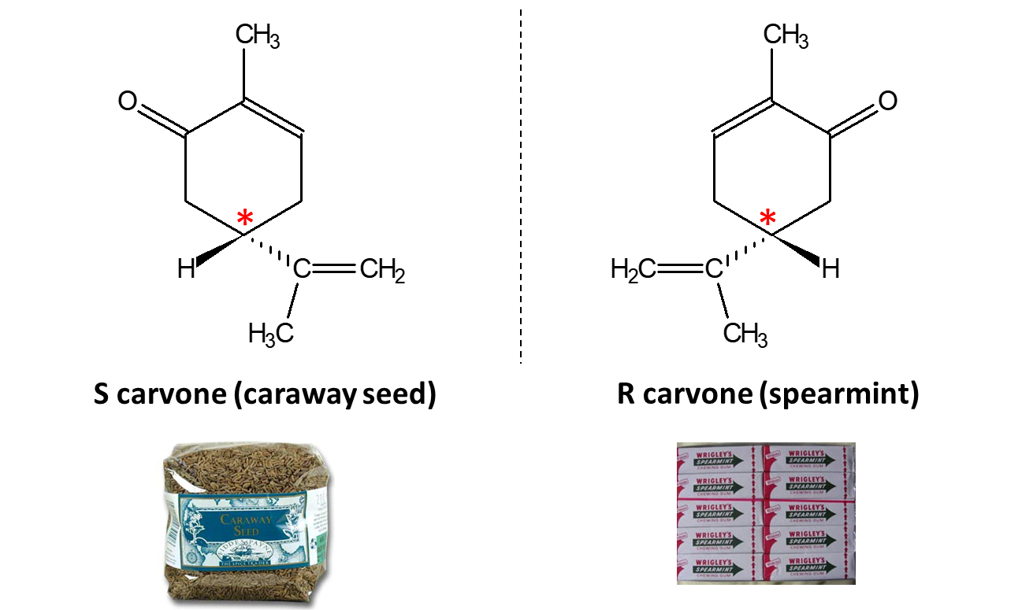

Limonene

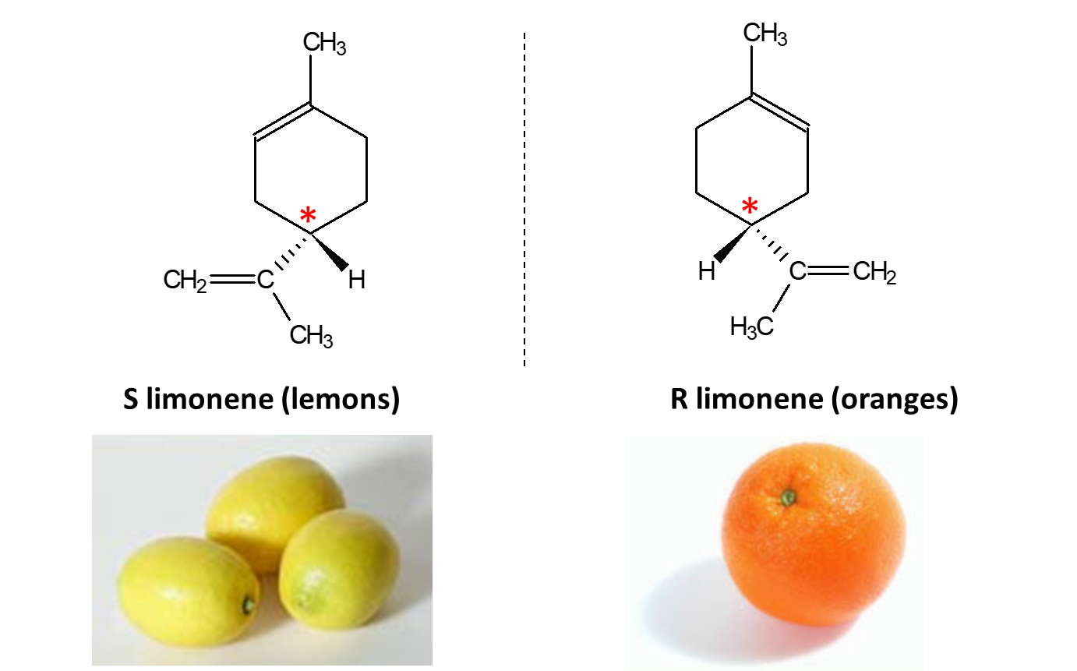

**Synthesis of optically active compounds**

Many organic synthesis reactions produce optically isomers. A **50:50 mixture or racemate** will be formed so the product will **not be optically** active as the **effects** of the two isomers will **cancel out**.

Synthesis of lactic acid

The synthetic manufacture of lactic acid can be used to show how a racemate can be produced. Its synthesis produces a **racemic mixture of optical isomers**.

***Task: Draw out 2-hydroxypropanoic acid & identify the chiral carbon with an asterisk***

|  |  |
| --- | --- |
|  |  |

***Demo: Model*** ***enantiomers*** ***2-hydroxypropanoic acid***

It can be made in a 2-step process from ethanal:

***Stage 1 – nucleophilic addition***

Hydrogen cyanide (a nucleophile) is added across C=O in ethanal to form   
2-hydroxypropanenitrile

N.B. The product carbon chain has one more carbon

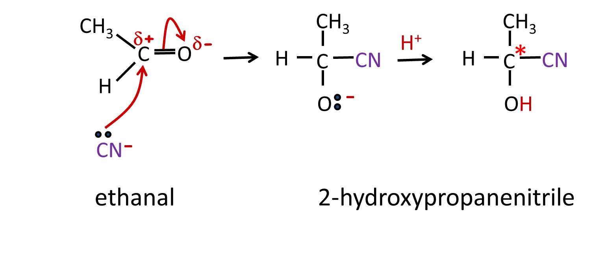

The other isomer

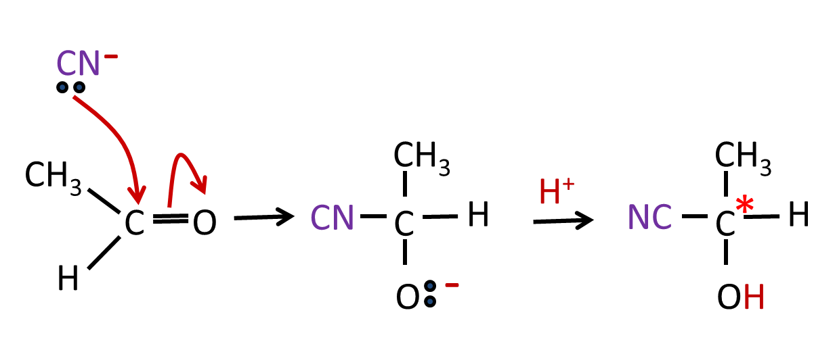

The reason why two enantiomers are produced is because the **ethanal is a planar** molecule due to the **carbonyl group** so the **cyanide** group can add with **equal probability** from **above** and **below** giving a **racemate**.

***Demo: Nucleophilic addition of cyanide ion to ethanal***

***Stage 2 – hydrolysis***

The **nitrile** group is **converted** to a **carboxylic** **acid** by reacting with **water acidified** with dilute hydrochloric acid.

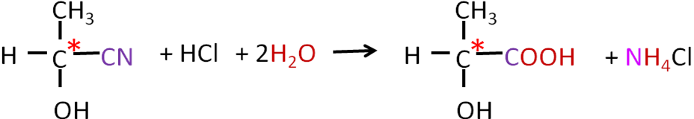

The other isomer

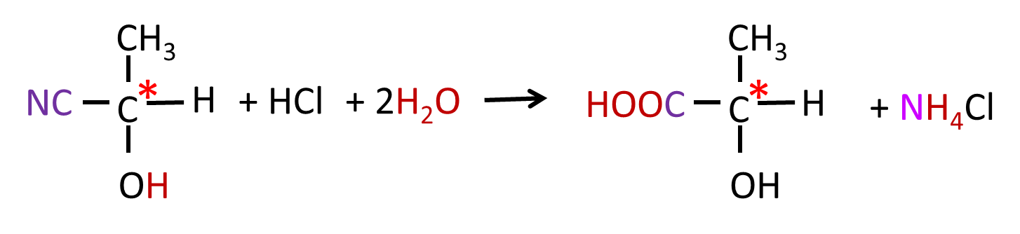

Chiral drugs

Drugs extracted **from nature**, such as quinine (extracted from the bark of the [cinchona](http://en.wikipedia.org/wiki/Cinchona) tree and used to prevent malaria,) are **single** **enantiomers**.

Approximately half of all **commercially-available drugs** contain one **chiral centre**, so are produced as **racemic mixtures**. **Separating** the **enantiomers** is **difficult** and involves **high costs** so they are usually **marketed as racemates** if the racemic mixture is **safe to use**. The problem with this is that it is wasteful as only half the drug is active.

**Example: Ibuprofen**

|  |
| --- |
|  |

If **both isomer** are **safe** then it can be sold as a **mixture**.

However, if one isomer isn’t safe then there are **2 options**:

* **design an alternative synthesis** that produces only one isomer
* **separate the isomers** – difficult and expensive due to having similar properties.

**Separation** can be achieved using a technique called **resolution**, either by:

* a **reaction with a chiral reagent** to give products with different physical properties
* using **chromatography** to separate.

Many **drugs work** because a molecule in the active ingredient **fits a receptor** on a cell, the receptors have a **3-D structure**, and so **only one of the enantiomers will fit**.

|  |  |  |
| --- | --- | --- |
|  |  |  |
| Only this enantiomer will fit the active sites |  |  |

In some cases **only one isomer will have an effect on the body** and the **other is inactive**. In other cases one of the enantiomers can be **toxic or have undesired side effects**.

**Example: Thalidomide**

In the 1950’s **thalidomide** was given to pregnant women to **reduce** the effects of **morning** **sickness**, it is an **antiemetic**. It was given as a **racemate**; however, it led to many **disabilities** in babies and **early deaths** in many cases. It was withdrawn in 1961.

One enantiomer was a **teratogenic** (caused malformations in a fetus) leading to birth defects. The other is not, but unfortunately, the **two stereoisomers can interconvert** in vivo (within the body).

|  |  |
| --- | --- |
|  | |
| **S thalidomide (effective drug)** | **R thalidomide (dangerous drug)** |

However, it is starting to be used again to treat leprosy and HIV. Its **use is restricted** though and women will have to have a pregnancy test first (if they are at child-bearing age) and use two forms of contraception (if sexually active). It is safe to use on men.

***Sheet: HSW - Thalidomide***

***Application: CGP173 PQ1-3***

***Fact recall: CGP173 Q1-4***

***Exam questions: Oxford p150-151 Q1-3***