**The Parthenon’s Relief Sculpture**

**Pediment**: the triangular space at both ends of a temple. It could contain sculpture or be left blank

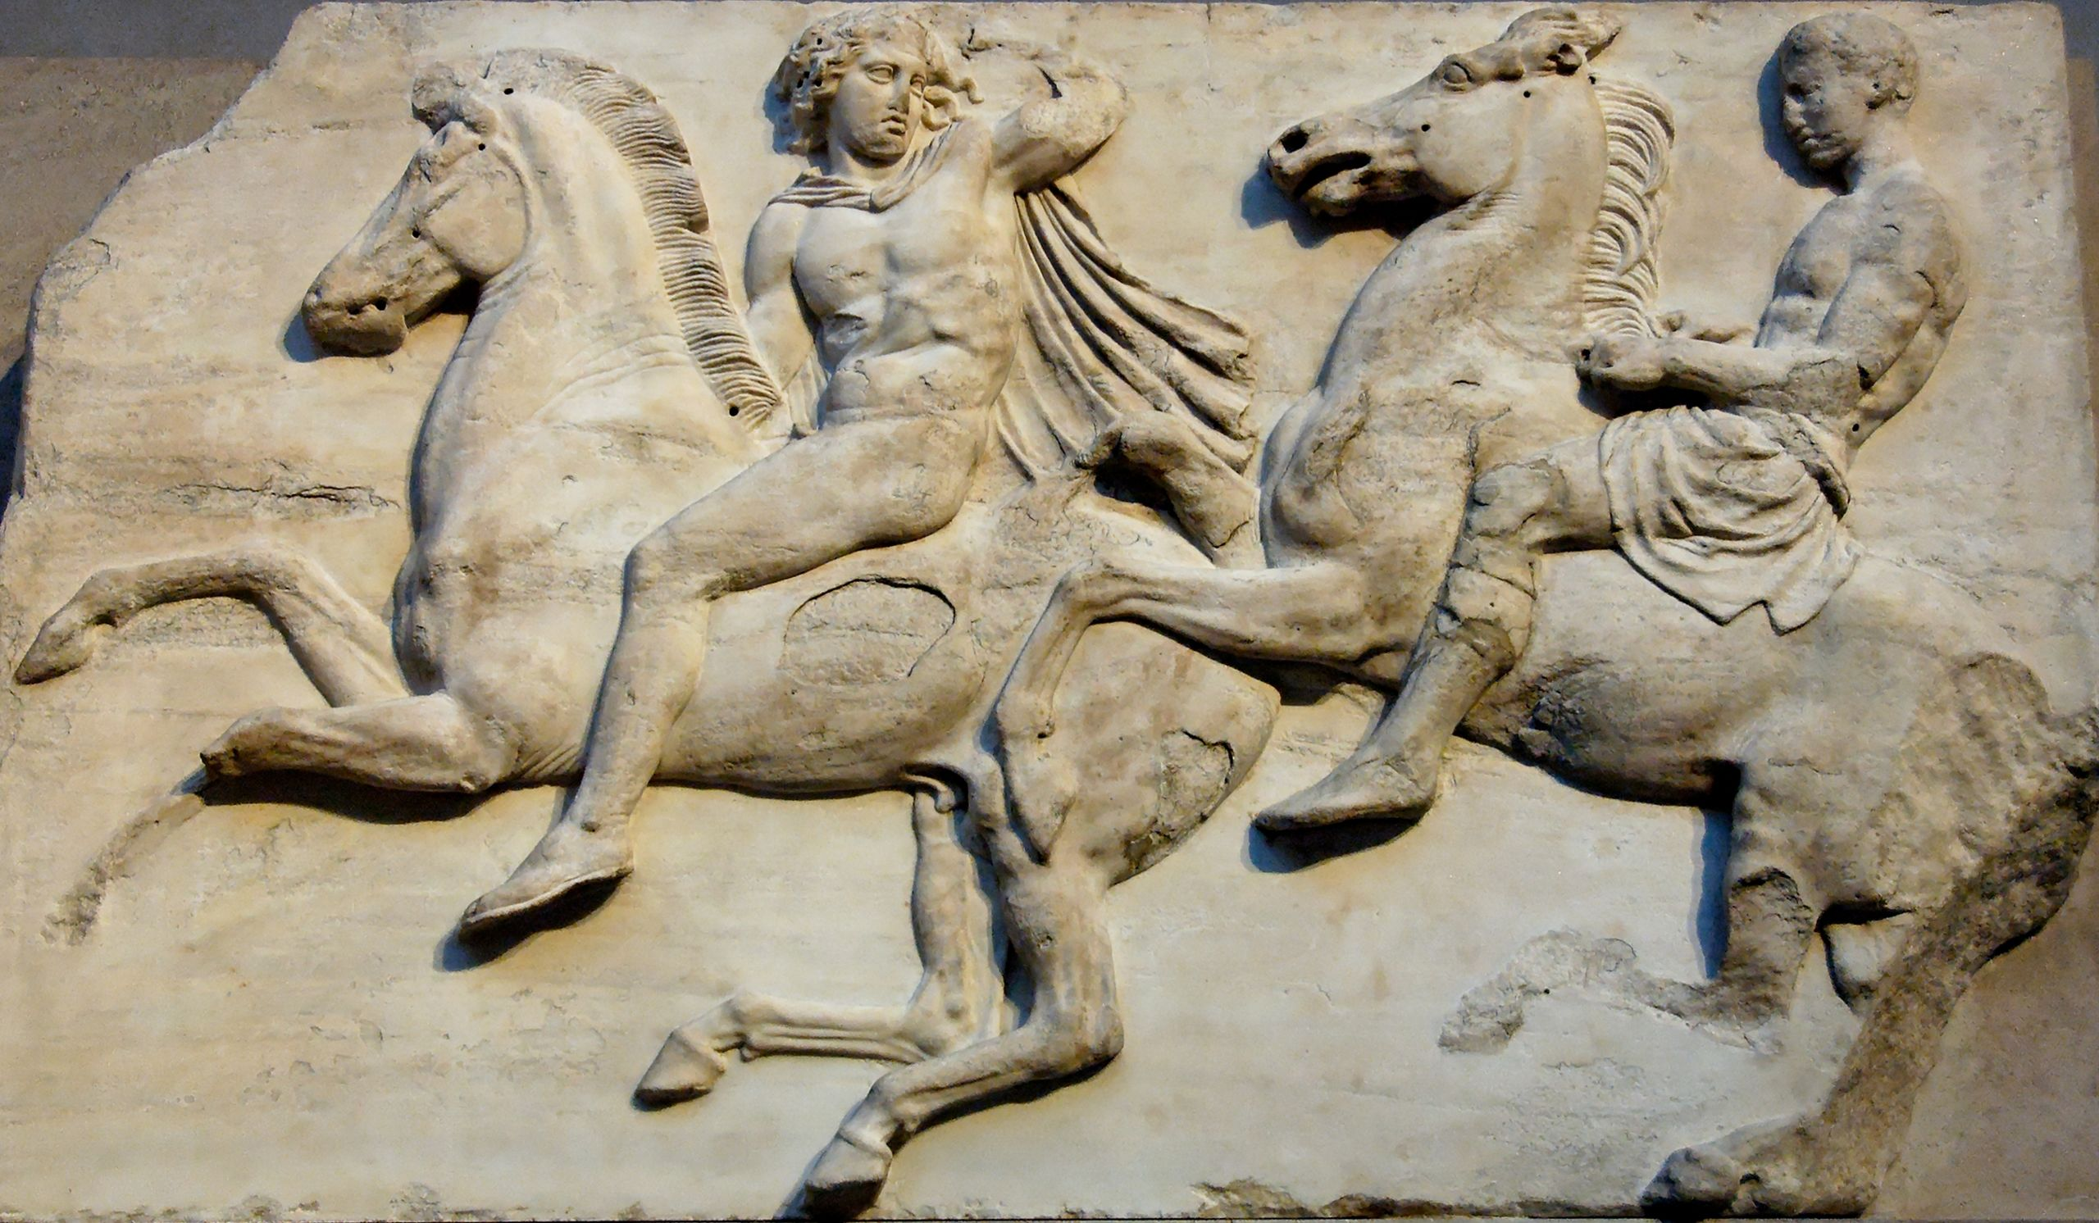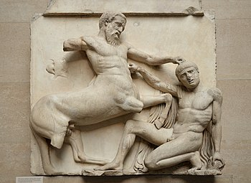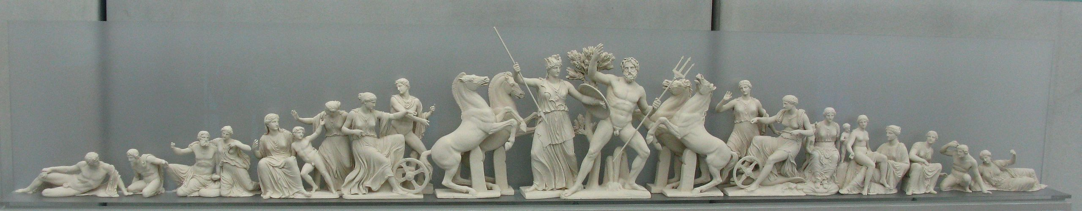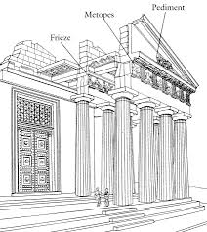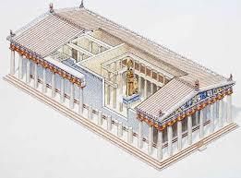

cavalry from the western side of the frieze

**Ionic Frieze**: a continuous strip of stone or marble that ran around a temple. It allowed a sculptor to tell one continuous story or include many characters.

metope depicting a centaur vs a Lapith

**Doric Frieze**: strip of stone or marble divided into **metopes**. It allowed the sculptor to tell several stories or depict several episodes.

west pediment scene