**The Aeneid – Book 1**

**Read lines 1-33**

Based on the opening lines, what themes do you think Virgil will focus on in this epic?

How does Virgil invoke comparisons between the Trojan War and the rivalry between Carthage and Rome?

How does Virgil remind us of the *nostos* journeys of the Achaeans (especially Odysseus)?

**Read lines 34-156**

How does Juno contrast herself with Athena (=Minerva)?

|  |  |
| --- | --- |
| **Athena/Minerva** | **Herself** |
|  |  |

Annotate the pictures of Juno and Aeolus to show what we learn about them in this passage:

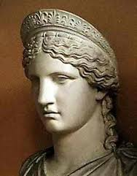

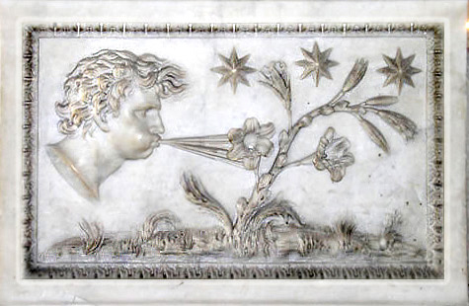

Collect quotes that show how Virgil creates pathos for Aeneas and his crew and explain why these quotes do this:

|  |  |
| --- | --- |
| **Quote** | **Explanation** |
|  |  |
|  |  |
|  |  |
|  |  |

In the boxes surrounding the diagram, describe the storm and its effects on the ships:

**Effects on the ships:**

**Description of the storm:**

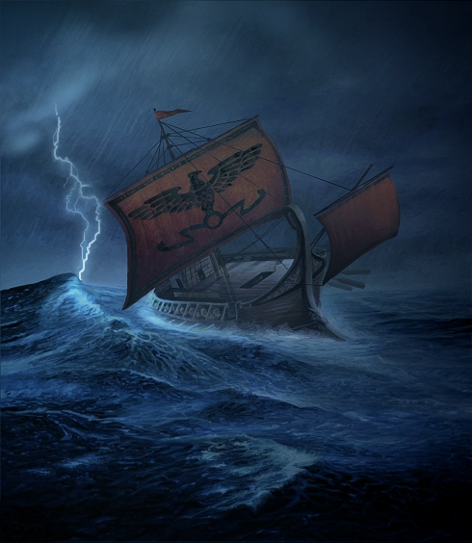

How does Neptune demonstrate his power and authority in both words and actions:

**Words:**

**Actions:**

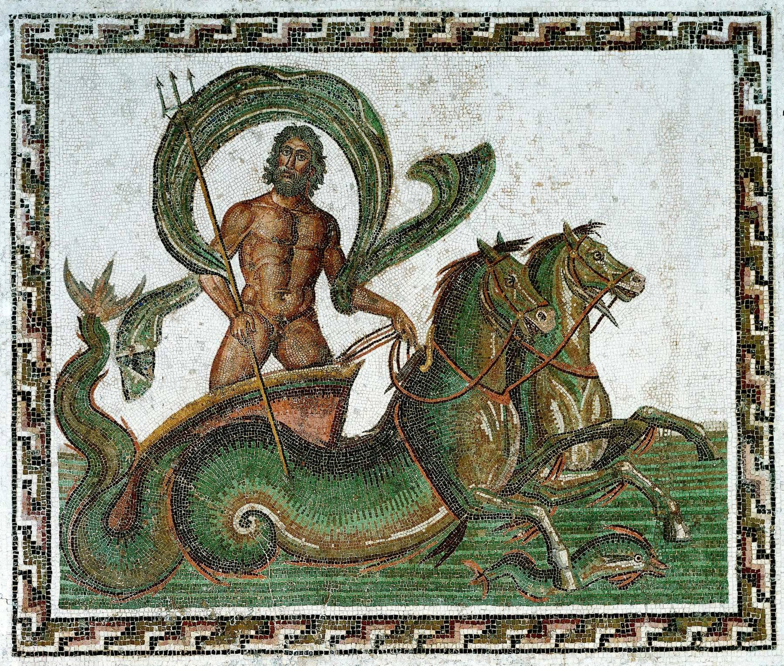

Reread the simile, ‘As when disorder arises…the crashing of the sea fall silent’ [lines 148-155]. Answer the following:

1. As with Homer, Virgil uses similes to create a vivid description. But how does Virgil go beyond this to reflect the wider themes of his epic as well?
2. How does Virgil alter Homer’s usual practice of describing human action using the natural world (e.g. Achilles like a lion or the noise of battle like a roaring torrent)? What does this show us about Virgil’s relationship with the Homeric tradition?

***Extension:*** read the storm account in the *Odyssey* 5.282-332. Create a table with two columns with the headings ‘Similarities between Virgil and Homer’ and ‘Virgil’s innovation’. Fill these with evidence from the two passages.

**Read lines 156-222**

What features does Virgil describe in and around the harbor Aeneas’ companions arrive at?



What actions of Aeneas (both those he does in the passage and those he speaks of) remind us of Odysseus’ adventures?

|  |  |
| --- | --- |
| **Aeneas’ actions** | **Parallel in the Odyssey** |
|  |  |
|  |  |
|  |  |

How does Aeneas show concern for his companions in this passage? Annotate the picture with quotes:

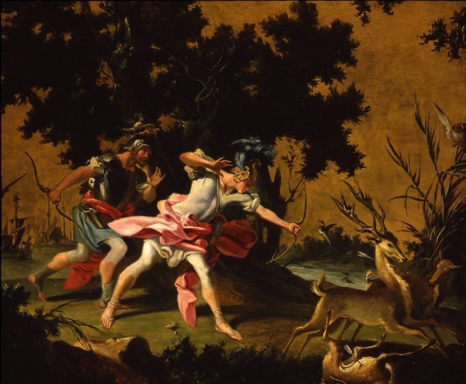

**Read lines 223-304**

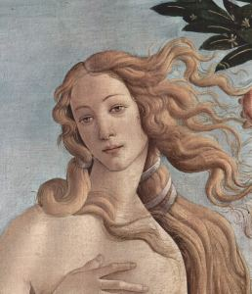How does Venus show her concern for Aeneas and the Trojans?

How do the following lines echo Virgil’s sentiments in his introduction to the epic?

“We are betrayed and kept far away from the shores of Italy because there is one who hates us. Is this our reward for piety and obedience?”

What impression do you get of the relationship between Venus and Jupiter?

Complete the scroll of the Fates, as read by Jupiter:

The Secret Scroll of the Fates

* **Aeneas will wage war in Italy and crush its tribes.**



Glossary

‘**the priestess queen’** – known as Rhea Silvia in the story of Romulus and Remus.

‘**toga**’ – the iconic Roman (male) clothing.

‘**Assaracus**’ – the great-grandfather of Aeneas

‘**reduce Achilles’ Pythia…city of Argos’** – refers to the Roman conquest of Greece (2nd Century BC)

**‘Oceanus’** – the Romans believed this was a river that encircled the whole world.

**‘Vesta’** – the Roman goddess of the hearth (like the Greek Hestia). Note how ‘truth’, the hearth and ‘justice’ were important Roman ideals.

**‘Gates of War**’ – the gates of Janus’ temple were closed in Rome in peace time (hardly ever until the reign of Augustus).

‘**Strife**’ – a male here called Enyalius, the son of Eris. It was Eris that began the whole violent cycle of the epics with her famous golden apple. It seems fitting that her son is imprisoned when peace is established at the end of the saga.

Find four quotes that you think allude to the Age of Augustus in which Virgil is writing. What do they show about the Augustan Roman Empire?

|  |  |
| --- | --- |
| **Quote** | **What does it show?** |
|  |  |
|  |  |
|  |  |
|  |  |

What appears to have been Mercury’s mission?

**Read lines 305-418**

List all the ways Venus’ appearance (and that of her imaginary sister) differ from a typical Roman woman:

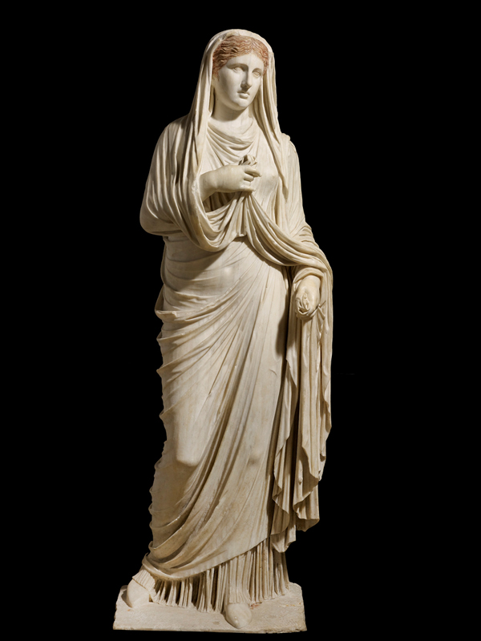

Why is Virgil keen to emphasise the differences between the Trojans and those they meet in Libya?

Statue of Eumachia, a Roman woman from Pompeii.

Why do you think Aeneas guesses that Venus is Diana (= Artemis)?

How does Aeneas demonstrate his piety in his initial reply to Venus?

Complete this storyboard for Dido’s backstory:

|  |  |  |
| --- | --- | --- |
|  |  |  |
|  |  |  |
|  |  |  |
|  |  |  |
|  |  |  |
|  |  |  |

What evidence does Aeneas offer for his claim that he is known for his devotion?

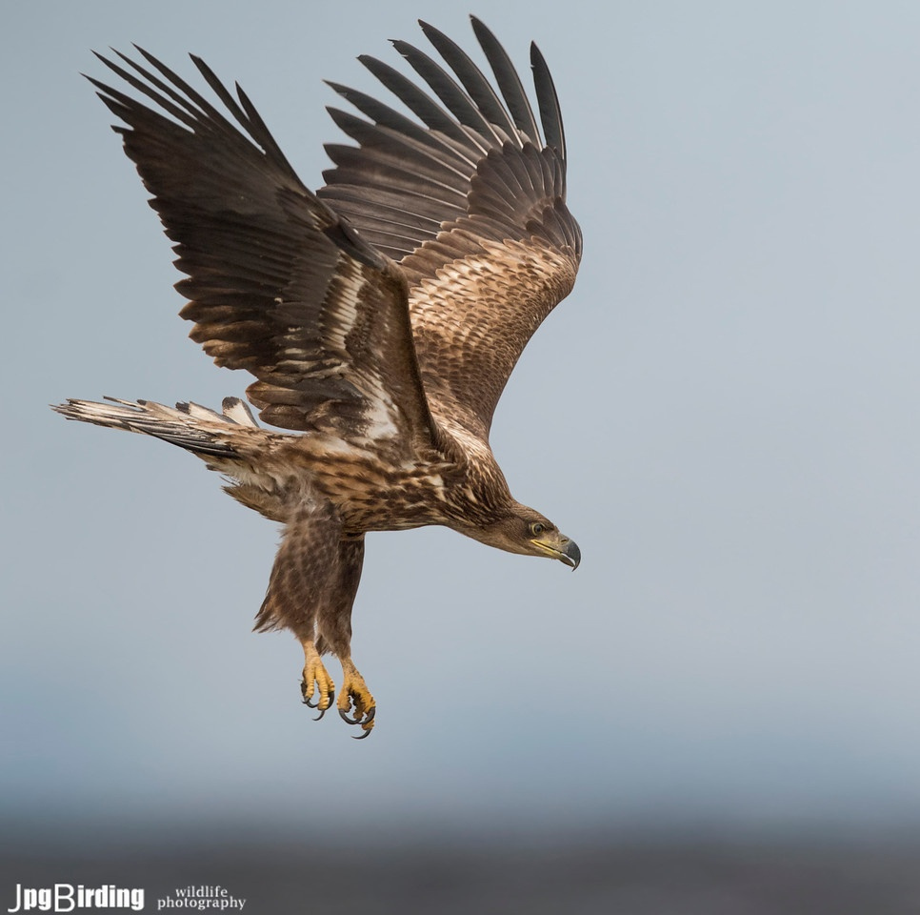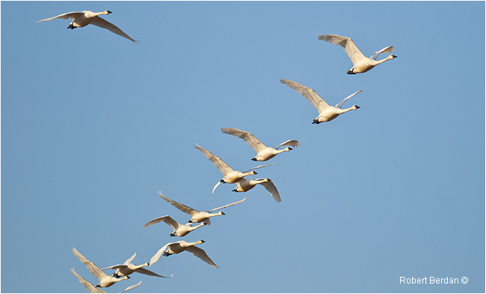What omen does Venus observe and what is her interpretation?

How does Virgil alter the typical Homeric recognition scene to suit his own purposes?

What assistance does Venus provide for Aeneas and Achates? What scene in Homer does this recall?

**Read lines 419-440**

Next to each bee, write one task Aeneas observes the Tyrians doing:

















Why is the beehive simile such an appropriate one?

Why does Aeneas say ‘*Their* walls are already rising’?

**Read lines 441-494**

What do we learn about the temple Dido is building for Juno?

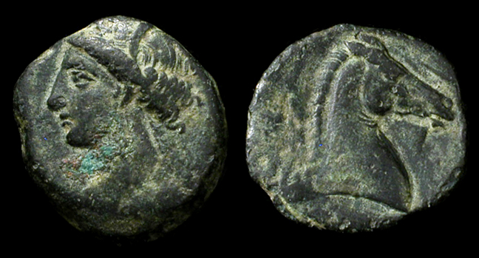Aeneas’ phrase ‘there are tears for suffering’ (*sunt lacrimae rerum*) is the most quoted phrase from the *Aeneid*. Why do you think this is?

Coin from Carthage showing their patron goddess, Tanit (OBV) and a horse head (REV)

How do the episodes depicted of the Trojan War resonate with what Aeneas just told Achates? Give 4 examples:



**Read lines 495-579**

What impression do we get of Dido from Aeneas’ first encounter with her? Support your points with quotes:

|  |  |
| --- | --- |
| **Quote** | **Explanation** |
|  |  |
|  |  |
|  |  |
|  |  |

How does Ilioneus do the following?

1. Create sympathy for the Trojans:
2. Argue that the Trojans should be well received:
3. Praise Aeneas:

What are the two options Dido offers the Trojans and what help will she provide for each?

|  |  |
| --- | --- |
| Option A: | Option B: |
| Assistance: | Assistance: |

**Read lines 580-631**

What does Venus do for Aeneas when the invisible cloud disappears? What scene in Homer does this recall?

List all the ways Aeneas compliments Dido:



Consider the following lines:

“May the gods bring you the reward you deserve, if there are any gods who have regard for goodness, if there is any justice in the world, if their minds have any sense of right.”

1. Why is this line particularly tragic given to whom it is addressed?
2. How does this line echo Virgil’s approach to suffering and piety?

How does Dido’s response remind us of her own backstory?

**Read lines 632-756**

Throughout this passage, complete the following diagram to show how Dido’s feast is similar to those in Homer:

|  |
| --- |
| **Quote** |
|  |
|  |
|  |
|  |

Find four quotes from the passage that suggest Dido is doomed to a terrible fate:

What has Juno got to do with Venus’ decision to bring about Dido’s doom?

Complete the following:

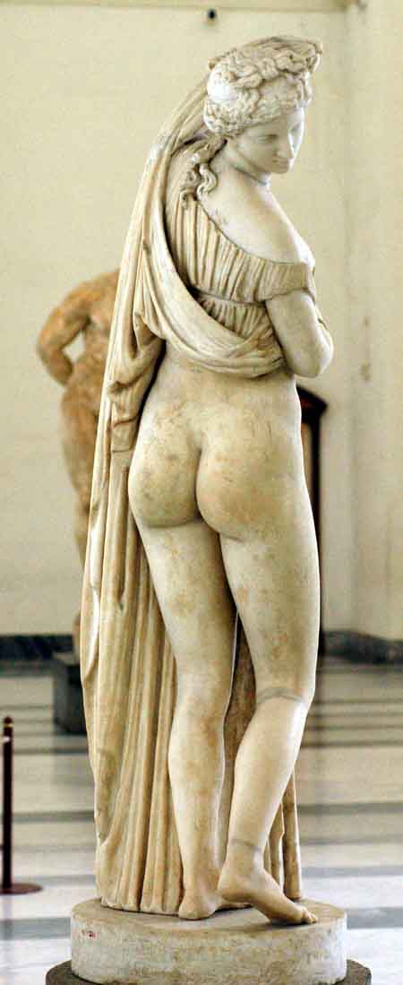

Your brother is in trouble because…

Here’s what we’ll do together:

Annotate Cupid with his actions, thoughts and effects throughout the passage:

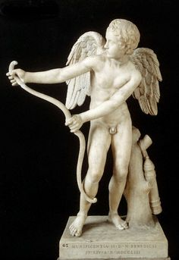

**Appendix – Aeneas’ Trojan Companions**

Throughout *The* *Aeneid*, you will notice certain names occur repeatedly amongst the Trojans. They often gain the epithet ‘brave’ alongside their names. Here is a summary of the most important characters:

|  |  |
| --- | --- |
| **Character** | **Description** |
| Achates | The closest companion of Aeneas, who travels by his side. |
| Aletes | A Trojan elder, whose words appear to hold weight at council. |
| Antheus | Captain of one of Aeneas’ ships, separated from him at the start of *The Aeneid*. |
| Gyas | Captain of the ship named *Chimaera* |
| Ilioneus | Prominent Trojan who often is the one to speak as an ambassador |
| Mnestheus | Captain of the ship named *Pristis* |
| Serestus | Close companion of Aeneas. |
| Sergestus | Captain of the ship named *Centaur*. He is also named as the founder of the Sergian family in Rome. |
| Cloanthus | Captain of the ship named *Scylla* |