

**Higher IGCSE (9 – 1) Revision Pack**

**2D Trigonometry**

**Name --------------------------------**

**Questions**

**Q1.**

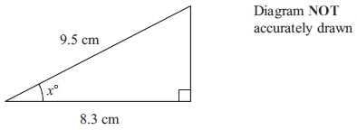

Work out the value of *x*.  
 Give your answer correct to 1 decimal place.

*x* = ...........................................................

**(Total for question = 3 marks)**

**Q2.**

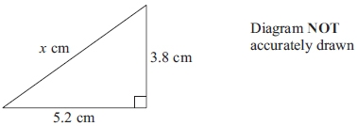

Calculate the value of *x*.  
 Give your answer correct to 3 significant figures.

*x* = ...........................................................

**(Total for question = 3 marks)**

**Q3.**

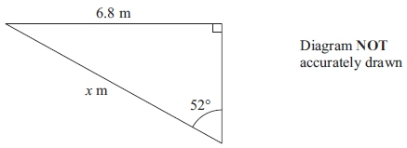

Calculate the value of *x*.  
 Give your answer correct to 3 significant figures.

*x* = ...........................................................

**(Total for question = 3 marks)**

**Q4.**

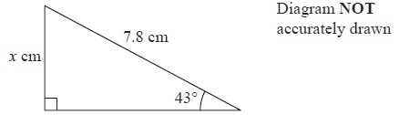

Work out the value of *x*.   
Give your answer correct to 3 significant figures.

*x* = ...........................................................

**(Total for Question is 3 marks)**

**Q5.**

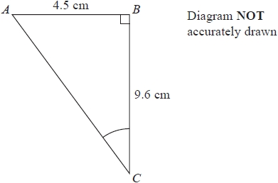

Work out the size of angle *ACB*.   
Give your answer correct to 1 decimal place.

........................................................... °

**(Total for question = 3 marks)**

**Q6.**

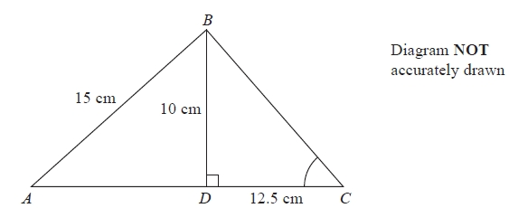

*ABC* is a triangle.   
The point *D* lies on *AC*.   
Angle *BDC* = 90°   
*BD* = 10 cm, *AB* = 15 cm and *DC* = 12.5 cm.

(a)  Calculate the length of *AD*.   
       Give your answer correct to 3 significant figures.

........................................................... cm

**(3)**

(b)  Calculate the size of angle *BCD*.   
       Give your answer correct to 1 decimal place.

........................................................... °

**(3)**

**(Total for question = 6 marks)**

**Q7.**

The diagram shows parallelogram *EFGH*.

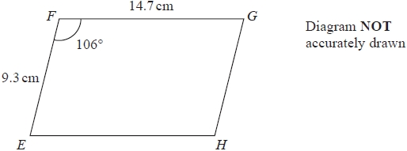

*EF* = 9.3 cm   
*FG* = 14.7 cm   
Angle *EFG* = 106°

(a)  Work out the area of the parallelogram.   
Give your answer correct to 3 significant figures.

........................................................... cm2

**(2)**

(b)  Work out the length of the diagonal *EG* of the parallelogram.   
Give your answer correct to 3 significant figures.

........................................................... cm

**(3)**

**(Total for question = 5 marks)**

**Q8.**

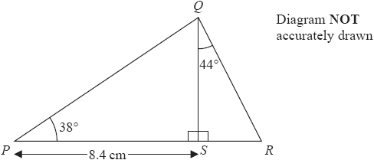

*PSR* is a straight line.   
  
Angle *PSQ* = 90°   
*PS* = 8.4cm   
Angle *QPS* = 38°   
Angle *SQR* = 44°   
  
Work out the length of *QR*.   
Give your answer correct to 3 significant figures.

........................................................... cm

**(Total for question = 4 marks)**

**Q9.**

Here is triangle *ABD*.

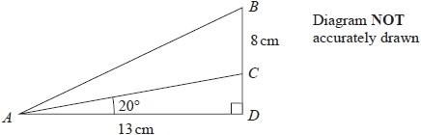

The point *C* lies on *BD*.

*AD* = 13 cm          *BC* = 8 cm          angle *ADB* = 90°          angle *CAD* = 20°

Calculate the size of angle *BAC*.   
Give your answer correct to 1 decimal place.

°

**(Total for question = 5 marks)**

**Q10.**

Here is isosceles triangle *ABC*.

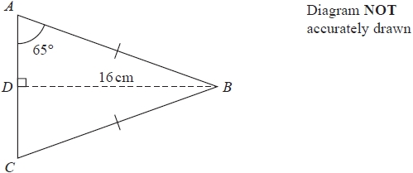

*D* is the midpoint of *AC* and *DB* = 16 cm.

Angle *DAB* = 65°

Work out the perimeter of triangle *ABC*.   
Give your answer correct to one decimal place.

........................................................... cm

**(Total for question = 4 marks)**

**Q11.**

*ABCD* is a trapezium.

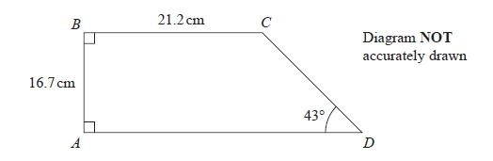

Calculate the perimeter of the trapezium.   
Give your answer correct to 3 significant figures.

........................................................... cm

**(Total for question = 4 marks)**

**Q12.**

Here is a triangle *QRS*.

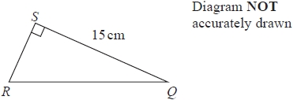

*SQ* = 15 cm   
Angle *RSQ* = 90°   
Area of triangle *QRS* = 60 cm2

Work out the size of angle *SQR*.   
Give your answer correct to 1 decimal place.

........................................................... °

**(Total for question = 4 marks)**

**Q13.**

The diagram shows triangle *ABC*.

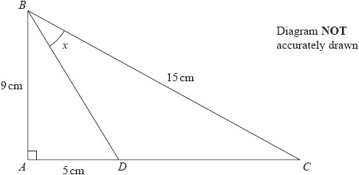

*AB* = 9 cm    *BC* = 15 cm   
*D* is the point on *AC* such that *AD* = 5 cm.   
Angle *BAC* = 90°

Calculate the size of angle *x*.   
Give your answer to the nearest degree.

........................................................... °

**(Total for question = 4 marks)**

**Q14.**

Here is the quadrilateral *ABCD*.

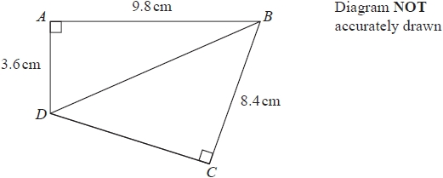

Angle *BAD* = 90° and angle *BCD* = 90°   
*AB* = 9.8cm   
*AD* = 3.6cm   
*BC* = 8.4cm

Calculate the length of *DC*.

........................................................... cm

**(Total for question = 4 marks)**

**Q15.**

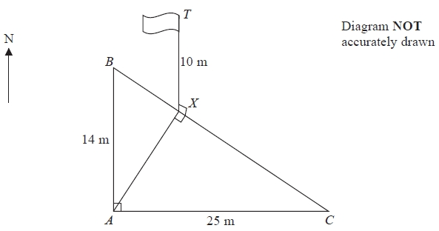

*A*, *B* and *C* are points on horizontal ground.   
*B* is due North of *A* and *AB* is 14 m.   
*C* is due East of *A* and *AC* is 25 m.

A vertical flagpole, *TX*, has its base at the point *X* on *BC* such that the angle *AXC* is a right angle.

The height of the flagpole, *TX*, is 10 m.

Calculate the size of the angle of elevation of *T* from *A*.   
Give your answer correct to 1 decimal place.

...........................................................°

**(Total for question = 6 marks)**

**Q16.**

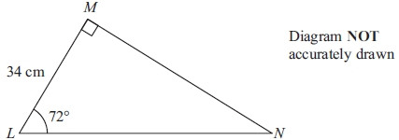

Calculate the length of *MN*.  
 Give your answer correct to 3 significant figures.

...........................................................cm

**(Total for question = 3 marks)**

**Q17.**

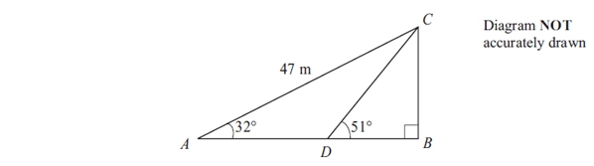

Triangle ABC is right-angled at B.  
 Angle BAC = 32°  
 AC = 47 m.  
 D is the point on AB such that angle BDC = 51°

Calculate the length of BD.  
 Give your answer correct to 3 significant figures.

(i) the number on the second counter is 2 more than the number on the first counter,

........................................................... m

**(Total for question = 5 marks)**

**Q18.**

*ABCD* is a trapezium.

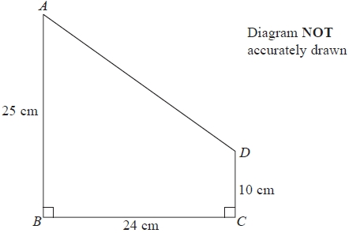

*AB* = 25 cm.   
*BC* = 24 cm.   
*CD* = 10 cm.

Angle *ABC* = angle *BCD* = 90°

Calculate the size of angle *CDA*.   
Give your answer correct to 3 significant figures.

...........................................................°

**(Total for question = 4 marks)**

**Q19.**

The diagram shows the positions of two towns, *A* and *B*.

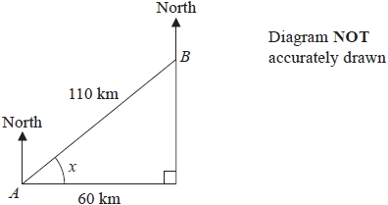

The distance from *A* to *B* is 110 km.   
*B* is 60 km east of *A*.

(a)  Work out the size of angle *x*.

Give your answer correct to 1 decimal place.

........................................................... °

**(3)**

(b)  Work out the bearing of *B* from *A*.

Give your answer correct to the nearest degree.

........................................................... °

**(2)**

The distance from *A* to *B* is 110 km correct to 2 significant figures.

(c) (i)  Write down the lower bound for the distance from *A* to *B*.

........................................................... km

(ii)  Write down the upper bound for the distance from *A* to *B*.

........................................................... km

**(2)**

**(Total for question = 7 marks)**

**Q20.**

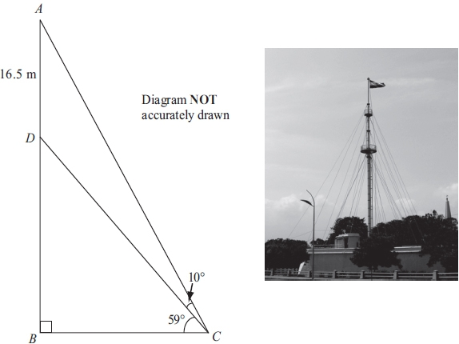

The diagram shows a vertical flagpole in Chennai, India.  
 The point *A* is at the top of the flagpole.  
 The point *B* is at the foot of the flagpole.  
 There is a platform at the point *D* on the flagpole.  
*B* and *C* are points on horizontal ground.  
 AD = 16.5 m  
 The angle of elevation of A from C is 69°  
 The angle of elevation of D from C is 59°

Calculate the height, *AB*, of the flagpole.  
 Give your answer correct to 3 significant figures.

...........................................................m

**(Total for question = 6 marks)**

**End of questions**