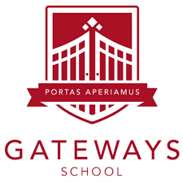

**Higher IGCSE (9 – 1) Revision Pack**

**Volume problems**

**Name --------------------------------**

**Questions**

**Q1.**

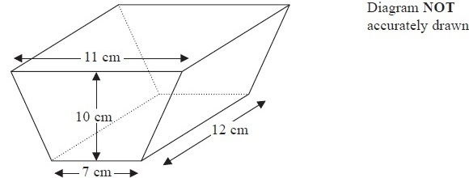

The diagram shows a solid prism.   
The cross section of the prism is a trapezium.   
The lengths of the parallel sides of the trapezium are 11 cm and 7 cm.   
The perpendicular distance between the parallel sides of the trapezium is 10 cm.   
The length of the prism is 12 cm.

(a)  Work out the area of the trapezium.

........................................................... cm2

**(2)**

(b)  Work out the volume of the prism.

........................................................... cm3

**(2)**

**(Total for Question is 4 marks)**

**Q2.**

Here is a sector, *AOB*, of a circle with centre *O* and angle *AOB* = *x*°

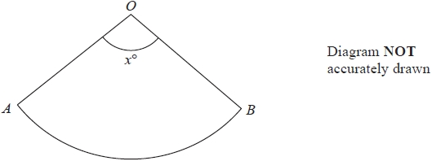

The sector can form the curved surface of a cone by joining *OA* to *OB*.

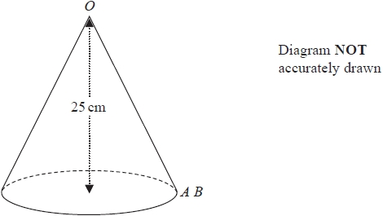

The height of the cone is 25 cm.   
The volume of the cone is 1600 cm3

Work out the value of *x*.   
Give your answer correct to the nearest whole number.

*x* = ...........................................................

**(Total for question = 6 marks)**

**Q3.**

A cylinder has diameter 14 cm and height 20 cm.

Work out the volume of the cylinder.   
Give your answer correct to 3 significant figures.

........................................................... cm3

**(Total for question = 2 marks)**

**Q4.**

The diagram shows a solid cylinder with radius 3 m.

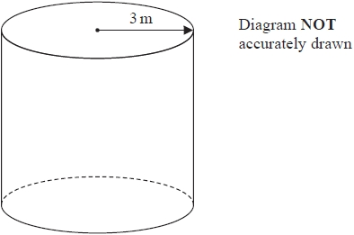

The volume of the cylinder is 72*π* m3

Calculate the **total** surface area of the cylinder.   
Give your answer correct to 3 significant figures.

........................................................... m2

**(Total for question = 5 marks)**

**Q5.**

The diagram shows a sphere and a cone.

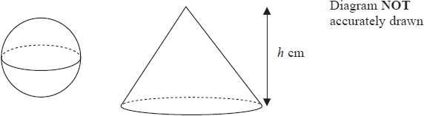

The cone has height *h* cm.   
The radius of the base of the cone is 3 times the radius of the sphere.

Given that the volume of the sphere is equal to the volume of the cone, find an expression for the radius of the sphere in terms of *h*.   
Give your expression in its simplest form.

...........................................................

**(Total for question = 3 marks)**

**Q6.**

The diagram shows a solid cone.

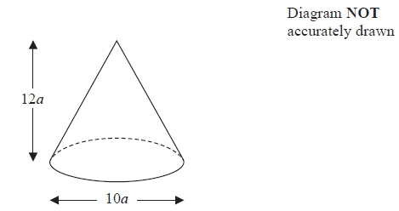

The diameter of the base of the cone is 10*a* cm.   
The height of the cone is 12*a* cm.

The total surface area of the cone is 360*π* cm2  
The volume of the cone is *kπ* cm3, where *k* is an integer.

Find the value of *k*.

*k* = ...........................................................

**(Total for Question is 6 marks)**

**Q7.**

The diagram shows a solid hemisphere.

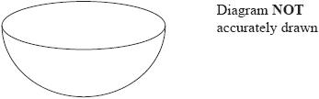

The hemisphere has a **total** surface area of *π* cm2

The hemisphere has a volume of *kπ* cm3

Find the value of *k*.

...........................................................

**(Total for question = 4 marks)**

**Q8.**

The diagram shows a cylinder inside a cone on a horizontal base.   
The cone and the cylinder have the same vertical axis.   
The base of the cylinder lies on the base of the cone.   
The circumference of the top face of the cylinder touches the curved surface of the cone.

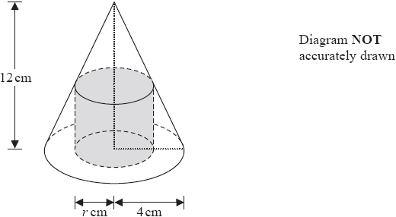

The height of the cone is 12cm and the radius of the base of the cone is 4cm.

(a)  Work out the curved surface area of the cone.

Give your answer correct to 3 significant figures.

........................................................... cm2

**(3)**

The cylinder has radius *r* cm and volume *V* cm3

(b)  Show that *V* = 12*πr*2 – 3*πr*3

**(3)**

(c)  *V* = 12*πr*2 – 3*πr*3

Find the value of *r* for which *V* is a maximum.

*r* = ...........................................................

**(4)**

**(Total for question = 10 marks)**

**Q9.**

The diagram shows a solid cone.

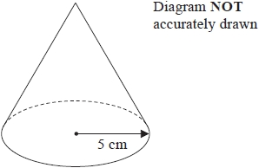

The radius of the base of the cone is 5 cm.   
The total surface area of the cone is 90*π* cm2

Work out the volume of the cone.   
Give your answer as a multiple of *π*.

........................................................... cm3

**(Total for question = 5 marks)**

**Q10.**

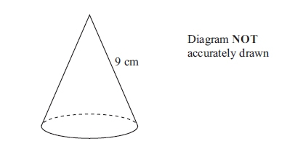

A solid cone has a slant height of 9 cm.   
The **curved** surface area of the cone is 100 cm2.

Calculate the volume of the cone.   
Give your answer correct to 3 significant figures.

........................................................... cm3

**(Total for question is 5 marks)**

**Q11.**

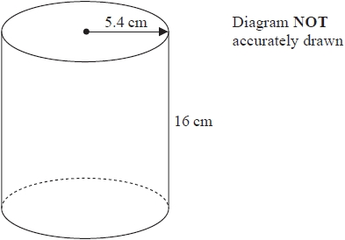

A cylinder has radius 5.4 cm and height 16 cm.

(a)  Work out the volume of the cylinder.   
Give your answer correct to the nearest whole number.

........................................................... cm3

**(2)**

The radius 5.4 cm is correct to 2 significant figures.

(b)  (i)  Write down the upper bound of the radius.

........................................................... cm

(ii)  Write down the lower bound of the radius.

........................................................... cm

**(2)**

**(Total for question = 4 marks)**

**Q12.**

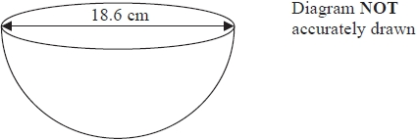

The diagram shows a hemisphere with a diameter of 18.6 cm.

Work out the volume of the hemisphere.   
Give your answer correct to 3 significant figures.

........................................................... cm3

**(Total for question = 3 marks)**

**Q13.**

Here is a prism.

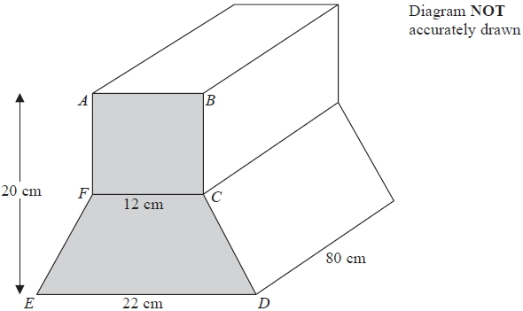

*ABCDEF* is a cross section of the prism.

*ABCF* is a square of side 12 cm.

*FCDE* is a trapezium.   
*ED* = 22 cm.

The height of the prism is 20 cm.   
The length of the prism is 80 cm.

Work out the total volume of the prism.

........................................................... cm3

**(Total for question = 5 marks)**

**Q14.**

The total surface area of a solid hemisphere is equal to the curved surface area of a cylinder.

The radius of the hemisphere is *r* cm.   
The radius of the cylinder is twice the radius of the hemisphere.

Given that

volume of hemisphere : volume of cylinder = 1 : *m*

find the value of *m*.

*m* =

**(Total for question = 4 marks)**

**Q15.**

A solid is made from a hemisphere and a cylinder.   
The plane face of the hemisphere coincides with the upper plane face of the cylinder.

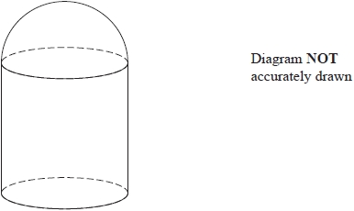

The hemisphere and the cylinder have the same radius.

The ratio of the radius of the cylinder to the height of the cylinder is 1 : 3

Given that the solid has volume 792*π* cm3  
work out the height of the solid.

........................................................... cm

**(Total for question = 5 marks)**

**Q16.**

A solid metal cube has sides of length 125 mm, correct to 3 significant figures.

The cube is melted down and the metal used to make solid spheres.   
The volume of each sphere is to be 140 cm3, correct to the nearest 10 cm3

Work out the greatest number of spheres that could be made from the metal.   
Show your working clearly.

...........................................................

**(Total for question = 4 marks)**

**Q17.**

A cone has a volume of 562.5π cm3

The radius of the base of the cone is equal to twice the height of the cone.

Work out the curved surface area of the cone.   
Give your answer correct to 3 significant figures.

........................................................... cm2

**(Total for question = 5 marks)**

**Q18.**

The diagram shows a cuboid and a triangular prism.

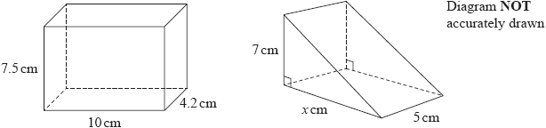

The volume of the cuboid is equal to the volume of the triangular prism.

Work out the value of *x*.

...........................................................

**(Total for question = 4 marks)**

**Q19.**

A container is made from a hemisphere on top of a cylinder, as shown in the diagram.

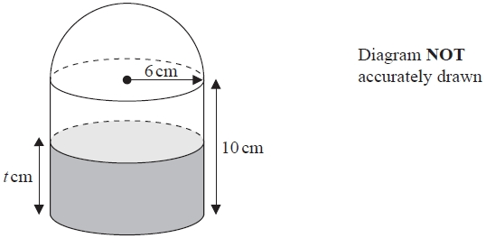

The hemisphere and the cylinder both have radius 6 cm.   
The height of the cylinder is 10 cm.

There is water to a depth of *t* cm in the cylinder.   
The volume of water in the container is half the total volume of the container.

Work out the value of *t*.

...........................................................

**(Total for question = 4 marks)**

**Q20.**

The diagram shows two solid shapes, shape **A** and shape **B**.   
Shape **A** is made of a hemisphere and a cone.   
Shape **B** is a cylinder.

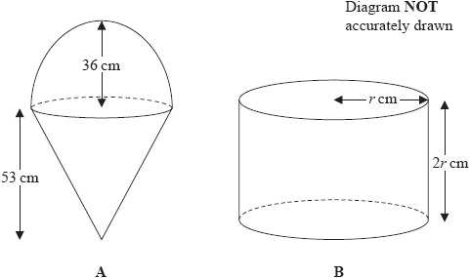

For shape **A**

radius of the hemisphere is 36 cm   
radius of the base of the cone is 36 cm   
height of the cone is 53 cm

For shape **B**

radius of the cylinder is *r* cm   
height of the cylinder is 2*r* cm

The volume of shape **A** = the volume of shape **B**

Calculate the height of shape **B**.

........................................................... cm

**(Total for question = 6 marks)**

**Q21.**

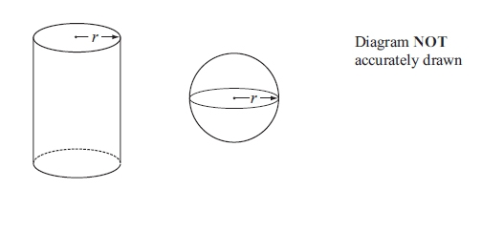

The diagram shows a solid cylinder and a solid sphere.  
 The cylinder has radius r.  
 The sphere has radius r.

Given that  = 2

find the value of 

      ..............................................................................................................................................

**(Total for question = 5 marks)**

**Q22.**

The diagram shows a cylinder and a sphere.

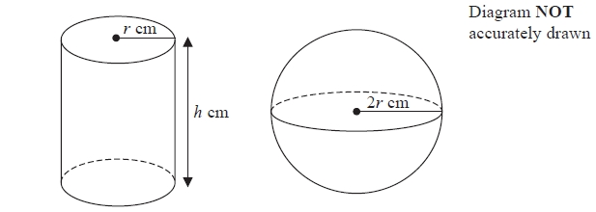

The cylinder has radius *r* cm and height *h* cm.   
The sphere has radius 2*r* cm.

The volume of the cylinder is equal to the volume of the sphere.   
Find an expression for *h* in terms of *r*.   
Give your answer in its simplest form.

...........................................................

**(Total for question = 3 marks)**

**Q23.**

The diagram shows a solid cylinder.

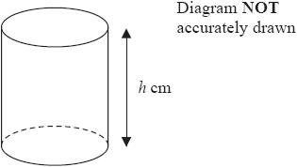

The cylinder has radius 4√3 cm and height *h* cm.   
The total surface area of the cylinder is 56*π*√6 cm2

Find the exact value of *h*.   
Give your answer in the form *a*√2 + *b*√3, where *a* and *b* are integers.   
Show your working clearly.

*h* = ...........................................................

**(Total for question = 5 marks)**

**Q24.**

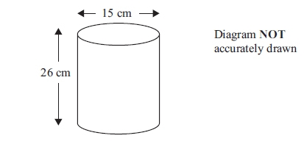

A cylinder has a diameter of 15 cm and a height of 26 cm.   
Work out the volume of the cylinder.

Give your answer correct to 3 significant figures.

........................................................... cm3

**(Total for question is 3 marks)**

**Q25.**

A frustum is made by removing a small cone from a large cone.   
The cones are mathematically similar.

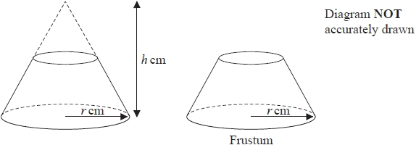

The large cone has base radius *r* cm and height *h* cm.

Given that



find an expression, in terms of *h*, for the height of the frustum.

........................................................... cm

**(Total for question = 4 marks)**

**Q26.**

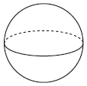

A sphere has a surface area of 81π cm2.

Work out the volume of the sphere.   
Give your answer correct to 3 significant figures.

........................................................... cm3

**(Total for Question is 4 marks)**

**Q27.**

A solid metal sphere has radius 1.5 cm.   
The mass of the sphere is 109.6 grams.

Work out the density of the sphere.   
Give your answer correct to 3 significant figures.

........................................................... g / cm2

**(Total for question = 3 marks)**

**Q28.**

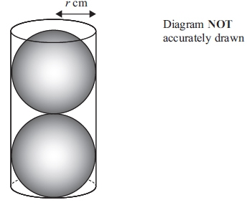

Two solid spheres, each of radius *r* cm, fit exactly inside a hollow cylinder.  
 The radius of the cylinder is *r* cm.  
 The height of the cylinder is equal to 4*r* cm.

The volume of the space inside the cylinder, not occupied by the spheres, is  cm3

Calculate the value of *r*.

Show your working clearly.

*r* = ...........................................................

**(Total for question = 5 marks)**

**Q29.**

The diagram shows a container for water in the shape of a prism.

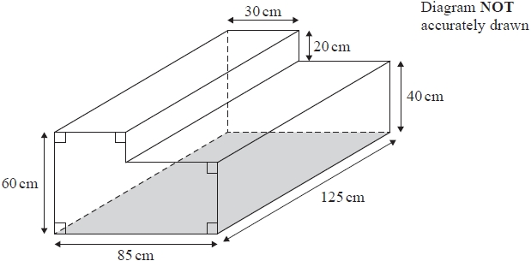

The rectangular base of the prism, shown shaded in the diagram, is horizontal.   
The container is completely full of water.

Tuah is going to use a pump to empty the water from the container so that the volume of water in the container decreases at a constant rate.

The pump starts to empty water from the container at 10 30 and at 12 00 the water level in the container has dropped by 20 cm.

Find the time at which all the water has been pumped out of the container.

...........................................................

**(Total for question = 4 marks)**

**End of questions**