

**Higher IGCSE (9 – 1) Revision Pack**

**Functions**

**Name --------------------------------**

**Questions**

  
**Q1.**

(a)  Find the value of f(11)

...........................................................

**(1)**

(b)  State which value of *x* must be excluded from any domain of f

...........................................................

**(1)**

(c)  Find f –1(*x*)

...........................................................

**(3)**

(d)  State the value which cannot be in any range of f

...........................................................

**(1)**

**(Total for question = 6 marks)**

**Q2.**

The function f is such that   f (*x*) =

(a)  Find  f(–2)

...........................................................

**(1)**

The function g is such that   g (*x*) =

(b)  Find g–1(6)

...........................................................

**(2)**

(c)  Find  fg(–5)

...........................................................

**(2)**

(d)  Solve the equation   f(*x*) = g (*x*)

Show clear algebraic working.

...........................................................

**(4)**

**(Total for question = 9 marks)**

**Q3.**



(a)  Express the composite function gf in the form gf:*x* → ...   
       Give your answer as simply as possible.

gf:*x* → ...........................................................

**(2)**

(b) Express the inverse function g−1 in the form g−1:*x* → ...

g−1:*x* → ...........................................................

**(3)**

**(Total for question = 5 marks)**

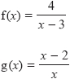**Q4.**

(a)  Express the inverse function f−1 in the form f−1(*x*) = ...

f−1(*x*) = ...........................................................

**(3)**

(b)  Solve    fg(*a*) = 1

Show clear algebraic working.

*a* = ...........................................................

**(3)**

**(Total for question = 6 marks)**

**Q5.**

f is a function such that



f(*x*) =

(a) Find f(1/2)

...........................................................

**(1)**

g is a function such that



g(*x*) = ; *x* ≥ 1

(b) Find fg(*x*)

Give your answer as simply as possible.

fg(*x*) =...........................................................

**(2)**

**(Total for question = 3 marks)**

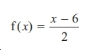**Q6.**

The function f is defined as

(a) Find f (8)

...............................

**(1)**

(b) Express the inverse function f −1 in the form f −1(*x*) = ...

f −1(*x*) =..............................................

**(2)**

The function g is defined as

(c) Which values of *x* cannot be included in a domain of g?

..............................................

**(2)**

(d) Express the function gf in the form gf (*x*) = ...

Give your answer as simply as possible.

gf(*x*) =..............................................

**(2)**

**(Total for question = 7 marks)**

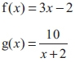**Q7.**

(a) Express the inverse function f−1 in the form f−1(*x*) = ...

f−1(*x*) =...........................................................

**(2)**

(b) Find gf(*x*)

Simplify your answer.

gf(*x*) =...........................................................

**(2)**

**(Total for question = 4 marks)**

**Q8.**



(a) Show that can be written as

State the value of *k*.

*k* = ...........................................................

**(2)**

(b) f(*x*) =

Find the inverse function f−1 in the form f−1(*x*) = ......

Show your working clearly.

f−1(*x*) = ........................................................

**(3)**

**(Total for question = 5 marks)**

**Q9.**

 f(*x*) =

(a)  State one value of *x* which cannot be included in any domain of f.

...........................................................

**(1)**

(b)  Find the value of f(0)

...........................................................

**(1)**

(c)  Find the value of *x* for which f(*x*) = 0

Show clear algebraic working.

*x* = ...........................................................

**(3)**

**(Total for question = 5 marks)**

**Q10.**

f is the function such that

(a)  Find     f(0.5)

...........................................................

**(1)**

(b)  Find     ff(–1)

...........................................................

**(2)**

(c)  Find the value of *x* that cannot be included in any domain of f

...........................................................

**(1)**

(d)  Express the inverse function f –1 in the form f –1(*x*) = ...

Show clear algebraic working.

f –1(*x*) = ...........................................................

**(3)**

**(Total for question = 7 marks)**

**Q11.**

The functions g and h are defined as

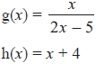

(a)  Find the value of g(1)

...........................................................

**(1)**

(b)  State which value of *x* must be excluded from any domain of g

...........................................................

**(1)**

(c)  Find gh(*x*)   
       Simplify your answer.

gh(*x*) =...........................................................

**(2)**

(d)  Express the inverse function g−1 in the form g−1(*x*) =...

g−1(*x*) =...........................................................

**(3)**

**(Total for question = 7 marks)**

**Q12.**

f is the function f(*x*) = 2*x* + 5

(a)  Find f(3)

...........................................................

**(1)**

(b)  Express the inverse function f−1 in the form f−1(*x*) =

f−1(*x*) = ...........................................................

**(2)**

g is the function g(*x*) = *x*2 − 25

(c)   Find g(−3)

...........................................................

**(1)**

(d)  (i)  Find gf(*x*)

Give your answer as simply as possible.

gf(*x*) = ...........................................................

(ii)  Solve gf(*x*) = 0

...........................................................

**(5)**

**(Total for Question is 9 marks)**

**Q13.**

The functions f and g are such that   f(*x*) = *x* + 3   and   g(*x*) =

(a)  Find fg(*x*)

Give your answer as a single algebraic fraction expressed as simply as possible.

...........................................................

**(3)**

(b)  Express the inverse function g−1 in the form g−1(*x*) = ...

g−1(*x*) = ...........................................................

**(3)**

**(Total for Question is 6 marks)**

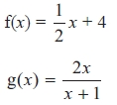**Q14.**

The functions f and g are defined as

(a)   Work out f(6)

...........................................................

**(1)**

(b)   Work out fg(−3)

...........................................................

**(2)**

(c)   g(*a*) = −2

Work out the value of *a*.

*a* = ...........................................................

**(2)**

(d)   Express the inverse function f−1 in the form f −1(*x*) = ...

f−1(*x*) = ...........................................................

**(3)**

**(Total for Question is 8 marks)**

**Q15.**

The function f is defined as

(a)   Find the value of f(1)

...........................................................

**(1)**

(b)   State which value of *x* must be excluded from any domain of f.

...........................................................

**(1)**

The function g is defined as g(*x*) = 5 + *x*

(c)   Given that g(*a*) = 7, find the value of *a*.

*a* = ...........................................................

**(1)**

(d)   Calculate fg(1)

...........................................................

**(2)**

(e)   Find fg(*x*)   
Simplify your answer.

fg(*x*) = ...........................................................

**(2)**

**(Total for Question is 7 marks)**

**Q16.**

The diagram shows the graph of     *y* = f(*x*) for −3.5 ≤ *x* ≤ 1.5

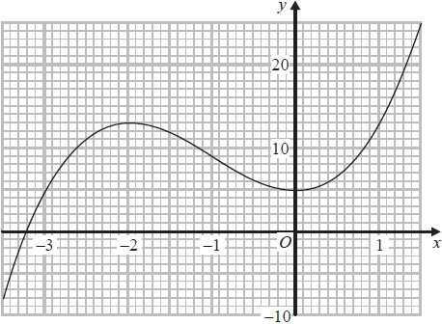

(a)  Find f(0)

...........................................................

**(1)**

(b)  For which values of *k* does the equation f(*x*) = *k* have only one solution?

...........................................................

**(2)**

(c)  Find an estimate for the gradient of the curve at the point where *x* = −2.5

...........................................................

**(3)**



(d)  State which value of *x* must be excluded from any domain of g

...........................................................

**(1)**

(e)  Find fg(−3)

...........................................................

**(2)**

**(Total for question = 9 marks)**

**Q17.**

(a) Find f(10)

...........................................................

**(1)**

(b) State which values of *x* must be excluded from a domain of *f*

...........................................................

**(2)**

The diagram shows part of the graph of *y* = g(*x*)

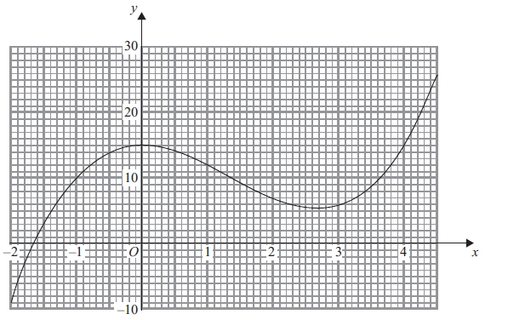

(c) Find g(2)

...........................................................

**(1)**

(d) Find fg(0)

...........................................................

**(2)**

(e) One of the solutions of g(*x*) = *k*, where *k* is a number, is *x* = 1

Find the other solutions.   
Give your answers correct to 1 decimal place.

...........................................................

**(3)**

(f) Find an estimate for the gradient of the curve at the point where *x* = 3.5   
Show your working clearly.

...........................................................

**(3)**

**(Total for question is 12 marks)**

**Q18.**

The diagram shows parts of the graphs of *y* = f(*x*) and *y* = g(*x*).

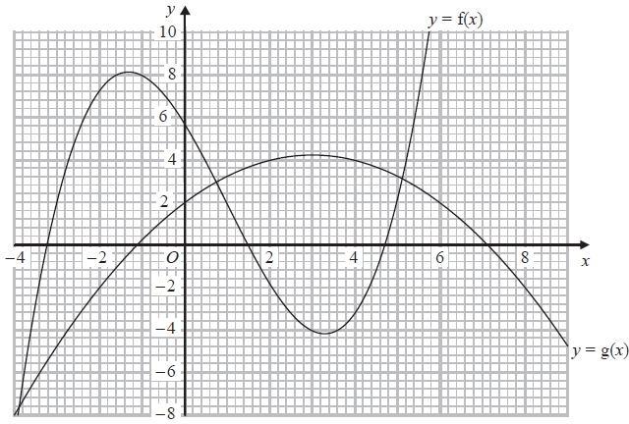

(a)  Find g(0)

...........................................................

**(1)**

(b)  Find gf(−1)

...........................................................

**(2)**

(c)  Calculate an estimate for the gradient of the curve *y* = f(*x*) at the point on the curve where *x* = 3

...........................................................

**(3)**

**(Total for question = 6 marks)**

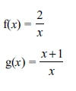

**Q19.**

(a) State which value of *x* cannot be included in the domain of f or g.

...........................................................

**(1)**

(b) Solve gf(*a*) = 3

*a* = ...........................................................

**(3)**

(c) Express the inverse function g−1 in the form g−1(*x*)

g−1(*x*) = ...........................................................

**(3)**

**(Total for question = 7 marks)**

**Q20.**

f is the function such that f(*x*) = 2*x* – 5

g is the function such that g(*x*) = *x*2 – 10

(a)  Find f(4)

...........................................................

**(1)**

(b)  Find fg(–4)

...........................................................

**(2)**

(c)  Express the inverse function f –1 in the form f –1(*x*) = ...

f –1(*x*) = ...........................................................

**(2)**

(d)  Solve gf(*x*) = –1

...........................................................

**(4)**

**(Total for question = 9 marks)**

**Q21.**

The function f is defined as f(*x*) =

(a)  State the value of *x* which cannot be included in any domain of f.

...........................................................

**(1)**

(b)  Find f(–4)

...........................................................

**(1)**

(c)  Express the inverse function f –1 in the form f –1(*x*) = ...

f –1(*x*) = ...........................................................

**(2)**

The function *g* is defined as g(*x*) =

(d)  Express the function fg in the form fg(*x*) = ...

Simplify your answer.

fg(*x*) = ...........................................................

**(2)**

**(Total for question = 6 marks)**

**Q22.**

The functions f and g are such that

(a)  State which value of *x* must be excluded from any domain of f.

...........................................................

**(1)**

(b)  Find g(10)

...........................................................

**(1)**

(c)  Calculate gf(−7)

...........................................................

**(2)**

(d)  Express the inverse function g−1 in the form g−1(*x*) = ...

g−1(*x*) = ...........................................................

**(2)**

**(Total for question = 6 marks)**

**End of questions**