Gateways School

**Thermodynamics**

**Revision PPQ**

45 marks

**Name: ______________________________ Date: __________**

**Q1.**

(a)     Write an equation for the process that has an enthalpy change equal to the electron affinity of chlorine.

___________________________________________________________________

**(1)**

(b)     In terms of electrostatic forces, suggest why the electron affinity of fluorine has a negative value.

___________________________________________________________________

___________________________________________________________________

___________________________________________________________________

___________________________________________________________________

**(2)**

(c)     (i)      Complete the Born–Haber cycle for silver fluoride by adding the missing species on the dotted lines.

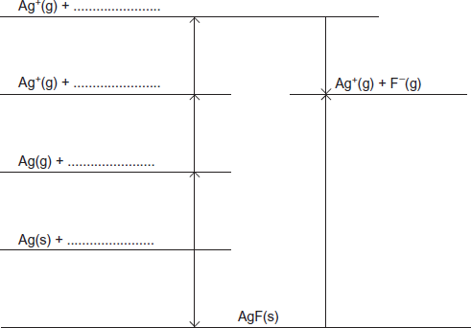

**(3)**

(ii)     Use the cycle in part (i) and the data in the table to calculate a value, in kJ mol–1, for the bond enthalpy of the fluorine–fluorine bond.

|  |  |
| --- | --- |
| **Enthalpy change** | **Value / kJ mol–1** |
| Enthalpy of atomisation for silver | +298 |
| First ionisation energy for silver | +732 |
| Electron affinity for fluorine | –348 |
| Experimental enthalpy of lattice dissociation for silver fluoride | +955 |
| Enthalpy of formation for silver fluoride | –203 |

______________________________________________________________

______________________________________________________________

______________________________________________________________

______________________________________________________________

______________________________________________________________

**(2)**

(d)     A theoretical value for enthalpy of lattice dissociation can be calculated using a perfect ionic model.

The theoretical enthalpy of lattice dissociation for silver fluoride is +870 kJ mol–1.

(i)      Explain why the theoretical enthalpy of lattice dissociation for silver fluoride is different from the experimental value that can be calculated using a Born–Haber cycle.

______________________________________________________________

______________________________________________________________

______________________________________________________________

______________________________________________________________

______________________________________________________________

**(2)**

(ii)     The theoretical enthalpy of lattice dissociation for silver chloride is +770 kJ mol–1.

Explain why this value is less than the value for silver fluoride.

______________________________________________________________

______________________________________________________________

______________________________________________________________

______________________________________________________________

______________________________________________________________

**(2)**

**(Total 12 marks)**

**Q2.**

This question is about bond dissociation enthalpies and their use in the calculation of enthalpy changes.

(a)     Define *bond dissociation enthalpy* as applied to chlorine.

___________________________________________________________________

___________________________________________________________________

___________________________________________________________________

___________________________________________________________________

**(2)**

(b)     Explain why the enthalpy of atomisation of chlorine is exactly half the bond dissociation enthalpy of chlorine.

___________________________________________________________________

___________________________________________________________________

___________________________________________________________________

**(1)**

(c)     The bond dissociation enthalpy for chlorine is +242 kJ mol−1 and that for fluorine is +158 kJ mol−1. The standard enthalpy of formation of ClF(g) is −56 kJ mol−1.

(i)      Write an equation, including state symbols, for the reaction that has an enthalpy change equal to the standard enthalpy of formation of gaseous ClF

______________________________________________________________

**(1)**

(ii)     Calculate a value for the bond enthalpy of the Cl – F bond.

______________________________________________________________

______________________________________________________________

______________________________________________________________

______________________________________________________________

______________________________________________________________

______________________________________________________________

**(2)**

(iii)    Calculate the enthalpy of formation of gaseous chlorine trifluoride, ClF3(g). Use the bond enthalpy value that you obtained in part (c)(ii).

(If you have been unable to obtain an answer to part (c)(ii), you may assume that the Cl – F bond enthalpy is +223 kJ mol−1. This is **not** the correct value.)

______________________________________________________________

______________________________________________________________

______________________________________________________________

______________________________________________________________

______________________________________________________________

______________________________________________________________

**(3)**

(iv)    Explain why the enthalpy of formation of ClF3(g) that you calculated in part (c)(iii) is likely to be different from a data book value.

______________________________________________________________

______________________________________________________________

**(1)**

(d)     Suggest why a value for the Na – Cl bond enthalpy is **not** found in any data book.

___________________________________________________________________

___________________________________________________________________

**(1)**

**(Total 11 marks)**

**Q3.**

The following equation shows the formation of ammonia.

|  |  |  |  |  |
| --- | --- | --- | --- | --- |
| N2(g) | + | H2(g) |  | NH3(g) |

The graph shows how the free-energy change for this reaction varies with temperature above 240 K.

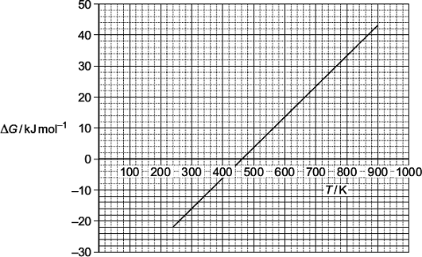

(a)     Write an equation to show the relationship between ∆*G*, ∆*H* and ∆*S*.

___________________________________________________________________

**(1)**

(b)     Use the graph to calculate a value for the slope (gradient) of the line. Give the units of this slope and the symbol for the thermodynamic quantity that this slope represents.

Value of the slope ____________________________________________________

___________________________________________________________________

Units ______________________________________________________________

Symbol ____________________________________________________________

**(3)**

(c)     Explain the significance, for this reaction, of temperatures below the temperature value where the line crosses the temperature axis.

___________________________________________________________________

___________________________________________________________________

___________________________________________________________________

___________________________________________________________________

**(2)**

(d)     The line is not drawn below a temperature of 240 K because its slope (gradient) changes at this point.

Suggest what happens to the ammonia at 240 K that causes the slope of the line to change.

___________________________________________________________________

___________________________________________________________________

**(1)**

**(Total 7 marks)**

**Q4.**

The enthalpy of hydration for the chloride ion is −364 kJ mol−1 and that for the bromide ion is −335 kJ mol−1.

(a)     By describing the nature of the attractive forces involved, explain why the value for the enthalpy of hydration for the chloride ion is more negative than that for the bromide ion.

___________________________________________________________________

___________________________________________________________________

___________________________________________________________________

___________________________________________________________________

___________________________________________________________________

___________________________________________________________________

___________________________________________________________________

___________________________________________________________________

**(3)**

(b)     The enthalpy of hydration for the potassium ion is −322 kJ mol−1. The lattice enthalpy of dissociation for potassium bromide is +670 kJ mol−1.

Calculate the enthalpy of solution for potassium bromide.

___________________________________________________________________

___________________________________________________________________

___________________________________________________________________

___________________________________________________________________

___________________________________________________________________

___________________________________________________________________

___________________________________________________________________

___________________________________________________________________

**(2)**

(c)     The enthalpy of solution for potassium chloride is +17.2 kJ mol−1.

(i)      Explain why the free-energy change for the dissolving of potassium chloride in water is negative, even though the enthalpy change is positive.

______________________________________________________________

______________________________________________________________

______________________________________________________________

______________________________________________________________

______________________________________________________________

**(3)**

(ii)     A solution is formed when 5.00 g of potassium chloride are dissolved in 20.0 g of water. The initial temperature of the water is 298 K.

Calculate the final temperature of the solution.

In your calculation, assume that only the 20.0 g of water changes in temperature and that the specific heat capacity of water is 4.18 J K−1 g−1.

______________________________________________________________

______________________________________________________________

______________________________________________________________

______________________________________________________________

______________________________________________________________

______________________________________________________________

______________________________________________________________

______________________________________________________________

______________________________________________________________

______________________________________________________________

______________________________________________________________

**(5)**

**(Total 13 marks)**

**Q5.**

Which one of the following best explains why the lattice enthalpy of magnesium chloride is much larger than that of lithium chloride?

**A**       Magnesium has a greater electronegativity than lithium.

**B**       Magnesium ions have a greater polarising power than lithium ions.

**C**       Magnesium ions have a greater ionic radius than lithium ions.

**D**       Magnesium ions have a greater charge than lithium ions.

**(Total 1 mark)**

**Q6.**

In which one of the following reactions is there a decrease in entropy?

**A**       [Fe(H2O)6]3+(aq) + 3C2O (aq) → [Fe(C2O4)3]3−(aq) + 6H2O(l)

**B**       [Cu(H2O)6]2+(aq) + EDTA4−(aq) → [Cu(EDTA)]2−(aq) + 6H2O(l)

**C**       [CoCl4]2−(aq) + 6H2O(l) → [Co(H2O)6]2+(aq) + 4Cl− (aq)

**D**       Na2CO3(s) + 2H+(aq) → 2Na+(aq) + CO2(g) + H2O(l)

**(Total 1 mark)**