

**Higher IGCSE (9 – 1) Revision Pack**

**Circle area problems**

**Name --------------------------------**

**Questions**

**Q1.**

The diagram shows the path of an athlete on a running track.

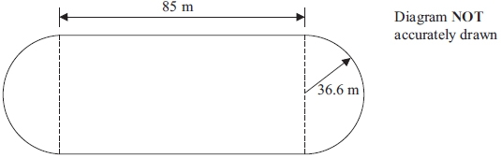

The path consists of two straight lengths and a semicircle at each end.  
 Each straight length is 85 metres.  
 Each semicircle has a radius of 36.6 metres.

Calculate the area enclosed by the path.  
 Give your answer correct to 3 significant figures.

...........................................................m2

**(Total for question = 4 marks)**

**Q2.**

A steam engine for pulling trains has wheels of diameter 1.5 metres.

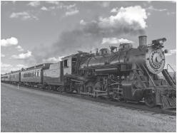

(a)  Calculate the circumference of a wheel.   
Give your answer correct to 3 significant figures.

........................................................... m

**(2)**

The steam engine travels 1000 metres along a test track.   
(b)  Work out the number of complete turns of a wheel.

...........................................................

**(2)**

**(Total for question = 4 marks)**

**Q3.**

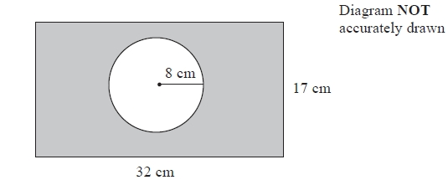

The diagram shows a circle inside a rectangle.

Work out the area of the shaded region.   
Give your answer correct to 3 significant figures.

........................................................... cm2

**(Total for question = 3 marks)**

**Q4.**

Here are two circles.

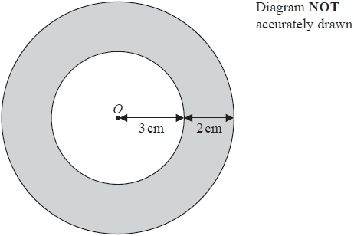

The circles have the same centre *O*.   
The radius of the inner circle is 3cm.   
The width of the shaded region between the inner circle and outer circle is 2cm.

Work out the area of the shaded region.   
Give your answer correct to 3 significant figures.

........................................................... cm2

**(Total for question = 3 marks)**

**Q5.**

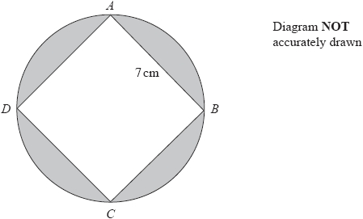

*A*, *B*, *C* and *D* are points on a circle.   
*ABCD* is a square of side 7 cm.

Work out the total area of the shaded regions.   
Give your answer correct to the nearest whole number.

........................................................... cm2

**(Total for question = 5 marks)**

**Q6.**

A square hole is cut from a circular piece of card.

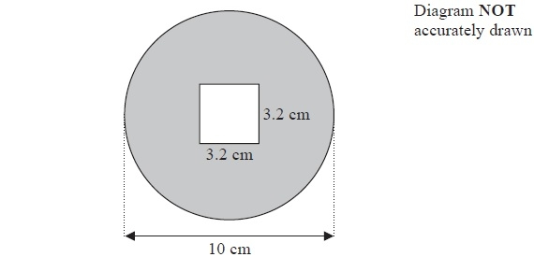

The square has sides of length 3.2 cm.

The diameter of the circular piece of card is 10 cm.

Work out the area of the shaded region.

Give your answer correct to 3 significant figures.

........................................................... cm2

**(Total for Question is 4 marks)**

**Q7.**

The diagram shows a circle inside a rectangle.

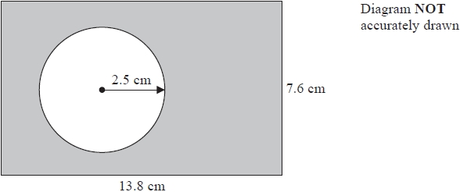

Work out the area of the shaded region.   
Give your answer correct to 3 significant figures.

........................................................... cm2

**(Total for question = 3 marks)**

**Q8.**

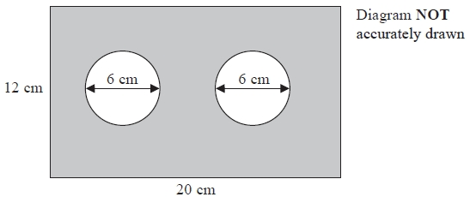

The diagram shows a metal plate in the shape of a rectangle.   
The rectangle has length 20 cm and width 12 cm.   
Two identical circles, each of diameter 6 cm, have been cut out of the plate.

Work out the area of the shaded region of the metal plate.   
Give your answer correct to the nearest cm2.

........................................................... cm2

**(Total for Question is 4 marks)**

**Q9.**

The wheel of the Singapore Flyer is a circle with a diameter of 150 metres.

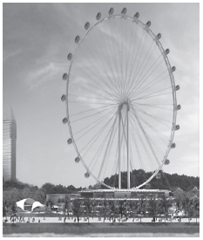

(a)  Calculate the circumference of the wheel.   
       Give your answer correct to the nearest metre.

........................................................... metres

**(2)**

The wheel takes 30 minutes to rotate once.

(b)  Work out the average speed of a point on the circumference of the wheel as it rotates once.   
       Give your answer in metres per second correct to 3 significant figures.

........................................................... metres per second

**(3)**

The diagram shows a giant wheel above horizontal ground.

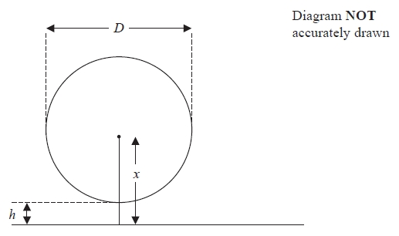

The wheel is a circle of diameter *D* metres.   
The lowest point of the wheel is *h* metres above the ground.   
The centre of the wheel is *x* metres above the ground.

(c)  Express *h* in terms of *D* and *x*

...........................................................

**(2)**

**(Total for question = 7 marks)**

**Q10.**

A circle has a diameter of 7.6 cm.  
 Work out the circumference of the circle.  
 Give your answer correct to 3 significant figures.

...........................................................cm

**(Total for question = 2 marks)**

**Q11.**

There is a World Peace Bell in South Korea.

At its widest, the bell has a circular cross section with a diameter of 2.5 m.

(a)  Work out the circumference of a circle with diameter 2.5 m.

Give your answer correct to 3 significant figures.

........................................................... m

**(2)**

The World Peace Bell in South Korea has a height of 4.7 m.   
At its widest, the bell has a circular cross section with a diameter of 2.5 m.

A scale model is made of the bell.   
At its widest, the scale model has a circular cross section with a diameter 10 cm.

(b)  Work out the height of the scale model.

Give your answer in centimetres.

........................................................... cm

**(2)**

**(Total for question = 4 marks)**

**Q12.**

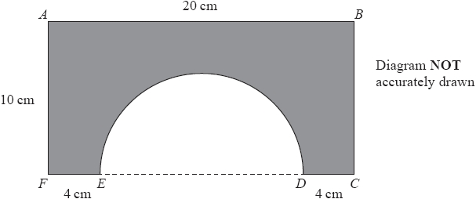

The shaded shape is made by cutting a semicircle from a rectangular piece of card, *ABCF*, as shown in the diagram.

*FEDC* is a straight line.   
The centre of the semicircle lies on *ED*.   
*AF* = *BC* = 10 cm, *AB* = 20 cm, *FE* = *DC* = 4 cm.

Work out the perimeter of the shaded shape.   
Give your answer correct to 3 significant figures.

........................................................... cm

**(Total for question = 3 marks)**

**Q13.**

The diagram shows triangle *KLM*.

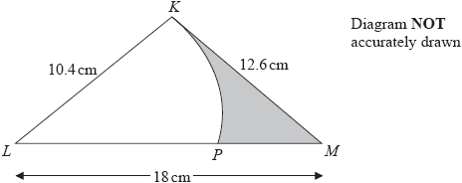

*KLP* is a sector of a circle with centre *L* and radius 10.4 cm.   
The region of the triangle outside the sector is shown shaded in the diagram.

Calculate the area of the shaded region.   
Give your answer correct to 3 significant figures.

........................................................... cm2

**(Total for question = 5 marks)**

**Q14.**

The diagram shows a rectangle and a circle.

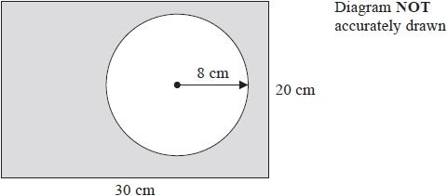

The rectangle has length 30 cm and width 20 cm.   
The circle has radius 8 cm.

Work out the area of the shaded region.   
Give your answer correct to 3 significant figures.

........................................................... cm2

**(Total for question = 4 marks)**

**Q15.**

The shape *OABC* is made from a triangle and a sector of a circle.

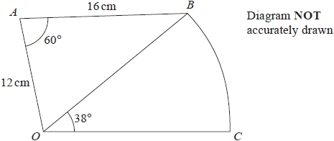

*OAB* is a triangle.   
*OBC* is a sector of a circle, centre *O*.

*OA* = 12 cm   
*AB* = 16 cm   
Angle *OAB* = 60°   
Angle *BOC* = 38°

Work out the area of *OABC*.   
Give your answer correct to 3 significant figures.

........................................................... cm2

**(Total for question = 5 marks)**

**Q16.**

The region, shown shaded in the diagram, is a path.

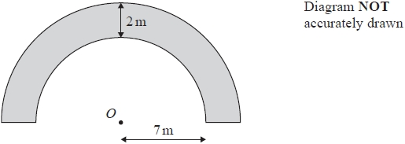

The boundary of the path is formed by two semicircles, with the same centre *O*, and two straight lines.

The inner semicircle has a radius of 7 metres.   
The path has a width of 2 metres.

Work out the perimeter of the path.   
Give your answer correct to one decimal place.

........................................................... m

**(Total for question = 3 marks)**

**Q17.**

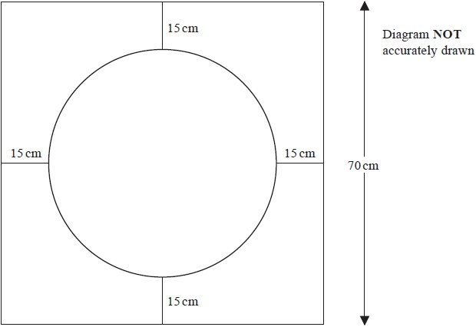

The diagram shows a design made from wire.

The design is made from

a square with side 70 cm,   
a circle with diameter 40 cm,   
4 straight pieces each of length 15 cm.

Find the total length of wire needed for the design.   
Give your answer correct to the nearest centimetre.

........................................................... cm

**(Total for question = 4 marks)**

**Q18.**

The diagram shows a circle and a trapezium.

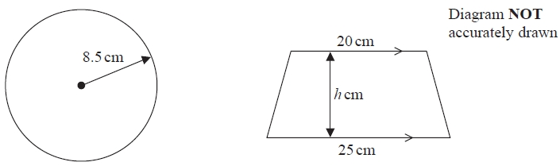

The height of the trapezium is *h* cm.

The area of the circle is equal to the area of the trapezium.

Work out the value of *h*.   
Give your answer correct to 1 decimal place.

...........................................................

**(Total for question = 4 marks)**

**End of questions**