**The Aeneid – Book 8**

**Read lines 1-17**

‘…levying men everywhere, stripping the fields of those who tilled them.’ What insight does this line give us of Virgil’s views of war?

How does the message sent to Diomedes seek to show him that Aeneas poses a serious threat?



**Read lines 18-102**

How is Aeneas characterised as he witnesses Latium approaching war?

Annotate the diagram for Tibur’s appearance to Aeneas:

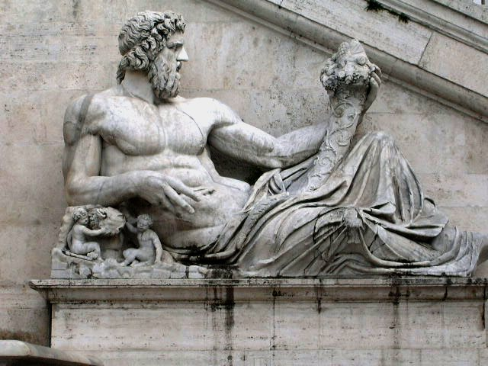

What do we learn about Aeneas’ view of the gods from his response to Tibur’s message as he departs?

Why does Virgil have Aeneas sacrifice the white sow to Juno?

How and why does Virgil depict the journey along the Tibur as idyllic and peaceful?

**Read lines 103-189**

What do we learn from the following about Evander and his people?

|  |  |
| --- | --- |
| **Quote:** | **What we learn:** |
| ‘…performing yearly rite in honour of the mighty Hercules…’ |  |
| ‘’…all the leading warriors and senators…’ |  |
| ‘…poor men as they were…’ |  |
| ‘…were offering incense and warm blood was smoking on the altars…’ |  |
| ‘What race are you? Where is your home?’ |  |
| ‘…come and speak with my father face to face…’ |  |
| ‘Come as a guest into our house.’ |  |

Complete a family tree to show how Aeneas believes he is related to Evander:

How do the following show Aeneas and Evander are natural allies?

|  |  |
| --- | --- |
| **Factor** | **Why does it make them natural allies?** |
| Atlas |  |
| The Rutulians |  |
| Anchises |  |

What does Evander provide as part of his *xenia* for Aeneas and his men?



**Read lines 190-279**

Complete the following for Evander’s story behind the religious rites they are observing:

|  |  |  |
| --- | --- | --- |
|  |  |  |
|  |  |  |
|  |  |  |
|  |  |  |
|  |  |  |
|  |  |  |

**Read lines 280-306**

The Roman historian Livy tells how the Salii priests were introduced by Rome’s second king, Numa (Livy, *History of Rome*, 1.20). Here, Virgil describes how they are already in existence by the time of Evander. What does he tell us about them?

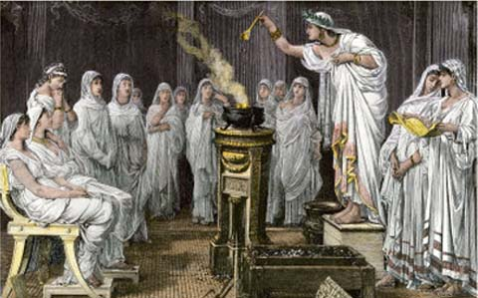

What feats of Hercules are mentioned here?

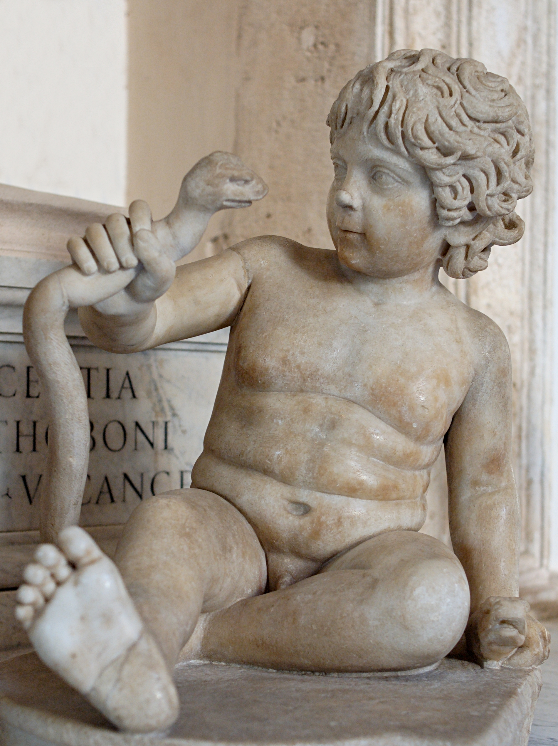

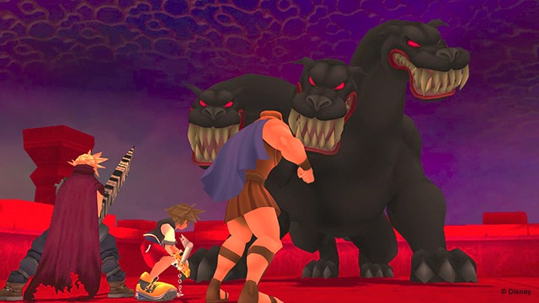

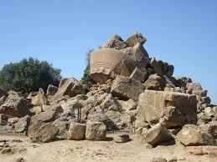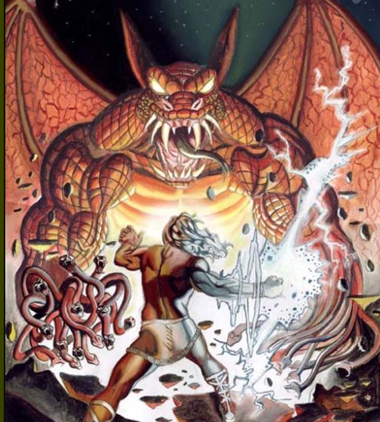

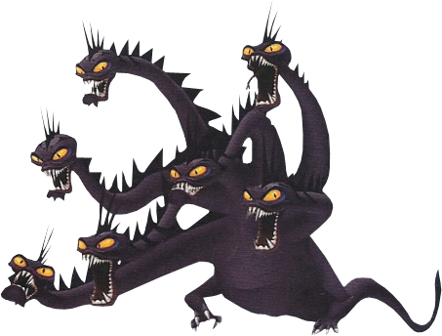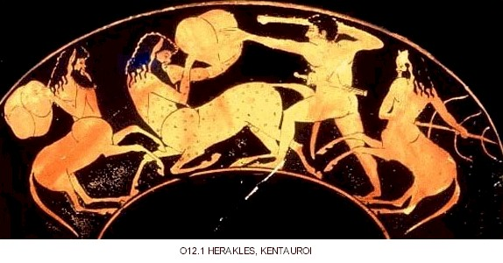

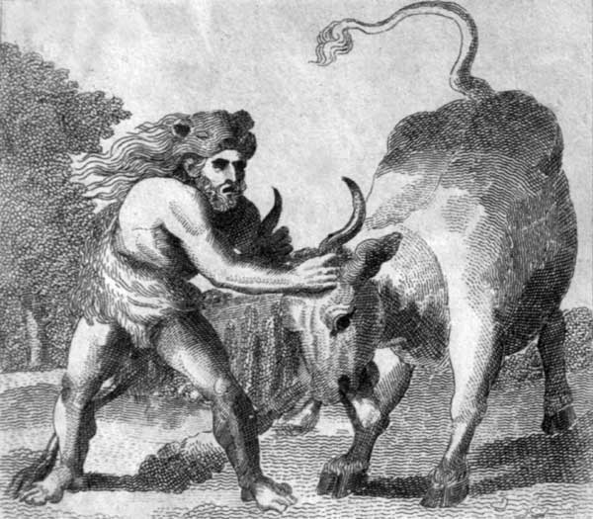

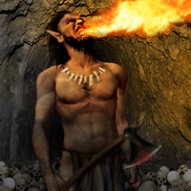

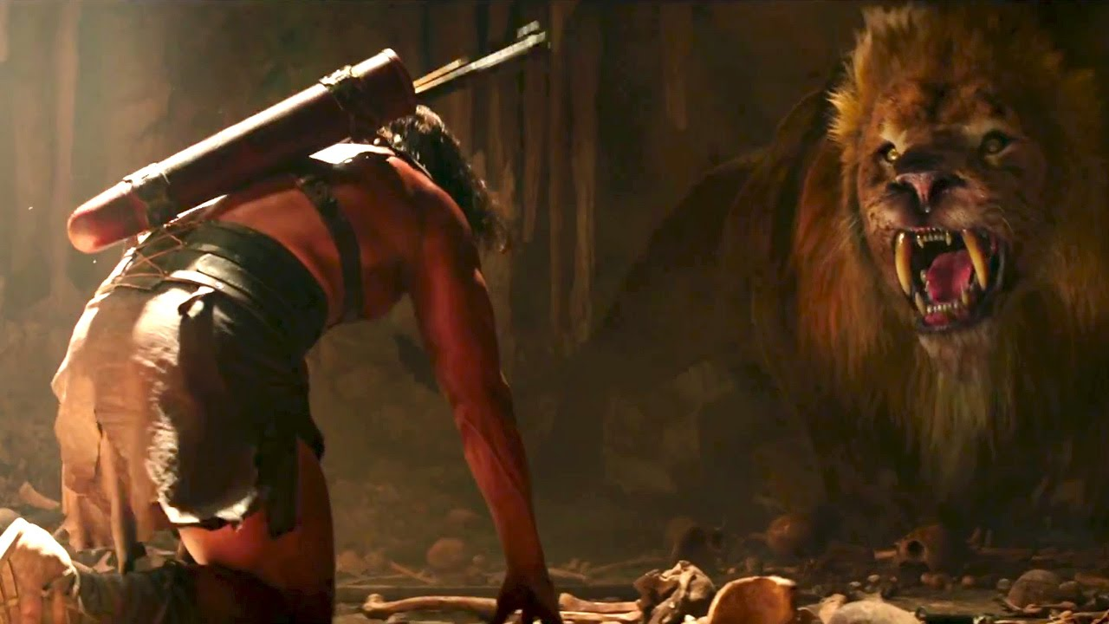

Which goddess is the adversary of Hercules? Why is this mentioned by Virgil?

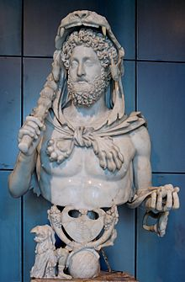The Romans revered Hercules. He was a favourite divinity of Mark Antony and the emperor Commodus. The story of his fight with Cacus was unique to the Romans (i.e. not in the Greek tradition). Why do you think they admired him so much?

Bust of Commodus in the guise of Hercules.

**Read lines 307-369**

Complete the following for Evander’s short history of Pallanteum (site of future Rome):

**Post-Saturn**

**Saturn’s Golden Age**

**Pre-Saturn**

|  |  |
| --- | --- |
| *The Golden Age was first; when Man, yet new,*  *No rule but uncorrupted Reason knew:*  *And, with a native bent, did good pursue.*  *Unforc'd by punishment, un-aw'd by fear.*  *His words were simple, and his soul sincere;*  *Needless was written law, where none opprest:*  *The law of Man was written in his breast.*  [Ovid, *Metamorphoses*, 1] | How does Ovid portray the Golden Age? |
| *Now the last age by Cumae's Sibyl sung*  *Has come and gone, and the majestic roll*  *Of circling centuries begins anew:*  *Astraea returns,*  *Returns old Saturn's reign,*  *With a new breed of men sent down from heaven.*  [Virgil, *Ecologues*, 4] | What is Virgil suggesting here? |

Study the following Augustan poetry by Virgil and Ovid:

What does Evander say about the following familiar sites of Virgil’s day?

|  |  |
| --- | --- |
| **Site** | **Description** |
| Altar of Carmentis and the Carmental Gate |  |
| The Asylum |  |
| The Lupercal |  |
| House of Tarpeia and the Capitol |  |
| Citadels of the Janiculum and Saturnia |  |

Why do you think Virgil continues to reference sites familiar with his contemporary audience?

List all the details that show Evander had a ‘humble home’:



What do you think the Romans would think of this?

**Read lines 370-454**

What episode from the *Iliad* does Venus recall when addressing Vulcan?

How is Venus shown to have control over Vulcan?

‘…just when the ashes are first stirred…bring her sons to manhood’ Discuss Virgil’s use of this simile from the following angles:

1. Virgil’s approach to Homeric similes
2. Realism

Annotate Virgil’s description of Vulcan and the Cyclopes to show his techniques for creating a vivid narrative:

Between Lipari in the Aeolian Islands and the flank of Sicily, an island of smoking rocks rises sheer from the sea. Deep within it is a great vault, and in that vault caves have been scooped out like those under Etna to serve as forges for the Cyclopes. The noise within them is the noise of thunder. Mighty blows can be heard booking on the groaning anvils, the caves are filled with the sound of hissing as the Chalybes plunge bars of white-hot pig-iron into the water and all the time the fires are breathing in the furnaces. This is the home of Vulcan, and Vulcania is the name of the island. Into these depths the God of Fire descended from the heights of heaven.

The Cyclopes were forging steel, working naked in that vast cavern, Bronte, Sterope and Pyracmon. In their hands was a thunderbolt which they had roughed out, one of those the Father of Gods and Men hurls down upon the earth in such great numbers from every part of the sky. Some of it was already burnished, some of it unfinished. They had attached three shafts of lashing rain to it, three shafts of heavy rainclouds, three of glowing fire and three of the south wind in full flight. They were now adding to the work the terrifying lightning and the sound of thunder, then Fear and Anger with their pursing flames. In another part of the cave they were working for Mars, busy with the wing-wheeled chariot in which he stirs up men and cities to war. Others were hard at work polishing the armour worn by Pallas Athene when roused, the fearsome aegis and its weaving snakes with their reptilian scales of gold, even the Gorgon rolling her eyes in the bodiless head on the breast of the goddess. ‘Put all this away!’ he cried. ‘Whatever work you have started, you Cyclopes of Etna, lay it aside and give your attention here. Armour has to be made for a brave hero. You need strength and quick hands now. Now you need all your arts to guide you. Let nothing stand in your way.’ He said no more, but instantly they all bent to the work, dividing it equally between them. The bronze was soon flowing in rivers. The gold ore and iron, the dealer of death, were molten in a great furnace. They were shaping one great shield to be a match for all the weapons of the Latins, fastening the seven thicknesses of it circle to circle. Bellows were taking in air and breathing it out again. Bronze was being plunged into troughs of water and hissing. The cave boomed with the anvils standing on its floor while the Cyclopes raised their arms with all their strength in time with one another and turned the ore in tongs that did not slip.

What four points would you use to summarise Virgil’s techniques for creating a vivid narrative:

1)

2)

3)

4)

**Read lines 455-541**

What items does Evander put on in the morning:



What impression do you get of him from this?

In the previous book Virgil tells us that ‘The first to enter upon the war and arm his columns was cruel Mezentius from Etruria, scorner of the gods…[His son Lausus] deserved a father whom it would have been more of a joy to obey, a father other than Mezentius.’

What do we now learn that confirms this description?

Why is Aeneas suited to leading the Etruscan army but Evander and Pallas are not?

What is interesting about the line ‘it is not the will of heaven that such a race as the Etruscans should ever obey an Italian.’?

How is Evander’s view of Aeneas similar to that of Latinus in the previous book?

Complete the following diagram:

**Omen 2**

**Omen 1**

How does Aeneas interpret these?

**Read lines 542-609**

Collect quotes to show the following:

What parallel does Virgil create between Evander and Priam in the *Iliad*? How does it assist the wider theme of the *Aeneid*?

**Read lines 610-732**

How are the following items, which Aeneas’ receives from his mother, described?

|  |  |
| --- | --- |
| **Item:** | **Description:** |
| Helmet |  |
| Sword |  |
| Breastplate |  |
| Greaves |  |
| Spear |  |
| Shield |  |

**Cato**

**Catiline**

**Reconciliation of Romulus and Tatius**

**Augustus’ Triple Triumph**

**Rape of the Sabine Women**

**Romulus and Remus**

**Mark Antony’s Forces**

**Battle, presided over by the Gods**

**Augustus’ Forces**

**Battle of Actium**

**Tartarus**

**The Salii and Luperci Priests**

**Manlius’ defense**

**of the Capitoline**

**Lars Porsenna’s Assault on Rome**

**Punishment of Mettus**

Annotate each section of the shield with details from Virgil:

**Appendix – The Significance of War Gear in Homer and Virgil**

A Guide to Aeneas’ Shield

|  |  |
| --- | --- |
| **Episode:** | **Mythic/Historical Context:** |
| **Romulus and Remus** | Twin sons of Mars and Rhea Silvia. They were exposed to death on the orders of the usurper of Alba Longa, Amulius. They were reared be a she-wolf and grew up to found Rome. |
| **Rape of the Sabine Women** | Romulus lured the Sabines to a festival in Rome in order to maintain wives for the Romans. On his signal, the seized a Sabine woman each for their wife. |
| **Romulus and Tatius** | The Sabines march on Rome to reclaim their wives but the women themselves intervene to stop bloodshed. Tatius and Romulus united the two peoples and ruled jointly until Tatius’ death. |
| **Mettus** | Mettus was king of Alba Longa and ally of Rome, but he withheld support in an important battle. The king of Rome sentences him to be pulled apart by two chariots because he was torn between two cities. |
| **Horatius Cocles** | When Lars Porsenna, an Etruscan king, attacked Rome, Horatius defended the Janiculum bridge against the Etruscans, initially with two companions and then on his own. The Romans destroyed the bridge and Horatius fell into the river but swam to safety. |
| **Cloelia** | Cloelia was a captive of Lars Porsenna who escaped and swam to safety. Porsenna demanded she be returned and the Romans gave her back but the king was so impressed with her bravery he freed her and half the Roman captives he had. |
| **Manlius** | When the Gauls captured Rome in 390 (or 387) BC, Manlius held out on the Capitoline citadel. When the Gauls attempted to scale the side, the sacred geese sounded the alarm and Manlius drove them off. He was later condemned to death for his pro-Plebeian sympathies and thrown from the Tarpeian Rock |
| **Salii** | The Salii were the twelve ‘leaping’ priests of Mars, equipped with a breastplate, sword, red cloak, *apex* (spiked headdress) and heaven-sent bronze shields called the *ancilia*. |
| **Luperci** | The Luperci ‘brotherhood of the wolf’ were the priests who oversaw the Lupercalia, a festival in honour of the she wolf and the founding of Rome. |
| **Catiline** | A Roman conspirator, allegedly planning a revolution, which was uncovered by Cicero in 63 BC. He fled Rome and fell in battle. |
| **Cato** | Cato the Younger was a model of Roman virtue but was caught on the wrong side of the civil war against Julius Caesar and committed suicide. |
| **Battle of Actium** | A naval battle fought between Mark Antony, with Cleopatra and her Egyptian army, and Augustus, whose general was Agrippa. Augustus claimed help from his patron god Apollo. |
| **Triple Triumph** | When Augustus returned to Rome after the civil wars, he celebrate a triple triumph in 29 BC in honour of victories in Dalmatia, Actium and Egypt. |

Aeneas’ shield vs Achilles’ shield

Both shields are examples of ‘*ecphrasis’*, the detailing a work of art set within a narrative poem. Virgil has employed this elsewhere: Dido’s temple depicts the Trojan Wars in Book 1 and the doors of Apollo’s temple at Cumae depict the story of Daedalus and Icarus in Book 6. Compare the two shields of Aeneas and Achilles:

|  |  |
| --- | --- |
| **Aeneas’ Shield** | **Achilles’ Shield** |
| * Depicts Rome’s heroic future (and complements Book 6’s pageant of Roman heroes), featuring recogniseable characters. * Praises Augustus’ achievements | * Depicts human activity in both peace and war in a generalised manner. * Portrays life in Homeric society beyond the Trojan War. |
| **Parallels of Context:**   * Both shields are made by the smith god. * Both shields are the product of the hero’s divine mother’s efforts. | |

Alternative Conception of Aeneas’ Shield

*punata in ordine bella* = ‘the battles which were fought, in order’

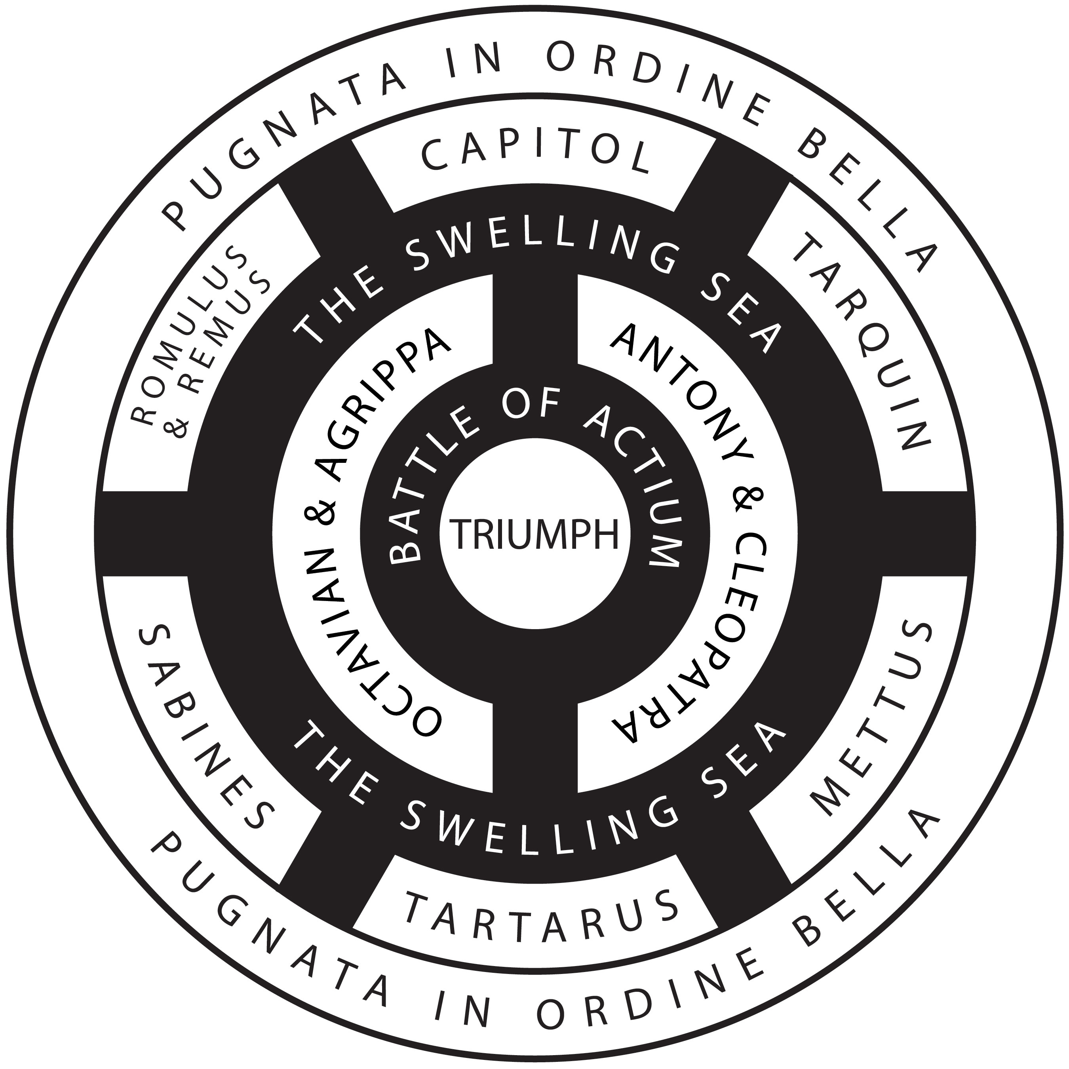

Wear Gear in the Epic Tradition

Both Homer and Virgil make extensive use of the war gear of their heroes to enhance their narrative:

|  |  |  |
| --- | --- | --- |
| **Theme** | **Virgil** | **Homer** |
| Fought over | * Aeneas sets up a trophy of the armour at the start of Book 11, which he has stripped. It appears to be similar to the Roman *spolia* (dedicated spoils). * Euryalus takes wargear as a prize during his night mission. | * Trojans and Achaeans fight over Achilles’ armour (on Patroclus’ body) * Fight over Sarpedon’s body. |
| Given as gifts | * Weapons are prizes awarded at Anchises’ funeral games. * Helmet and armour of Neoptolemus are given to the Trojans by Helenus. * Euryalus and Nisus receive gifts from other Trojan heroes ahead of their night mission. | * Glaucus and Diomedes exchange gifts in an act of *xenia*. * Odysseus receives an ornate sword from Euryalus. * Diomedes and Odysseus receive gifts from other Achaean heroes ahead of their night mission. * Weapons are prizes awarded at Patroclus’ funeral games |
| Enhances heroic status | * Pallas’ armour marks him out amongst the ranks. His shield’s final use reminds us of his fate. * Aeneas’ shield gives him an advantage in battle. * Turnus’ sword appears to be superior to all others. | * The sight of Achilles’ armour terrifies the Trojans. * Heroes are known for their iconic weaponry, such as Ajax’s great shield and Teucer’s bow. |
| Instrumental to plot | * Aeneas’ soldiers in Troy are attacked by both sides after donning Achaean armour. * Aeneas and Turnus are both foiled by weaponry * Aeneas’ recognised Pallas’ baldric in the climatic fight. * Euryalus is betrayed by his spoils | * Patroclus’ disguise eventually leads to Achilles’ reentry into the war. * Odysseus’ bow produces the climax of the *Odyssey*. |