

**Higher IGCSE (9 – 1) Revision Pack**

**Straight Lines 3**

**Name --------------------------------**

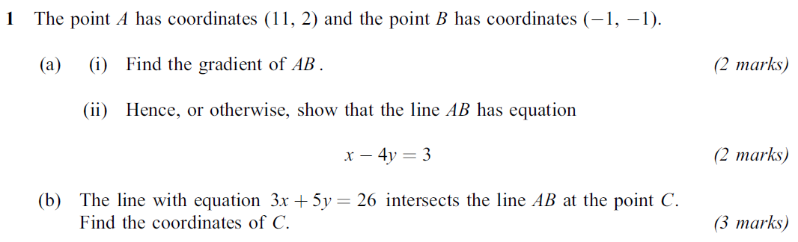  
Jan 05

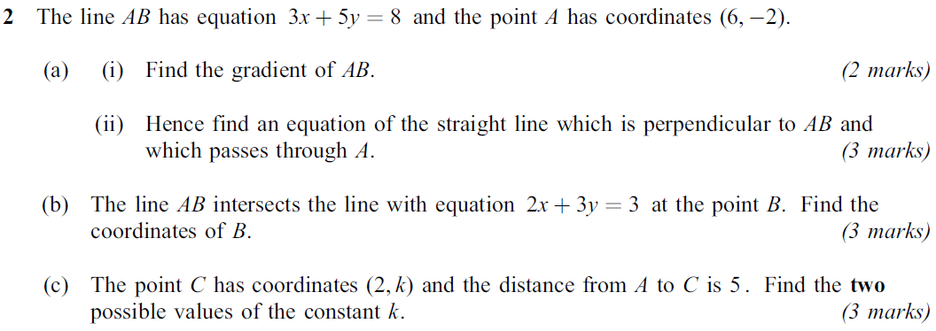Jan 07

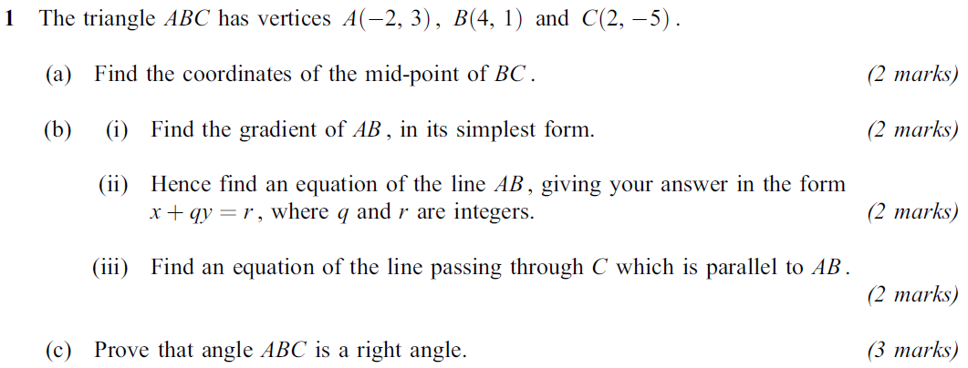Jan 08

**3**

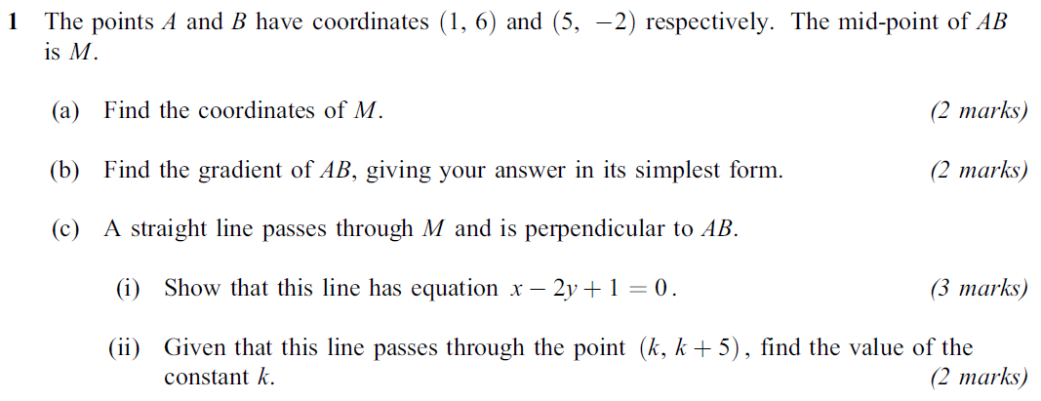Jan 09

**4**

**5**

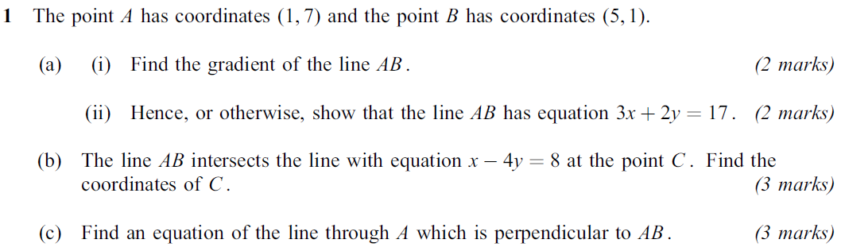Jun 06

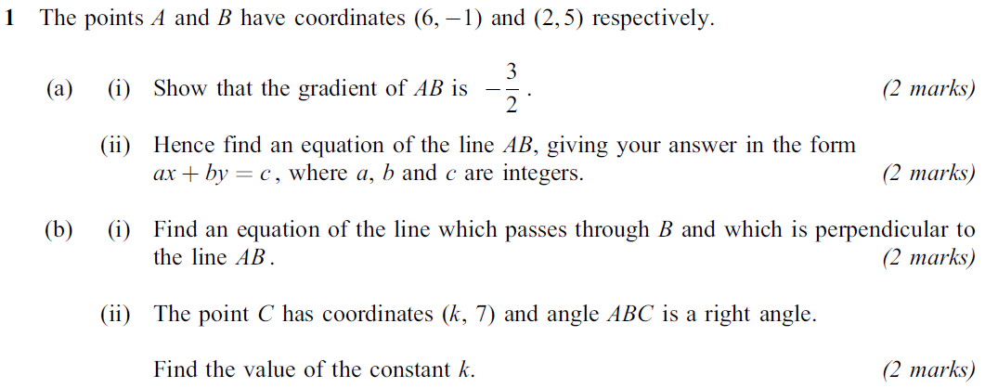Jun 07

**6**

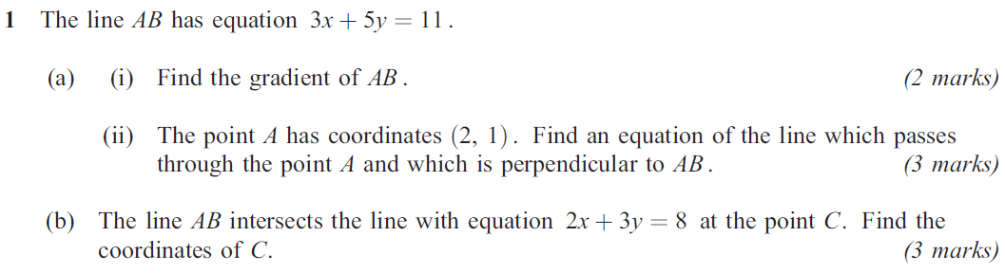Jun 09

**7**

**8**

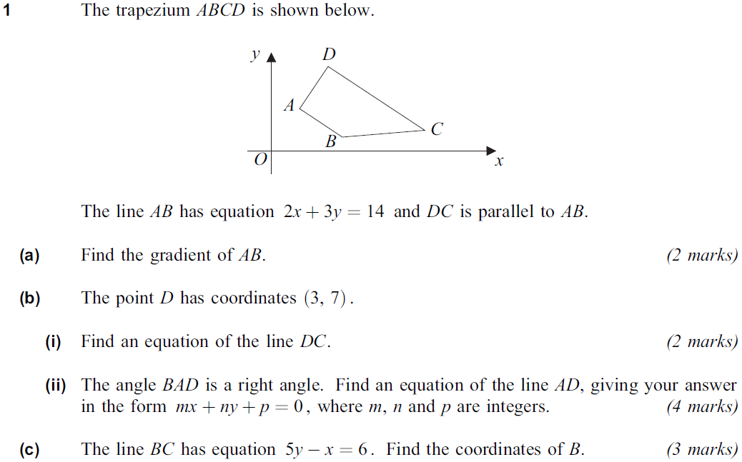Jun 10

**End of questions**