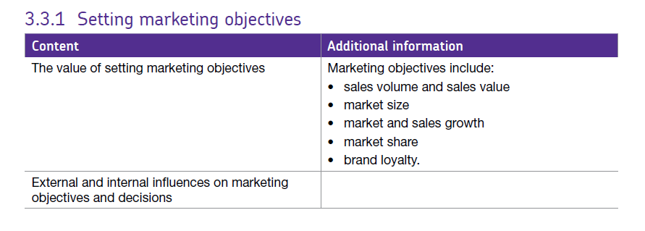3.3.1 Marketing objectives & 3.3.2 Markets and customers

# Marketing is about identifying and fulfilling customers wants needs. The marketing department carries out research and communicates with customers about products and services and how the meet consumer needs.

# Marketing Objectives (Introduction)

Marketing objectives set out what a business wants to achieve from its marketing activities. They need to be consistent with overall aims and objectives of the business. They also provide an important focus for the marketing team. **Marketing is “the process of identifying, anticipating (predicting) and satisfying customer needs profitably”.**

Marketing objectives therefore need to be consistent with the purpose of marketing. They also need to be consistent with and support the overall corporate (business) objectives:

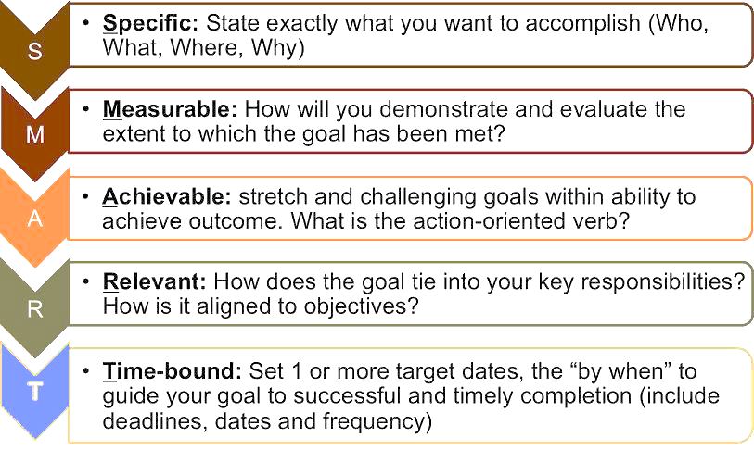What makes a good marketing objective? It is often said that an effective marketing objective meets the SMART criteria:

As functional objectives, the marketing objectives need to be consistent with, and support the overall business (or corporate) objectives.

Below are some examples of how marketing objectives could be set to support the overall corporate objectives.

## Business Objective: Maintain or Increase Market Share

### ****The marketing objectives might be:****

* Achieve revenue growth of 20% per year for the next four years
* Increase our market share in the UK by 5% by 2017
* Add 1,000 new customer accounts generating at least £100,000 per account within four years

## Business Objective: Develop Innovative New Products

### The marketing objectives might be:

* Launch at least 25 new products into the industrial channel in 2016 and 2017
* Grow average first-year sales of new editions by 25% in the Higher Education sector

## Business Objective: Increase the Quality of Service to Existing Customers

### The marketing objectives might be:

* Achieve at least an 95% excellent customer service rating each month
* Increase the proportion of sales bookings from repeat business to 45% for the summer season

## Business Objective: Enter a New Market

### The marketing objectives might be:

* Supply a minimum of 50,000 trial downloads per month
* Increase the number of customer enquiries from the EU by 10,000 per month
* Recruit five distribution agents in the four target countries within 12 months

## Business Objective: Build Competitive Advantage

### The marketing objectives might be:

* Reduce average distribution costs to less than 5% of gross revenue
* Reduce the order lead time by 15%
* Improve brand recognition amongst the 25-34 age group

## Marketing objectives can also be in relation to:

### Sales volume / sales value

A firm can increase the number of items it sells, however, if this is done through price cutting it may not boost overall profits and so a firm must exercise caution when reducing prices to ensure they still maintain healthy profit margin as increased volume may be at the expense of their profit margin.

### Market share

This refers to the % of sales in a market attributed to a particular firm. It is based on sales value.

### Brand loyalty

This refers to the customer’s loyalty to a business and whether they will make repeat purchases. If a customer is brand loyal they will always buy from that company and so become a good source of income, however, brand loyalty can be easily damaged if a firm receives bad publicity, if a new competitor comes into the market or if there is a change in the external environment e.g. if real incomes start to fall (or rise) and customers trade up or down.

### Market / sales growth

Market growth refers to an increase in the total number of customers in a market rather than just the number of customers which a firm is selling to within the market – which would be an increase in market share.

For example, in the table below we can see the difference between the number of 55-75 year olds owning smartphones / tablets in 2012 and 2017.

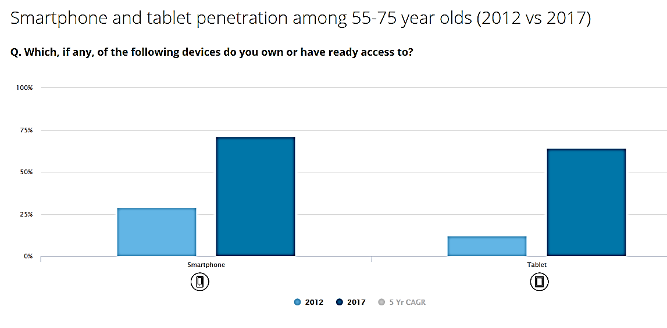

In 2012 29% of this age group owned a smartphone, but by 2017 this was 71%, in 2012 12% owned a tablet and in 2017 this had risen to 64%. This is an example of market growth– the total number of people in this age group owning the product has increased.

Firms which make and sell smartphones will have been able to exploit this increase in purchases by this age group to increase their sales without necessarily stealing market share from other firms in the market.

# Influences on marketing objectives.

There are many potential internal and external influences which shape and influence the marketing objectives of a business.

## Internal Influences on Marketing Objectives

### Corporate objectives

As with all the functional areas, corporate objectives are the most important internal influence. A marketing objective should not conflict with a corporate objective

### Finance

The financial position of the business (profitability, cash flow, liquidity) directly affects the scope and scale or marketing activities.

### Human resources

For a services business, the quality and capacity of the workforce is a key factor in affecting marketing objectives. A motivated and well-trained workforce can deliver market-leading customer service and productivity to create a competitive marketing advantage

### Operational issues

Operations has a key role to play in enabling the business to compete on cost (efficiency / productivity) and quality. Effective capacity management also plays a part in determining whether a business can achieve its revenue objectives

### Business culture

E.g. a marketing-orientated business is constantly looking for ways to meet customer needs. A production-orientated culture may result in management setting unrealistic or irrelevant marketing objectives.

## External Influences on Marketing Objectives

### Economic environment

The key factor in determining demand. E.g. many marketing objectives have been thwarted or changed because of the recession. Factors such as exchange rates would also impact objectives concerned with international marketing.

### Competitor actions

Marketing objectives must take account of likely / possible competitor response. E.g. an objective of increasing market share means that competitor response will not be effective

### Market dynamics

The key market dynamics are market size, growth and segmentation. Changes in any of these undoubtedly influence marketing objectives. A market whose growth slows is less likely to support an objective of significant revenue growth or new product development

### Technological change

Consumer and other markets are now affected by rapid technological change, shortening product life cycles and creating great opportunities for innovation. These have to be taken into account when setting marketing objectives.

### Social & political change

Changes to legislation may create or prevent marketing opportunities. Change in the structure and attitudes of society also have major implications for many markets.

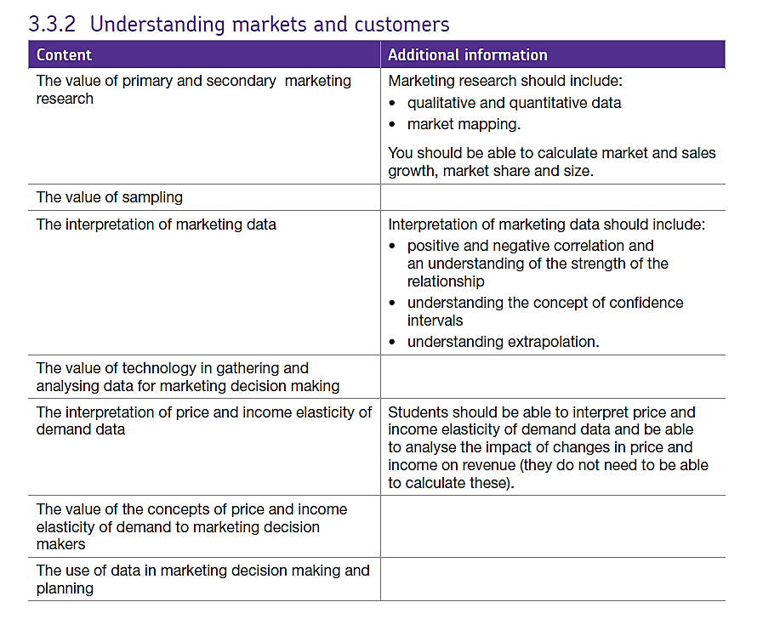3.3.2 Markets and customers

# Understanding markets and customers.

**Market research** is the systematic and objective collection, analysis and evaluation of market and customer information that is intended to assist the marketing process, it is necessary throughout the life of the business for the following reasons:

* **Achieving objectives**: has the business achieved its target sales figure or its desired percentage market share?
* **Identifying trends**: are sales rising or falling? Is the trend stable or unpredictable?
* **Comparisons**: how are the firm’s sales performing relative to a competitor? Is its advertising expenditure matching its rivals? Is it appealing to the same market segments?
* **Explanatory reasons**: market research can help an organisation to investigate why certain things occur.
* **Predictive reasons**: information can be used to predict trends and find links between sets of data. This might help the business to predict what might happen in the future.
* **Exploratory reasons**: on occasions, such as when a new product is introduced, there will be no existing data to guide the organisation. In this situation, a business may conduct research into the probable consumer reaction to a product or its marketing.

## Types of market research

There are two types of market research:

**Primary market research** is sometimes referred to as **field research** because the business will go out and find the information for itself. This research is generally up to date and tailored to meet the specific needs of the business. However, it can take time to collect and is generally more expensive than other methods of research.

**Secondary market research** is also known as **desk research** because the business can carry out much of this research in the office. This research has already been carried out for another purpose and so the business has to adapt this ‘second hand’ information to suit its own purposes so it might not be as accurate as primary market research. The information gathered may also be out of date.

# Scan_20160221.jpgTypes of primary market research

## Focus groups

A group of customers are encouraged to discuss their feeling about a product or a market. The meeting will be recorded and analysed afterwards. A psychologist might be employed to lead the focus group.

|  |  |
| --- | --- |
| Advantages of focus groups | Disadvantages of focus groups |
| They enable the business to establish why consumers might act the way they do and this can help the business to modify products according to customers’ comments. It might also enable the business to identify gaps in the market.  They can help identify new ideas on how to market products and services. | There might be bias in the focus group as the group consists of people who are already customers and have an existing interest in the product or service  They can be relatively expensive and time consuming. |

## Telephone or personal interviews

A market researcher telephones members of the public, seeking their answers to particular questions. This is a useful method for a business trying to gauge a customer’s opinion of a recent purchase.

|  |  |
| --- | --- |
| Advantages of interviews | Disadvantages of interviews |
| Telephone calls can be cheap to make.  The calls can be directed towards known customers.  The interviewer can explain any uncertainties in the wording and this prevents questions being misinterpreted.  A wide range of information can be obtained. Questions can be closed (where a limited choice of answers are allowed) or open (where customers are asked their opinion). | Detailed questions are difficult as most interviewees are reluctant to spend too much time on the telephone.  The increased use of this type of survey by telesales companies has led to increased customer resentment.  Image result for surveyThey can be time consuming, particularly when members of the public may be reluctant to participate. |

## Surveys

A survey is where customers are questioned specifically about the product or service. A survey can take a number of forms but they usually involve the completion of a questionnaire. The main types of surveys are:

## Postal surveys

Surveys are posted to the addresses of potential customers, who are then expected to complete the survey and then return it in a prepaid envelope.

## Internet surveys

Questionnaires on internet sites enable customers to express their views about a product, service or company giving valuable information to the business whose website is visited.

|  |  |
| --- | --- |
| Advantages of surveys | Disadvantages of surveys |
| It is relatively inexpensive to place a questionnaire on a website.  Responders are more likely to be interested as they chose to log onto the website.  The surveys can be easily updated and questions changed when required.  May be able to use a detailed questionnaire.  Can allow targeting of a specific geographical area.  an be quite cheap depending on the type | The sample may be biased towards existing customers with an established interest or loyalty in the product or service.  Related imageThey are less useful if the target market does not use the internet. |

## Experiment

An organisation may try out a new idea or a new approach on a small section of their market. If it is successful, the business may then introduce the new approach to the entire market.

## Observation

Stores might watch customers while they are shopping and gather information on customer reactions throughout the process. This enables the business to gain useful data such as which displays and offers attract customers. Psychologists might be employed to analyse customer behaviour

# Types of secondary research.

Secondary marketing research uses **data that already exists** and has been collected by someone else for another purpose. This can come from within the firm itself – this is known as internal secondary data. External secondary data, on the other hand, is data that has been published by other organisations

## What are internal sources of secondary data?

Every department within an organisation will have its own records that represent a potential source of valuable data. For instance, records of past advertising campaigns within the marketing department can be compared with copies of invoices held in the sales department in order to judge their effectiveness and get ideas for future campaigns. Past sales figures can also be used to spot trends and forecast future figures.

The increasing availability and use of loyalty cards and big data has given businesses the chance to gather a wide range of valuable information on customer buying habits, allowing them to target promotional campaigns more effectively.

Internal sources of data should always be considered as a first line of enquiry for any investigation because they are usually the quickest, cheapest and most convenient source of information available. Internal data will also be exclusive to the organisation that generated it, so that rival firms will not have access to it.

However, internal data may be incomplete or out of date, and, if a project is new, there may be no relevant data at all. In such cases, an organisation may need to consider using external sources of secondary data.

## What are external sources of secondary data?

There are several sources of existing data available from outside of the business that may be of value. These include:

* Commercial market research organisations – including MINTEL, Keynote and Euromonitor
* The Government – the much wider availability of open data from the government has significantly increased the availability of such data
* Competitors – company reports, and websites are easily accessible and contain a limited amount of information
* Trade Publication and other general media

Accurate, up-to-date information obtained by marketing research can be of enormous value to a business in gaining and/or maintaining its competitive edge. However, there are a number of reasons why, in reality, these potential benefits may not be realised.

# Constraints and limitations to consider with marketing research.

## Budgetary constraints

Gathering and processing data can be very expensive. Many organisations may lack the expertise to conduct extensive surveys to gather primary data, whatever the potential benefits, and also lack the funds to pay specialist market research agencies to gather such data for them. In these cases, organisations may be forced to rely on data that is less than ‘perfect’ but that can be accessed more cheaply, e.g., from secondary sources

## Time constraints

Organisations are often forced to balance the need to build up as detailed a picture as possible regarding customer needs etc. against the desire to make decisions as quickly as possible, in order to maintain or improve their position in the market

## Reliability of the data

The value of any research findings depend critically on the accuracy of the data collected. Data quality can be compromised via a number of potential routes, e.g., leading questions, unrepresentative samples, biased interviewers etc. Efforts to ensure that data is accurate, samples are representative and interviewers are objective will all add to the costs of the research but such costs are necessary if poor decisions and expensive mistakes are to be avoided.

## Legal & ethical constraints

The Data Protection Act (1998) is a good example of a law that has a number of implications for market researchers collecting and holding personal data. For instance, researchers must ensure that the data they obtain is kept secure, is only used for lawful purposes and is only kept for as long as it is necessary. It must be made clear as to why data is being collected and the consent of participants must be obtained. In addition to this, there are a number of guidelines, laid down by such organisations as the Market Research Society, that, although not legally binding, encourage organisations to behave ethically when dealing with members of the public.

# Sampling.

What is sampling? In market research, sampling means getting opinions from a number of people, chosen from a specific group, in order to find out about the whole group. It would be expensive and time-consuming to collect data from the whole population of a market.

Sample choice can be **simple** or **complex depending on** the type of information required and how the sample is selected. The more precision the market researcher requires, the more complex the design and larger the sample size will be.

The sample design doesn’t have to be **proportionally representative, it might need to** draw a larger sample than expected from some parts of the population to ensure that sufficient data is obtained for analysis on such groups. Many sample designs use **random selection**.

## Sample Size

For any sample design, deciding upon the appropriate sample size will depend on several key factors:

1. No estimate taken from a sample is expected to be exact: assumptions about the overall population based on the results of a sample will have an attached **margin of error**
2. The confidence level is the likelihood that the results obtained from the sample lie within a required precision: the higher the confidence level, the more certain you wish to be that the results are not atypical. Statisticians often use a 95% confidence level to provide strong conclusions

## Types of Sampling

There are many different types of sampling methods, here's a summary of the most common:

### Cluster sampling

Units in the population can often be found in certain geographic groups or "clusters" for example, primary school children in Derbyshire. A random sample of clusters is taken, then all units within the cluster are examined.

### Convenience sampling

Uses those who are willing to volunteer and easiest to involve in the study.

### Quota sampling

The aim is to obtain a sample that is "representative" of the overall population. The population is divided ("stratified") by the most important variables such as income, age and location. The required quota sample is then drawn from each level.

### Random sampling

This makes sure that every member of the population has an equal chance of selection.

# Using marketing data

## Correlation

A correlation is the relationship between 2 variables, it can be positive or negative

A **positive correlation** occurs when an increase in one factor causes an increase in another factor for example sunnier weather increases sales of ice-cream, there is a positive correlation between sunshine and ice-cream sales.

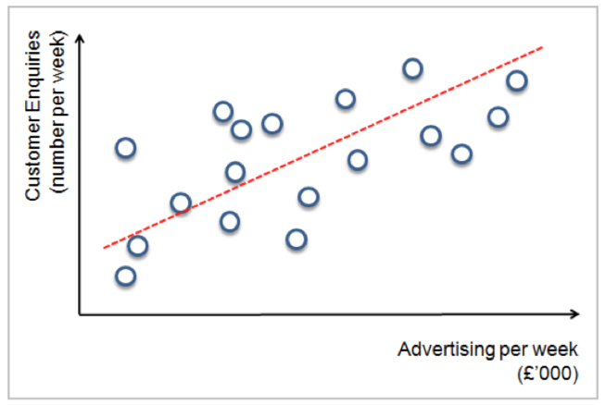A **negative correlation** occurs when an increase in one factor leads to a decrease in another for example an increase in a disease in one area of the world may affect the number of people travelling to that part of the work e.g. the Zika virus in Brazil.

The relationship is usually give in terms of a value between -1 and +1. Sometimes there is no relationship at all between the factors and this is just described as no correlation

A minus figure represents a negative correlation and a positive figure represents a positive correlation.

A **strong correlation** (positive or negative) would be over (+/-) 0.5 where a **weak correlation** would be less than (+/-) 0.5

## Extrapolation.

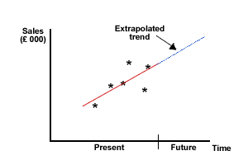Extrapolation refers to a firm’s ability to use currently available data to predict future sales. There are many different ways of extrapolating data but in A Level Business we are only required to look at a basic method.

As mentioned earlier, firms are interested in confidence levels when looking at data – how confident they can be that a particular outcome will actually happen. The higher the confidence level, the more certain you wish to be that the results are not atypical. Statisticians often use a 95% confidence level to provide strong conclusions

## Value of technology in gathering data for marketing decision making

Traditionally, businesses gathered data from sources such as their own sales records, market research surveys and from the observations made by their sales force. However, technology has improved information gathering in the following ways:

**Businesses have become interlinked** meaning that suppliers and businesses depend upon one another; manufacturers using Just In Time (JIT) operation systems are ‘connected’ to suppliers to the extent that orders can be triggered automatically. Manufactures and retailers often share information on the popularity of certain product lines and changes in consumer tastes and preferences.

* **The internet** provides a wealth of information.
* **Loyalty cards** can enable the business to gather data on the lifestyles and tastes of its customers. Retailers can use this information to target offers which increases marketing effectiveness.
* **Competitors’ websites and data** can provide a rich source of marketing intelligence about competitors.
* **Social media** is being used by businesses to gather profiles of likes and dislikes for example.

**The value of information technology in analysing data for marketing decision making**

Technology allows the business to analyse and distribute a wealth of data quickly and cost effectively. For example:

* Forecasting calculations can be completed at the push of a button, saving time and money.
* Organisations are able to link their sales records to other databases such as stock control. Monitoring sales data will also ensure that sudden changes in trends or patterns of trade can be detected straight away.
* Organisations can use loyalty cards to tailor individual products to customer needs.
* The internet or company intranet allows more data to be stored cheaply. Sophisticated programs allow businesses to draw up correlations and extrapolate.
* New analytical software allows the business to analyse their own sales data, linking them to promotional campaigns and special offers.

# Elasticity.

This a term which refers to how sensitive demand is to changes in price or changes in income.

Sometimes firms need to change their prices, demand may rise or fall – it depends on the product’s elasticity – how sensitive the demand is to the changes in price.

If a firm lowers price, then they may find that demand rises and if they raise the price they may find that demand falls as customers go elsewhere. Good examples of this would items such as bread which is something everyone buys but there are plenty of choices for customers and they can trade-down if the price goes too high for them.

The likely changes to demand can be calculated by looking at the relationship between the % change in price and the % change in demand. This is known as the **co-efficient** of elasticity of demand.

## Values for price elasticity of demand

* **If Ped = 0** demand is **perfectly inelastic** - demand does not change at all when the price changes.
* **If Ped is between 0 and 1** (i.e. the % change in demand is smaller than the percentage change in price), then **demand is inelastic**.
* **If Ped = 1** (i.e. the % change in demand is exactly the same as the % change in price), then demand is **perfectly elastic**. A 15% rise in price would lead to a 15% contraction in demand leaving total spending the same at each price level.
* **If Ped > 1**, then demand responds more than proportionately to a change in price i.e. **demand is elastic**. For example if a 10% increase in the price of a good leads to a 30% drop in demand. The price elasticity of demand for this price change is –3

## Factors affecting price elasticity of demand

1. **The number of close substitutes** – the more close substitutes there are in the market, the more elastic is demand because consumers find it easy to switch. E.g. Air travel and train travel are weak substitutes for inter-continental flights but closer substitutes for journeys of around 200-400km e.g. between major cities in a large country.

2. **The cost of switching between products** – there may be **costs** involved in switching. In this case, demand tends to be inelastic. For example, mobile phone service providers may insist on a12 month contract which has the effect of locking-in some consumers once a choice has been made

3. **The degree of necessity or whether the good is a luxury** – necessities tend to have an inelastic demand whereas luxuries tend to have a more elastic demand. An example of a necessity is rare-earth metals which are an essential raw material in the manufacture of solar cells, batteries. China produces 97% of total output of rare-earth metals – giving them monopoly power in this market

4. **The proportion of a consumer’s income allocated to spending on the good** – products that take up a high % of income will have a more elastic demand

5. **The time period allowed following a price change** – demand is more price elastic, the longer that consumers have to respond to a price change. They have more time to search for cheaper substitutes and switch their spending.

6. **Whether the good is subject to habitual consumption** – consumers become less sensitive to the price of the good of they buy something out of habit (it has become the default choice).

7. **Peak and off-peak demand** - demand is price inelastic at peak times and more elastic at off-peak times – this is particularly the case for transport services.

8. **The breadth of definition of a good or service** – if a good is broadly defined, i.e. the demand for petrol or meat, demand is often inelastic. But specific brands of petrol or beef are likely to be more elastic following a price change.

## Elasticity of demand and total revenue for a producer

The relationship between elasticity of demand and a firm’s total revenue is an important one.

• When demand is **inelastic** – a rise in price leads to a rise in total revenue – a 20% rise in price might cause demand to contract by only 5% (Ped = -0.25)

• When demand is **elastic** – a fall in price leads to a rise in total revenue - for example a 10% fall in price might cause demand to expand by only 25% (Ped = +2.5)

• When demand is **perfectly inelastic** (i.e. Ped = zero), a given price change will result in the same revenue change, e.g. a 5 % increase in a firm’s prices results in a 5 % increase in its total revenue

## Peak and Off-Peak Demand and Prices

Why are prices for package holidays more expensive during school holiday weeks? Why are rail fares more expensive at peak times? During peak demand periods, market demand is higher and also more price inelastic. This allows producers to sell their products for higher prices and make increased profits.

## The Usefulness of Price Elasticity of Demand for Producers

Firms can use PED estimates to predict:

* The effect of a change in price on total revenue
* The price volatility in a market following changes in supply – this is important for commodity producers who suffer big price and revenue shifts from one time period to another.
* The effect of a change in an indirect tax on price and quantity demanded and also whether the business is able to pass on some or all of the tax onto the consumer.
* Information on the PED can be used by a business for price discrimination. This is where a supplier decides to charge different prices for the same product to different segments of the market e.g. peak and off peak rail travel or prices charged by many of our domestic and international airlines.
* Usually a business will charge a higher price to consumers whose demand for the product is price inelastic

## 

## Income elasticity of demand

This measures the relationship between a change in quantity demanded for good X and a change in real income. The formula for calculating income elasticity is:

***% change in demand divided by the % change in income***

### (a) Normal Goods

* **Normal goods** have a **positive income elasticity of demand** so as consumers’ income rises more is bought.
* **Normal necessities** have an income elasticity of demand of **between 0 and +1** for example, if income increases by 10% and the demand for fresh fruit increases by 4% then the income elasticity is +0.4.
* **Luxury goods and services** have an income elasticity of demand **> +1** i.e. demand rises more than proportionate to a change in income – for example a 8% increase in income might lead to a 10% rise in the demand for new kitchens. The income elasticity of demand in this example is +1.25.

### (b) Inferior Goods

**Inferior goods** have a **negative income elasticity of demand** meaning that demand falls as income rises.

Typically, inferior goods or services exist where **superior goods are available** if the consumer has the money to be able to buy it. Examples include the demand for cigarettes, low-priced own label foods in supermarkets and the demand for council-owned properties.

The income elasticity of demand is usually strongly positive for

• Fine wines and spirits, high quality chocolates and luxury holidays overseas.

• Sports cars

• Consumer durables - audio visual equipment, smart-phones

• Sports and leisure facilities (including gym membership and exclusive sports clubs).

In contrast, income elasticity of demand is lower for

• Staple food products such as bread, vegetables and frozen foods.

• Mass transport (bus and rail).

• Beer and takeaway pizza!

• Income elasticity of demand is negative (inferior) for cigarettes and urban bus services.

## Product ranges, income elasticity and longer-term trends

Income elasticity of demand will vary *within* a product range. For example, the Income elasticity for **own-label foods** in supermarkets is less for the high-value “finest” food ranges.

There is a general downward trend in the income elasticity of demand for many basic products, particularly foodstuffs. One reason is that as a society becomes richer, there are **changes in tastes and preferences**. What might have been considered a luxury good several years ago might now be regarded as a necessity? How many of you regard a Sky sports subscription or an iPhone5, an iPad2 or a new Blackberry as a necessity?

|  |  |
| --- | --- |
| *How high is the income elasticity for fine wines?* | *Income elasticity for baked beans? Likely to be low but positive as beans are a staple food* |
| Image result for cigarettes image  *Income elasticity for cigarettes? According to some estimates, cigarettes are inferior goods* | *What of the income elasticity of demand of private exclusive air flights* |

## How do businesses make use of estimates of income elasticity of demand?

Knowledge of income elasticity of demand helps firms predict the effect of an economic cycle on sales. **Luxury products** with high income elasticity see greater sales volatility over the business cycle than **necessities** where demand from consumers is less sensitive to changes in the cycle.

### Income elasticity and the pattern of consumer demand

As we become better off, we can afford to increase our spending on different goods and services. The income elasticity of demand will also affect the pattern of demand over time.

* For **normal luxury goods** - income elasticity of demand exceeds +1, so as incomes rise, the proportion of a consumer’s income spent on that product will go up.
* For **normal necessities** (income elasticity of demand is positive but less than 1) and for inferior goods (where the income elasticity of demand is negative) – then as income rises, the share or proportion of their budget on these products will fall
* For inferior goods as income rise, demand will decline and so too will the share of income spent on inferior products.

## Use of data in marketing decision making and planning

Data analysis is a growing feature in modern day marketing in the following ways:

* Market research enables the business to gain a better understanding of their customers and the market place.
* Market mapping shows where they are positioned in the market and the potential opportunities in the market.
* Sampling ensures sufficient data is gathered quickly and in a cost effective manner.
* Statistical techniques such as correlation and extrapolation are likely to improve the accuracy of marketing forecasts.
* Technology allows the business to gather a broad range of data and it can be used effectively to provide a more sophisticated analysis of data to improve marketing decisions.
* Data on price and income elasticity of demand will assist marketing decisions by providing information on how demand will respond to changes in price or income levels.

However, data may not be available in new markets where there is no previous information. In this case, qualitative data may be more effective. The business environment may also be changing rapidly and therefore basing marketing decisions on past data and trends might be inappropriate. Also, it must be remembered that any technique will rely on accurate data and forecasting. Sales may be overestimated or even underestimated and this will create several problems in the business. For example, a sales forecast is essential to planning throughout the business:

* Human resources need to know what the staffing requirements are likely to be.
* The finance function needs to be able to estimate future cash flows and profits.
* Operations need to know the expected level of sales to ensure that it can be produced.