

**Foundation IGCSE (9 – 1) Revision Pack**

**Pythagoras and Trigonometric Ratio (Foundation)**

**Name --------------------------------**

**Questions**

**Q1.**

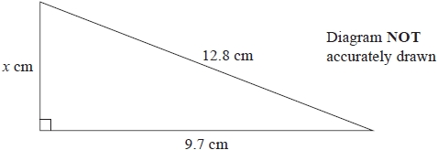

Work out the value of *x*.   
Give your answer correct to 3 significant figures.

...........................................................

**(Total for question = 3 marks)**

**Q2.**

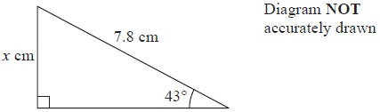

Work out the value of *x*.

Give your answer correct to 3 significant figures.

*x* = ...........................................................

**(Total for Question is 3 marks)**

**Q3.**

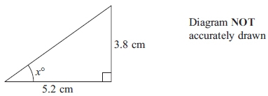

Calculate the value of *x*.  
 Give your answer correct to 1 decimal place.

*x* = ...........................................................

**(Total for question = 3 marks)**

**Q4.**

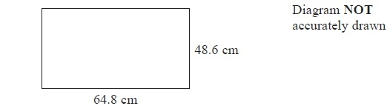

A TV screen is rectangular.

The width of the rectangle is 64.8 cm and the height is 48.6 cm.

(a)  Calculate the area of the rectangle.

Give your answer correct to 3 significant figures.

........................................................... cm2

**(3)**

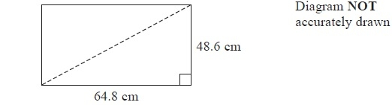

The length of a diagonal of the rectangle gives the 'size' of the TV screen.

(b)  Calculate the 'size' of the TV screen.

........................................................... cm

**(3)**

**(Total for Question is 6 marks)**

**Q5.**

**Write your answers in the spaces provided.**

**You must write down all the stages in your working.**

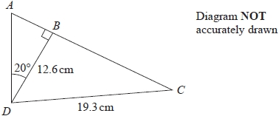

*ABC* is a straight line.

Work out the length of *AC*.   
Give your answer correct to 1 decimal place.

cm

**(Total for question = 5 marks)**

**Q6.**

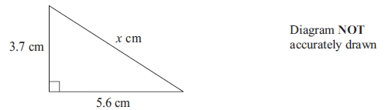

Work out the value of *x*.  
 Give your answer correct to 3 significant figures.

*x* = ..........................................................

**(Total for question = 3 marks)**

**Q7.**

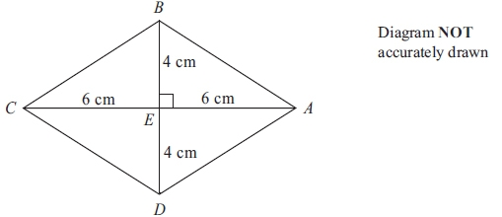

*ABCD* is a rhombus.   
The diagonals *AC* and *BD* cross at the point *E*.   
*AE* = *CE* = 6 cm.   
*BE* = *DE* = 4 cm.   
Angle *AEB* = 90°

(a) Work out the area of the rhombus.

...........................................................cm2

**(3)**

(b) Work out the length of *AB*.   
Give your answer correct to 3 significant figures.

........................................................... cm

**(3)**

**(Total for question is 3 marks)**

**Q8.**

The diagram shows a rectangle *PQRS*.   
*PQ* = 14 cm and *QR* = 9 cm.   
The point *A* lies on *PS* so that *PA* = 5 cm.   
The point *B* lies on *SR* so that *BR* = 8 cm.

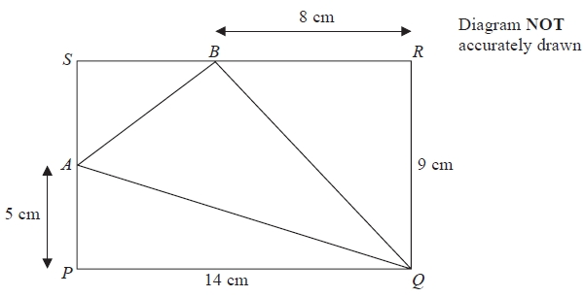

(a)   Work out the area of triangle *AQB*.

........................................................... cm2

**(4)**

(b)   Work out the length of *AQ*.   
Give your answer correct to 3 significant figures.

........................................................... cm

**(3)**

**(Total for Question is 7 marks)**

**Q9.**

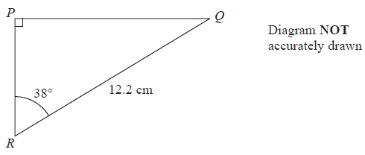

Calculate the length of *PQ*.   
Give your answer correct to 3 significant figures.

........................................................... cm

**(Total for Question is 3 marks)**

**Q10.**

Here is an isosceles triangle.

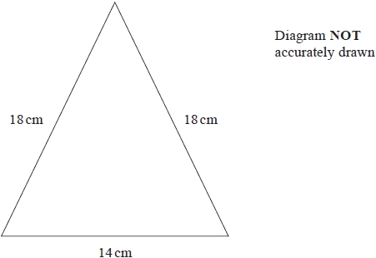

Work out the area of the triangle.   
Give your answer correct to 3 significant figures.

........................................................... cm2

**(1)**

**(Total for question = 4 marks)**

**Q11.**

*R* and *S* are points on a circle with centre *O*.

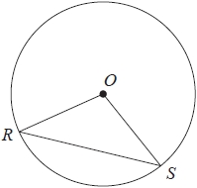

(a)  On the diagram above, shade a segment of the circle.

**(1)**

(b)  Write down the mathematical name of the straight line *RS*.

...........................................................

**(1)**

In the diagram below, *P* and *Q* are points on a circle with centre *O*.

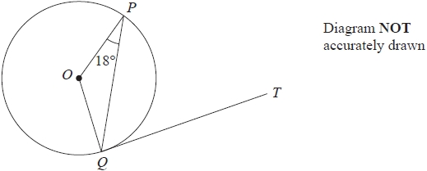

*QT* is a tangent to the circle.   
Angle *OPQ* = 18°

(c)  Work out the size of angle *PQT*.

Give a reason for each stage of your working.

........................................................... °

**(3)**

**(Total for question = 5 marks)**

**Q12.**

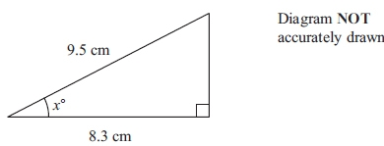

Work out the value of *x*.  
 Give your answer correct to 1 decimal place.

*x* = ...........................................................

**(Total for question = 3 marks)**

**Q13.**

The diagram shows a circle with centre *O* and radius 6.5cm

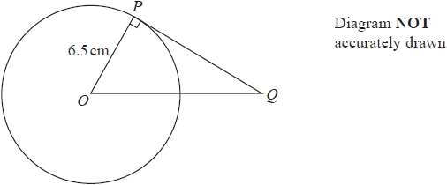

(a)  Work out the area of the circle.   
Give your answer correct to 3 significant figures.

........................................................... cm2

**(2)**

*PQ* is the tangent to the circle at *P*  
*OQ* = 10.5cm

(b)  Work out the length of *PQ*  
Give your answer correct to 3 significant figures.

........................................................... cm

**(3)**

**(Total for question = 5 marks)**

**Q14.**

The diagram shows an isosceles triangle.

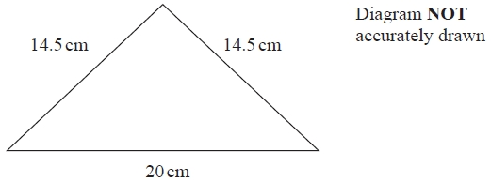

Work out the area of the triangle.

........................................................... cm2

**(Total for question = 4 marks)**

**Q15.**

Here is a trapezium *ABCD*.

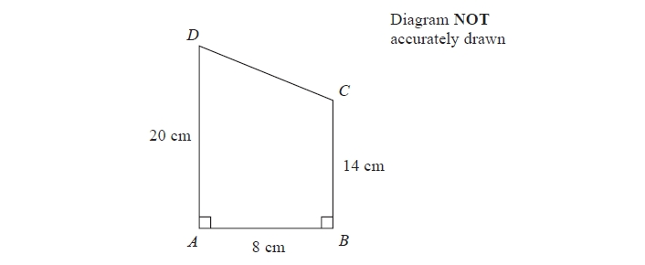

Angle *DAB* = angle *ABC* = 90°

*AD* = 20 cm   
*AB* = 8 cm   
*BC* = 14 cm

(a)  Calculate the area of the trapezium *ABCD*.

.......................................................... cm2

**(2)**

(b)  Calculate the length of *CD*.

.......................................................... cm

**(4)**

**(Total for question = 6 marks)**

**Q16.**

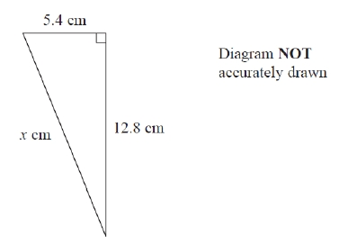

Work out the value of *x*.

Give your answer correct to 3 significant figures.

*x* = ...........................................................

**(Total for question = 3 marks)**

**Q17.**

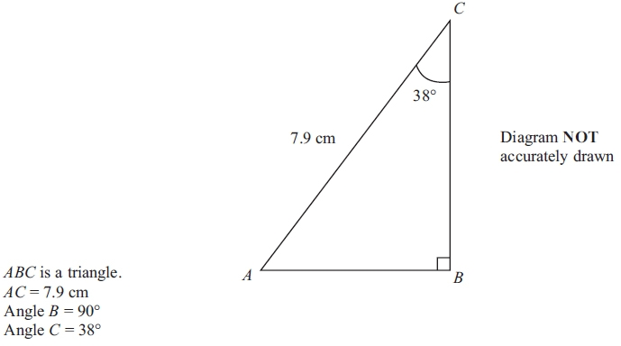

(a) Calculate the length of *BC*.   
Give your answer correct to 3 significant figures.

........................................................... cm

**(3)**

(b) The size of angle *C* is 38º, correct to 2 significant figures.

(i) Write down the lower bound of the size of angle *C*.

........................................................... °

(ii) Write down the upper bound of the size of angle *C*.

........................................................... °

**(2)**

**(Total for question = 5 marks)**

**Q18.**

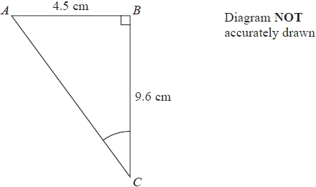

Work out the size of angle *ACB*.   
Give your answer correct to 1 decimal place.

...........................................................°

**(Total for question = 3 marks)**

**Q19.**

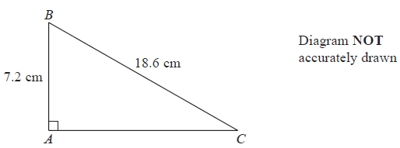

Calculate the length of *AC*.   
Give your answer correct to 3 significant figures.

........................................................... cm

**(Total for Question is 3 marks)**

**Q20.**

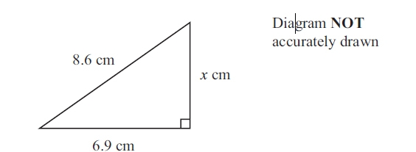

Work out the value of *x*.

Give your answer correct to 3 significant figures.

*x*  =...........................................................

**(Total for question = 3 marks)**

**Q21.**

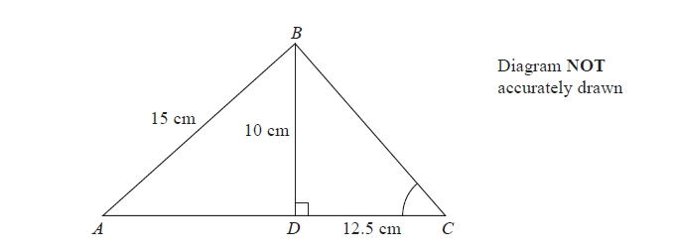

*ABC* is a triangle.   
The point *D* lies on *AC*.   
Angle *BDC* = 90°   
*BD* = 10 cm, *AB* = 15 cm and *DC* = 12.5 cm.

(a)  Calculate the length of *AD*.   
      Give your answer correct to 3 significant figures.

...........................................................cm

**(3)**

(b)  Calculate the size of angle *BCD*.   
      Give your answer correct to 1 decimal place.

...........................................................°

**(3)**

**(Total for question = 6 marks)**

**Q22.**

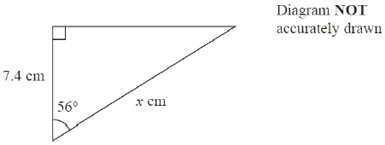

Work out the value of *x*.   
Give your answer correct to 3 significant figures.

*x* = ...........................................................

**(Total for question = 3 marks)**

**Q23.**

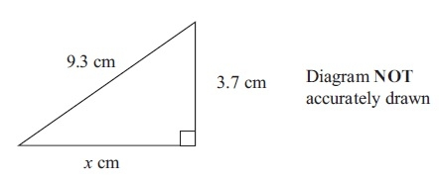

Work out the value of *x*.  
Give your answer correct to 3 significant figures.

*x* = .......................................

**(Total for question = 3 marks)**

**Q24.**

The diagram shows a shaded shape *ABCD* made from a semicircle *ABC* and a   
right-angled triangle *ACD*.

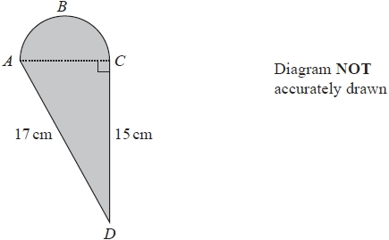

*AC* is the diameter of the semicircle *ABC*.

Work out the perimeter of the shaded shape.   
Give your answer correct to 3 significant figures.

........................................................... cm

**(Total for question = 5 marks)**

**Q25.**

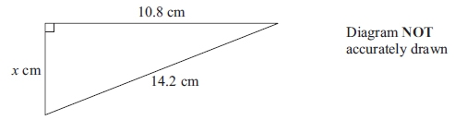

Work out the value of *x*.  
 Give your answer to 3 significant figures.

*x* = ...........................................................

**(Total for question = 3 marks)**

**Q26.**

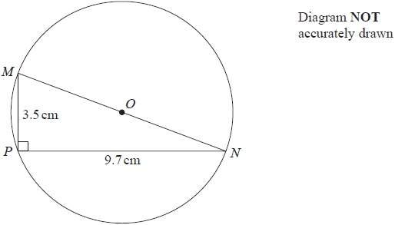

*M*, *N* and *P* are points on a circle, centre *O*.   
*MON* is a diameter of the circle.

*MP* = 3.5 cm   
*PN* = 9.7 cm

Angle *MPN* = 90°

Work out the circumference of the circle.   
Give your answer correct to 3 significant figures.

........................................................... cm

**(Total for question = 4 marks)**

**Q27.**

Here is a right-angled triangle.

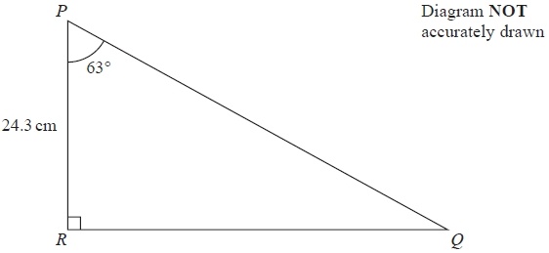

Calculate the length of *PQ*.   
Give your answer correct to 3 significant figures.

........................................................... cm

**(Total for question = 3 marks)**

**Q28.**

The diagram shows the positions of three ships *A*, *B* and *C*.

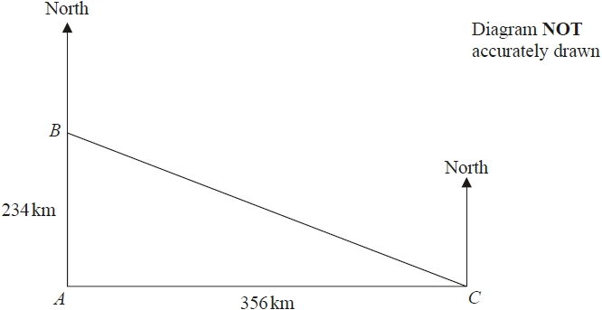

*B* is 234 km due north of *A*.   
*C* is 356 km due east of *A*.

Work out the bearing of *B* from *C*.   
Give your answer correct to the nearest degree.

........................................................... °

**(Total for question = 4 marks)**

**Q29.**

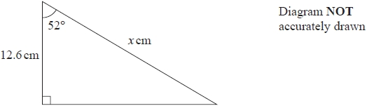

Work out the value of *x*.   
Give your answer correct to 3 significant figures.

*x* = ...........................................................

**(Total for question = 3 marks)**

**Q30.**

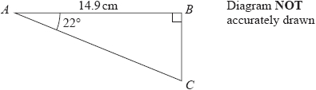

Calculate the length of *AC*.   
Give your answer correct to 3 significant figures.

........................................................... cm

**(Total for question = 3 marks)**

**Q31.**

Here is a right-angled triangle.

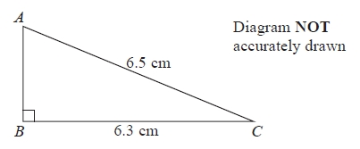

*AC* = 6.5 cm.

*BC* = 6.3 cm.

Angle *ABC* = 90°

Calculate the length of *AB*.

........................................................... cm

**(Total for question = 3 marks)**

**Q32.**

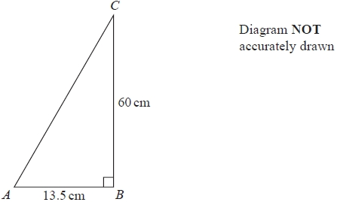

(a)  Work out the perimeter of the triangle.

........................................................... cm

**(4)**

(b)  The length of *AB* is 13.5 cm correct to 3 significant figures.   
Write down the lower bound of the length of *AB*.

........................................................... cm

**(1)**

**(Total for question = 5 marks)**

**Q33.**

The diagram shows a ladder, *EF*, leaning against a vertical wall.   
The foot, *E*, of the ladder is on horizontal ground.

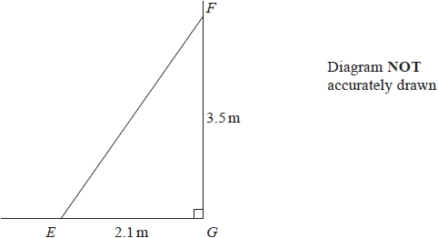

*EG* = 2.1 m          *FG* = 3.5 m          angle *EGF* = 90°

(a)  Work out the length of the ladder.   
       Give your answer correct to 1 decimal place.

........................................................... m

**(3)**

(b)  Work out the size of angle *EFG*.   
      Give your answer correct to the nearest degree.

........................................................... °

**(3)**

**(Total for question = 6 marks)**

**Q34.**

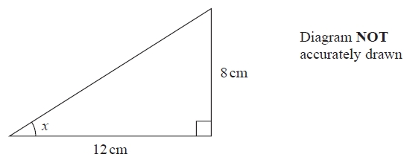

Calculate the size of angle *x*.   
Give your answer correct to 1 decimal place.

........................................................... °

**(Total for question = 3 marks)**

**Q35.**

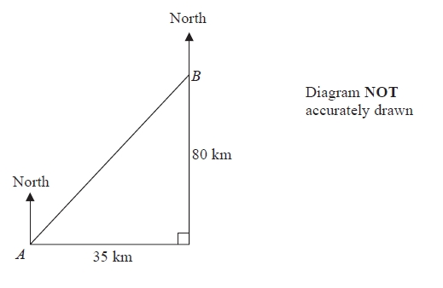

Town *B* is 35 km east and 80 km north of town *A*.

Work out the bearing of town *A* from town *B*.   
Give your answer correct to the nearest degree.

...........................................................°

**(Total for question = 4 marks)**

**Q36.**

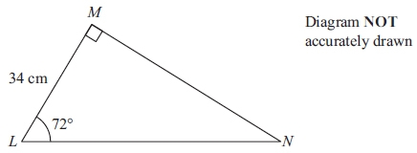

Calculate the length of *MN*.  
 Give your answer correct to 3 significant figures.

........................................................... cm

**(Total for question = 3 marks)**

**Q37.**

The diagram shows the positions of two towns, *A* and *B*.

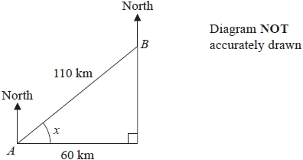

The distance from *A* to *B* is 110 km.   
*B* is 60 km east of *A*.

(a)  Work out the size of angle *x*.   
       Give your answer correct to 1 decimal place.

........................................................... °

**(3)**

(b)  Work out the bearing of *B* from *A*.   
       Give your answer correct to the nearest degree.

........................................................... °

**(2)**

The distance from *A* to *B* is 110 km correct to 2 significant figures.

(c) (i)  Write down the lower bound for the distance from *A* to *B*.

........................................................... km

(ii)  Write down the upper bound for the distance from *A* to *B*.

........................................................... km

**(2)**

**(Total for question = 7 marks)**

**Mark Scheme**

Q1.

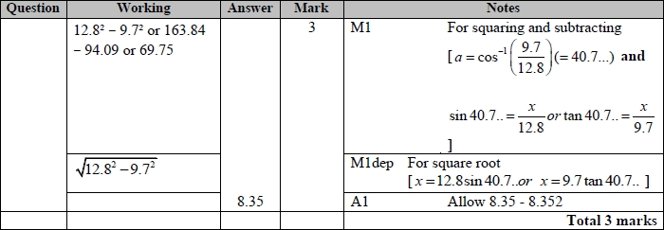

**Q2.**

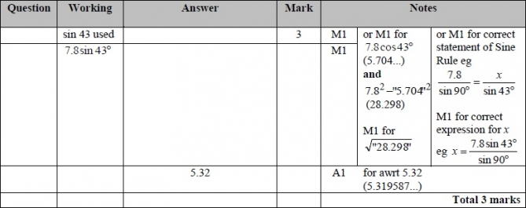

**Q3.**

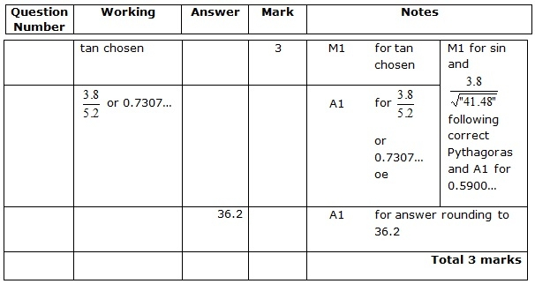

**Q4.**

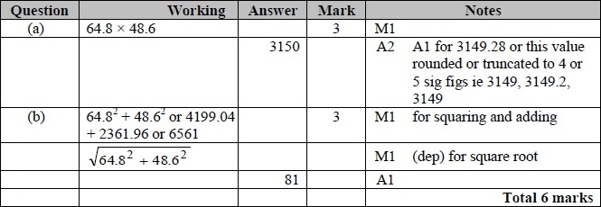

**Q5.**

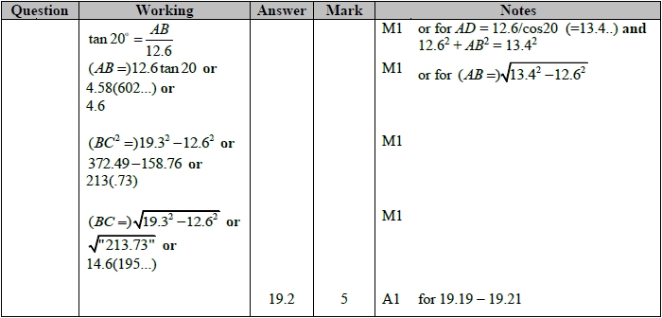

**Q6.**

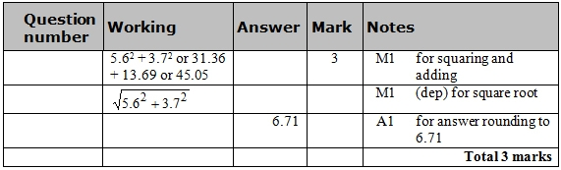

**Q7.**

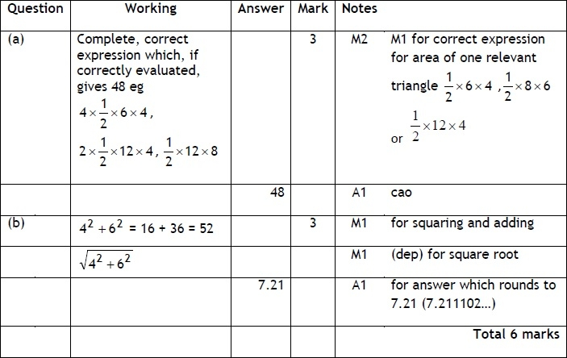

**Q8.**

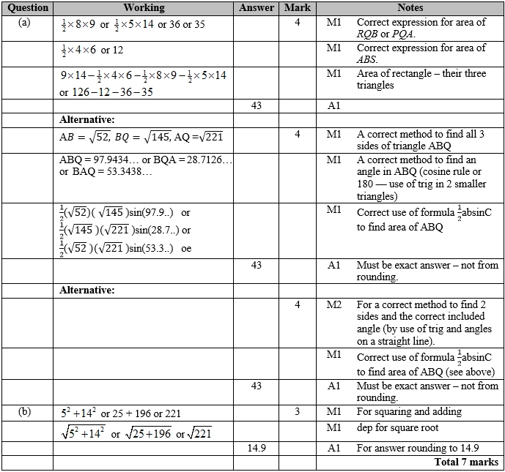

**Q9.**

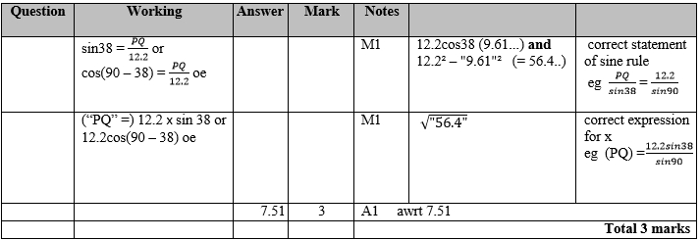

**Q10.**

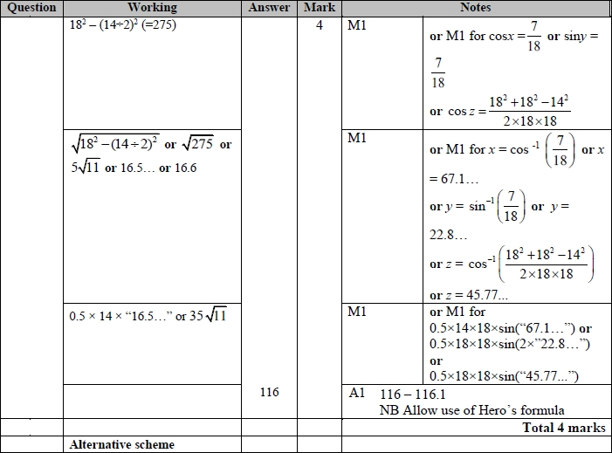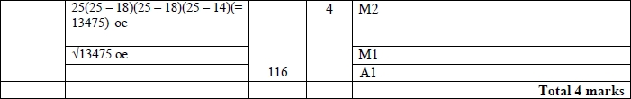

**Q11.**

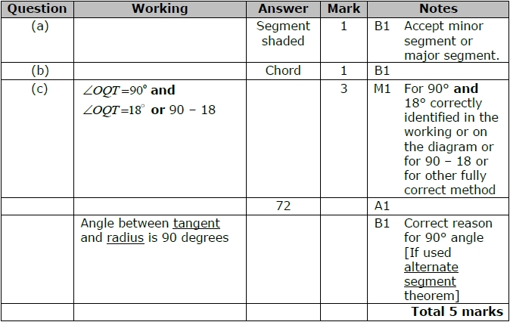

**Q12.**

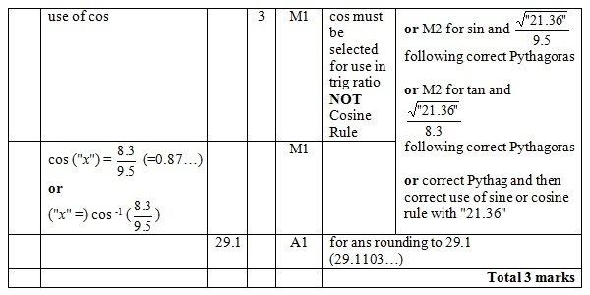

**Q13.**

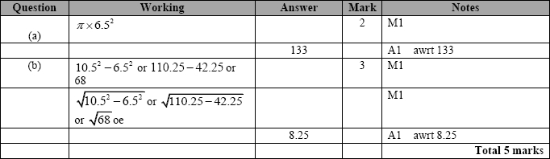

**Q14.**

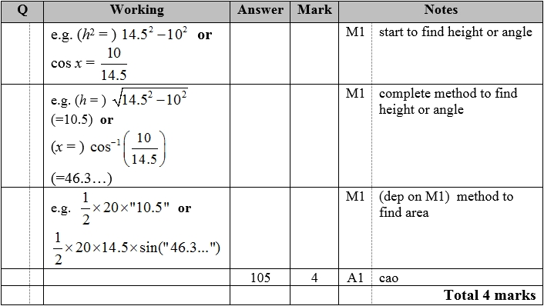

**Q15.**

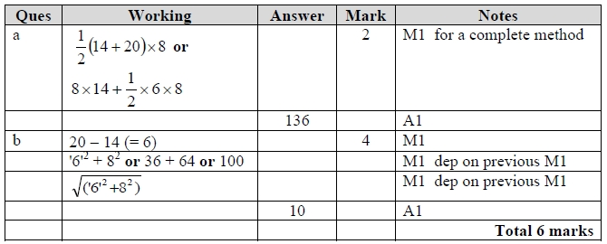

**Q16.**

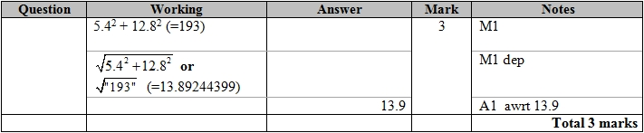

**Q17.**

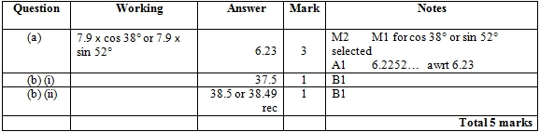

**Q18.**

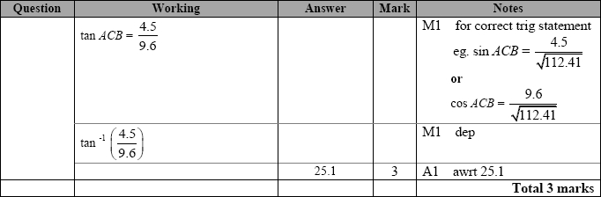

**Q19.**

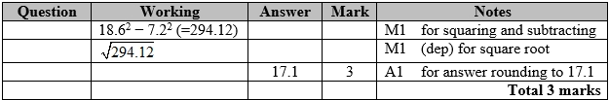

**Q20.**

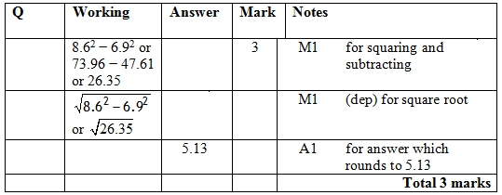

**Q21.**

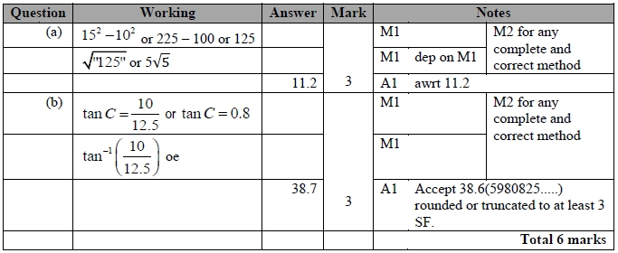

**Q22.**

The correct answer, unless clearly obtained by an incorrect method, should be taken to imply a correct method.

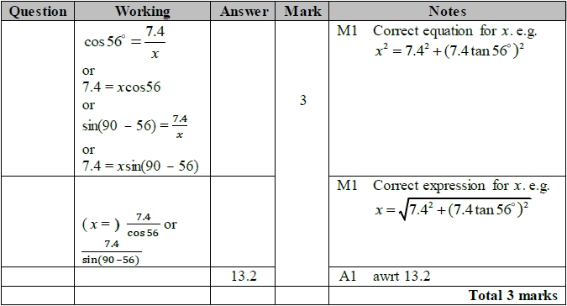

**Q23.**

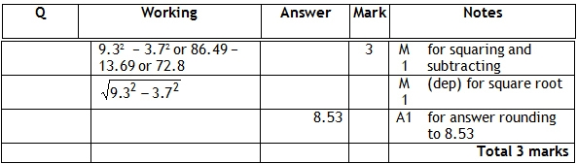

**Q24.**

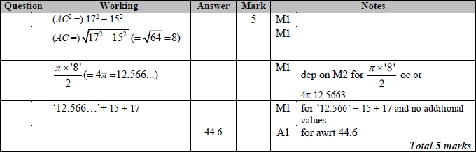

**Appendix 1**

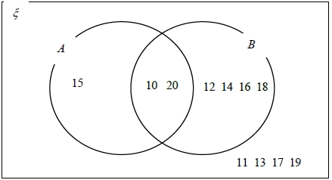

**Q25.**

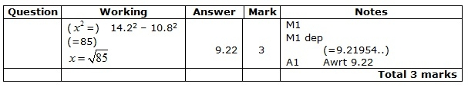

**Q26.**

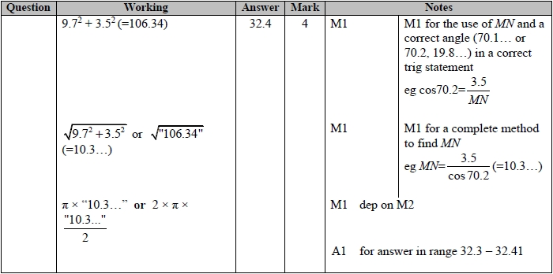

**Q27.**

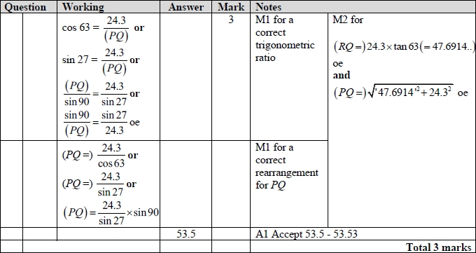

**Q28.**

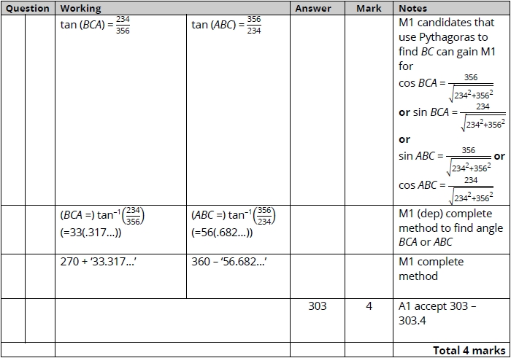

**Q29.**

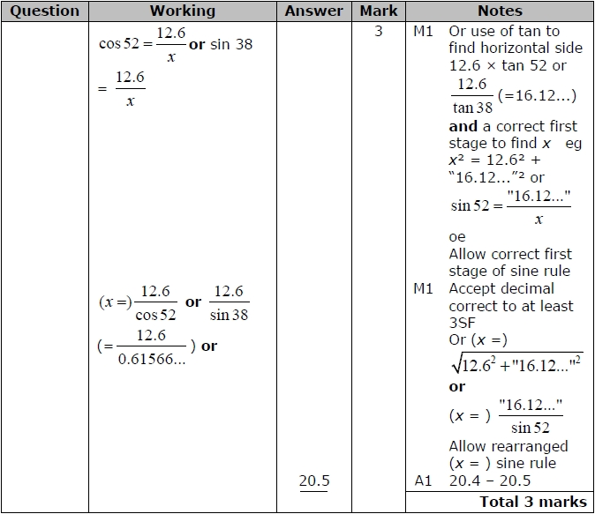

**Q30.**

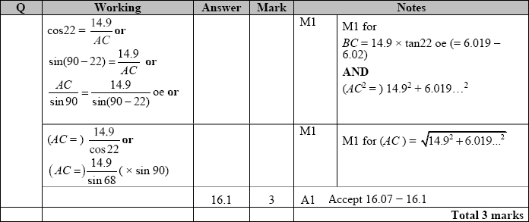

**Q31.**

For all questions, the correct answer, unless clearly obtained by an incorrect method, should be taken to imply a correct method.

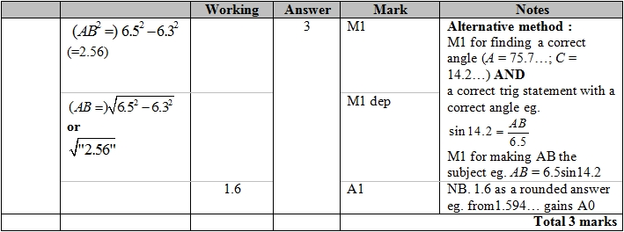

**Q32.**

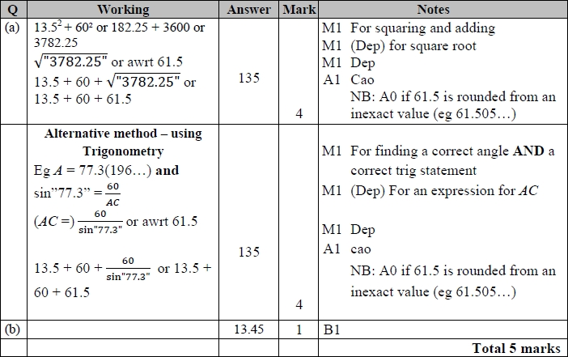

**Q33.**

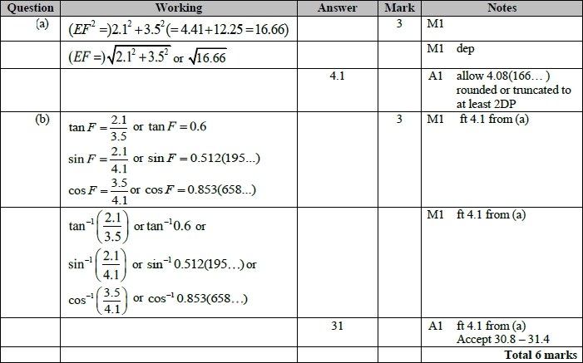

**Q34.**

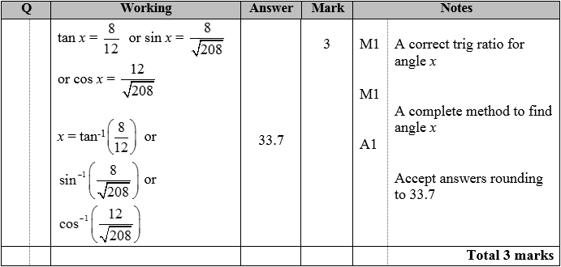

**Q35.**

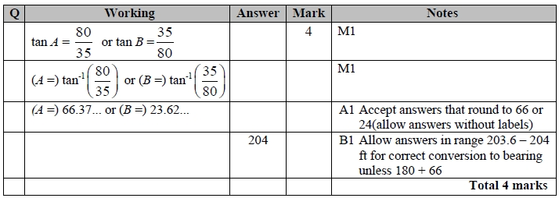

**Q36.**

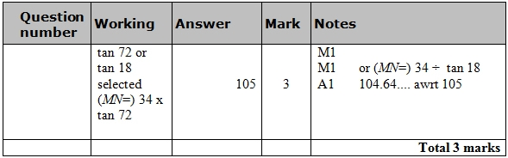

**Q37.**

