**STEM CELLS**

**Specialised Cells: Review**

* Multicellular organisms are organisms made from more than one cell
  + You (a human) are multicellular, being made from trillions of cells
* Specialised cells have a particular structure and composition that allow them to perform a specific function, and they form through a process known as **differentiation**
  + There are about 250 specialised cell types in the human body (e.g. red blood cell, motor neurone cell etc.)
* If a specialised cell is able to divide by **mitosis**, the daughter cells produced will be the same type of specialised cell. These cells have lost their ability to differentiate into other types of cell

**Stem Cells**

* If cells are isolated at an early stage of growth (before they have started to become too specialised), they can retain their ability to grow into a range of different types of cells – these are stem cells
* A stem cell is an **undifferentiated**cell of an organism which is capable of dividing (giving rise) to many more cells of the same type (undifferentiated stem cells)
* From these cells, other cells can arise through the process of differentiation  
  The table below summarises the different types of stem cell you need to know about:

**Stem cells**

[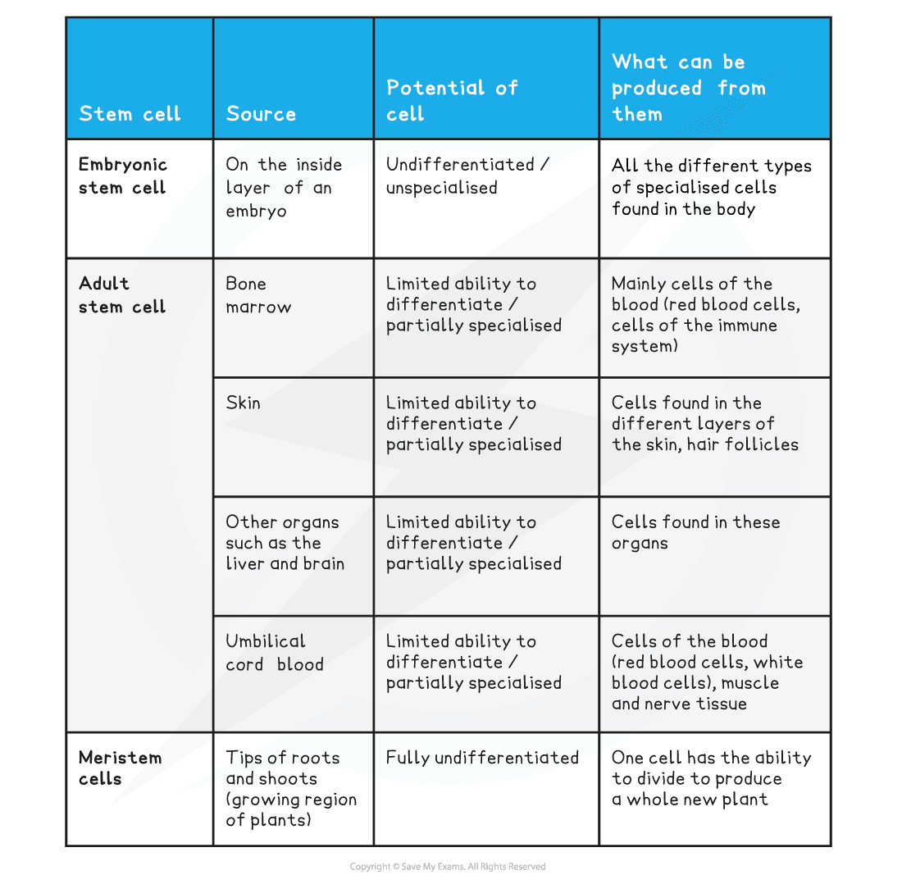](https://cdn.savemyexams.co.uk/wp-content/uploads/2020/07/Stem-cells-table-1.png)

**Stem Cells: Animals v Plants**

* Embryonic stem cells are important as they help to form all of the different tissues and organs needed during development to form a new individual
* The role of adult stem cells is predominantly to replace cells lost through damage or to produce new cells for growth – although the bone marrow has to continually make new blood cells throughout life
* In plants, meristem cells are unspecialised cells which can differentiate into the cells needed by the plant in regions where growth is occurring
* For example, meristem cells in the roots can differentiate into root hair cells as well as other cells required in this part of the plant
* The stem cells found in the meristems of plants retain the ability to differentiate into any type of plant cell **throughout the life of the plant**

**Stem Cells in Medicine**

* It is possible to grow human embryos in the lab and to extract **embryonic stem cells** from them
* These embryonic stem cells can then be encouraged to differentiate into most types of specialised cell
* Scientists and doctors could use stem cell technology to repair damaged organs by growing new tissue from stem cells produced by embryos created using genetic information from the patient
* Adult stem cells can also be cultured in the lab and made to differentiate into specialised cells, but of fewer types than embryonic stem cells (predominantly cells of the blood)
* Stem cells could be used to cure many diseases in the future, such as diabetes and paralysis:

**Stem cell treatment**

[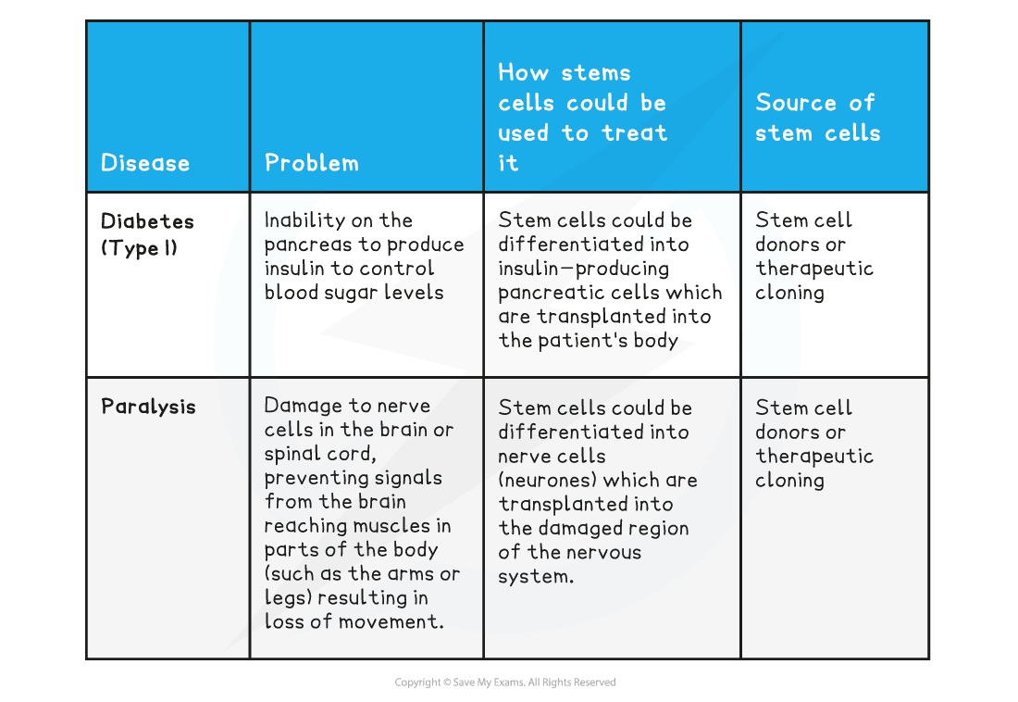](https://cdn.savemyexams.co.uk/wp-content/uploads/2020/07/Stem-cell-treatment-table-2.png)

**Therapeutic Cloning**

* In therapeutic cloning, an embryo is produced with the same genes as the patient
* A 5-day old embryo is the best source of embryonic stem cells
* Stem cells from embryos created in this way are not rejected by the patient’s body
* So they may be used for medical treatment without the patient having to take drugs to suppress their immune system (which reduce the body’s ability to fight infection)

[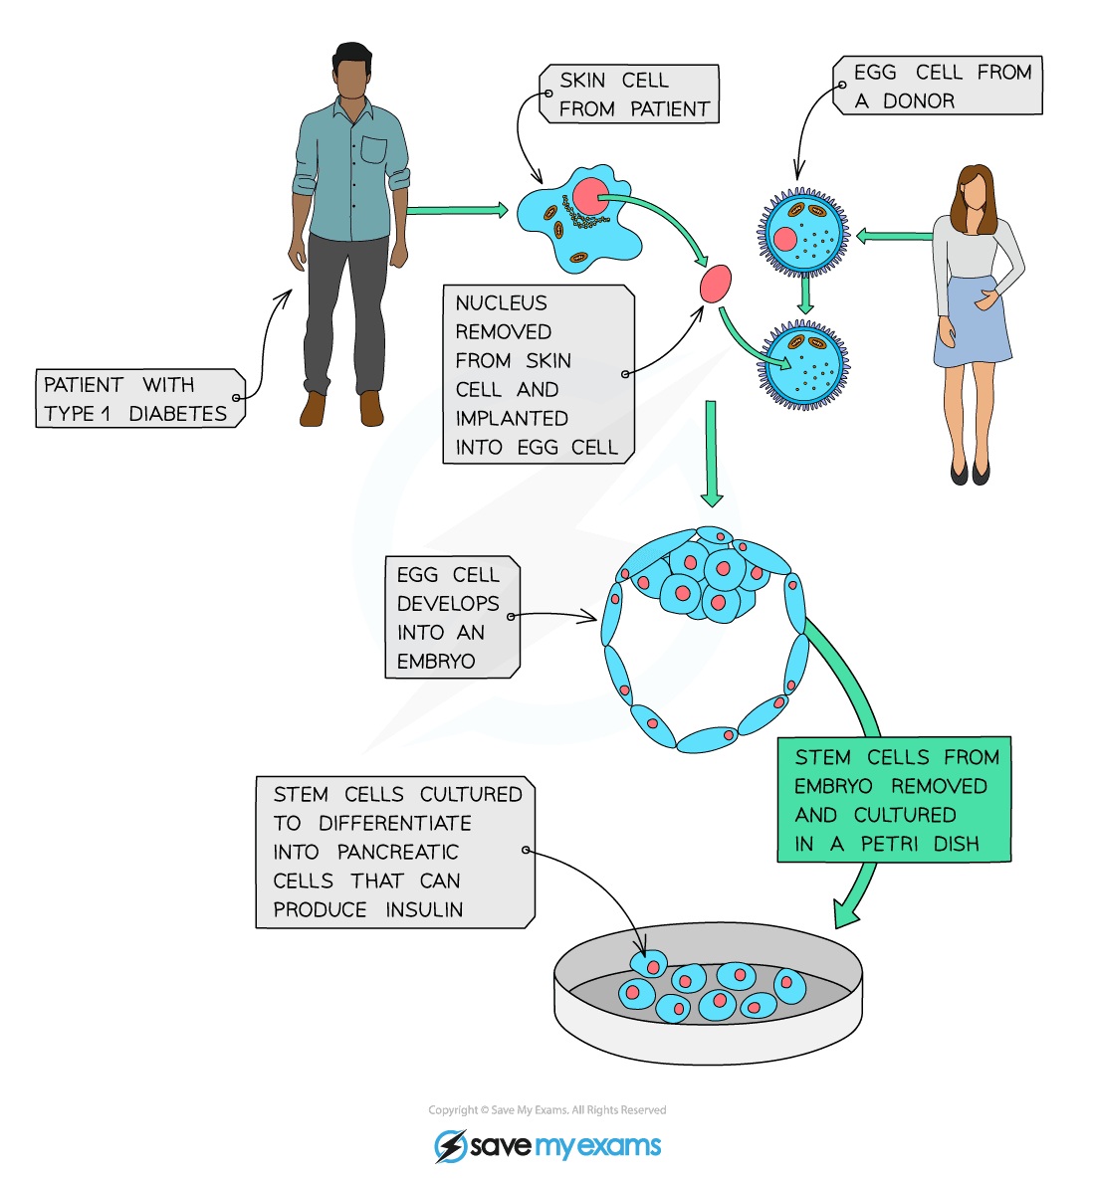](https://cdn.savemyexams.co.uk/wp-content/uploads/2020/08/1.2.3-Stem-cells-1.png)

***Diagram showing the process of therapeutic cloning***

**Evaluating Stem Cells in Medicine**

**Evaluating stem cells**

[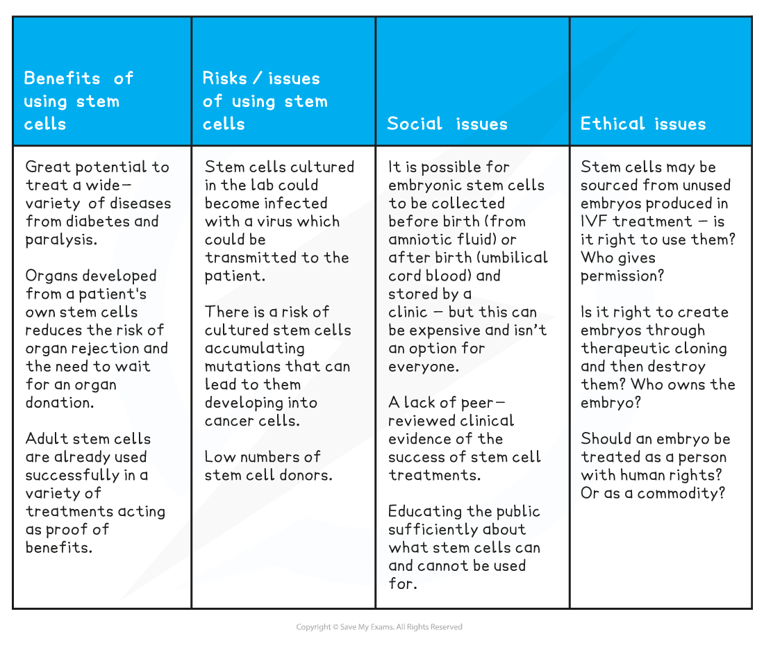](https://cdn.savemyexams.co.uk/wp-content/uploads/2020/08/Evaluating-stem-cells-table-3.png)

**Stem Cells in Plants**

* Unlike in animals, plant stem cells can be obtained easily, and without ethical objection, from meristems. They can then be used to produce **clones** of plants quickly and economically
  + Plant clones can be produced in weeks at a relatively low cost for their potential value
* Rare species at risk of extinction as a result of human activity can be cloned to protect them and maintain biodiversity
  + The plants produced are clones, so although numbers increase, **genetic diversity** within clones is low
  + Cloning rare plants gives scientists more time to study them to see if they can produce any compounds of interest
* Crop plants with special features such as disease or pest resistance can be cloned to produce large numbers of identical plants for farmers
  + This reduces the need to use chemicals such as pesticides, which has environmental benefits