

**Marking Schemes**

**Inequalities and Regions (Linear)**

**Q1.**

The correct answer, unless clearly obtained by an incorrect method, should be taken to imply a correct method.

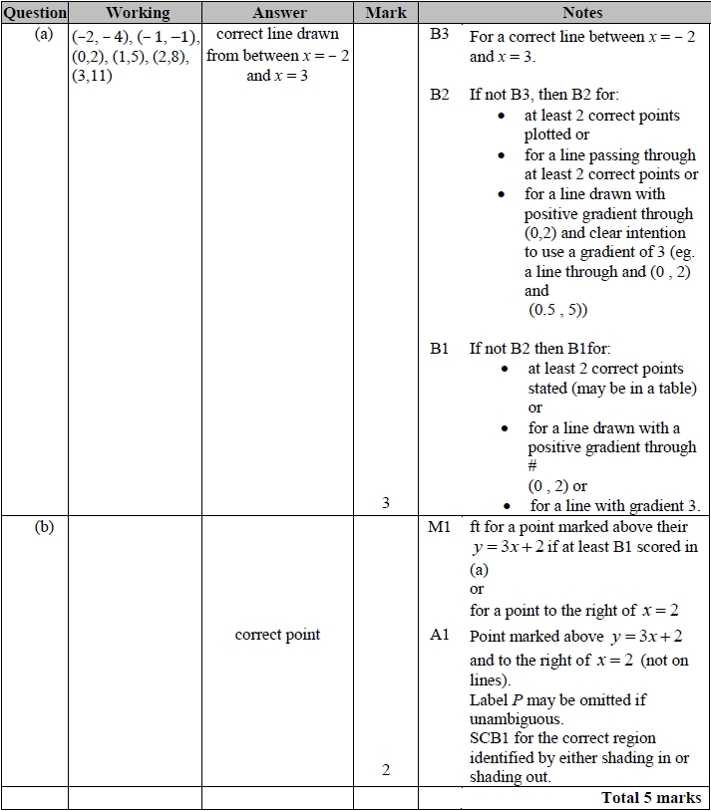

**Q2.**

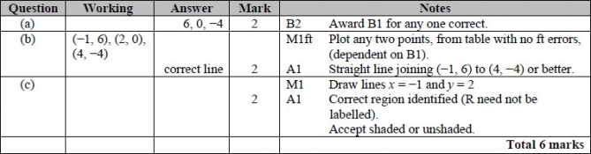

**Q3.**

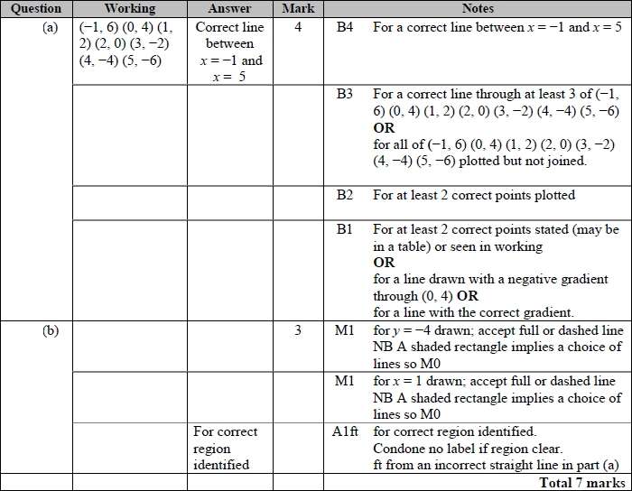

**Q4.**

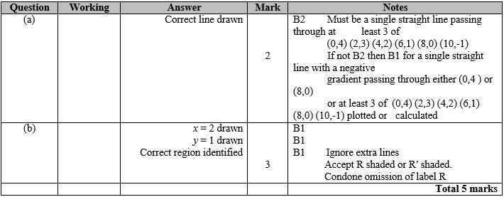

**Q5.**

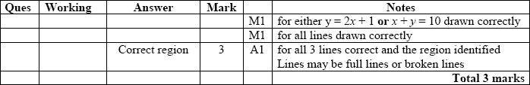

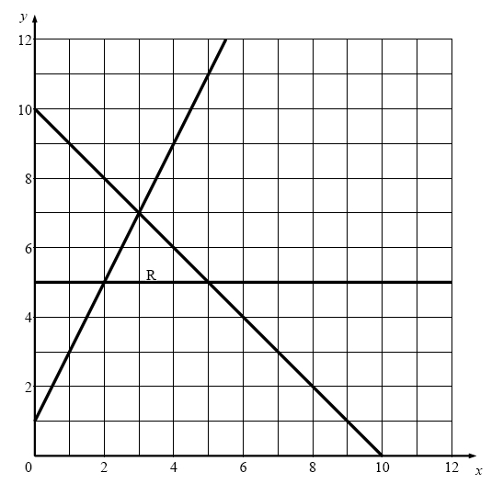

**Q6.**

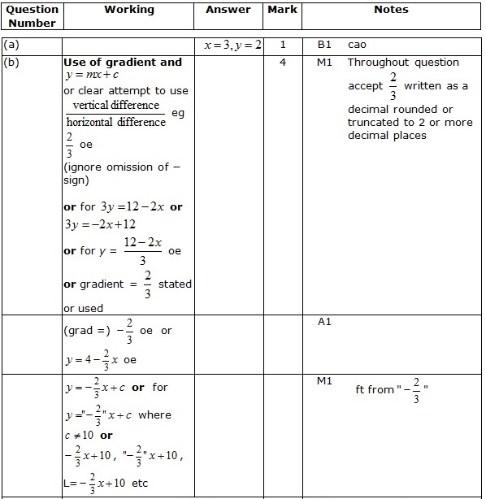  
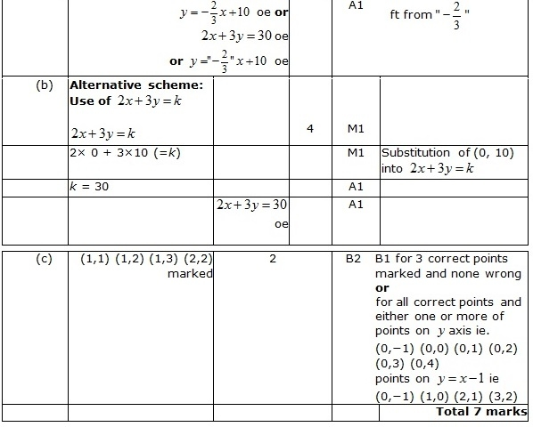

**Q7.**

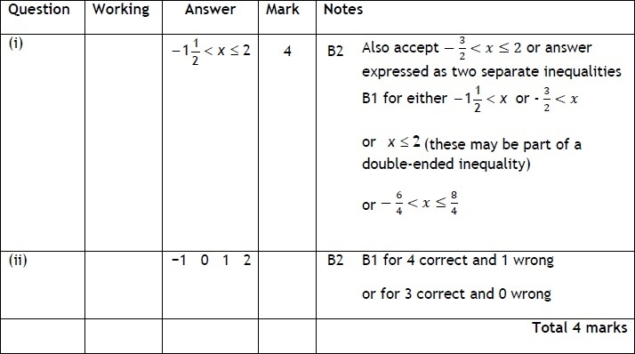

**Q8.**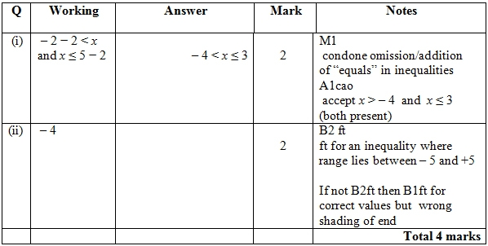

**Q9.**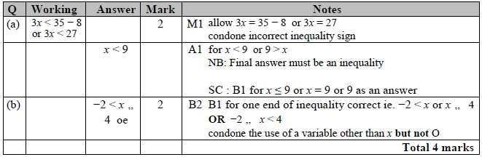

**Q10.**

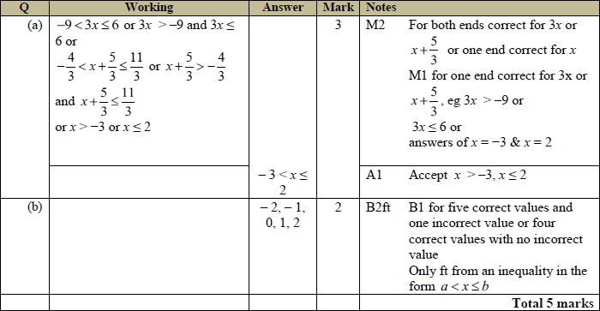

**Q11.**

The correct answer, unless clearly obtained by an incorrect method, should be taken to imply a correct method.

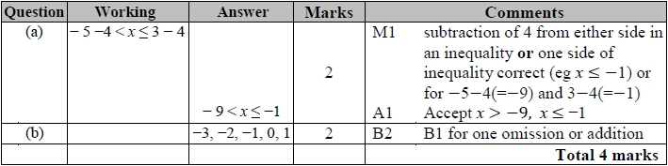

**Q12.**

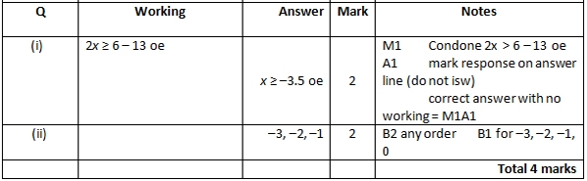

**Q13.**

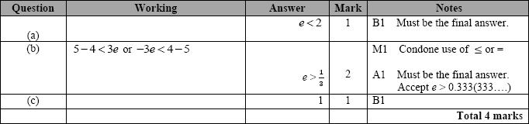

**Q14.**

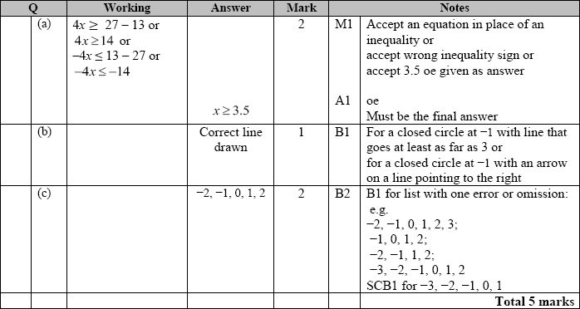

**Q15.**

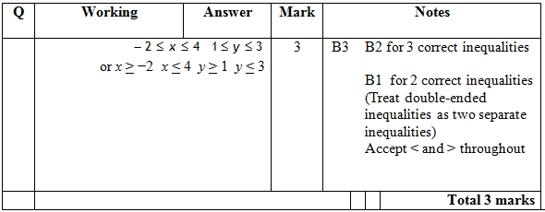

**Q16.**

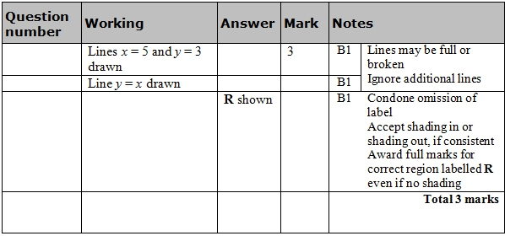

**Q17.**

