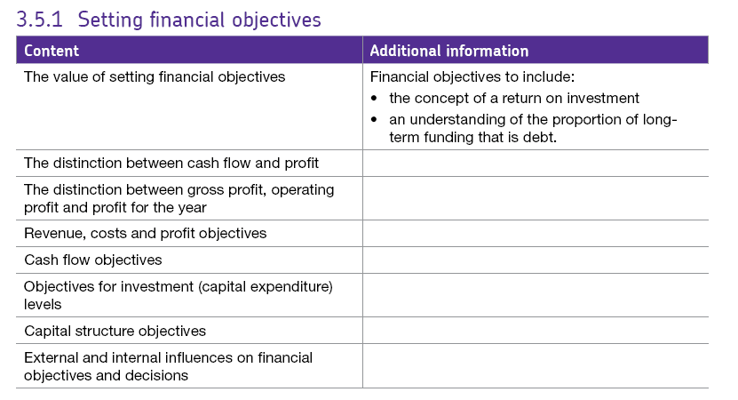3.5.1 Financial Objectives

# The value of setting financial objectives

Financial objectives are the specific aims and goals of the finance department within an organisation. It is important to understand that financial goals and targets are not set in isolation. They must be set with the aim of meeting or working towards the **corporate objectives** of the organisation. Financial objectives have a range of benefits and financial objectives can:

* Act as a focus for decision-making.
* Provide a measure for success.
* Improve coordination of teams and departments.
* Improve efficiency.
* Allow shareholders to assess whether an investment is worthwhile.
* Enable external stakeholders to check the financial viability of the business.

# Types of financial objective

There are several possible financial objectives but the main ones are listed below:

* Revenue
* Cost
* Profit
* Cash flow
* Objectives for Investment (capital expenditure) levels
* Capital structure
* Return on investment
* Objectives relating to debts as a proportion of long term funding (aka gearing)

# Cash flow and profit.

It is important to remember that there is an important difference between cash flow and profit, even a profitable business can go bankrupt due to a lack of cash.

This could be because, for example the revenue generated from goods sold will be included in profit calculations straight away but the money may not be received by the firm immediately if the goods are paid for on credit – this has a negative effect on cash flow.

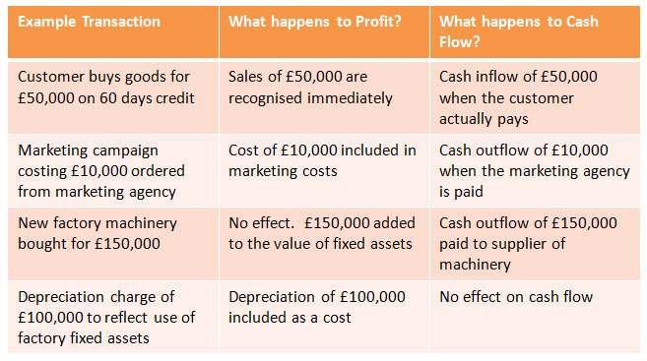

# Types of profit: Gross Profit, Net Profit and Profit for the Year

There are different types of profit calculations and these are all recorded on the firm’s Income Statement (see example on the next page).

#### 1. Gross Profit= Sales Revenue – direct costs (also known as variable costs or the **cost of sales**).

This is the most basic type of profit just looking at whether the firm’s income pays the actual costs of making the product.

#### 2. Operating Profit **=** Gross Profit - all indirect costs (also known as fixed costs or expenses).

Operating profit takes account of normal operating revenue and costs incurred in the day to day running of the business but doesn’t include any extra income or costs e.g. if the firm gets interest on profits in the bank.

#### 3. Profit for the Year (Net profit) **=** Operating Profit + (finance or investment income - finance

#### charges) e.g. tax payable to the Government.

For example, the firm will receive interest on money in the bank and may receive dividends on shares held in other companies but may have to pay charges such as loan interest & corporation tax.

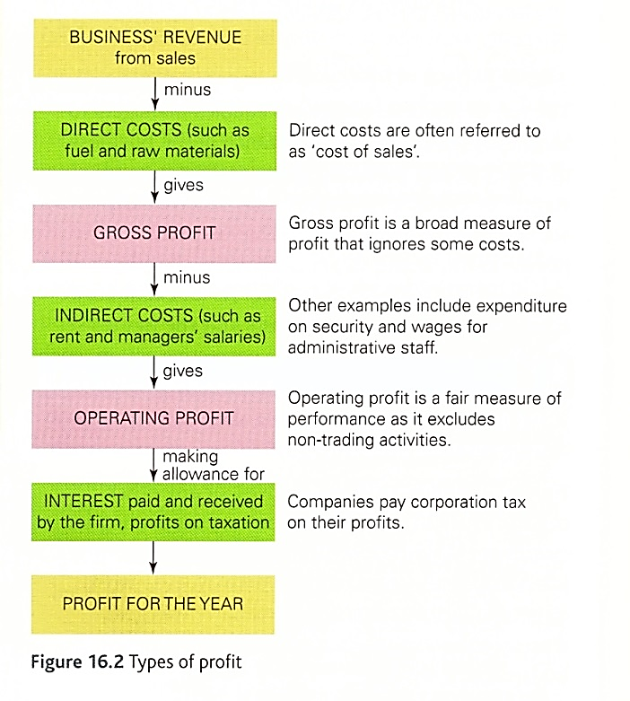

The managers of the business must decide how the Profit for the Year is going to be distributed.

It can either be distributed to shareholders by way of a dividend or it can be retained in the company to either finance capital investment, provide cash in the business or simply to add to savings.

# Financial Objectives

There are several financial objectives and we will look at these in turn.

## Revenue Objectives

A business may set an objective of generating an increase in revenue over the next financial year. A business which aims to grow will almost certainly set a revenue objective; this is particularly important for new businesses that are generating a customer base and are establishing themselves in the market.

Some businesses also sell products which have very short product life cycles and they therefore wish to make the most of short term selling opportunities.

Revenue objectives do not have to relate to the business as a whole, they can relate to a particular product line. Sometimes a business may set a difficult revenue target which becomes even more challenging over time. For example, a 10% increase in year one and a 15% increase in year two etc.

The strategies for achieving revenue objectives will depend on *the elasticity of demand for the product (revise this from 3.3)*.

**Reduce price** if the product is **price elastic** (sensitive to a price changes). In this case, the percentage increase in demand would be greater than the percentage decrease in price. Price elastic products are more likely to exist in highly competitive markets where many substitutes exist.

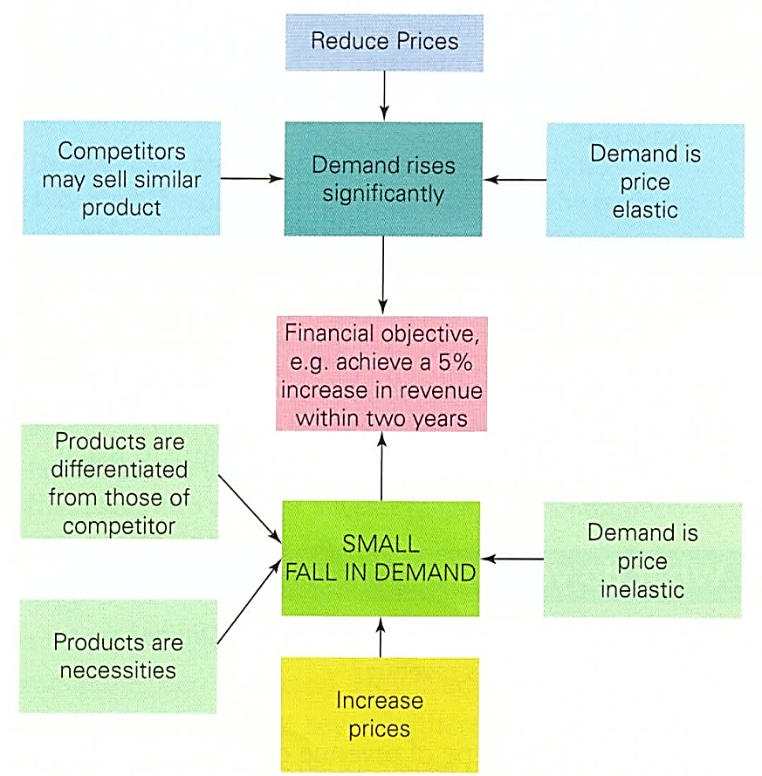**Increase price** if the product is **price inelastic** (not sensitive to price changes). In this case, the percentage decrease in demand would be less than the percentage increase in price. Price inelastic products are more likely to exist in markets where there are few substitutes for the product or service and the product is likely to be a necessity.

**Increased advertising and promotion** may increase the awareness for the product and thereby increase revenue. However, while this may increase revenue, it may not result in an increase in profits since additional spending on marketing campaigns will add to fixed costs or overheads.

## Cost objectives

The business may set itself the objective of reducing costs by a certain percentage if profits are falling. In this case, by reducing costs, the business is still able to maintain their profit margin. For example, in some highly competitive markets, there may be pressure to lower prices as much as possible. The business then has a decision to make: do they accept lower profits or do they reduce costs?

In order to do this, some businesses pursue a policy of **cost minimisation** by keeping all costs throughout the business as low as possible; e.g. EasyJet with their ‘no frills’ airline or supermarkets Aldi or Lidl.

## Profit objectives

It is common for most businesses to have a profit objective. This objective might be to improve the profits generated from that achieved in the previous year. Sometimes the objective may be set as a **percentage increase** in profits; for example a 7% increase in annual net (operating) profit. The profit objective may also be set **as a percentage compared to sales** by calculating either:

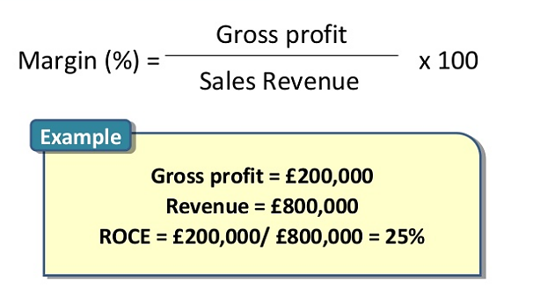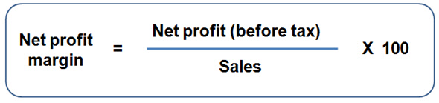**The Gross Profit Margin or the Net Profit Margin**.

**The net profit margin can be a bit confusing – we are using the operating profit here because we want the figures before tax, this is because tax rates are different between countries and so, in order to make international comparisons viable we have to look at the figures before tax.**

Profit objectives can motivate employees and, if the objectives are met, they show external stakeholders that the business is successful. However, if actual profits are below the target set, then the opposite can happen; profit targets provide very clear and possibly public evidence of underperformance. In turn, this may lead to falling share price and concern amongst banks and other financial institutions.

## Cash Flow Objectives

Cash flow is regarded as being the ‘lifeblood’ of the business since without it the business will be unable to meet its day to day expenses and is likely to go bankrupt.

This is particularly the case if the business has long delays in the cash flow cycle – the time between spending the money and cash coming in from sales.

Also, companies that experience strong growth often have cash flow problems; they need regular cash inflows in order to finance the purchasing of increased labour and raw materials. Failure of a growing business to ensure it has sufficient cash to meet its expenditure is referred to as ***overtrading.***

## Setting objectives for returns on Investment (ROI)

This refers to how well an investment will pay for itself – what are the expected profits from it?

Return on investment is calculated as:

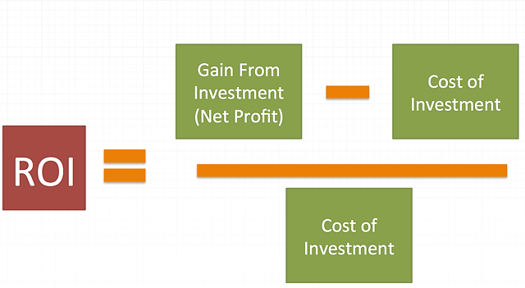

Costs of the investment

Gains from the investment

Initial cost of the investment

**X 100**

The top part of the equation shows the gain (net profit) from the investment i.e. the additional revenue – the associated or additional costs of the investment.

e.g.1 an advertising campaign costs £400,000 and based on the revenue and costs that it generates, it provides an additional income (or return) of £32,000.

Therefore, it’s ROI = £32,000 / £400,000 X 100 = 8%

e.g. 2

The new delivery of vehicles cost £350,000 and generates additional revenue of £700,000. However, costs increase by £570,000. The ROI for the new delivery vehicles is therefore:

£700,000 - £570,000 x 100 = £130,000 x 100 **= 37.1%**

£350,000 £350,000

In this case the purchase of the delivery vehicles is the better option since it represents a more efficient use of the businesses financial resources. However, the difference is small and therefore non-financial factors would also need to be taken into account before the final decision is made.

However, ROI data must be used with caution!

The figures may only refer to the first year so it’s important to check that the data you are given refers to the lifetime of the project or just a year.

Also, although the data suggests that sales increase as a result of the ad campaign it’s really impossible to say whether that alone caused sales to rise as there may have been other factors in the external environment which affected sales.

However, the calculation can help a business to choose between different investment. They could reject those investments where the return not much higher than the cost of borrowing or there may be non-financial reasons for rejecting an investment e.g.

* The impact on employees – will they need training? Will workers be made redundant?
* Will the investment fit in with the existing company image?
* Does the investment fit in with the corporate objectives set by the organisation?

## Setting objectives for the level of investment (or capital) expenditure

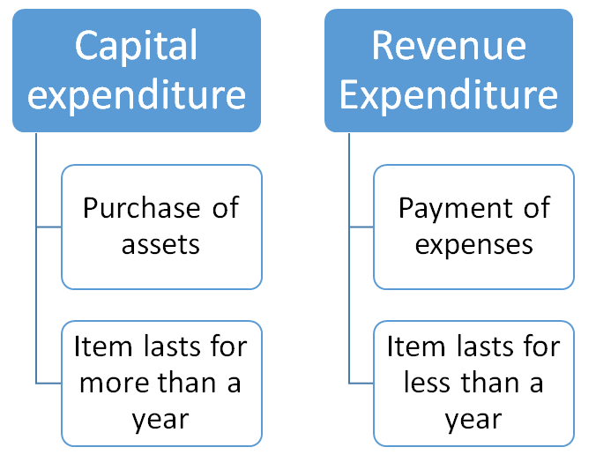Capital expenditure is the purchase of long term assets (things the business owns which have a long term life e.g. vehicles, land, building or machinery. This type of asset is also referred to as a **non-current asset**.

A business may seek a certain level of capital expenditure over the year e.g. to support growth they may need to buy land to build a new, larger factory.

Alternatively, the management team may reduce the amount spent on equipment, the managers could decide to concentrate on reducing the money owed to banks.

## Capital structure objectives

Capital structure refers to the way in which a business has raised the capital to finance its long term assets. There are two options for finance:

1. Financing through ***long term debt*** by using long term loans, mortgages or debentures for example.

This would mean it will have to pay interest which may become a problem if the business encounters falls in sales revenue or profits. On the other hand, financing through debt would mean that the business did not lose any control of the business.

1. Financing though ***equity*** and this includes shareholder funds and retained profits.

Raising funds through the sale of shares will mean the business loses some control plus shareholders will also expect a dividend. However, funds raised on the stock market do not have to be repaid.

## Objectives relating to debt as a proportion of long term funding (***gearing***)

A business which has more than 50% of its capital structure from borrowing is said to be **highly geared**. These companies may be at risk if interest rates rise or their sales revenue declines as they would have difficulty meeting the repayments which could result in cash flow problems. Highly geared firms are thought to be **high risk** because of this.

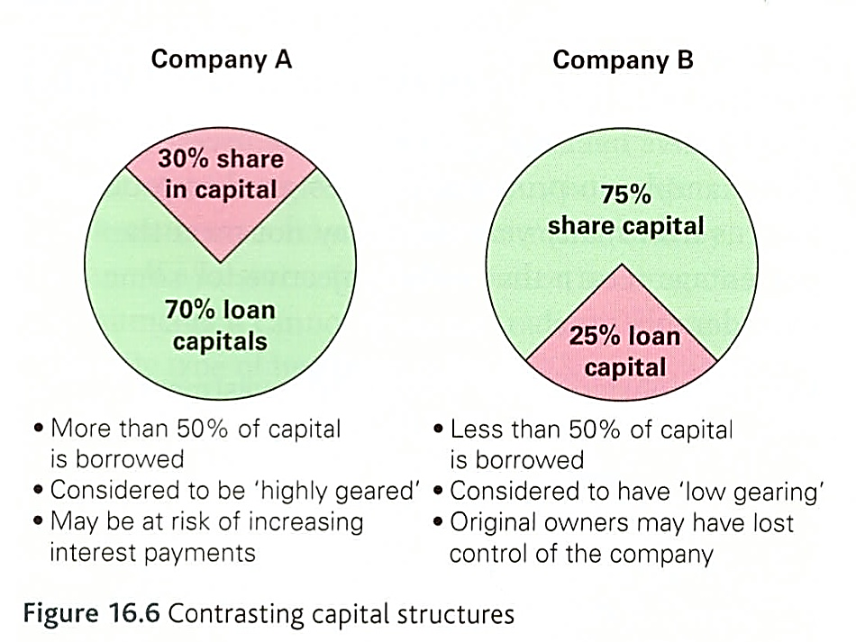A company with much less than 50% of its capital structure financed through loans is said to have **low gearing** and these companies might be better to finance further capital expenditure through loan capital rather than diluting their ownership through share capital.

### Factors which influence capital structure

* Low interest rates will encourage firms to finance capital structure by the use of debt since repayments will be relatively low.
* When inflation is high, companies may opt to finance capital expenditure through debt. Inflation is the measure of an increase in the general price level over time. However, while prices may be rising, the value of money will be falling along with debts.
* During prosperous times when the economy is booming and demand for shares are high, the business may opt to finance capital expenditure through share capital (equity).
* The willingness to finance through issuing further shares will depend upon the management view to ownership and control. If the current owners wish to keep control they may not want to raise funds on the stock market.

# Internal and external influences on financial objectives and decisions

There are a range of factors which the management team will need to consider when setting its financial objectives. Some of these influences arise from within the business and others are external.

## Internal factors

### The overall objectives of the business

A financial objective must assist the business in meeting its corporate objectives. For example, a business that has profit maximisation and its primary corporate objective may operate a financial objective of cost minimisation. Reducing costs will result in increased profitability.

### The nature of the product sold

Businesses who manufacture their products may have long cash flow cycles depending on the type and nature of production. Such companies are much more likely to use cash flow targets. However, if the demand for the product is highly sensitive to price changes, the management may choose to focus on cost minimisation.

### The objectives of the business’s senior managers

If the managers of the business hold large numbers of shares, perhaps because they originally founded the business, the pursuit of maximising profit might be appropriate as this may increase the share price and the value of their shareholding. On the other hand, managers might be more interested in marker growth and in this case they may be more interested in a financial objective which includes the increase in sales revenue.

## External factors

### The competitive market environment

A business will be unlikely to ignore the actions of their competitors when setting financial targets. For example, supermarkets such as Aldi are challenging the cost structure of other supermarkets such as Morrison’s by driving down price as low as possible. In this case, cost minimisation would be appropriate.

### The economic environment

As a result of the credit crunch in 2008, many businesses still experience difficulty in obtaining loans from banks. As a result, the business may focus on profit objectives in an effort to reassure potential investors or shareholders. Also, if the economy is in a growth or a boom phase of the economic cycle, a business is more likely to wish to expand and set objectives for improved profits. When the economy experiences a downturn or recession, the business may focus on cash flow targets.

### Technological environment

Many businesses face a fast moving technological environment where continued capital expenditure is essential to stay ahead. In this case, the business might set capital expenditure targets.

### The political and legal environment

Political and legal changes can have considerable implications for the financial performance of the business. The expansion of the EU to include the Eastern European and Balkan countries has resulted in considerable levels of immigration into the UK from countries such as Latvia and Bulgaria. This in turn has created a supply of relatively cheap labour, enabling businesses to control costs and cash flow more effectively.