3.2.1 Management and leadership theories

## Tannenbaum and Schmidt Continuum of Leadership

Tannenbaum and Schmidt devised their continuum that illustrates a range of potential leadership and management styles.

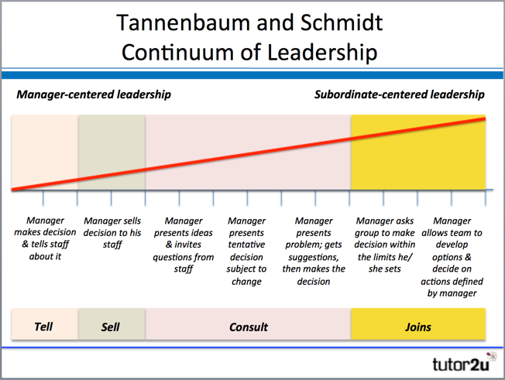

The Tannenbaum and Schmidt Continuum recognises that the chosen leadership style depends on a variety of factors, including the leader's personality, the perceived qualities of subordinates. It also allows for "situational" factors e.g. the need for urgency in leadership and decision-making.

The continuum represents a range of action related to the:

– Degree of authority used by the leader or manager

– Area of freedom available to non-managers

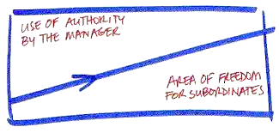

As the styles move from left to right, workers have more freedom or a greater voice in what is happening.

4 main styles of leadership are identified on the Continuum:

**TELLS**

The leader identifies problems, makes decision and announces them to subordinates; they then expect their decisions to be implemented

**SELLS**

The leader still makes a decision but attempts to overcome resistance from workers through discussion & persuasion

**CONSULTS**

The leader identifies problem and presents it to the group. They listen to advice and suggestions before making a decision

**JOINS**

Leader defines the problem and passes on the solving & decision-making to the group (which includes the leader / manager).

**Types of firm where each style might be seen:**

|  |  |  |
| --- | --- | --- |
| **Style** | **Example of firm** | **Reason** |
| **Tell** |  |  |
| **Sell** |  |  |
| **Consult** |  |  |
| **Join** |  |  |

# Blake Mouton Managerial Grid

The Blake Mouton Managerial Grid identifies five different leadership styles based on a grid.

The grid has two axes, measuring:

1. Concern for People (y-axis)
2. 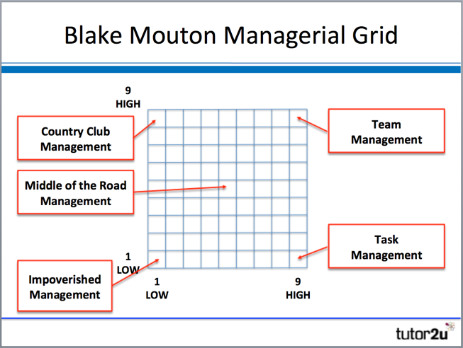Concern for Completing Task (x-axis)

Through a series of questions about their leadership and management style, the position on the Blake Mouton grid is mapped in terms of:

**Concern for People (High = 9 Low = 1)**

This is the degree to which a leader considers the needs of team members, their interests, and areas of personal development when deciding how best to accomplish a task.

**Concern for Task (High = 9 Low = 1)**

This is the degree to which a leader emphasizes concrete objectives, organizational efficiency and high productivity when deciding how best to accomplish a task.

Whilst someone's position could be anywhere on the grid depending on the relative importance he/she attaches to People and Task, the Blake Mouton Grid highlights five extremes on the grid - each of which is given a memorable name:

* Impoverished Management
* Country Club Management
* Task Management
* Team Management
* Middle of the Road Management

