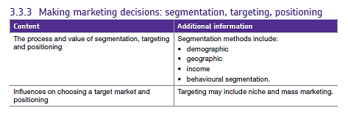3.3.3 Segmentation, targeting and positioning.

Market segmentation splits up a market into different categories (segments) to enable a business to better target its products to the relevant customers.

Segments are usually measured in terms of sales value or volume. Each segment will be a different size and have a different level of sales. In the diagram below, segment B is twice the size of segment C

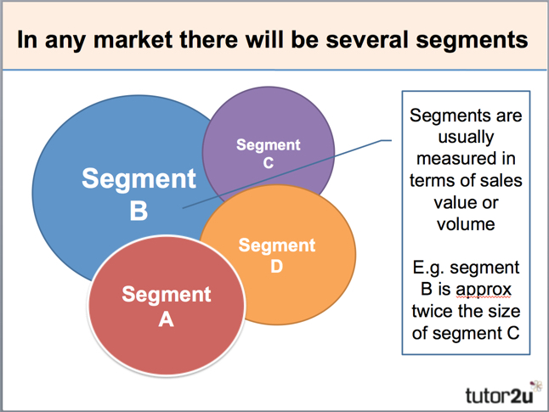

Why do businesses need to segment their markets? The answer is quite straightforward - because customers differ in many respects:

* The value / qualities they want
* Amount they are able to or willing to pay
* Media (e.g. television, newspapers, and magazines) they see
* Quantities they buy
* Time and place that they buy

## Market segmentation offers the following potential benefits to a business:

|  |  |
| --- | --- |
| Better matching of customer needs | Customer needs differ. Creating separate products for each segment makes sense |
| Enhanced profits for business | Customers have different disposable incomes and vary in how sensitive they are to price. By segmenting markets, businesses can raise average prices and subsequently enhance profits |
| Better opportunities for growth | Market segmentation can build sales. For example, customers can be encouraged to "trade-up" after being sold an introductory, lower-priced product |
| Retain more customers | By marketing products that appeal to customers at different stages of their life ("life-cycle"), a business can retain customers who might otherwise switch to competing products and brands. |
| Target marketing communications | Businesses need to deliver their marketing message to a relevant customer audience. By segmenting markets, the target customer can be reached more often and at lower cost |
| Gain share of the market segment | Through careful segmentation and targeting, businesses can often achieve competitive production and marketing costs and become the preferred choice of customers and distributors |

There are various methods (or "bases") a business can use to segment a market, here is a summary:

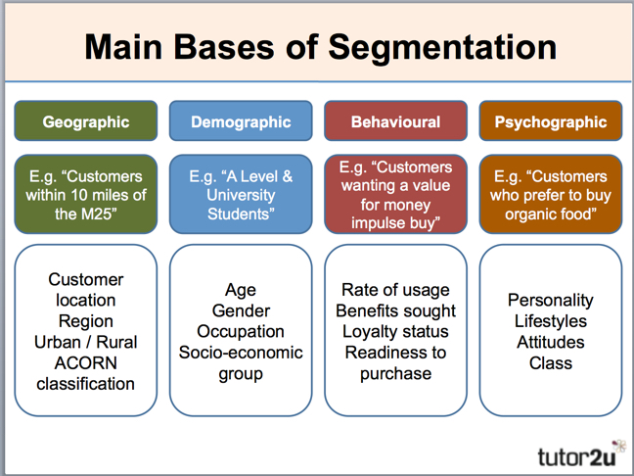

## Targeting

Once a business has identified segments, it will target those which it thinks will have greatest potential. For example, it must:

* Have sufficient demand and profit potential to justify investment. Some segments may be too small to make sufficient profits.
* Match the existing skills and competences of the business.
* Fit in with the existing brand image of the company.
* Have potential for the business to develop a strong competitive advantage in the market.

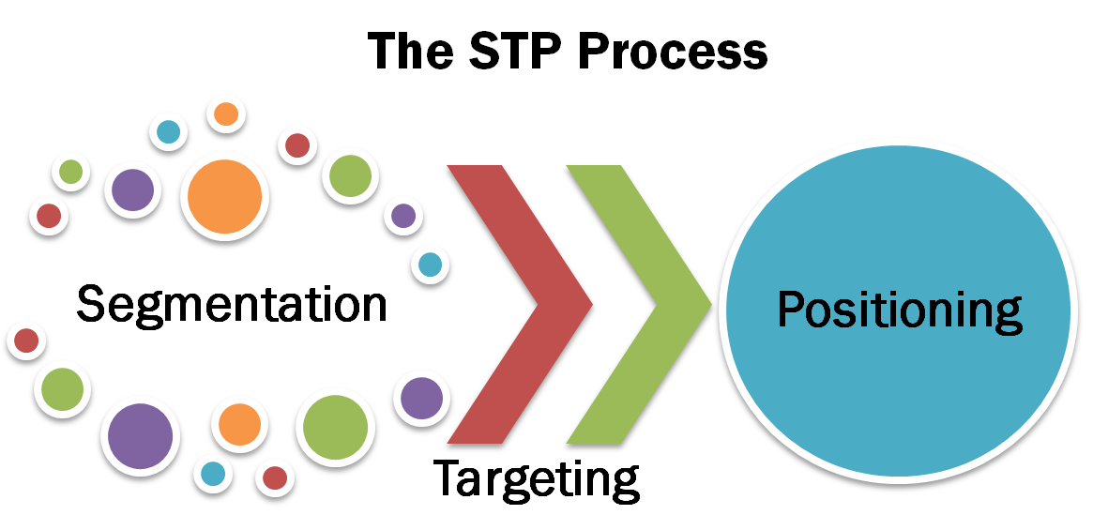

## Positioning

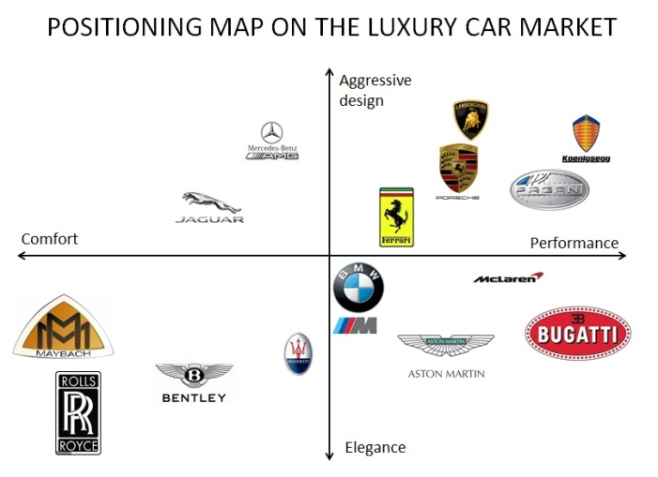Once a business has decided upon the segment it wishes to target, it must then establish itself amongst its competitors who may already be in the market. It does this by a process of *positioning* which involves *identifying the benefit and price combination of a product relative to others provided by competitors in the market.* The business needs to establish how their product is going to be perceived relative to other competitors. The company could use the perception map we have studied previously. For example:

The positioning of a product can be based features such as:

* Price
* The benefits the product or service offers to customers
* The brand image
* The level of service the company provides

The combination of such features relative to other competitors will determine how competitive the business is. For example, the business may charge more than competitors but it may offer more benefits, on the other hand, a business offering fewer benefits may combat this by charging a much lower price. However, if the business offers less or the same benefits as rivals BUT also charges a higher price, it will be uncompetitive!

Mangers will want to choose the combinations of benefits, prices to charge and where they want to position the business in the market relative to others who are already there. The greater the amount of benefits provided, the more expensive the product or service will be.

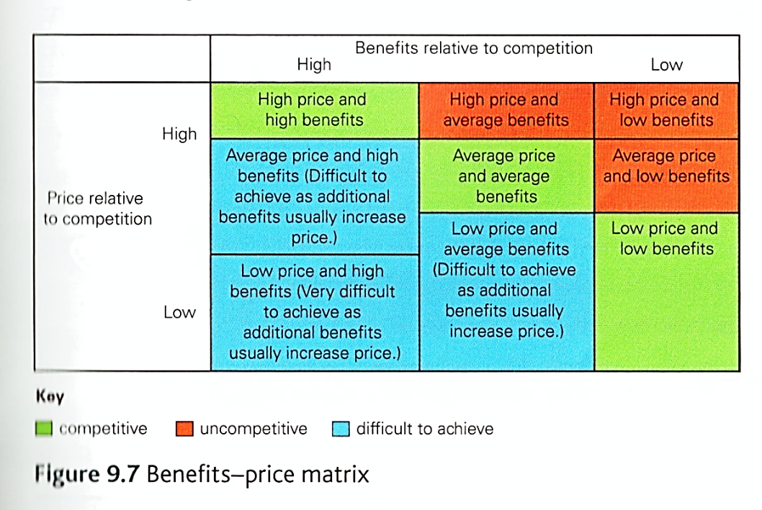

## Influences on positioning

* **The strength of the business** – for example, if the business is extremely efficient in production with high productivity, it may be in a good position to be a low price provider. If it is a large business, it may have good purchasing economies of scale. Companies such as Amazon have huge purchasing power over suppliers and this enables them to position themselves as a low price provider.
* **Innovative** businesses will have highly skilled employees, resources and systems geared to providing customers with greater benefits than rivals can. For example, Apple products are not cheap but the products are undoubtedly well designed and innovative with distinctive features.
* **Competition** in the market can influence the business significantly. The business may produce a market map with the intention of finding a gap in the market. If it chooses to target a gap in the market, it must have the necessary strengths to do this too.
* **Market conditions** are extremely important. External influences can be analysed using PESTLE analysis. For example, as the economy has begun to recover, the no-frills airline EasyJet has reconsidered their position in the market and has begun to offer more benefits to meet customer needs.

All aspects of the business’s marketing mix will then be focused on appealing to the particular target market:

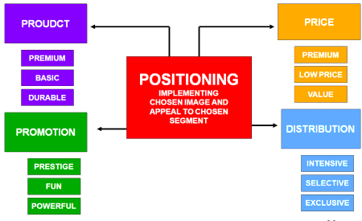

# Niche Markets and Mass Markets

The terms niche and mass refer to the size or a market and also how specialised it is. For example in the pen market, there are many different types of pen aimed at different groups of people.



Bic make pens which are aimed at the mass market and will be bought by many different types of customer.

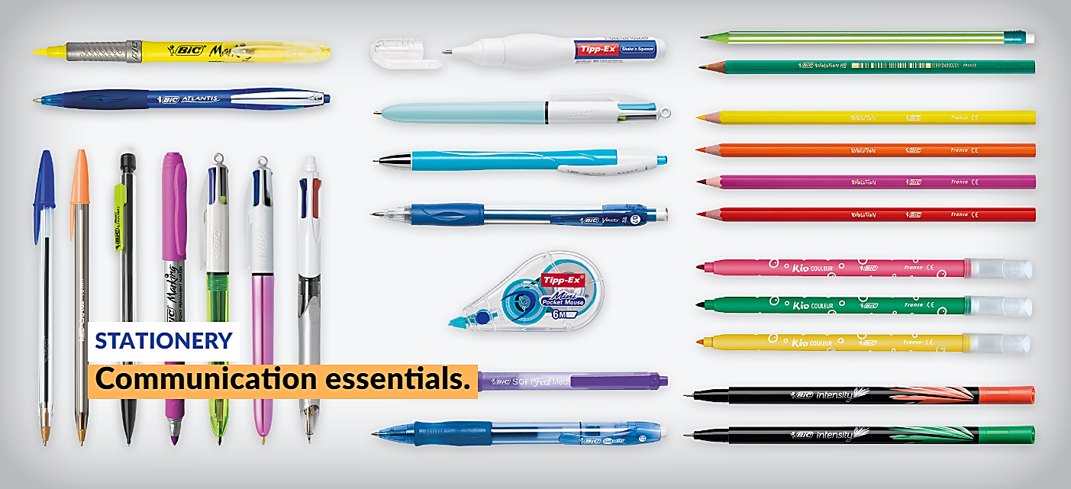

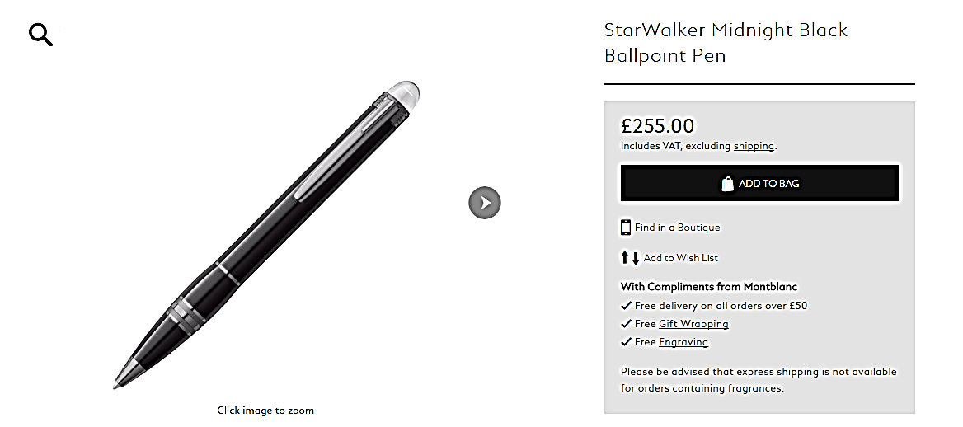On the other hand, Mont Blanc make a much smaller range of pens which are much more exclusive and expensive, they are in a niche within the pen market. These two firms are not in competition with each other because they target completely different types of customer. Although Mont Blanc do make ballpoint pens, their cheapest pen costs £255.

In most markets there is one dominant (mass) segment and several smaller (niche) segments. For example, in the confectionery market, a dominant segment would be the plain chocolate bar. Over 90% of the sales in this segment are made by three dominant producers – Cadbury's, Nestle and Mars. However, there are many small, specialist niche segments (e.g. luxury, organic or fair-trade chocolate).

## Niche marketing can be defined as:

**Where a business targets a smaller segment of a larger market, where customers have specific needs and wants**

Targeting a product or service at a niche segment has several advantages for a business (particularly a small business):

* Less competition – the firm is a "big fish in a small pond"
* Clear focus - target particular customers (often easier to find and reach too)
* Builds up specialist skill and knowledge and therefore market expertise which can give an advantage over competitors.
* Can often charge a higher price – customers are prepared to pay for expertise and exclusivity.
* Profit margins often higher
* Customers tend to be more loyal

The main disadvantages of marketing to a niche include:

* Lack of "economies of scale" (these are lower unit costs that arise from operating at high production volumes) as products are just made in small numbers
* Risk of over dependence on a single product or market
* Likely to attract competition if successful as they can see potential in the market
* Vulnerable to market changes – all "eggs in one basket" so if one market begins to decline the firm has no back-up plan.

## By contrast, mass marketing can be defined as:

**Where a business sells into the largest part of the market, where there are many similar products on offer**

The key features of a mass market are as follows:

* Customers form the majority in the market
* Customer needs and wants are more "general" & less "specific"
* Associated with higher production output and capacity (economies of scale)
* Success usually associated with low-cost operation, heavy promotion, widespread distribution or market leading brands