

**Higher IGCSE (9 – 1) Revision Pack**

**Standard Form**

**Name --------------------------------**

**Questions**

**Q1.**

(a)  Write   0.000451   in standard form.

...........................................................

**(1)**



(b)  Work out

Give your answer in standard form.

...........................................................

**(2)**

**(Total for question = 3 marks)**

**Q2.**

The table shows the diameters, in kilometres, of five planets.

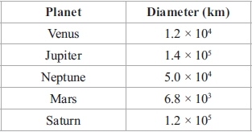

(a) Which of these planets has the smallest diameter?

...........................................................

**(1)**

(b) Calculate the difference, in kilometres, between the diameter of Saturn and the   
diameter of Neptune.  
Give your answer in standard form.

...........................................................km

**(2)**

The diameter of the Moon is 3.5 × 103 km.  
The diameter of the Sun is 1.4 × 106 km.

(c) Calculate the ratio of the diameter of the Moon to the diameter of the Sun.   
Give your answer in the form 1 : *n*

...........................................................

**(2)**

**(Total for question = 5 marks)**

**Q3.**

(a)  Write 7.9 × 10–4 as an ordinary number.

...........................................................

**(1)**

(b)  Work out (6.5 × 105) × (3.1 × 104)

Give your answer in standard form.

...........................................................

**(2)**

**(Total for question = 3 marks)**

**Q4.**

The table shows the land areas, in km2, of four countries.

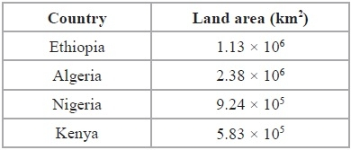

(a)  Which country has the largest land area?

...........................................................

**(1)**

(b)  Calculate the total land area, in km2, of all four countries.   
Give your answer in standard form.

........................................................... km2

**(2)**

Population density is calculated by the formula



(c)  In one year, the population of Ethiopia was 7.91 × 107  
Calculate the population density of Ethiopia for that year.

........................................................... people / km2

**(2)**

**(Total for Question is 5 marks)**

**Q5.**

*y* = 16 × 108*k* where *k* is an integer.   
  
Find an expression, in terms of *k*, for

Give your answer in standard form.

...........................................................

**(Total for question = 3 marks)**

**Q6.**

*I* = *kT*4

*k* = 5.67 × 10−8

*T* = 5800

(a)  Work out the value of *I*.   
       Give your answer in standard form correct to 3 significant figures.

*I* = ...........................................................

**(2)**

(b)  Rearrange the formula *I* = *kT*4 to make *T* the subject.

...........................................................

**(2)**

**(Total for question = 4 marks)**

**Q7.**

2.2 × 107 passengers passed through Beijing Capital International Airport in 2014.

(a)  Write 2.2 × 107 as an ordinary number.

...........................................................

**(1)**

950 000 tonnes of cargo traffic passed through Tokyo International Airport in 2014.

(b)  Write 950 000 as a number in standard form.

...........................................................

**(1)**

**(Total for question = 2 marks)**

**Q8.**

The table gives the populations of each of five countries in 2014

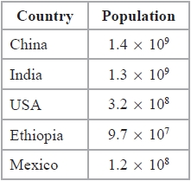

(a)  Write 9.7 × 107 as an ordinary number.

...........................................................

**(1)**

The population of Russia in 2014 was 140000000

(b)  Write 140000000 in standard form.

...........................................................

**(1)**

In 2014, there were more people living in China than were living in the USA.

(c)  How many more?

Give your answer in standard form.

...........................................................

**(2)**

In 2014, the population of India was *k* times the population of Mexico.

(d)  Work out the value of *k*.

Give your answer to the nearest whole number.

*k* = ...........................................................

**(2)**

**(Total for question = 6 marks)**

**Q9.**

(a)  *x* = 9 × 102*m* where *m* is an integer.

Find, in standard form, an expression for √*x*

...........................................................

**(2)**

(b)  *y* = 9 × 102*n* where *n* is an integer.

Find, in standard form, an expression for *y*

Give your answer as simply as possible.

...........................................................

**(3)**

**(Total for Question is 5 marks)**

**Q10.**

The table shows some information about the five Great Lakes in North America.

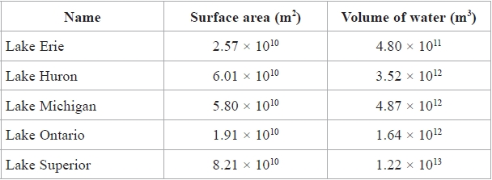

(a)  Work out the total surface area of the five Great Lakes.   
Give your answer in standard form.

........................................................... m2

**(2)**

Loch Ness is the largest lake in Scotland.   
The lake has a volume of water of 7.45 × 109 m3

The volume of water in Lake Superior is *k* times the volume of water in Loch Ness.

(b)  Work out the value of *k*.   
Give your answer correct to 3 significant figures.

*k* = ...........................................................

**(2)**

**(Total for question = 4 marks)**

**Q11.**

(a)  Write 0.000076 in standard form.

...........................................................

**(1)**

The area covered by the Pacific Ocean is 1.6 × 108 km2  
The area covered by the Arctic Ocean is 1.4 × 107 km2

(b)  Write 1.6 × 108 as an ordinary number.

...........................................................

**(1)**

The area covered by the Pacific Ocean is *k* times the area covered by the Arctic Ocean.

(c)  Find, correct to the nearest integer, the value of *k*.

*k* = ...........................................................

**(2)**

**(Total for question = 4 marks)**

**Q12.**

(a)   Write 1.2 × 10−5 as an ordinary number.

...........................................................

**(1)**

(b)   Work out      7.9 × 105 + 6 × 104  
Give your answer in standard form.

...........................................................

**(2)**  
**(Total for Question is 3 marks)**

**Q13.**

The mass of the Space Shuttle is 7.8 × 104 kilograms. 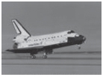

(a) Write 7.8 × 104 as an ordinary number.

...........................................................

**(1)**

The Space Shuttle docks with the International Space Station.  
The mass of the International Space Station is 4.62 × 105 kilograms.

(b) Calculate the total mass of the Space Shuttle and the International Space Station.   
Give your answer in standard form.

...........................................................kg

**(2)**

**(Total for question = 3 marks)**

**Q14.**

The table shows the diameters, in kilometres, of five planets

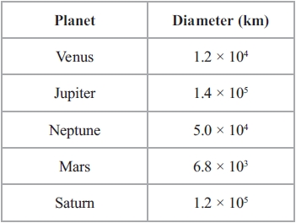

(a)  Write 1.4 × 105 as an ordinary number.

...........................................................

**(1)**

(b)  Which of these planets has the smallest diameter?

...........................................................

**(1)**

(c)  Calculate the difference, in kilometres, between the diameter of Saturn and the diameter of Neptune.

Give your answer in standard form.

........................................................... km

**(2)**

The diameter of the Moon is 3.5 × 103 km.   
The diameter of the Sun is 1.4 × 106 km.

(d)  Calculate the ratio of the diameter of the Moon to the diameter of the Sun.

Give your ratio in the form 1 : *n*

...........................................................

**(2)**

**(Total for question = 6 marks)**

**Q15.**

(a) Write as an ordinary number

(i) 4.2 × 106

...........................................................

(ii) 3.82 × 10−4

...........................................................

**(2)**

(b) Here are three numbers written in standard form.   
Arrange these numbers in order of size.  
Start with the smallest number.



...........................................................

**(2)**

**(Total for question = 4 marks)**

**Q16.**

(a)  Write 250 000 in standard form.

...........................................................

**(1)**

The radius of the planet Jupiter is 6.99 × 107 metres.   
The radius of the Earth is 6.37 × 106 metres.

The volume of Jupiter is *k* times the volume of the Earth.

(b)  Assuming that both planets are spheres, calculate the value of *k*.

Give your answer correct to 3 significant figures.

...........................................................

**(3)**

**(Total for question = 4 marks)**

**Q17.**

The table shows information about the oil production, in barrels per day, of five countries during one year.

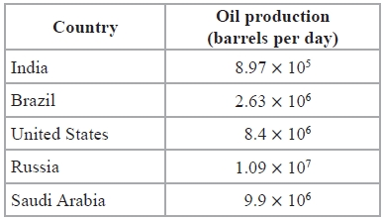

(a)  Which country had the highest oil production?

...........................................................

**(1)**

(b)  Calculate the difference between the oil production of Brazil and the oil production of India.   
Give your answer in standard form.

........................................................... barrels per day

**(2)**

During the same year, the oil production of California was 6.3 × 105 barrels per day.

(c)  Work out the oil production of California as a proportion of the oil production of the United States.

...........................................................

**(2)**

**(Total for question = 5 marks)**

**Q18.**

Rob is making a scale model of the Solar System on the school field.   
He wants the distance from the Sun to Jupiter to be 8 metres on his scale model.

The real distance from the Sun to Jupiter is 7.8 × 108 kilometres.

(a)   Find the scale of the model.   
Give your answer in the form 1: *n*, where *n* is written in standard form.

1: ...........................................................

**(3)**

Rob wants to put the position of a space probe on the scale model.   
The real distance of the space probe from the Sun is 1.9 × 1010 kilometres, correct to 2 significant figures.

(b)   Work out the maximum distance of the space probe from the Sun on the scale model.   
Give your answer in metres.

........................................................... m

**(3)**

**(Total for Question is 6 marks)**

**Q19.**

The table shows the population of each of three countries in 2012.

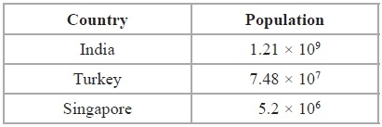

(a)  Find the total population of India, Turkey and Singapore in 2012.   
Give your answer in standard form.

...........................................................

**(2)**

Population density is calculated by the formula

Population density = Population ÷ Land area

The land area of India is 3.29 × 106 km2

(b)  Calculate the population density of India in 2012.   
Give your answer correct to 3 significant figures.

........................................................... people/km2

**(2)**

**(Total for Question is 4 marks)**

**Q20.**

Find, in standard form, an expression for x2.  
Give your expression as simply as possible.

...........................................................

**(Total for question = 3 marks)**

**Q21.**

(a) (i)  Use your calculator to work out the value of

Write down all the figures on your calculator display.

...........................................................

(ii)  Write your answer to (a) (i) correct to 3 significant figures.

...........................................................

**(3)**

(b)  Work out

Give your answer in standard form.

...........................................................

**(2)**

**(Total for question = 5 marks)**

**Q22.**

*m* = 8 × 109*n* where *n* is an integer.

Express  in standard form.   
Give your answer, in terms of *n*, as simply as possible.

...........................................................

**(Total for question = 3 marks)**

**Mark Scheme**

Q1.

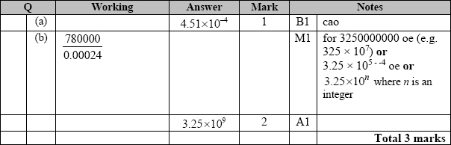

**Q2.**

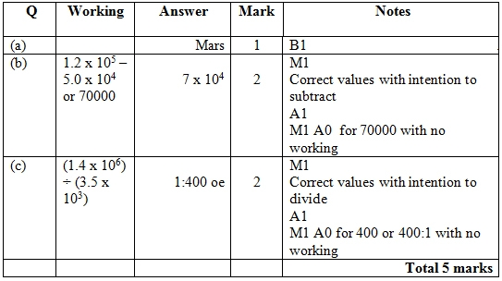

**Q3.**

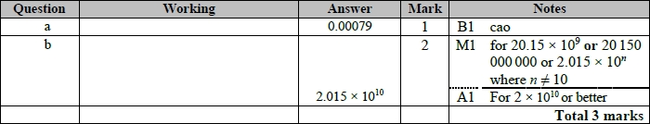

**Q4.**

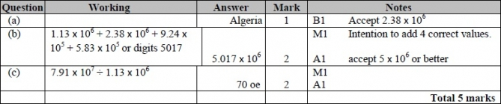

**Q5.**

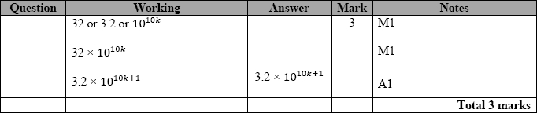

**Q6.**

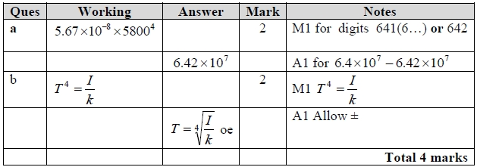

**Q7.**

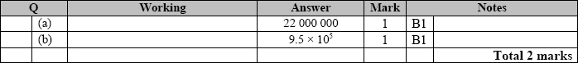

**Q8.**

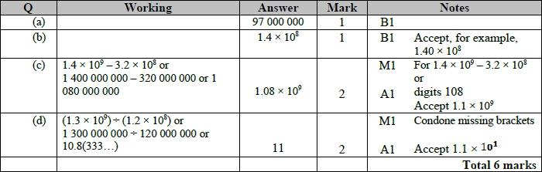

**Q9.**

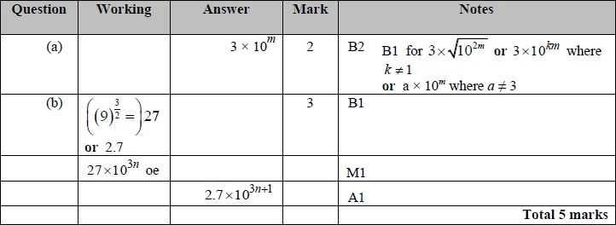

**Q10.**

The correct answer, unless clearly obtained by an incorrect method, should be taken to imply a correct method.

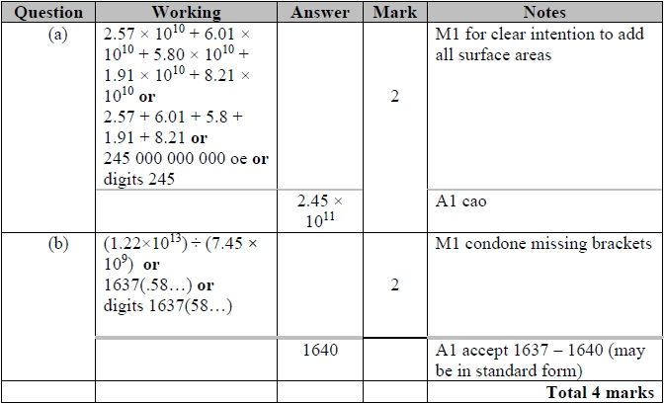

**Q11.**

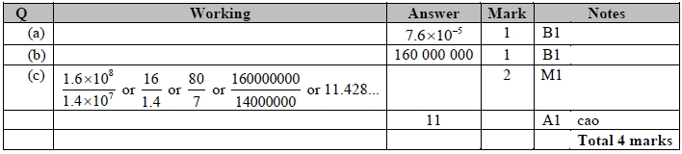

**Q12.**

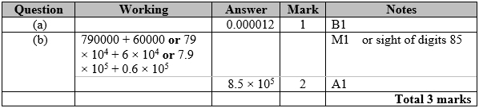

**Q13.**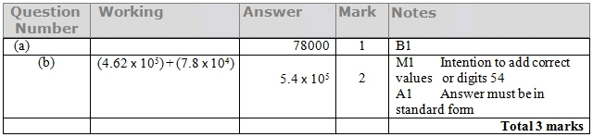

**Q14.**

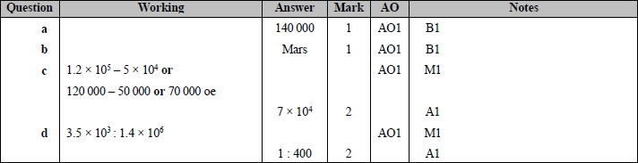

**Q15.**

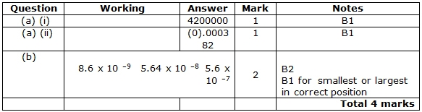

**Q16.**

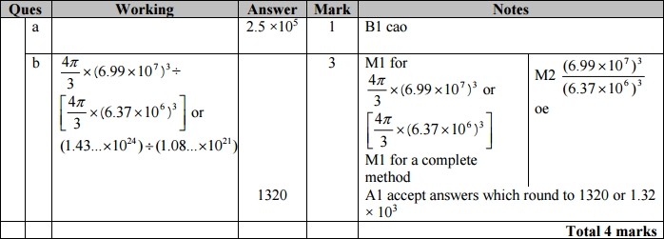

**Q17.**

The correct answer, unless clearly obtained by an incorrect method, should be taken to imply a correct method.

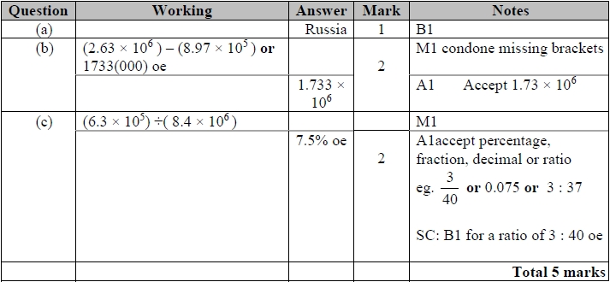

**Q18.**

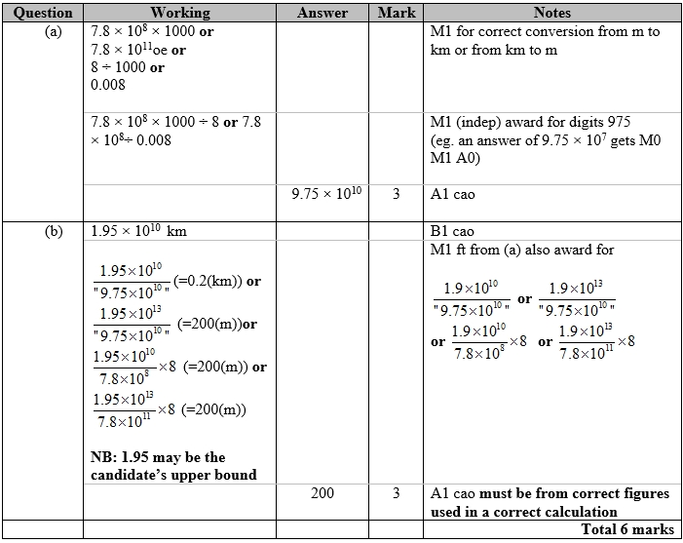

**Q19.**

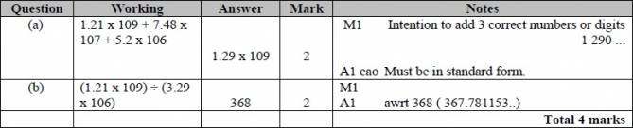

**Q20.**

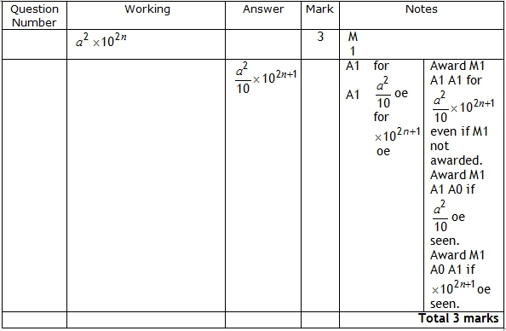

**Q21.**

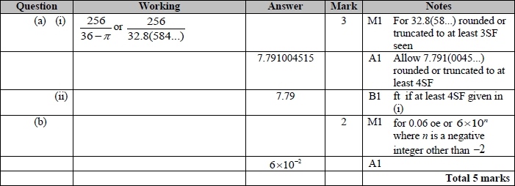

**Q22.**

