3.10.3 Strategic implementation

(Including Network analysis (aka Critical Path)

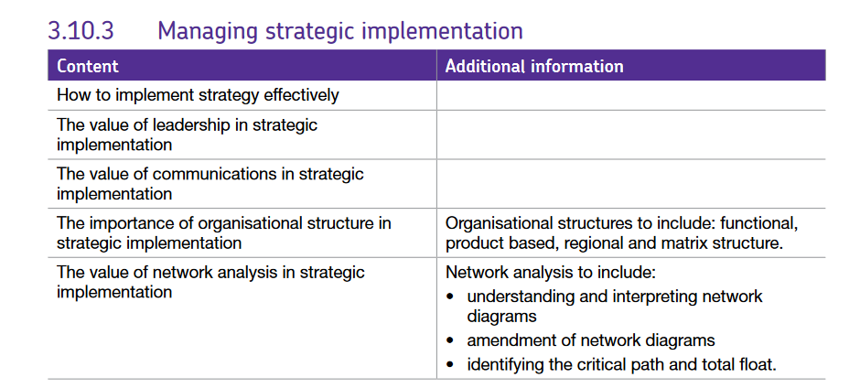

## How is strategy implemented?

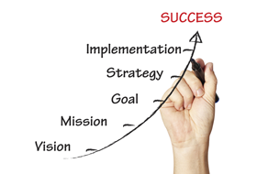Strategic implementation involves creating a framework for carrying out the strategy agreed at both corporate and functional levels by assigning responsibilities and operational targets. While most organisations create a strategic plan, they are not all successful in implementing it. Research suggests that about 70% of strategic plans and strategies are never implemented. Understanding which factors, whether external or internal, has the greatest impact on the effective implementation of a strategy, allows a business to respond more quickly and effectively if these factors change.

**The strategic planning processes**

**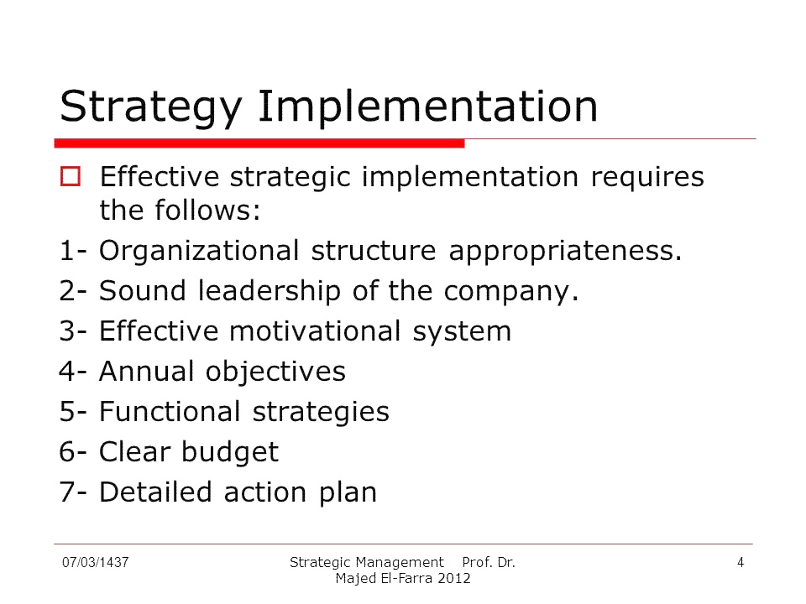**

Firstly, the strategic plan must be formulated and in order to do this, several steps must be followed. The senior managers must identify the mission and goals of the organisation. A SWOT analysis must then be completed before strategies are put together. Once implemented, the strategies must be reviewed and implemented.

Implementing strategy involves using a structured format or framework to assign targets and responsibilities and therefore complete a task. CPA can often be part of a firm’s strategic implementation plans.

There are various factors which affect the likely success of strategic planning, these might include:

* Changes in the external environment (PESTLE)
* Changes to the competitive environment (Porter’s five forces)

These are both factors in the external environment but there are also internal factors:

* **Leadership style** – is there strong leadership (**not** is it autocratic, but is it clear)?

Leaders set and communicate strategy to their staff who implement it to get results. It is important that employees feel the change is going to happen and that their work needs to be efficiently completed so that a strategy can be implemented. For example if a firm is going to bring in a new IT system, staff may need to book themselves onto training courses at suitable points, if they don’t realise the importance of this they may delay it and the systems may be brought in whilst some staff are still unable to use them. Managers would be responsible for overseeing this.

Leaders must demonstrate commitment to strategy, they are likely to be involved in setting strategy, communicating the strategy and implementing the strategy. If leaders do not invest time in this way, the strategy is unlikely to be successful. Leaders need to help employees understand how the company could benefit from the change the strategy will involve for the organisation.

* **Organisational structure** – is the structure suitable for supporting change and implementing strategy and is it supportive of change i.e. are there sufficient resources? Can a decision be made within a suitable amount of time?

For example - in a centralised structure the Head office can dictate how strategies are followed and when the most experienced people can make the decisions, and this should reduce the risk of failure. However, there is little flexibility and it can take a long time for decisions to be rolled out across the company, people in regional offices may feel demotivated by their lack of input.

* **Communication** – **The value of communication in strategic implementation**

Strategy is usually developed by the senior leaders and managers in the organisation and this represents a problem. Detailed knowledge about the strategy, the research behind it and the expected impact is only really known and understood by ‘a few’ yet it must be implemented by everyone. Regardless of how well researched and well planned the strategy is, if it is not communicated well to the employees, then it will fail. Communication is essential to overcome resistance and it needs to reach every level of the organisation.

**The importance of organisational structure (including functional, product based, regional and matrix structures) in strategic planning**

The organisational structure is likely to be determined by many factors such as the organisational culture, the size of the business, leadership and management, the type of product or service the business produces and the market it is in.

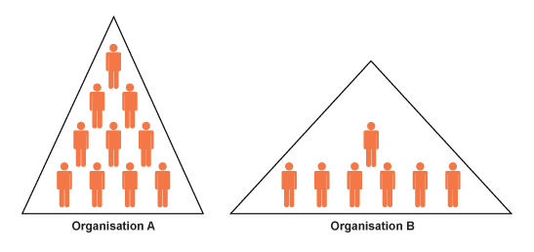Structure is not just about an organisational chart, it is also about the people, the positions, procedures, processes, culture, technology and related elements that make up the organisation. For example, a strategy may be implemented which successfully delivers higher sales but if the rest of the organisation has not expanded and restructured to cope with the increase in work this will entail, ultimately the strategy will fail.

Overall strategic plans will be broken up into functional plans, such as a marketing plan, an operations plan and a HR plan. In this sense, a clear organisational structure with clear functional responsibility should assist strategic implementation.

Where strategic implementation requires a focus on products or geographical regions, **product-based** or **regional organisational structures** may be more appropriate.

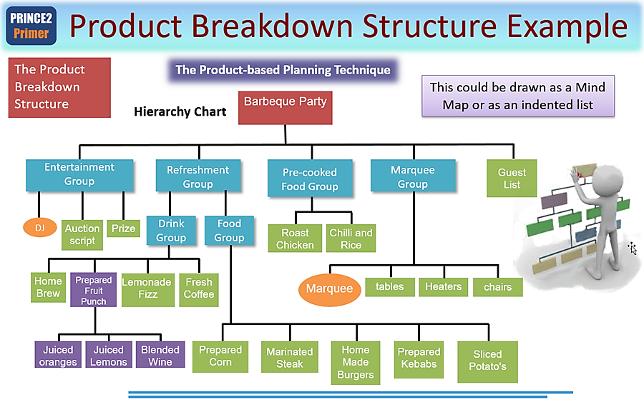For example, if a business has quite distinct product lines and the strategic implementation applies to just one product line, then a product-based structure would help strategic implementation.

Likewise, if a company is operating in many different countries, then a regional organisational structure would help in strategic implementation.

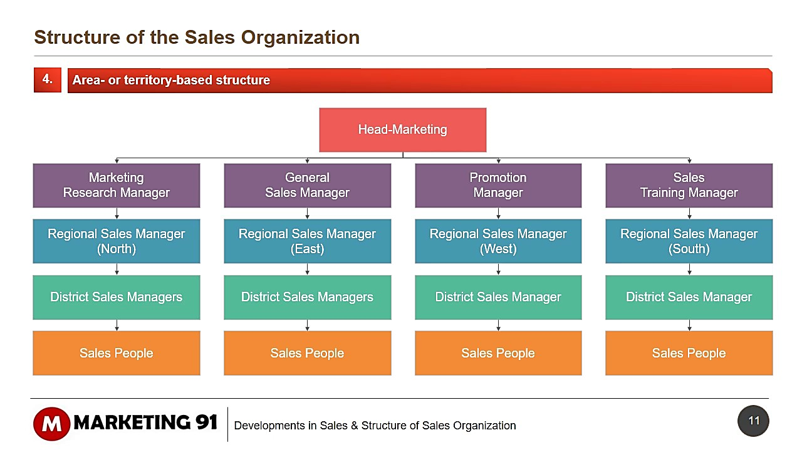

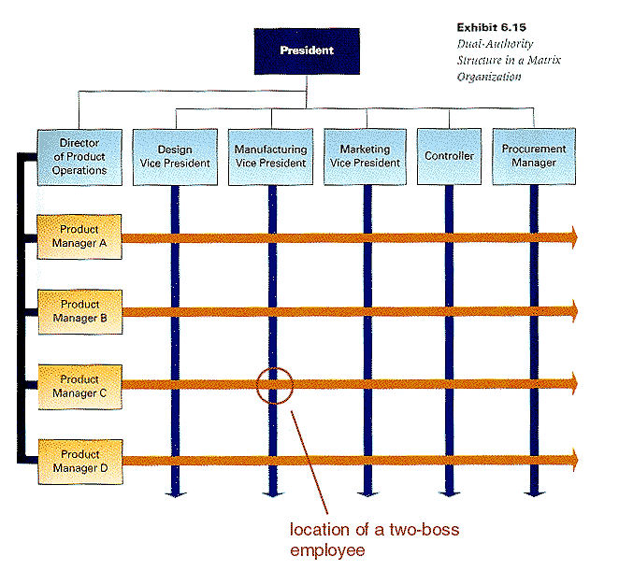Where strategic implementation cuts across traditional functional areas, the more flexible approach of the matrix structure would help. For example, strategic implementation might involve a range of new product developments and teams of employees consisting of engineers, marketing personnel, designers and accountants.

There are also other factors to consider which will be specific to each firm, these include:

* Timing – are there lots of changes taking place at the same time – might there be resistance to change? Are employees used to change and can cope with it?
* Adequate resourcing – financial – capital and equipment, staffing (including training and rewards.
* Planning (CPA) (network analysis which we will come onto next.
* Monitoring and accountability – who is responsible for delivering the outcomes and at which level?
* Reviewing and evaluating

Network analysis.

Network analysis shows how activities can be divided into their component tasks and how these can be scheduled – it’s a planning tool for completing projects. This information is displayed on a **critical path (or network) diagram**

In any job there are individual tasks, some can happen simultaneously while others happen sequentially. This means there are some tasks which can be delayed without changing the completion time of the whole job but others, if started late, will mean the total completion time is longer.

Tasks which can’t be delayed are said to be on the **critical path**, knowing which tasks are critical allows a firm to measure the available ‘spare time’ where some tasks could be delayed.

For example, a decorator may put off going to buy gloss paint until he has painted on the undercoat because he can go and buy the gloss while he waits for the undercoat to dry – it is a simultaneous activity and delaying it won’t affect the time for completing the whole job…

A critical path diagram is made up of

1. **Nodes**

These show where activities (tasks) begin and end. They are used to join activities together.

**2**

**3**

3

Node number

EST

(Earliest start time of next activity)

LFT

Latest finishing time of this activity)

1. **Activities**

These are shown between nodes and with the duration of the activity under the line (usually in hours, minutes, days or weeks).

Activity ref or name

**2**

**3**

3

**3**

**7**

7

**B**

**3**

Activity / task duration

This information allows firms to allocate their resources most effectively to meet their current needs e.g. if they get a rush order they can re-allocate workers who are not currently being used and move them back when they must complete their tasks. This means that workers are not "hanging around" waiting for some-one else to do their job first…

## Critical path - an example

|  |  |  |  |
| --- | --- | --- | --- |
|  |  | Duration (weeks) | Previous activity |
| A | Plan and advertising campaign | 4 | - |
| B | Make a poster | 6 | A |
| C | Make a TV advert | 7 | A |
| D | Test market the of poster | 8 | B |
| E | Test suitability TV advert | 10 | C |
| F | Present campaign to board of directors | 9 | D and E |
| G | Tell other workers about campaign | 5 | D, E and F |

Activities don't always take place one after the other, sometimes they can take place at the same time. This column shows which activities follow each other.

## How do we put this onto a diagram?

The basic diagram would look as follows.

We know that activities B and C are simultaneous because they both follow activity A.

We know that D and E are simultaneous because they follow B and C respectively.

**1**

**0**

**6**

**30**

**7**

**35**

**2**

**4**

**3**

**10**

**4**

**11**

**5**

**21**

**A**

**4**

**B**

**6**

**D**

**8**

**E**

**10**

**C**

**7**

**F**

**9**

**G**

**5**

Here the earliest stat times have also been added. Task F cannot start until 21 weeks because task E (which must precede it) will not be completed until that time.

In this second diagram we can see that the latest finishing times have been added.

**1**

**0**

0

**6**

**30**

30

**7**

**35**

35

**2**

**4**

4

**3**

**10**

13

**4**

**11**

11

**5**

**21**

21

**A**

**4**

**B**

**6**

**D**

**8**

**E**

**10**

**C**

**7**

**F**

**9**

**G**

**5**

**||**

**||**

**||**

**||**

**||**

**||**

The Critical path is shown where the EFT and LFT are equal A C E F G

– shown by through the activity lines

## So, where is the spare time? Which activities can be delayed and by how long?

The critical path does not include activities D and E, so they are the activities which can be delayed, but by how much? To work this out we need to calculate something called "Float".

### Float time.

This is the total amount of free time within the job. It is calculated with this formula: **LFT - (EST + Duration),** so the float can be calculated as shown below…

|  |  |  |
| --- | --- | --- |
| Activity | Formula | Float |
| A | 4 - (0+4) | 0 |
| B | 13 - (6+4) | 3 |
| C | 11 - (7+4) | 0 |
| D | 21 - (8 + 10) | 3 |
| E | 21 - (10 + 11) | 0 |
| F | 30 - (9 + 21) | 0 |
| G | 35 - (5 + 30) | 0 |

**DO NOT ADD THE FLOAT TIMES TOGETHER, THE FLOAT IS THE HIGHEST NUMBER YOU CAN SEE.**

Total float therefore = 3. The activities which can be delayed are B and D.

## the_critical_path.pngEvaluating network analysis or CPA

The main advantages and disadvantages of a business using CPA can be summarised as follows:

**Benefits of network analysis (critical path analysis or CPA)**

* Network analysis allows a business to improve the efficiency of its resources. If a business can reduce the time taken to complete the project, it can achieve cost savings.
* It helps the business know precisely when activities are scheduled to take place. This assists the business in its resource planning and stock ordering.
* A business can use CPA to divert resources from non-critical activities to critical activities. In doing this, it might be possible to reduce the completion of the project even further.
* CPA can help the business to monitor and review the project.
* It forces managers to undertake detailed planning.
* If delays happen, CPA can be used to identify what the impact of these changes are likely to be.
* The technique identifies the critical path and the business can then focus attention of these particular activities.
* It can be used alongside lean production because the focus of CPA is using time and resources efficiently.

**Problems of using network analysis (critical path analysis)**

* Managers might be inflexible and rigidly stick to the timing in the CPA. They may miss opportunities to reduce the overall time of a project by failing to recognise the importance of non-critical activities.
* Any delay in the network can have serious consequences if the business has employed contractors and subcontractors. These businesses might not be in a position to wait until their services are needed because they have commitments elsewhere.
* Complex activities might be difficult to represent accurately on a network diagram.
* CPA is based on time estimates for ESTs and LFTs. These may not be accurate. This is especially the case if the person completing the network is inexperienced or the project itself, or aspects of it, are unfamiliar to the business.

# June 2007 6131

Construct a critical path network diagram for the ‘long-haul project’, using the information in **Appendix B**. Insert all earliest start times and latest finish times. *(10 marks)*

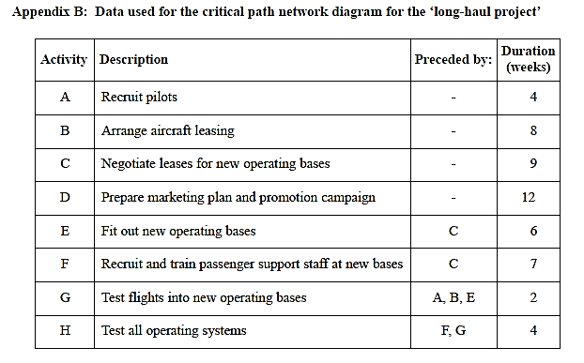

# June 09 6131

Draw the network diagram for the **Commuter Bus Project** based on the data in **Appendix A** and indicate the critical path. *(8 marks)*

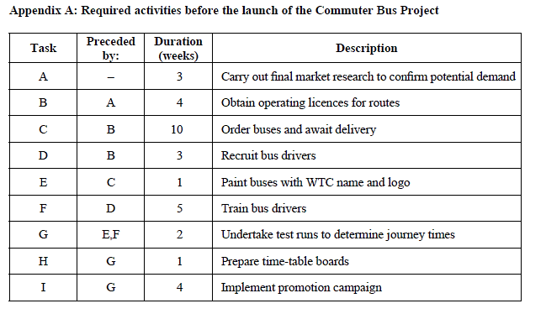

# June 06 6131

A petrol retailer is looking to open several new branches of its business. The location of the new sites would be crucial to their success and the firm has hired consultants who used quantitative decision-making techniques, as well as considering qualitative factors, before making their proposals for the three locations.

Timing is important for the company’s cash flow, as the sooner these service stations and high-quality convenience stores open; the faster the payback would be on the project. Network analysis (**Appendix B**) suggested that the duration of the critical path for redeveloping the sites would be 14 weeks.

Refer to the network diagram in **Appendix B**.

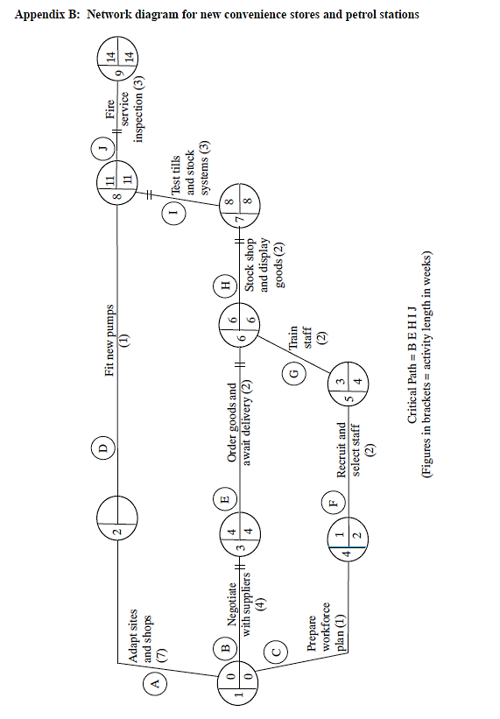(i) State the earliest start time and latest finish time at node 2. *(2 marks)*

(ii) Calculate the total float time on activities D and F. *(4 marks)*

(iii) Assume that there is a delay of two weeks in completing activity F. Analyse **one** action that the Operations Manager could take to avoid exceeding the current length of the critical path. *(4 marks)*