Gender and crime



Specification Content:

What you need to know for **Crime and Deviance**  in your Paper 3 exam.

* crime, deviance, social order and social control
* the social distribution of crime and deviance by ethnicity, gender and social class, including recent patterns and trends in crime
* globalisation and crime in contemporary society; the media and crime; green crime; human rights and state crimes
* crime control, surveillance, prevention and punishment, victims, and the role of the criminal justice system and other agencies.

|  |  |  |  |  |  |
| --- | --- | --- | --- | --- | --- |
| **Questions may be based specifically on the following areas:** | | Do I have completed Notes? | Have I made revision Notes? | Have I memorised this info? | Have I practised exam style questions? |
| Social distribution of crime and deviance by gender, including recent patterns and trends and different explanations for these | * Feminism * Chivalry Thesis * Sex role theory * Social control * Liberation thesis |  |  |  |  |
| Sociologists you must know | * Pollak * Heidenson * Carlen |  |  |  |  |

Exam Structure:

|  |
| --- |
| **These topics will appear in paper 3 of the A’Level.** 2 hour written exam 80 marks in total (50 for this bit)   * 33.3% of A-level   Crime and Deviance: short answer and extended writing, 50 marks (4 marks, 6 marks, 10 marks, 30 marks) |

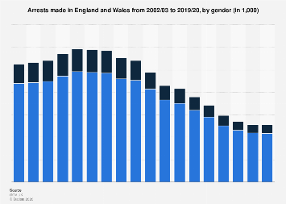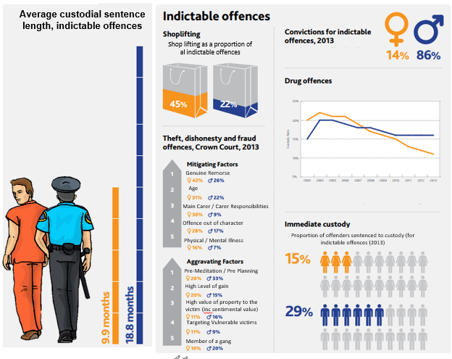

Sum arise the trends in these statistics.

**Patterns and Trends:**

In 2008, the Ministry of Justice reported that, compared to white people:

* Afro Caribbeans were:
  + more likely to be arrested for robbery;
  + three times more likely to be cautioned by the police;
  + three and a half times more likely to be arrested; if arrested, more likely to be charged and face court proceedings than to receive a caution;
  + more likely, if found guilty, to receive a custodial (prison) sentence;
  + five times more likely to be in prison.
* Asians were:
  + twice as likely to be stopped and searched (mainly for drugs);
  + more likely to be charged and face court proceedings than to receive a caution;
  + more likely to receive a custodial sentence if found guilty;
  + more likely to be arrested for fraud and forgery.
* In 2007, 26 per cent of male prisoners and 29 per cent of females were from black and minority ethnic groups (they make up about 9 per cent of the general population).

These patterns, shown in contemporary official statistics, reflect a pattern that first emerged in the 1970s, suggesting what appear to be higher levels of criminality among some minority ethnic groups, particularly the black population.

[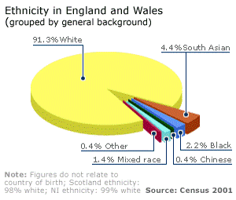](https://hecticteachersalevelsociologysite.files.wordpress.com/2015/08/picture4.gif)

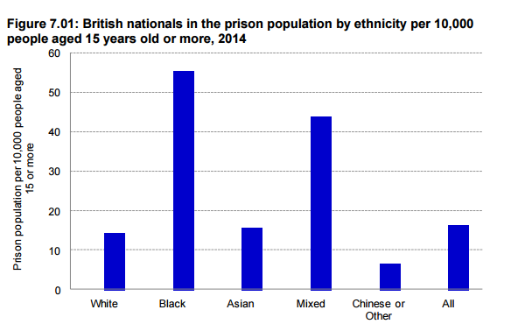

How might you explain these trends?

**Difference in Gender and Crime – possible explanations.**

There is so little female crime that much criminology and sociology has ignored it and focussed exclusively on men.

**Do women commit more crime that the statistics suggest?**

Where have we met the idea that our statistics may be wrong before?

Maybe the statistics underestimate female crime.

Because typical ‘female’ crimes are less likely to be reported. Shoplifting may not be noticed or reported in contrast to male violent or sexual crimes. Prostitution is also unlikely to be reported by either party.

Women may be less likely to be prosecuted.

**Another explanation – the chivalry thesis**

This is the claim that most criminal justice agents are men and they are socialised to act in a chivalrous way towards women.

Otto Pollak *‘Men hate to accuse women and thus send them to their punishment, police officers dislike to arrest them, district attorneys to prosecute them, judges and juries to find them guilty and so on.’* Men are socialised to be protective of women.

So the criminal justice system is more lenient with women, women are less likely to be arrested and are treated more fairly if they are arrested.

**Self-reported studies** these ask individuals to disclose their own dishonest and violent behaviour. These suggest that women are treated more leniently. Graham and Bowling found that men are more likely to offend but the difference is smaller than recorded in official statistics. They found men are 2.33 times more likely than women to commit a crime whereas official statistics suggest this figure is 4 times more likely. Flood-Page et al found that 1 in 11female self-reported offenders had been cautioned or prosecuted in contrast to 1 in 7 men.

[This Photo](http://snehabhatsepo.blogspot.com/2009/12/mcps-male-chauvinist-pig.html) by Unknown Author is licensed under [CC BY-NC-ND](https://creativecommons.org/licenses/by-nc-nd/3.0/)

**Official statistics** court statistics appear to support the chivalry thesis

**BUT** The Chivalry thesis has been criticised – some sociologists argue that women’s crimes are less serious (for example they are less likely to be violent) which is why they are punished less harshly than men. Women also often show remorse which means they are likely to be treated more leniently.

**Feminists say that** women are treated more harshly when they deviate from gender norms,

What does society expect of women and why might society treat them more harshly when they are not like this?

Feminists claim that double standards exist as society is patriarchal. Consider rape cases. Male judges may make sexist, victim blaming remarks.

Judge Wild said *‘Women who say no do not always mean no. It is not just a question of how she says it, how she shows and makes it clear. If she doesn’t want it she only has to keep her legs shut.*

Sandra Walklate argues that in rape cases it is not the defendant who is on trial but the victim. She has to prove her respectability in order to have evidence accepted.

Heidensohn suggests that while women are less likely to commit serious offenses, those who violate accepted patterns of behaviour are treated more harshly by the courts and may get harsher punishments than men. This is called double jeopardy – the are on trial for what they have done and are on trial for the extent to which they conform to female norms (warm, kind, caring relationships with others, mothers, daughters, partners)

CJS is patriarchal – run by men

* **Pat Carlen (1997)**argues that when women are jailed, it is less for the seriousness of their crimes and more according to the court’s assessment of them as wives, mothers and daughters. E.g. Scottish judges were much more likely to jail women whose children were in care than women who they saw as good mothers.

The ’evil woman’ theory looks at what happens when a woman is sexually promiscuous, a neglectful mother or violent. They are seen are really bad and doubly deviant.

Conclusion

It is difficult to conclude as generally women commit less serious crimes which is the most likely reason for them receiving more lenient sentences.

Recap – how can patriarchy be used to suggest bias in favour of women and bias against women in crime?

**Sex Role Theory – Functionalists (p107)**

How are boys and girl brought up? Think about early socialisation.

Parsons looks at the traditional nuclear family claiming that boys reject traditional feminine models of behaviour. How do boys try to be instead?

Why might this lead boys committing more crime?

How might this theory be criticised?

* Parsons (1937) argued that because females carry out the ‘expressive role’ in the family which involved them caring for their children and looking after the emotional needs of their husbands, that girls grew up to internalise such values as caring and empathy, both of which reduce the likelihood of someone committing crime simply because a caring and empathetic attitude towards others means you are less likely to harm others.
* The child caring role also means that women are also effectively more attached to their families and wider communities than men – It is traditionally women who keep in touch with relatives and get to know their children’s friends families and thus bond local communities together. In terms of bonds of attachment theory, women are thus more attached to wider society and thus less likely to commit crime.
* Similarly, because traditional female gender roles involve women being busier than men, especially since they have taken on the ‘dual burden’ and ‘triple shift’ in recent decades, this reduces the opportunities for women to commit crime.
* It has long been theorized that the early socialization of boys into traditional masculine identities is at least partly responsible for the higher male crime rate. Sociologist Sutherland (1960) stated this very simply by saying that ‘boys are taught to be “rough and tough,” which makes them more likely to become delinquent’. Talcott Parsons (1964) purported that masculinity was then internalized during adolescence, which led to boys engaging in more delinquent behavior than girls, and sub cultural theorists Cloward and Ohlin (1960) proposed that in gangs, younger members learn through contact with older males that traits such as toughness and dominance are necessary in order to assert a strong masculine reputation.
* One possible criticism of sex-role theory is that it is less relevant in today’s society because of the decline of traditional gender roles

**Social Control**

Do parents treat boys and girls differently? How might this explain crime?

Where else do women suffer control, how might this restrict their ability to commit crime?

**Heidensohn** suggests that women have less opportunity than men to commit crime. We live in a patriarchal, male dominated society so women can’t commit fraud for example as do not have access to large sums of money so female crimes are more related to the home (eg shoplifting).

BUT? (p108)

* Carlen also argues The feminist perspective views crime as rational. The behaviour of women can be understood in the context of patriarchal society. Women are born, bred and raised in a society where men are in charge.
* **Pat Carlen (1990)** – argued that due to the ‘class deal’ (material rewards) and the ‘gender deal’ (rewards from fulfilling roles), women are encouraged to conform to society’s norms and values.
* Most women just accept these deals and conform to society; they don’t want to commit crime because they have too much to lose, and so these deals prevent women from committing crime.
* Carlen also suggested that female crimes are crimes of the powerless from the women who have not been offered these deals (such as being unrewarded in the family and workplace) and so can’t receive the rewards.
* Therefore women commit crime as an alternative rational choice, for example shoplifting is an ‘easy’ alternative.
* Evaluation of Carlen
* (-) The theory is based on a study of only 39 participants, which may be too small of a sample size to make such generalisations.
* (-) The theory suggests that women deviate from their social norms due to feeling unrewarded, but this doesn’t fit with the control theory

**Liberation Thesis – growing female criminality**

Perhaps society is becoming less patriarchal which may suggest female crime will increase.

1957 men were responsible for 11 times more crimes than women. 2014 the ratio was 3:1

**Adler** argues that women’s offending behaviour is changing. Women have more freedom and independence and are becoming more successful than men in education. Traditional forms of control on women are weakening. Young women spend more of their leisure time on the streets so are more visible to surveillance and social control agencies like the police. This will lead to more female white collar crime. This can be supported by media coverage of girl gangs and suggestions that young women are more willing to take risks.

Criticisms of this theory?

**So why do men commit crime?**

Masculinity and crime

Explain how Messerschmidt sees crime and deviance as resources that different men may us for accomplishing masculinity.

1. White middle class youths
2. White working class youth
3. Black lower working-class youths

Criticisms of Messerschmidt

**How can globalisation and de-industrialisation be used to explain crime?**



**Eye on the exam…..**

**Some Gender questions related to Crime and Deviance**

**Outline 2 – 4 marks**

Outline two differences between the recorded patterns of male and female offending.

Outline two differences between the liberationist perspective on female crime on the ideas of Pat Carlen

**Outline 3 – 6 marks**

Outline three reasons why females may be less likely than males to commit crimes

Outline three ways in which it has been suggested that may be gender bias in the criminal justice system

**10 marker Applying material from Item A outline and explain TWO…….. –10 marks**

**Item A9**

*Most criminals are men. The most consistent findings of research into crime in different societies and over many decades is that there is a clear link between crime and masculinity. However, the kind of crimes committed there is between different groups of men. So to does what counts as being a ‘real man’ and the resources to achieve it. Changes over time in the economy and the employment structure -such as deindustrialization for example -may also affect men’s opportunities to express their masculinity.*

Applying material from item A9, analyse two reasons why men commit crime.

**Question Type 3: Using material from the item and your own knowledge, evaluate the view…. –30 marks**

**Item B6**

*Statistics showing that women commit less crime than men. Some suggest that this may be because women are treated more leniently by the criminal justice system, and so are less likely to have their offences recorded. others suggest it is because of different gender roles, which leads more men into crime, and women to commit fewer and less serious offences.*

Applying material from item B6 and your own knowledge, Evaluate sociological explanations for gender differences in the patterns of crime.