**3.2.1 Periodicity**

**The structure of the periodic table**

The periodic table is a list of all the elements in order of **increasing atomic number**. The properties of an element can be predicted from its position; it can help **explain the similarities of elements** and the **trends in their properties**.

The elements on the periodic table have been written in many forms, the arrangement familiar to most was thought of by the Russian scientist Dimitri Mendeleev.

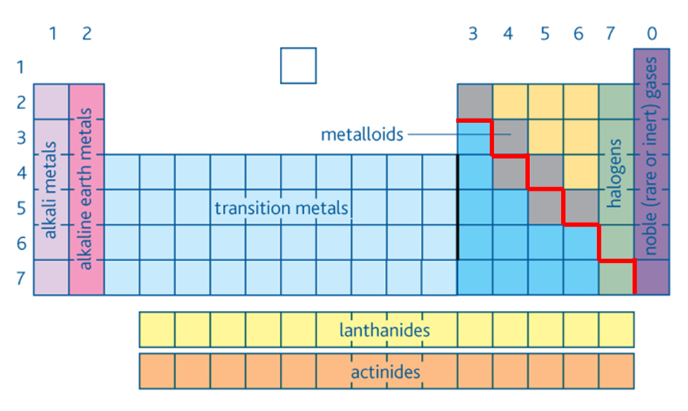

Some areas of the periodic table are given names. The **metals** are on the **left** and **non-metal** on the **right**. Elements which touch the dividing line have a combination of metallic and non-metallic properties and are called **semi-metals** or **metalloids**. The **lanthanides** (metals that form 3+ ions) and **actinides** (radioactive metals, only 2 occur naturally) are usually shown at the bottom of the table; this is purely for aesthetic reasons and allows the table to be displayed more easily.

The s, p and d blocks

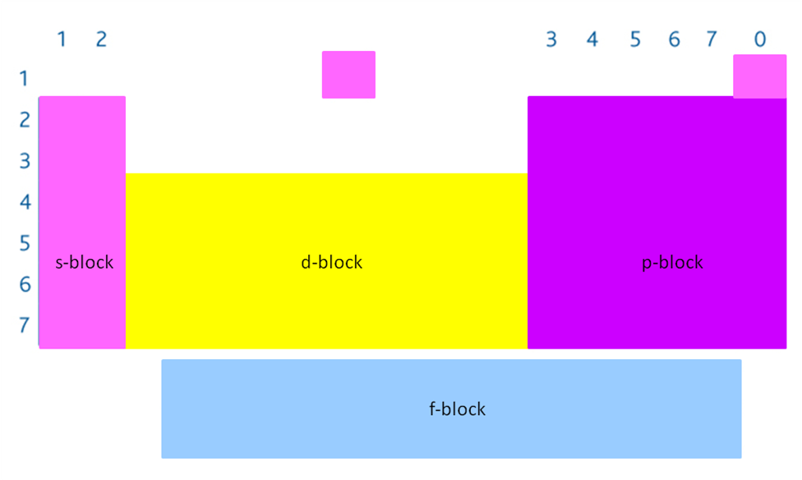

The diagram above shows the elements in terms of their **electronic arrangement**. Areas of the table are labelled **s, p and d block** because the elements have their **highest energy electrons** (i.e. outer electrons) in these **orbitals** or **sub-shells**.

**Example**

s-block Na 1s22s22p63**s**1

p-block C 1s22s22**p**2

d-block Fe 1s22s22p63s13p64s23**d**6

The position of an element in the period table can be used to work out its electronic configuration**.**

**Example CGP146**

Phosphorus (P) is in group 5 and period 3.

So it has 3 main energy levels, with the first and second levels full and 5 electrons in its out energy level.

Period 1 1s2 = 2

Period 2 2s22p6 = 8

Period 3 3s23p3 = 5

Putting them together gives 1s22s22p63s23p3

**Notes:**

* **Groups** – vertical columns (1-7 & 0 (or 1-8 or sometimes 1-18)
  + Elements form family groups with **similar chemical properties**
  + **Same number** of **electrons** in the o**uter main energy level.**
* **Periods** – horizontal rows (1-6)
  + **Trends in physical properties** and **chemical behaviour** across the periods
  + Elements in each period have electronsoccupying the **same number of main energy levels.**
* **Reactivity**
  + s-block elements (**metals**) get **more reactive as go down a group**
  + **Non-metals** more reactive as go **up a group**
  + **Transition** elements are **less reactive** but have many uses.
* **Helium** – usually placed with noble gases because of its properties but is **not a   
  p-block** element as it has this election arrangement **1s2.**
* **Hydrogen** – put in different places
  + In group 1 because it forms H+ ions but is not like group 1elements
  + In group 7 because it forms H- ion, is a gas and forms covalent bonds
  + Sometimes it’s placed on its own.

***Application: CGP147 PQ1-3***

***Fact recall: CGP147 Q1-2***

**Periodicity**

Periodicity is the study of the **trends in physical and chemical properties** of elements **across** the **periodic table**. The periodic table reveals repeating **patterns** within the elements, period means **recurring regularly.** Periodicity is **explained** by the **electron arrangements** of the elements.

A study of the trends in properties of period 3 elements explores periodicity.

|  |  |  |  |  |  |  |  |
| --- | --- | --- | --- | --- | --- | --- | --- |
| 1 | 2 | 3 | 4 | 5 | 6 | 7 | 0 |
| Alkali metal | Alkaline earth metal |  |  |  |  | Halogen | Noble gas |
| metal | metal | metal | semi-metal | non-metal | non-metal | non-metal | non-metal |
|  |  |  |  |  |  |  |  |
| [Ne]  3s1 | [Ne]  3s2 | [Ne]  3s23p1 | [Ne]  3s23p2 | [Ne]  3s23p3 | [Ne]  3s23p4 | [Ne]  3s23p5 | [Ne]  3s23p6 |
| s-block | | p-block | | | | | |

Atomic radius

The radius of an isolated atom can’t be measured because there is no clear point where election the cloud ends, so **half the distance between the centre of a pair of atoms** is used. This depends on the type of bonding, so the **covalent radius** is most **commonly** **used** as a measure of the size of an atom, as shown below.

|  |  |
| --- | --- |
|  |  |

|  |  |
| --- | --- |
|  | The **atoms** get **smaller across** the period.  The **radius decreases across the period** because the **nuclear charge increases** with **no additional electron shells** to provide shielding so the **outer** **electrons are pulled closer** to the nucleus.  Compared to going **down a group** the atoms get **bigger** as an extra main level of electrons is added. |

Melting points

|  |  |
| --- | --- |
|  | The **melting points** **increases** across the period with a clear break in middle where they then **decrease**.  This trend is linked to the **bond strength** and **structure**. |

**Na, Mg, Al are metals** so form a **giant metallic structure**. There is an **increase** in **melting** **point** due to **increase** in the **strength** of the **metallic bond**. The charge on the ion increases with more delocalised elections so there is a greater electrostatic attraction.

**Silicon** forms a **macromolecular** structure with **lots of strong covalent bonds**, therefore a lot of energy to break each covalent bond and it has a **very high melting point**.

**Phosphorus, sulphur** and **chlorine** form **molecules** held by **weak van der Waals’ forces**, so the **melting points** are **low**. Therefore the melting point is determined by **strength of the intermolecular forces** which is **related to molecule size**. Sulphur forms a ring of 8 atoms, **S8** so it’s the biggest of the 3 molecules and has the highest melting point. Phosphorus forms a pyramid structure with 4 atoms, **P4** with chlorine a diatomic molecule, **Cl2**.

**Argon** exists as **single atoms** held by **weak van der Waals’ forces**, so the **melting point** is **lowest**.

|  |  |  |  |  |  |  |  |
| --- | --- | --- | --- | --- | --- | --- | --- |
| Metals | | | Non-metals | | | | |
| Metallic bonding | | | Macro-  molecular | Simple molecules | | | Mon-atomic |
| Na | Mg | Al | Si | P | S | Cl | Ar |
|  |  |  |  |  |  |  |  |

First ionisation energies

**Link 3.1.1 Atomic structure**: 1st ionisation energy

***Definition***: **First ionisation energy** of an element is the enthalpy change for the removal on one mole of electrons from one mole of atoms of the element in the gas phase: X(g) → X+(g) + e-

|  |  |
| --- | --- |
|  | There is a generally **increase across a period**.  The **nuclear charge increases** with electrons added to same main level, so they are at the same distance but with **no extra shielding**. There is an increase in attraction between the outer electron and the nucleus. So **more energy** is **required** to remove an electron as you go across a period. |
|  | A similar trend in first ionisation energy is seen with elements in other periods.  The trend **down a group** is that the ionisation energy **decreases** because a **new main energy level** is added with the **outer electrons** **further** **from the nucleus**; they are therefore **less** **strongly attracted** and more easily removed.  This trend is shown by the green and blue dotted lines on the graph for group 1 and group 8 elements. |

***Task: Properties of period 3 – comment of the following information***

* Group
* Element
* Symbol
* Block
* Physical state & appearance
* Type of element
* Conductivity
* Structure

***Sheet: Periodicity (AS)***

***ICT task: Correlating trends***

***PPQs: Periodicity***

***Application: CGP150 PQ1-3***

***Fact recall: CGP150 Q1-3***

***Exam questions: Oxford p152-153 Q1-4***