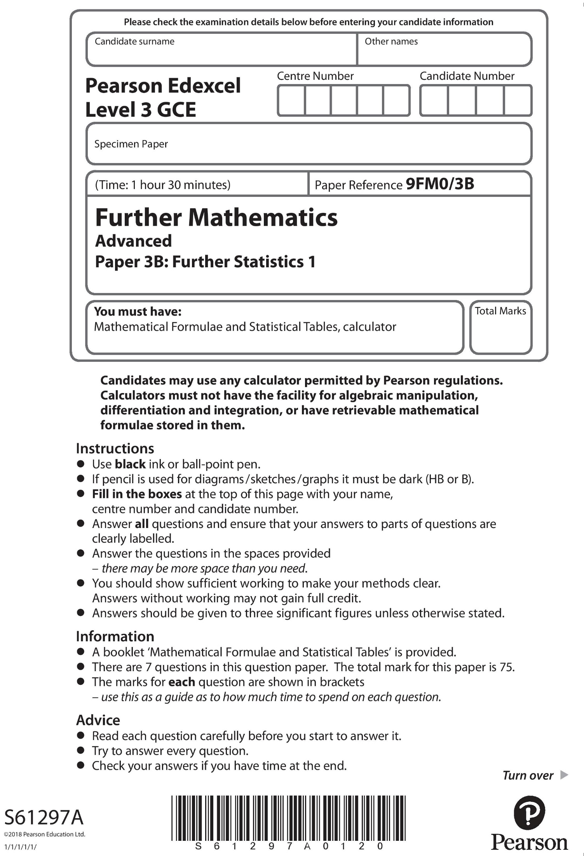

**Answer ALL questions. Write your answers in the spaces provided.**

**1.** In a randomly selected week, a camera recorded the number of speeding drivers on a

particular stretch of motorway.

|  |  |  |  |  |  |  |  |
| --- | --- | --- | --- | --- | --- | --- | --- |
|  | **Sunday** | **Monday** | **Tuesday** | **Wednesday** | **Thursday** | **Friday** | **Saturday** |
| **Frequency** | 35 | 30 | 28 | 24 | 40 | 51 | 37 |

Jeremy believes drivers are equally likely to be recorded speeding on any day of the week.

Carry out a hypothesis test, at the 5% level of significance, to see if the data support

Jeremy’s belief.

You should state your hypotheses, the degrees of freedom and the critical value used for

this test.

**(8)**

**(Total for Question 1 is 8 marks)**

**___________________________________________________________________________**

**2.** The discrete random variable *Y* has probability distribution given by

|  |  |  |  |
| --- | --- | --- | --- |
| *y* | *a* | 2 | 7 |
| P (*Y = y*) |  |  |  |

where *a* is a constant.

Given that Var(*Y* ) = 28 and E(*Y* ) < 0

(*a*) find the value of *a*.

**(6)**

(*b*) Find 

**(2)**

**(Total for Question 2 is 8 marks)**

**___________________________________________________________________________**

**3.** Tim and Sue are each typing a manuscript and they make errors at random.

On average, Tim makes 0.45 errors per page and Sue makes 0.2 errors per page.

A random sample of *n* pages of Tim’s typing is taken. The probability that these *n* pages

contain no errors is less than 0.05

(*a*) Find the smallest possible value of *n*.

**(3)**

The random variable *X* represents the total number of errors in a random sample of

5 pages of Tim’s typing and 5 pages of Sue’s typing.

(*b*) Find P(*X* = 2), stating a necessary assumption.

**(3)**

Random samples, each consisting of 5 pages of Tim’s typing and 5 pages of Sue’s typing,

are selected.

(*c*) Find the probability that in 10 of these samples there are at least 2 with no errors.

**(4)**

**(Total for Question 3 is 10 marks)**

**___________________________________________________________________________**

**4.** The discrete random variable *X* ~ B(*n*, *p*) has probability generating function given by

G*X*(*t*) = (0.4 + 0.6*t*)2

(*a*) Write down the value of *n* and the value of *p*

**(2)**

Using the probability generating function, find

(*b*) (i) P(*X* = 1)

**(2)**

(ii) E(*X* )

**(3)**

Two independent observations, *X*1 and *X*2, are taken from the distribution of *X*

The random variable *Y* = *X*1 + *X*2

(*c*) Use calculus to show that E(*Y*2) = 6.72

**(7)**

**(Total for Question 4 is 14 marks)**

**___________________________________________________________________________**

**5.** A company claims that the proportion of visitors to its website who make a purchase is 0.03

Nina believes that the proportion of visitors to the website who make a purchase is less

than 0.03 and asks the company for some data to test this.

The company tells Nina, for a particular day, the number of visits to its website until a

purchase is made. Nina assumes that visits to the website are made independently and

that each visitor has the same probability of making a purchase.

(*a*) Using a 5% level of significance, find the critical region for this test.

State your hypotheses clearly.

**(5)**

(*b*) Find the actual level of significance for this test.

**(2)**

The 94th visitor to the website was the first person to make a purchase.

(*c*) Test, at the 5% level of significance, whether or not there is evidence that the

proportion of visitors who make a purchase is less than 0.03.

**(2)**

**(Total for Question 5 is 9 marks)**

**___________________________________________________________________________**

**6.** The weights of bars of soap are known to be normally distributed.

The standard deviation of the weights is 3 grams.

A label on the bars of soap states that the mean weight is 120 grams.

Gizel believes that the mean weight of the bars of soap is greater than 120 grams.

She takes a random sample of 10 bars of soap and finds the mean weight of her sample.

Gizel then tests, at the 5% level of significance, whether there is evidence that the bars of

soap weigh more than 120 grams.

(*a*) Write down the probability of a Type I error.

**(1)**

Given that the true mean weight of the bars of soap is 122 grams,

(*b*) show that the power of Gizel’s test is 0.68 to 2 significant figures.

**(5)**

Alex decides to carry out the same test at the 1% level of significance.

(*c*) Without carrying out the test, compare the power of Alex’s test with the power of Gizel’s test.

Give a reason for your answer.

**(2)**

Joseph decides to increase the sample size and carry out the test at the 5% level of significance.

Assuming that the true mean weight of the bars of soap is 122 grams,

(*d*) calculate the smallest sample size that will produce a power of at least 0.9

**(5)**

(*e*) State which of Gizel’s and Joseph’s tests should be used.

Give a reason for your answer.

**(2)**

**(Total for Question 6 is 15 marks)**

**___________________________________________________________________________**

**7.** A radio station is running a contest each day for 30 days.

Each day it awards a prize to each of the first 12 callers who phone in and answer a

question correctly. Once 12 prizes are awarded, no more calls are taken that day.

It can be assumed that each caller has a chance of answering a question correctly,

independently of all other callers.

(*a*) Find the probability that there are exactly 15 calls taken on the first day.

**(2)**

(*b*) Find the probability that there are more than 13 calls taken on the first day.

**(3)**

(*c*) Estimate the probability that the mean number of calls taken over the 30 days is more

than 15.5

**(6)**

**(Total for Question 7 is 11 marks)**

**___________________________________________________________________________**

**TOTAL FOR PAPER IS 75 MARKs**