Name……………………………………..

**Lower 5 November Test Practice Paper**

**(Foundation-Tier)**

**NUMBERS**

**Q1.**

Joseph buys some heating oil.   
He puts it in his oil tank.

The scales show the numbers of litres of oil in the tank immediately before and immediately after Joseph puts the oil in the tank.

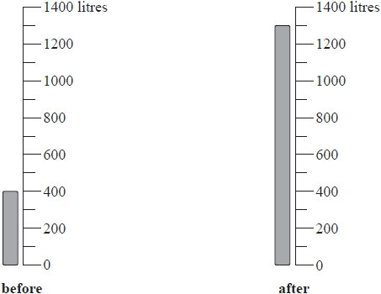

The oil Joseph buys costs 0.40 euros per litre.

Work out the total cost of the oil that Joseph buys.

........................................................... euros

**(Total for question = 3 marks)**

**Q2.**

(a) Find the value of 12 ÷ (2 − 5)

...........................................................

**(1)**

(b) Find the value of 64

...........................................................

**(1)**

(c) Write down the prime number whose value is nearest to 33

...........................................................

**(1)**

(d) Find the cube root of 343

...........................................................

**(1)**

**(Total for question = 4 marks)**

**Q3.**

Mike buys 150 burger buns.

He buys the burger buns in packs of 6 burger buns.   
Each pack of 6 burger buns costs £1.03

Work out how much Mike pays for the 150 burger buns.

£

**(Total for question = 3 marks)**

**Q4.**

(a)  Write down the cube root of 64

...........................................................

**(1)**

(b)  Calculate the value of 23 × 45

...........................................................

**(2)**

(c)  Express 600 as a product of powers of its prime factors.   
       Show your working clearly.

...........................................................

**(3)**

**(Total for question = 6 marks)**

**Q5.**

The table shows the lowest temperature for the month in each of six months for Winnipeg in Canada.

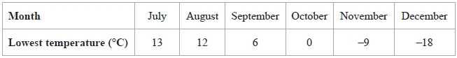

(a)  Which of these six months has the lowest temperature?

...........................................................

**(1)**

(b)  Work out the difference between the lowest temperature in August and the lowest temperature in November.

........................................................... °C

**(1)**

The lowest temperature in March was 23 °C lower than the lowest temperature in August.

(c)  Work out the lowest temperature in March.

........................................................... °C

**(1)**

**(Total for question = 3 marks)**

**Q6.**

(a)  (i)  Write the number on the dotted line to make the calculation correct.

283 + .................... = 576

(ii)  Write the number on the dotted line to make the calculation correct.

50% of .................... = 9.7

**(2)**

(b)  Write brackets in this calculation so that the answer is correct.

7 − 2 × 5 + 7 = 60

**(1)**

**(Total for question = 3 marks)**

**Q7.**

Some students take part in a quiz.

They all start with a score of zero.

When a student gives a correct answer, 1 point is added to the student's score.

When a student gives a wrong answer, 1 point is subtracted from the student's score.

Kasa has −4 points.

Mansi has 7 points.

(a)  How many more points has Mansi than Kasa?

...........................................................

**(1)**

Malik has −3 points.

He then gives the correct answer to 14 questions and the wrong answer to 5 questions.

(b)  How many points does Malik now have?

...........................................................

**(1)**

Trena has 12 points.

She gave the correct answer to 21 questions.

(c)  How many wrong answers did she give?

...........................................................

**(1)**

**(Total for Question is 3 marks)**

**Q8.**

(a) (i) Work out 2.912  
Write down all the figures on your calculator display.

...........................................................

(ii) Write your answer to part (a)(i) correct to 2 decimal places.

...........................................................

**(2)**

(b) (i) Find the cube root of 30   
Write down all the figures on your calculator display.

...........................................................

(ii) Write your answer to part (b)(i) correct to 2 significant figures.

...........................................................

**(2)**

**(Total for question = 4 marks)**

**Q9.**

Here is an incomplete number line.



(a)  Write a number on each dotted line to complete the number line.

**(1)**

(b)  Write the following numbers in order of size.

Start with the smallest number.

5          −7          3          −2          8          −4

.............................................................................................................................................

**(1)**

In Oymyakon, the average maximum temperature in July is 72°F.   
The average minimum temperature is January is −58°F

(c)  Work out the difference between 72°F and −58°F

........................................................... °F

**(2)**

**(Total for question = 4 marks)**

**Q10.**

Elvira and Anja go on holiday to Sweden and to Finland.

In Sweden, Elvira bought some trainers for 438 Swedish krona.   
In Finland, Anja bought the same type of trainers for 44.39 euros.

1 Swedish krona = 0.12 dollars

1 dollar = 0.92 euros

Work out the difference in the cost of the trainers bought by Elvira and the trainers bought by Anja.   
Give your answer in dollars.

........................................................... dollars

**(Total for question = 4 marks)**

**Q11.**

The table gives the minimum temperature for January 2018 in each of six cities.

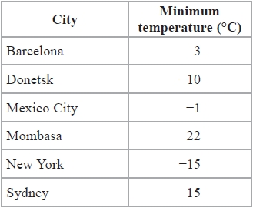

(a)  Which of these six cities has the lowest minimum temperature?

...........................................................

**(1)**

(b)  Work out the difference between the minimum temperature of Donetsk and the minimum temperature of Sydney.

........................................................... °C

**(1)**

The minimum temperature in Edmonton for January 2018 was 50°C less than the minimum temperature in Mombasa for January 2018

(c)  Work out the minimum temperature in Edmonton for January 2018

........................................................... °C

**(1)**

**(Total for question = 3 marks)**

**Q12.**

Write down all the factors of 30

...........................................................

**(Total for Question is 2 marks)**

**Q13.**

Write down all the factors of 20

...........................................................

**(Total for question = 2 marks)**

**Q14.**

(a)   Find all the factors of 45

...........................................................

**(2)**

(b)   A common factor of 42 and 45 is 1   
Find the other common factor of 42 and 45

...........................................................

**(1)**

**(Total for Question is 3 marks)**

**Q15.**

(a)  Write down all the factors of 9

...........................................................

**(1)**

(b)  Find the lowest common multiple (LCM) of 15 and 70

...........................................................

**(2)**

**(Total for question = 3 marks)**

**Q16.**

(a)  Write 224 as a product of powers of its prime factors.   
       Show your working clearly.

..........................................................

**(3)**

(b)  Write down 3 **different** factors of 224 with a sum between 99 and 110

..........................................................

**(2)**

**(Total for question = 5 marks)**

**Q17.**

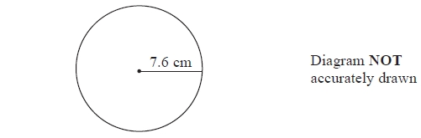

(a)   A circle has a radius of 7.6 cm.   
Work out the area of the circle.   
Give your answer correct to 3 significant figures.

........................................................... cm2

**(2)**

The radius, 7.6 cm, is correct to 1 decimal place.

(b) (i)   Write down the upper bound of the radius.

........................................................... cm

(ii)   Write down the lower bound of the radius.

........................................................... cm

**(2)**

**(Total for Question is 4 marks)**

**Q18.**

(a)  *A* = 22 × 3 × 52

*B* = 23 × 5

(i)  Find a common factor of *A* and *B*.

...........................................................

(ii)  Find a common multiple of *A* and *B*.

...........................................................

**(3)**

(b)

Find the value of *n*.

*n* = ...........................................................

**(2)**

**(Total for question = 5 marks)**

**Q19.**

(a) Work out the value of 2.53

...........................................................

**(1)**

(b) Work out the value of 

...........................................................

**(2)**

(c) Work out the value of 

...........................................................

**(2)**

**(Total for question = 5 marks)**

**Q20.**

(a)  Find the value of the cube of 4

...........................................................

**(1)**

(b)  Write 3 × 3 × 3 × 3 × 3 as a single power of 3

...........................................................

**(1)**

  
(c) Write as a single power of 7

...........................................................

**(2)**

**(Total for Question is 4 marks)**

**Q21.**

Express 560 as a product of powers of its prime factors.   
Show your working clearly.

...........................................................

**(Total for question = 3 marks)**

**Q22.**

Express 825 as a product of its prime factors.

...........................................................

**(Total for Question is 3 marks)**

**Q23.**

(a)  Express 600 as a product of powers of its prime factors.   
Show your working clearly.

...........................................................

**(3)**

  
(b)  Simplify     

Give your answer as a power of 5

...........................................................

**(2)**

**(Total for question = 5 marks)**

**SUBSTITUTING INTO EXPRESSIONS AND FORMULAE**

**Q24.**

*P* = 2*g* + 3*h*

(a)  Work out the value of *P* when *g* = 7 and *h* = −4

...........................................................

**(2)**

(b)  Simplify   *e*9 ÷ *e*5

...........................................................

**(1)**

(c)   Simplify   (*y*2)8

...........................................................

**(1)**

(d)  Expand and simplify   (*x* + 9)(*x* – 2)

...........................................................

**(2)**

(e)  Factorise fully   16*c*4*p*2 + 20*cp*3

...........................................................

**(2)**

**(Total for question = 8 marks)**

**Q25.**

(a)  Simplify 6*m* − 2*k* + 5*m* − *k*

...........................................................

**(2)**

*P* = 2*a* + 3*b*

(b)  Work out the value of *P* when *a* = 5 and *b* = 8

*P* = ...........................................................

**(2)**

*P* = 2*a* + 3*b*

(c)  Work out the value of *a* when *P* = 16 and *b* = 20

*a* = ...........................................................

**(3)**

**(Total for question = 7 marks)**

**Q26.**

*T* = 6*p* – 4*d*

(a)  Work out the value of *T* when *p* = 8 and *d* = 3

*T* = ...........................................................

**(2)**

*T* = 6*p* – 4*d*

(b)  Work out the value of *p* when *T* = – 41 and *d* = 5

*p* = ...........................................................

**(3)**

(c)  Solve 4(*x* – 3) = 7*x* + 15

Show clear algebraic working.

*x* = ...........................................................

**(3)**

**(Total for question = 8 marks)**

**Q27.**

(a)   Simplify 8*d* × 7*d*

...........................................................

**(1)**

(b)   Expand 4(3*e* – 5)

...........................................................

**(1)**

(c)   Factorise *f*2 – 2*f*

...........................................................

**(2)**

(d)   *H* = *g*3 + 6*g*  
Work out the value of *H* when *g* = 2

*H* = ...........................................................

**(2)**

**(Total for Question is 6 marks)**

**Q28.**

(a)  Simplify  9*x*2 + 2*x*2 – 5*x*2

...........................................................

**(1)**

*e* = 2*f* – 5*g*

(b)  Find the value of  *e*  when  *f* = 12  and  *g* = 3

*e* = ...........................................................

**(2)**

*e* = 2*f* – 5*g*

(c)  Find the value of *f* when  *e* = 8  and  *g* = –6

*f* = ...........................................................

**(3)**

**(Total for question = 6 marks)**

**Q29.**

This formula can be used to work out the cost, in Riyals, of hiring a car in Qatar for   
a number of days.



(a) Daisha hired a car for 12 days.   
Work out the cost.

.......................................................... Riyals

**(1)**

(b) Yusuf hired a car.   
The cost was 765 Riyals.  
Work out the number of days for which Yusuf hired the car.

..........................................................

**(2)**

(c) *C* Riyals is the cost of hiring a car for *n* days.   
Write down a formula for *C* in terms of *n*.

..........................................................

**(2)**

(d) As a special offer, the cost of hiring a car for a month is 1800 Riyals.   
Awad wants to hire a car for a number of days.  
He works out that 1800 Riyals is less than the cost of hiring the car at  
85 Riyals for each day.

Work out the smallest number of days for which Awad wants to hire a car.

..........................................................

**(2)**

**(Total for question = 7 marks)**

**Q30.**

This formula can be used to work out the value, in pounds (£), of a number of shares in a water company.



(a) Work out the value of 400 shares.

£...........................................................

**(1)**

The value of Elisha's shares in the water company is £875

(b) Work out the number of shares that Elisha has.

...........................................................

**(2)**

The value of *n* shares in the water company is £*V*.

(c) Write down a formula for *V* in terms of *n*.

...........................................................

**(2)**

**(Total for question = 5 marks)**

**SEQUENCES**

**Q31.**

Here is a sequence of shapes drawn on a square grid.

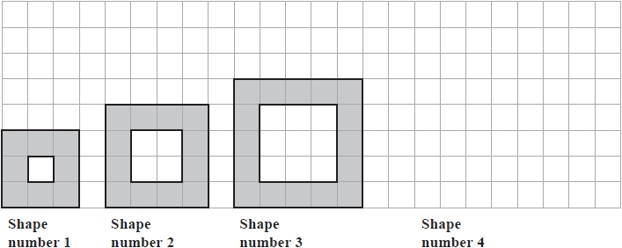

(a)  On the grid, draw Shape number 4

**(1)**

The table shows the number of shaded squares in the first three shapes.

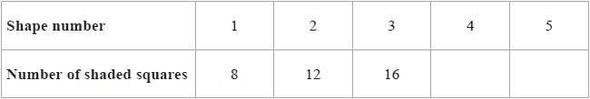

(b)  Complete the table to show the number of shaded squares in Shape number 4 and Shape number 5

**(1)**

(c)  Work out the number of shaded squares in Shape number 9

...........................................................

**(2)**

The width of Shape number 1 is 3 squares.   
The width of Shape number 2 is 4 squares.

(d)  Find the width of Shape number 8

........................................................... squares

**(1)**

The width of Shape number *n* is *W* squares.

(e)  Write down a formula for *W* in terms of *n*.

...........................................................

**(2)**

**(Total for question = 7 marks)**

**Q32.**

Here is a sequence of patterns made from short sticks and long sticks.

The short sticks make squares and the long sticks are diagonals of the squares.

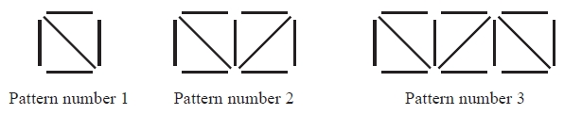

(a)  In the space below, draw Pattern number 4

**(1)**

(b)  Complete the table.

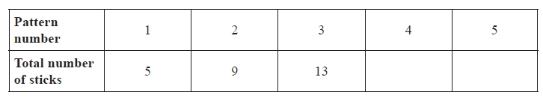

**(1)**

(c)  Find the total number of sticks in Pattern number 7

...........................................................

**(1)**

(d)  Work out the number of **short** sticks in Pattern number 12

...........................................................

**(1)**

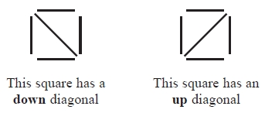

(e)  How many **up** diagonals are there in Pattern number 21?

...........................................................

**(1)**

**(Total for question = 5 marks)**

**Q33.**

Here are the first five terms of a number sequence.

7        11        15        19        23

(a)  Find an expression, in terms of *n*, for the *n*th term of this sequence.

...........................................................

**(2)**

The *n*th term of a different number sequence is given by 80 – 2*n*

(b)  Write down the first 3 terms of this sequence.

................ , ................ , ................

**(2)**

Yuen says there are no numbers that are in both of the sequences.   
Yuen is correct.

(c)  Explain why.

.............................................................................................................................................

.............................................................................................................................................

**(1)**

**(Total for question = 5 marks)**

**Q34.**

Here is a sequence of patterns made from white centimetre squares and grey centimetre squares.

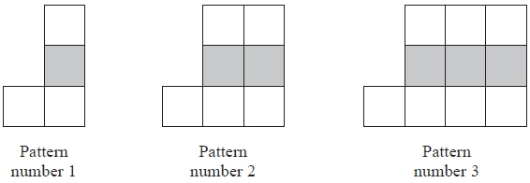

This rule can be used to find the total number of centimetre squares in each pattern.



(a)   Work out the total number of centimetre squares in Pattern number 6

...........................................................

**(1)**

(b)   Work out the number of white centimetre squares in Pattern number 20

...........................................................

**(1)**

A pattern in this sequence has a total of 88 centimetre squares.

(c)   Work out the Pattern number of this pattern.

...........................................................

**(2)**

**(Total for Question is 4 marks)**

**Q35.**

Here is a sequence of patterns made from buttons.

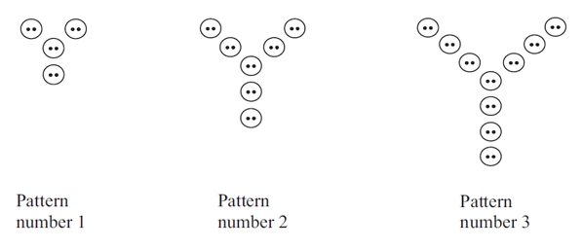

(a)  In the space below, draw Pattern number 4

**(1)**

This rule can be used to find the number of buttons in a pattern.

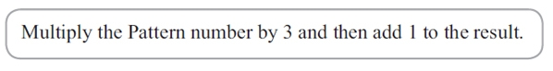

(b) Work out the number of buttons in Pattern number 8

...........................................................

**(2)**

(c) Work out the Pattern number of the pattern with exactly 55 buttons.

...........................................................

**(2)**

**(Total for question = 5 marks)**

**Q36.**

Here are the first five terms of a number sequence.

7          10          13          16          19

(a)  Write down the next term of the sequence.

...........................................................

**(1)**

(b)  Explain how you found your answer.

.............................................................................................................................................

**(1)**

(c)  Find the 11th term of the sequence

...........................................................

**(1)**

(d)  Explain why 60 cannot be a term of the sequence.

.............................................................................................................................................

.............................................................................................................................................

**(1)**

**(Total for question = 4 marks)**

**Q37.**

Here are the first five terms of a number sequence.



(a) Write down the next two terms of the sequence.

............................. , ..............................

**(2)**

(b) Explain how you worked out your answer.

      ..............................................................................................................................................

**(1)**

(c) Find the 15th term of the sequence.

...........................................................

**(1)**

(d) Explain why 0 cannot be a term of the sequence.

      ..............................................................................................................................................

**(1)**

**(Total for question is 5 marks)**

**Q38.**

Here are the first five terms of a number sequence.



(a)  Work out the next two terms of the sequence.

........................... , ...........................

**(2)**

(b)  Explain how you worked out your answer.

.............................................................................................................................................

**(1)**

The 15th term of this sequence is –10

(c)  Work out the 14th term of this sequence.

...........................................................

**(1)**

**(Total for question = 4 marks)**

**Q39.**

Here are the first 4 terms of an arithmetic sequence.

85          79          73          67

Find an expression, in terms of *n*, for the *n*th term of the sequence.

...........................................................

**(Total for question = 2 marks)**

**Q40.**

A sequence of shapes is made by shading squares on a square grid.

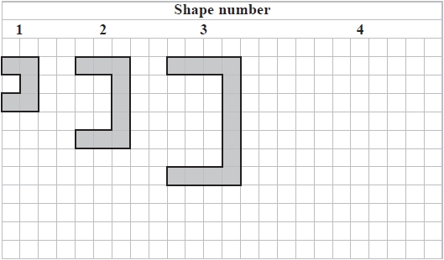

(a)  On the grid, draw Shape number 4

**(1)**

(b)  Complete the table.

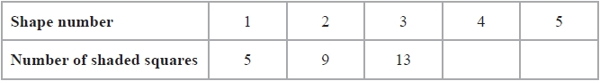

**(1)**

(c)  Find the number of shaded squares in Shape number 8

...........................................................

**(1)**

(d)  Explain why no shape in the sequence is made by shading exactly 50 squares.

.............................................................................................................................................

.............................................................................................................................................

**(1)**

**(Total for question = 4 marks)**

**RE-ARRANGING FORMULAE**

**Q41.**

Simon has *x* sweets.   
Yuen has 2 more sweets than Simon.   
Giulia has 3 times as many sweets as Yuen.

Simon, Yuen and Giulia have a total of *T* sweets.

(a)  Write down a formula for *T* in terms of *x*.

Give your formula in its simplest form.

...........................................................

**(3)**

(b)  Make *g* the subject of the formula  *r* = 4*g* + 7

...........................................................

**(2)**

(c)  Solve  6*y* – 3 = 2*y* + 8

Show clear algebraic working.

*y* = ...........................................................

**(3)**

**(Total for question = 8 marks)**

**Q42.**

(a)  Expand *x*(5 – *x*)

...........................................................

**(1)**

(b)  Factorise 3*y* – 21

...........................................................

**(1)**

(c)  Make p the subject of the formula *f* = 3*p* – *d*

...........................................................

**(2)**

Sergio buys *m* boxes of seeds and *n* packets of seeds.

Each box contains 10 seeds.   
Each packet contains 6 seeds.

The total number of seeds that Sergio buys is *T*.

(d)  Write down a formula for *T* in terms of *m* and *n*.

...........................................................

**(3)**

**(Total for question = 7 marks)**

**Q43.**

(a)  Expand and simplify 3*x*(2*x* + 3) – *x*(3*x* + 5)

...........................................................

**(2)**

(b)  Make *t* the subject of the formula *p* = *at* – *d*

...........................................................

**(2)**

Given that 

(c)  work out the value of *n*.

*n* = ...........................................................

**(2)**

**(Total for question = 6 marks)**

**Q44.**

(a)  Solve 5*m* + 7 = 24

*m* =

**(2)**

(b)  Make *t* the subject of 

**(2)**

(c)  Simplify *p*8 ÷ *p*3

**(1)**

(d)  Simplify *n*0

**(1)**

(e)  Simplify (3*x*2*y*5)3

**(2)**

**(Total for question = 8 marks)**

**Q45.**

There are 6 batteries in a small packet of batteries.   
There are 9 batteries in a large packet of batteries.

Chow buys *m* small packets of batteries and *g* large packets of batteries.

The total number of batteries Chow buys is *T*.

Write down a formula, in terms of *m* and *g*, for *T*.

...........................................................

**(Total for question = 3 marks)**

**Q46.**

The diagram shows a right-angled triangle and a rectangle.

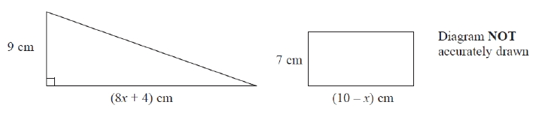

The area of the triangle is twice the area of the rectangle.

(i)  Write down an equation for *x*.

.............................................................................................................................................

(ii)  Find the area of the rectangle.

Show clear algebraic working.

........................................................... cm2

**(Total for question = 7 marks)**

**Q47.**

Here are two rectangles, rectangle *A* and rectangle *B*.

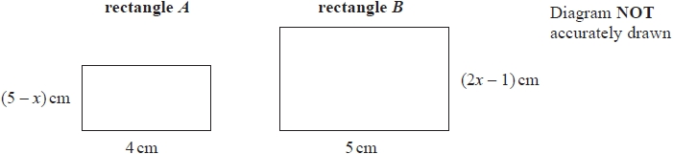

The area of rectangle *B* is twice the area of rectangle *A*.

Work out the value of *x*.   
Show your working clearly.

*x* = ...........................................................

**(Total for question = 4 marks)**

**Q48.**

(a)  Expand *x*(4 – *x*)

...........................................................

**(1)**

*t* = *ab* – *c*

*a* = 1.5 *b* = 2.4 *c* = –5.6

(b)  Work out the value of *t*.

*t* = ...........................................................

**(2)**

(c)  Make *d* the subject of *y* = *dx* – *e*

...........................................................

**(2)**

**(Total for question = 5 marks)**

**Q49.**

*c* = 4

*d* = 7

(a)  Work out the value of 3*c* + 2*d*

...........................................................

**(2)**

*p* = −6

*m* = −2

(b)  Work out the value of 2*p*2 + 3*m*

...........................................................

**(2)**

There are 6 eggs in a small box of eggs.   
There are 12 eggs in a large box of eggs.

Alex buys *g* small boxes of eggs and *h* large boxes of eggs.   
He buys a total of *T* eggs.

(c)  Write down a formula for *T* in terms of *g* and *h*.

...........................................................

**(3)**

**(Total for question = 7 marks)**

**Q50.**

(a)  Factorise fully    6*y*2 + 15*y*

...........................................................

**(2)**

(b)  Expand and simplify    (*m* + 9)(*m* – 5)

...........................................................

**(2)**

(c)  Make *t* the subject of

...........................................................

**(2)**

(d)  Solve

Show clear algebraic working.

*x* = ...........................................................

**(3)**

**(Total for question = 9 marks)**

**Mark Scheme**

Q1.

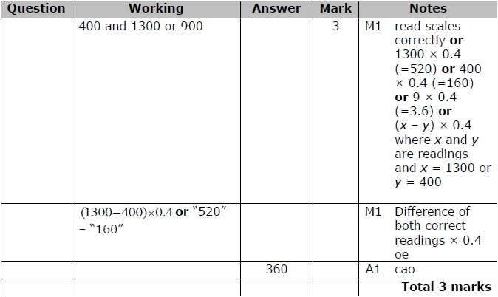

**Q2.**

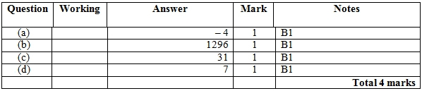

**Q3.**

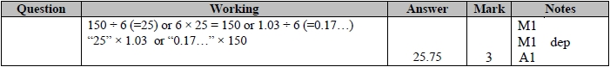

**Q4.**

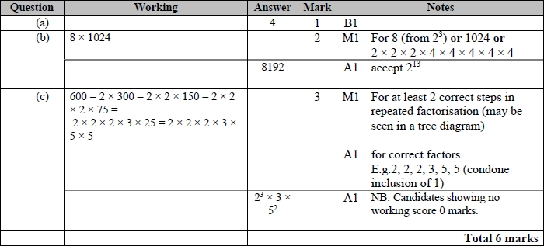

**Q5.**

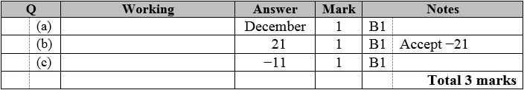

**Q6.**

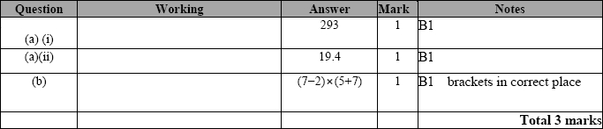

**Q7.**

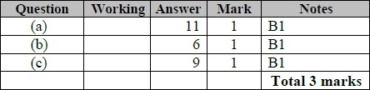

**Q8.**

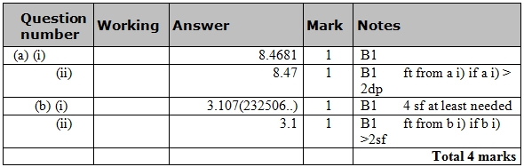

**Q9.**

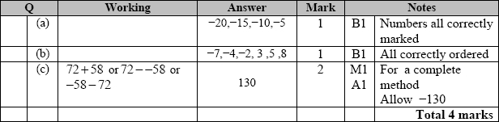

**Q10.**

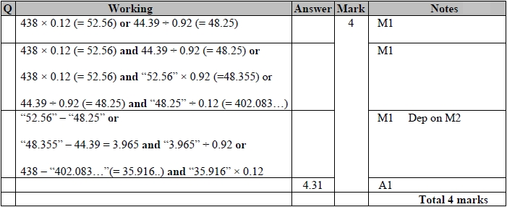

**Q11.**

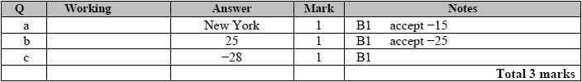

**Q12.**

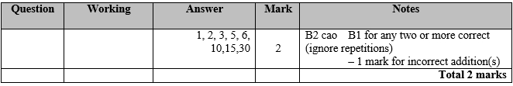

**Q13.**

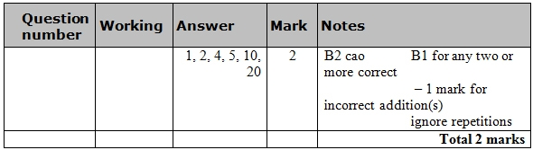

**Q14.**

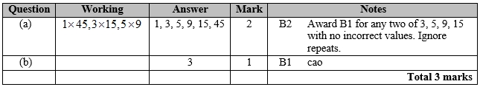

**Q15.**

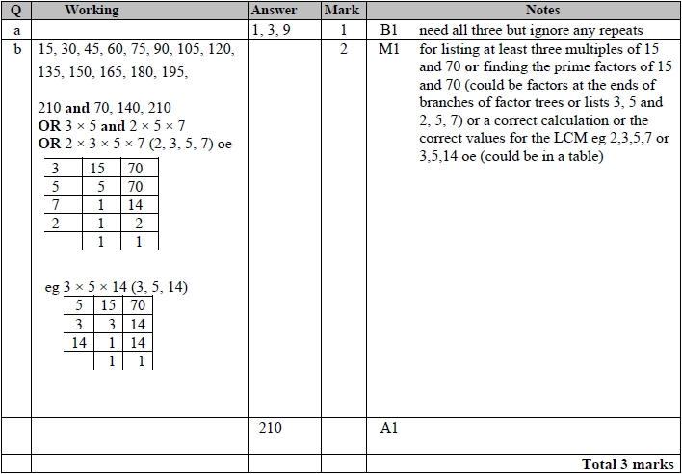

**Q16.**

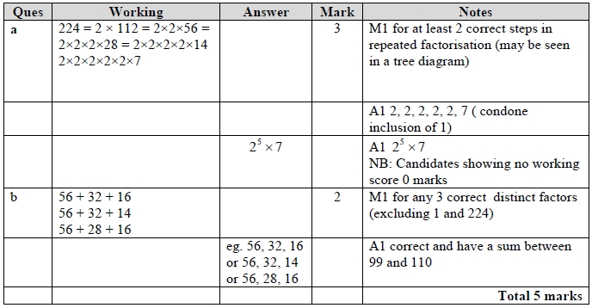

**Q17.**

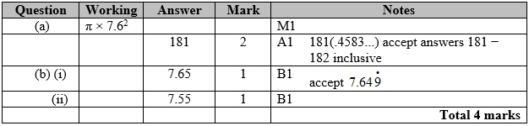

**Q18.**

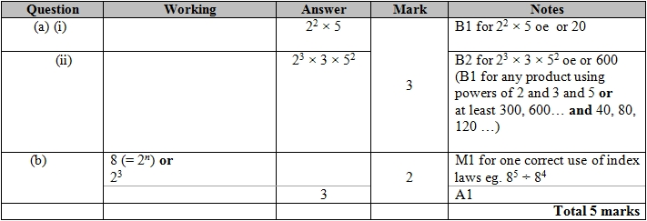

**Q19.**

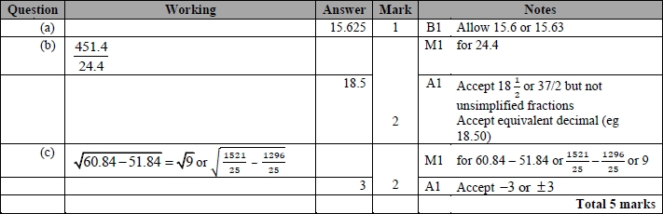

**Q20.**

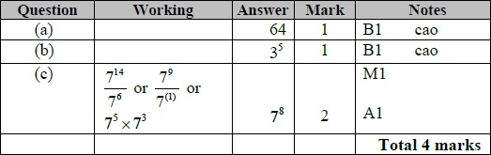

**Q21.**

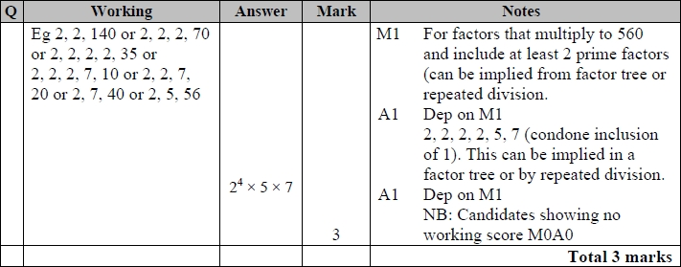

**Q22.**

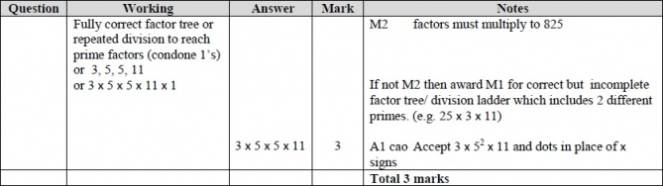

**Q23.**

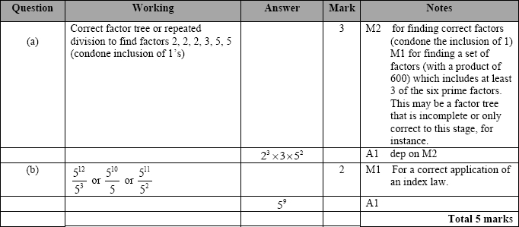

**Q24.**

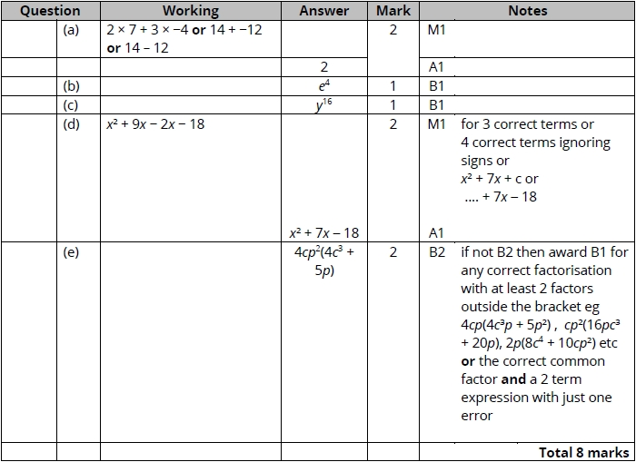

**Q25.**

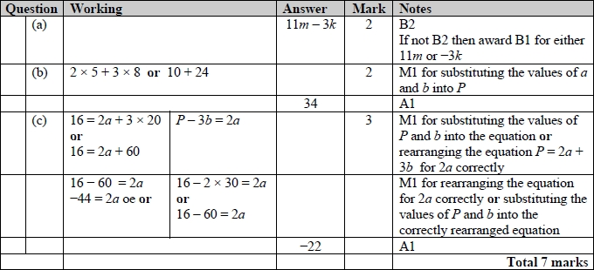

**Q26.**

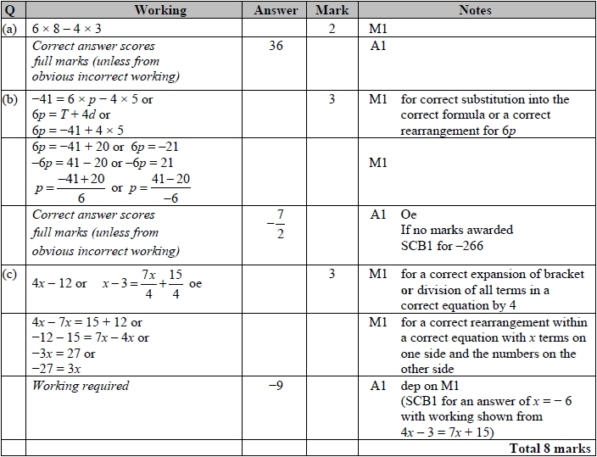

**Q27.**

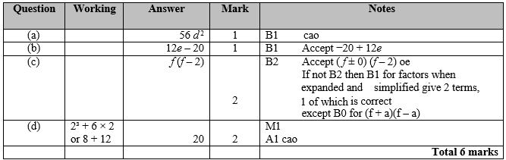

**Q28.**

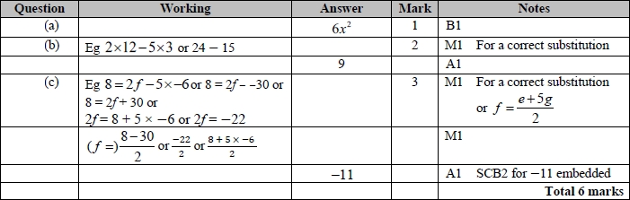

**Q29.**

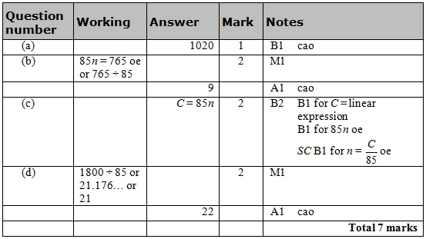

**Q30.**

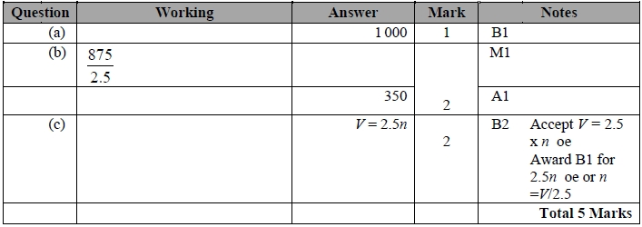

**Q31.**

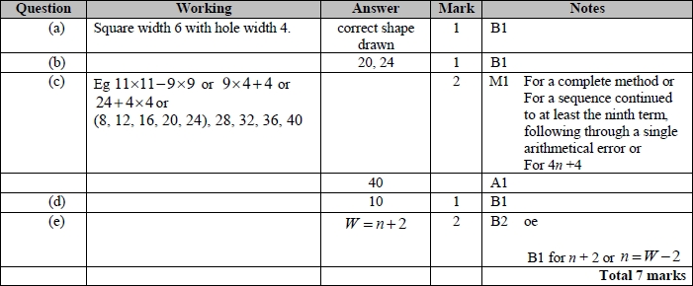

**Q32.**

For all questions, the correct answer, unless clearly obtained by an incorrect method, should be taken to imply a correct method.

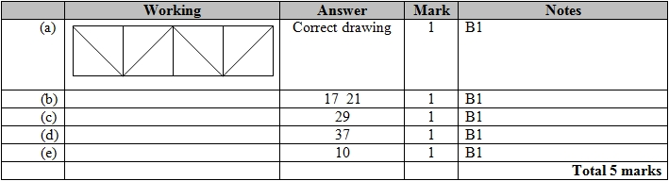

**Q33.**

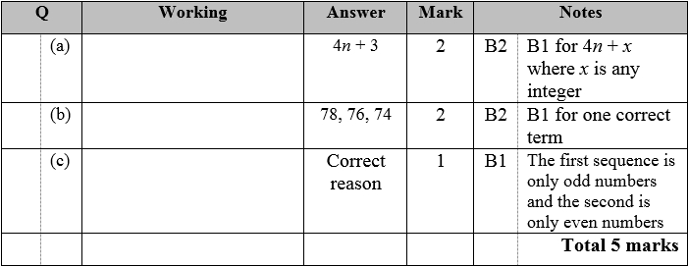

**Q34.**

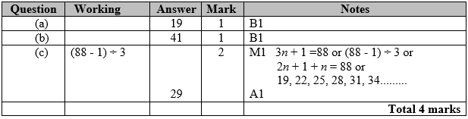

**Q35.**

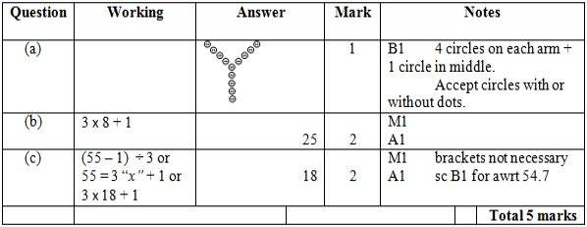

**Q36.**

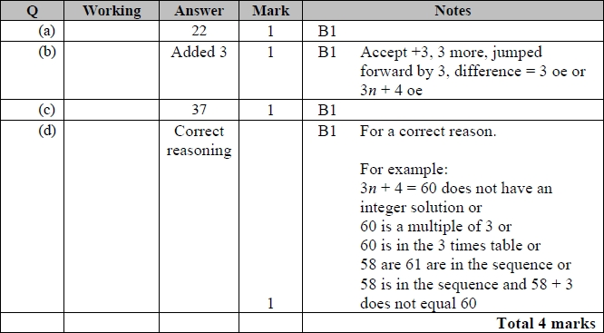

**Q37.**

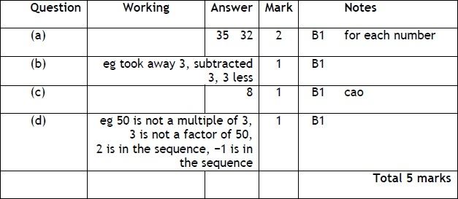

**Q38.**

Apart from question 18c where the mark scheme states otherwise, the correct answer, unless clearly obtained by an incorrect method, should be taken to imply a correct method.

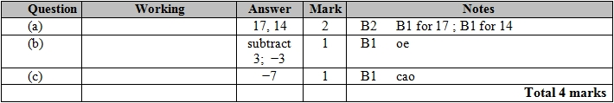

**Q39.**

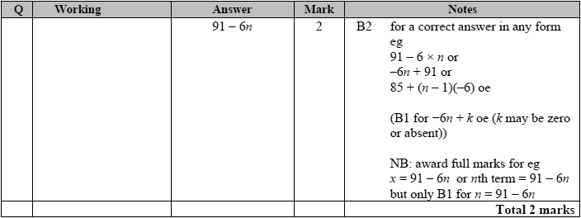

**Q40.**

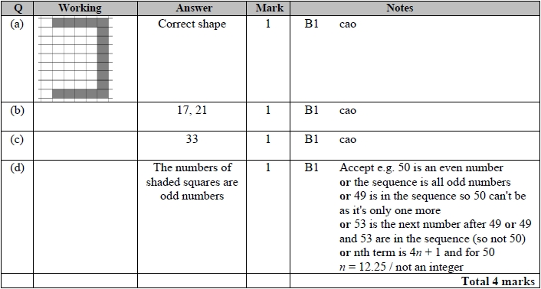

**Q41.**

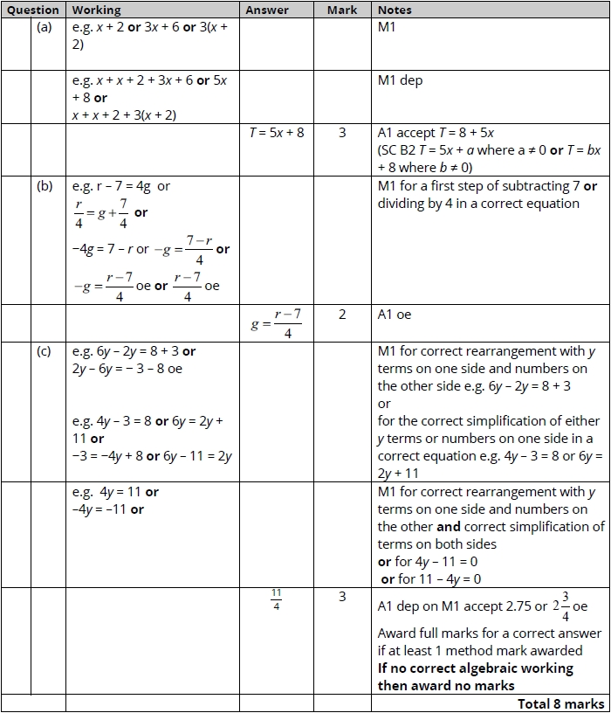

**Q42.**

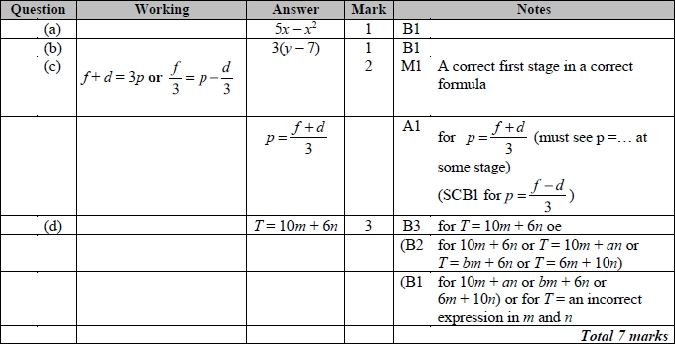

**Q43.**

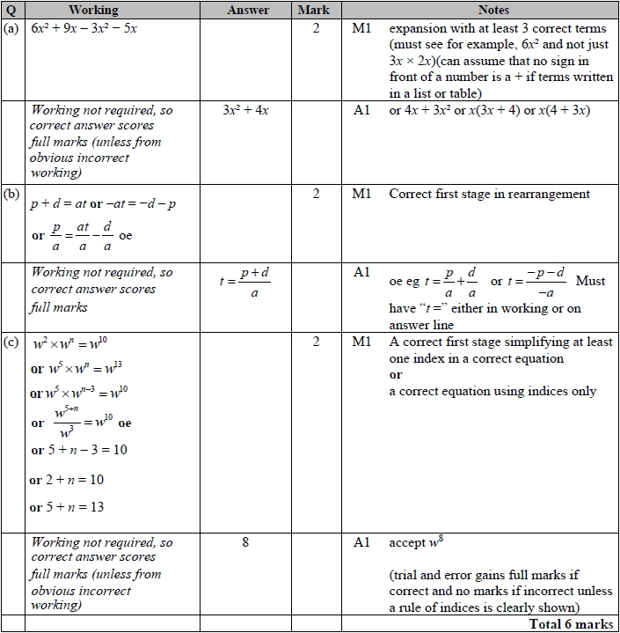

**Q44.**

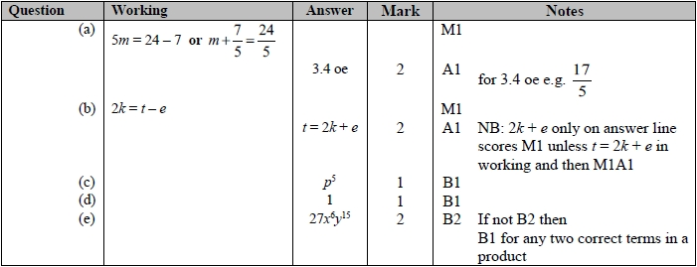

**Q45.**

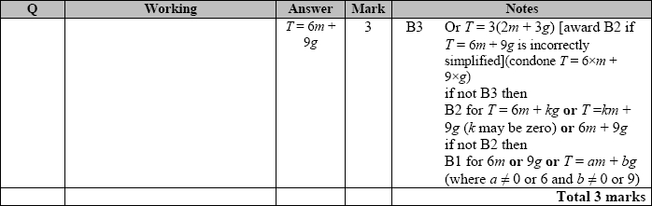

**Q46.**

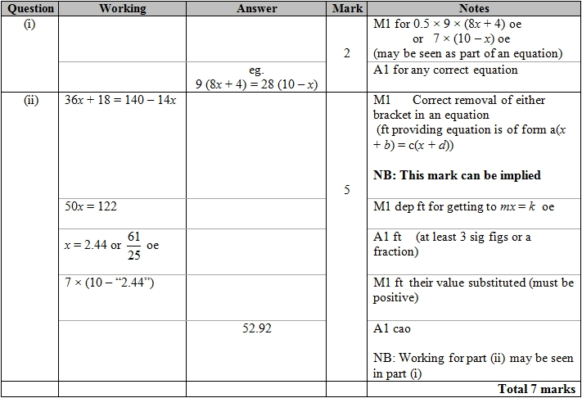

**Q47.**

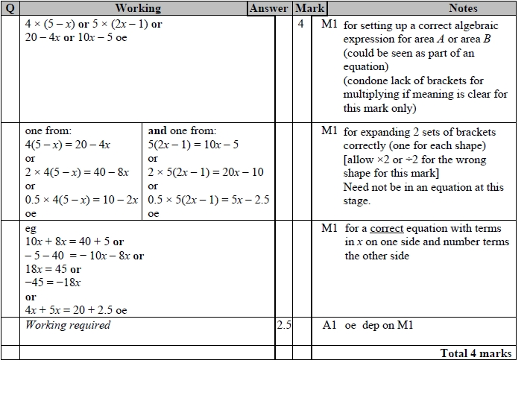

**Q48.**

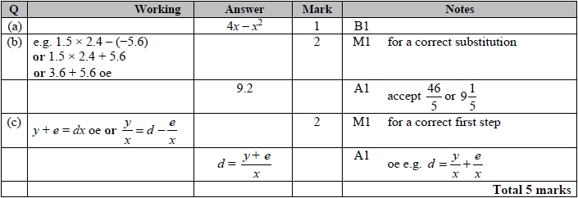

**Q49.**

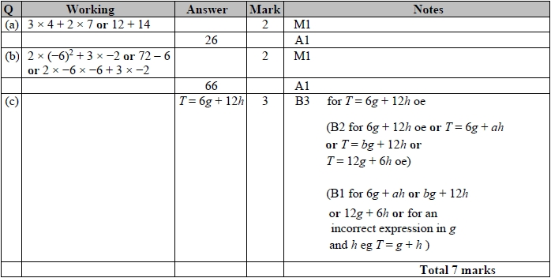

**Q50.**

