Booklet 8 Punishment

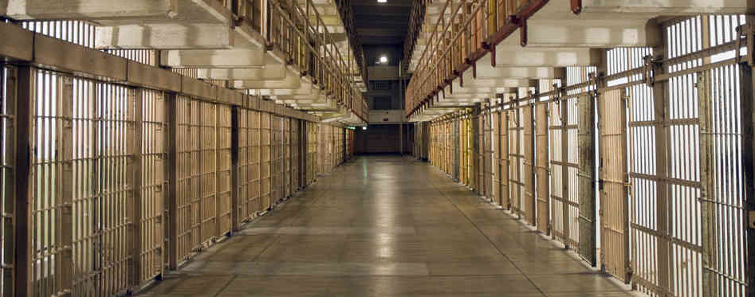

Name

Specification Content:

What you need to know for **Crime and Deviance**  in your Paper 3 exam.

* crime, deviance, social order and social control
* the social distribution of crime and deviance by ethnicity, gender and social class, including recent patterns and trends in crime
* globalisation and crime in contemporary society; the media and crime; green crime; human rights and state crimes
* crime control, surveillance, prevention and punishment, victims, and the role of the criminal justice system and other agencies.

|  |  |  |  |  |  |
| --- | --- | --- | --- | --- | --- |
| **Questions may be based specifically on the following areas:** | | Do I have completed Notes? | Have I made revision Notes? | Have I memorised this info? | Have I practised exam style questions? |
| Crime control, surveillance, prevention and punishment, eg crime prevention strategies, and sociological perspectives on punishment | .  **Durkheim, Rusche & Kirchheimer, Felson, Chaiken, Wilson & Kelling**  **Phillips and Webster** |  |  |  |  |
| Patterns of victimisation and explanations for these, eg positivist and critical victimology. | **Christie, Miers, Mawby & Walklate, Tombs & Whyte** |  |  |  |  |
| The role of the criminal justice system and other agencies, eg the role of police, courts and prisons | **Foucault, Garland, S.Cohen** |  |  |  |  |

Exam Structure:

|  |
| --- |
| **These topics will appear in paper 3 of the A’Level.** 2 hour written exam 80 marks in total (50 for this bit)   * 33.3% of A-level   Crime and Deviance: short answer and extended writing, 50 marks (4 marks, 6 marks, 10 marks, 30 marks) |

Victims

What have we done already?

Who are victims most likely to be?

Why might this be?

Victimology

What is a victim?

The UN defines victims as those who have suffered harm through acts or omissions that violate the laws of the state.

Harm can include:

* Mental, Physical or emotional suffering
* Economic loss
* Impairment of basic rights.

Nils Christie (1986) takes a different view, highlighting the notion that the concept of a “Victim” is a social construction. The stereotype of the “ideal victim” favoured by the media, public and criminal justice system is weak, innocent and blames individuals – such as the elderly or a small child – who is the target of a stranger’s attack.

It is important to study victims as they give us another perspective in our understanding of crime.

Are statistics reliable?

There are many crimes which are unreported and unrecorded so it is difficult to get a clear picture of who the victims are. In domestic violence cases there may be shame or the victim may think they have caused the violence by provoking their attacker. Tombs and Whyte suggest that accident victims of corporate crime arising from employer neglect may themselves be blamed for being accident prone or negligent. This links to Marxism as **Tombs and Whyte (2007)**show that “safety crimes” where employers’ violations of the law are explained away as the fault of the employee because they are “accident prone”. They note the ideological function of this “*Failure to label*”. By concealing the true extent of victimisation and its real causes, it hides the crimes of the powerful and denies the powerless victims justice. In the ***hierarchy of victimisation***the powerless are most likely to be victimised, yet least likely to have this acknowledged by the state.

The average chance of an individual being a victim of crime in any one year is 1:4. However the risk is unevenly distributed between social groups.

* *Class*
  + The poorest groups are more likely to be victimised. Crime rates are typically highest in areas of high unemployment and deprivation.
* *Age*
  + Younger people are more at risk of victimisation. Those most likely to be murdered are victims under 1, although teenagers are more likely to be victims of assault, sexual harassment, theft or abuse at home.
* *Ethnicity*
  + Minority groups are at greater risk of being victims of crime in general as well as racially motivated crime. In relation to the police, minority, the young and the homeless report feeling under protected and over controlled.
* *Gender*
  + Men are more likely to be victims of violent attacks by strangers whilst women are more likely to be victims of domestic violence, sexual violence, stalking and harassment.
* *Repeat victimisation*
  + This refers to the fact that if you have been a victim once you are more likely to be a victim again. According to the BCS 4% of the population are victims of 44% of the crime committed in any given year.

You can read more in the Ken Browne book about different victims on p 540 – 545. Summarise your findings below.

There are two approaches which explain victims.

* + 1. Positivist victimology
    2. Critical victimology

These approaches consider the possibility that there is something in the characteristics of victims which makes them different from non-victims. Perhaps they are more *prone* to crime.

1. **Positivist Victimology**

This approach tries to identify patterns and identify victims who may have contributed to their own victimisation as well as considering interpersonal crimes of violence.

**Miers** defines positivist victimology as having three features:

1. There are factors which produce crime patterns – especially those that make some individuals or groups more likely to be victims.
2. It focuses on interpersonal crimes of violence.
3. It aims to identify victims who have contributed to their own victimisation.

**Victim proneness**.

Early positivist studies aimed to identify particular characteristics of a victim that make them different and more vulnerable than non-victims.

**Relevant studies**

**Hans Von Hentig (1948)**identified 13 characteristics of victims. The implication being that the victim somehow *invites* victimisation by being the kind of person that they are. This can also include lifestyle factors such as victims of theft of ostentatiously display their wealth, or rape victims who wear provocative clothing.

**Marvin Wolfgang (1958)**conducted a study of 588 homicides in Philadelphia. He found that 26% of homicides involved *Victim Precipitation –*the victim triggered the events leading to the homicide. This was especially the case when the victim was male and the perpetrator female.

Evaluation of Positivist Victimology

 Wolfgang shows the importance of the victim offender relationship (Brookman)

Why would this be useful?



[This Photo](https://commons.wikimedia.org/wiki/File:SMirC-thumbsdown.svg) by Unknown Author is licensed under [CC BY-SA](https://creativecommons.org/licenses/by-sa/3.0/)

* This approach identifies patterns of interpersonal victimisation BUT ignores wider structural factors like poverty and patriarchy.
* It could tip over into victim blaming. Amir (1971) claimed that 1 in 5 rapes are victim precipitated. Why is this not a reasonable claim?
  + - There are also some situations where victims are not aware that they are victims eg in environmental crime which causes ‘harm’ but does not break the law.

1. **Radical / Critical Victimology**

Critical victimology is based on conflict theories such as Marxism and Feminism, and shares the same approach as a critical criminology.  It focuses on two elements:

* **Structural Factors**such as patriarchy and poverty, which place powerless groups such as women and the poor at greater risk of victimisation. *Mawby & Walklate* termed this *Structural Powerlessness.*
* **The State’s power to apply or deny the label of victim:**Victim is a social construction in the same way that “Crime” and “Criminal”.  Through the criminal justice system the state applies the label of victim to some but withholds it from others – for example when police decide not to press charges against a man for assaulting his wife, thus denying her the label of victim.

***Tombs and Whyte (2007)***see above – would come under critical victimology as their focus is on the powerless being victimised by those with power.

Evaluation of critical victimology



[This Photo](https://commons.wikimedia.org/wiki/File:SMirC-thumbsdown.svg) by Unknown Author is licensed under [CC BY-SA](https://creativecommons.org/licenses/by-sa/3.0/)

This approach disregards the role the victim may play in bringing victimisation on themselves through the choices they make (eg leaving their home insecure) of their own offending.

It is valuable as it draws attention to the fact that ‘victim’ status is constructed by power and this may benefit the powerful at the expense of the powerless.

**What is the impact of victimisation**

Crime may have serious physical and emotional impacts on its victims. For example, research has found a variety of effects (depending on the crime), including disrupted sleep, feelings of helplessness, increased security- consciousness and difficulties in social functioning.

Crime may also create ‘indirect’ victims, such as friends, relatives, witnesses to the crime. For example, ***Pynoos et al (1987)***found child witnesses of a sniper attack continued to have grief-related dreams and altered behaviour years after the event.

Similarly, hate crimes against minorities may create ‘waves of harm’ that radiate out to affect others. These are ‘message crimes’ aimed at intimidating whole communities not just the primary victims. Even more widely, such crimes also challenge the value system of the whole society.

**Secondary Victimisation:**This is the idea that in addition to the impact of the crime itself, individuals may suffer further victimisation from the criminal justice system. Feminists argue that rape victims are often so poorly treated by the police and courts that it amounts to a second violation.

**Fear of Victimisation:**Crime may create a fear of becoming a victim. Some sociologists argue that surveys show this fear to often be irrational. For example, women are more afraid of going out for fear of attack, yet it is young men who are more at risk of attack from a stranger.  However, Feminists have attacked the emphasis on fear of crime. They argue that it focuses on women’s passivity and their psychological state, when we should be focusing on their *safety –*i.e. on the structural patriarchal violence that they face.

Control and punishment

What do you think stops crime?

Topic areas

* Surveillance
* prevention and punishment
* sociological perspectives on punishment

Surveillance

Do people behave differently if they are being watched, or if they think they are being watched?

1. **Michel Foucault**: Discipline and Punish (1977)

Differentiates between sovereign power (before 19th century when the monarch had power over people and their bodies so control was through branding, limb amputations, execution. These were public so acted as a deterrent.

Disciplinary power this system governs not just the body but the mind or ‘soul’. This happens through surveillance.

Use the box on the bottom of p146 to give examples of the difference between the above two types of power.

**Foucault looked at the traditional layout of a prison** – called a panopticon

* **PANOPTICON**: A prison resembled a hub of a wheel with the spokes (prison wings) coming off the centre, allowing one guard to control hundreds of inmates because they weren’t sure if they were being watched

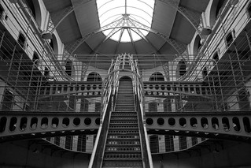

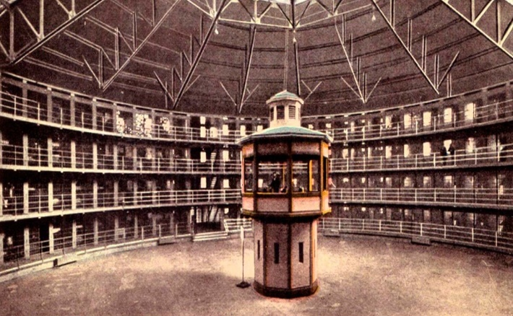

[This Photo](https://www.palomaviricio.com.br/2011/11/o-panoptismo-michael-foucault.html) by Unknown Author is licensed under [CC BY-NC-ND](https://creativecommons.org/licenses/by-nc-nd/3.0/)

* Foucault looks at how the disciplinary power of external surveillance and the uncertainty of whether one is being watched or not turns into internal surveillance or self-surveillance and individuals would control their own behaviour through self-control. Contemporary society has been transformed into a surveillance society or ‘disciplinary society’ as we are now in an ‘age of panopticism’. His ideas on surveillance match New Right notions of target hardening and rational choice. However, he thinks that this fear is a bad as opposed to a good thing as its sole purpose is for one group of people to impose their will on another in order to control behaviour.

Evaluation of Foucault

Use p 146

|  |  |
| --- | --- |
| What have we learned from this? | What is he criticised for? |
| * Stimulated further research into surveillance. | * Exaggerates extent of control * Are CCTV cameras a form of panopticism? * What do feminists say about CCTV? |

Surveillance theories since Foucault

Key Concepts: **LIQUID SURVEILLANCE, SELF-SURVEILLANCE**:

* **LIQUID SURVEILLANCE**: is associated with your digital footprint. E.g. when you use your phone or pay for something with a credit card this allows other people to potentially monitor your spending habits or track the places that you have been to which could potentially impinge on your civil liberties.
* **SELF-SURVEILLANCE**: this is where people, particularly new mothers, are so worried about the thought that other people are judging them to be doing a bad job that they constantly check themselves.
* **Henderson et al. (Radical Feminist)** applied Foucault’s concept of surveillance to the family and motherhood. They were conscious of how we increasingly spend our lives worrying about if we are doing the right thing especially in regards to being a parent. Mums in particular were sucked into a state of near paranoia about whether they were giving their new-born the right diet, amount of sleep and if it was OK to use disposable nappies. Henderson et al called this ***self-surveillance*** and one can see how this would link with deviance or even Merton’s idea of strain – the normlessness of not being able to attain what was an unrealistic goal in the first place of becoming a fully-fledged ‘yummy-mummy’ who goes out jogging every morning whilst pushing the baby along in a 3 wheeled pram
* **Newburn and Haymen**: approached the issue of surveillance from a completely different angle in that they acknowledged that although its use could erode civil liberties they recognised that it could also *protect* them.

In what became known as the ***Kilburn experiment*** they were granted access into the custody suite of a North London police station for 18 months. They were able to evaluate that as much as CCTV is an intrusion it could provide valuable evidence for defence lawyers in cases of alleged police brutality. The very fact that every single second of an offender’s time in a police station is being filmed may therefore ironically both intrude on and *protect* their rights at one and the same time. Newburn and Haymen also interviewed police officers on how they felt about being constantly monitored and they too agreed that it was potentially beneficial to them in reference to them being the subject of malicious allegations from detainees about their treatment at the hands of the police, especially in cases where a suspect died or fell ill whilst in custody.

* **Bauman & Lyon (Post-Modern)** wanted to demonstrate that as well as the thought that we are being watched can control our behaviour now we also are increasingly conscious of the fact that we are actually being watched. We enter a supermarket carpark and our number plate is displayed on a screen alongside our arrival time; we hand over our loyalty cards so the same supermarket can then target us with customized promotions based on our spending habits. In addition, employers google job applicants to see if any alarm bells ring as a result of our digital footprint and our phones demand that we turn location finding software on. Bauman and Lyon call this ***liquid surveillance*** and argue that the powers that be can now use this information to erode our civil liberties. Again the outcome of this is that it should prevent us from committing crime because we have been convinced that someone is monitoring everything that we do.

How useful is the study of surveillance?

Foucault is valuable as he shows how the power of surveillance can increase the power of the state. He sees this as oppressive social control inducing conformity and limiting opposition. Surveillance is everywhere and we have become unaware of it.

**Arguments Against:**

There is an assumption that surveillance is a bad thing, however, it has led to the arrest of many would-be terrorists before they can commit their planned atrocities.   Also, the only people who need to worry about being watched are those who are doing something wrong.

Perhaps we are now so used to surveillance we are no longer aware of it, which is why people may be careless on social media or when there is CCTV around.

Mathieson argues that Foucault’s account only tells us half the story as it focussed on the few monitoring the many whereas social media now allows *the many to monitor the few*. In late modernity we have a more fragmented situation where everybody watches everybody (he calls this ‘synopticon’). The public can monitor each other through dashcam etc.

Criticisms of the use of the term ‘disciplinary power’

Feeley and Simon – claim that we have a new ‘technology of power’ which is slightly different. They look at actuarial justice and risk management.

* Focusses on groups
* Focusses on prevention
* Calculates risk

Eg airport security. These approaches aim to protect and prevent. There is some *social sorting and labelling* involved here which could lead to particular groups being monitored and targeted and possible self-fulfilling prophecy. Norris and Armstrong found black males were disproportionately targeted. CCTV operators can make decisions about who they focus on.

Punishments

Whilst punishment occurs in many contexts (the school, the family etc) within the legal system it involves a number of connected areas – from law, conviction, sentencing and administering penalties.

A sociological understanding of punishment reveals different aims of punishment that prevail in different contexts, and it has also produced a number of sociological theories of punishment.

**Aims of Punishments**

There are different aims of punishment which impact on the forms of punishment devised. The main approaches include:

* **Deterrence:** this is associated with harsh punishments which should act to deter people from offending. However this appears to have limited success; it can be counterproductive (people gain credibility as being tough, or else commit more serious crimes if they are going to get severely punished anyway). The evidence of persistent re-offenders, and high crime rates in countries with capital punishment, also undermines the effectiveness of this approach.
* **Rehabilitation:** this approach believes that people can be reformed with appropriate supervision and treatment. This is seen as more humane and constructive approach, but societal calls for revenge and/deterrence punishment aims can lead to conflict. In practice there tend to be a balancing act between the competing aims of reform and retribution.
* **Reparation:** this approach believes offenders should make amends for their offences and that those they injure/affect should have some say in what that act of reparation should be. However, reparation can be difficult to apply (particularly if a financial compensation is appropriate), but it is seen as being workable and suitable for relatively minor offences (e.g. damage to property).

Sociological Theories of Punishments

**Functionalist perspectives**

Emphasise that punishment represents the ‘collective conscience’ of society and thus is an important element in social cohesion. In simple societies punishments will be harsher which reflects the intensity of the collective conscience, whereas in more complex societies there is greater diversity and interdependence which means that punishments for violations of the collective conscience will be more lenient. For Durkheim, the essence of punishment is the expression of moral condemnation (rather than the unpleasant nature).

Types of justice?

|  |  |
| --- | --- |
| Retributive | Restitutive |
|  |  |

**Conflict Perspective:**

Whilst Marx barely wrote on crime, conflict theorists emphasise punishment as a form of class control to maintain existing order. Emphasis is on maintaining existing social order as part of RSA. Rusche and Kirchheimer show that each type of economy has a corresponding punishment system. Money fines can only exist in a money economy. Prisons and capitalism have similar punishments, involving subordination and loss of liberty.

Prisons

Holding prisoners as punishment is quite a recent phenomenon. Since the 18th Century. Before that punishments were

Prison today

Most liberal democracies do not have the death penalty. However, prison has not proved to be effective. 2/3 prisoners reoffend when released. Prison may exist to remove offender from the streets. Prisons may now be taking more of a welfare role. This can lead to ‘transcarceration’ where vulnerable individuals are moved between different kinds of institutions.

Garland claimed that the USA and the UK are moving towards ‘mass incarceration’ claiming that prison numbers are rising. He claims this is due to the growing politicisation of crime control. This is due to zero tolerance and policies which crack down on crime.

Alternatives to prison?

Growth in community controls like curfews, community service orders, treatment orders and electronic tagging.

Stanley Cohen argues that the growth of community controls has cast a ‘net of control’ over more people. He argues that the increased range of sanctions simple allows control to go even deeper into society. Community control may divert young people into crime. Some argue that the police have used ASBOs to fast track young offenders into sentences.

How to prevent crime

1. Situational crime prevention

***Target hardening - this assumes that criminals are making a rational choice***

S. Cohen Rational choice theory - much crime is opportunistic, and if you reduce the opportunities to commit crime, you reduce the crime rate.

Right realists do not think the solution is to target the causes of crime.

Crime can be reduced by making it a less attractive choice. Many measures are possible, such as *target hardening* (e.g. making a house or car more difficult to break into), *surveillance* (e.g. close circuit television) and *Neighbourhood Watch schemes*. However, the crime prevention ‘industry’ has arguably only moved the crime elsewhere rather than reduce the total level.

Marcus Felson (1998) gives an example of a situational crime prevention strategy. The Port Authority bus terminal in New York City was poorly designed and provided opportunities for crimes – for example the toilets were a good place to steal luggage, deal drugs and engage in homosexual sex. Re-shaping the physical environment to ‘design out’ crime led to a large reduction in crime. For example, replacing the large sinks which homeless people used for washing reduced the numbers of homeless people hanging around the bus station.

Another example of where situational crime prevention has been successful is around suicide prevention. In the early 1960s, around half of all suicides in Britain were the result of gassing. At that time, Britain’s gas supply came from highly toxic coal gas, but from the 1960s coal gas was gradually replaced by less toxic natural gas, and by 1997, suicides from gassing had fallen to bear zero, with the suicide rate overall witnessing a corresponding decline (ie people hadn’t simply switched to other means of killing themselves.

There is a concern that this does not work and simply displaces the crime.

Chaiken - crime may move elsewhere. May be committed at a different time. Different victim. Different method.

These theories ignore the root cause of crime. They also mainly focus on vandalism, theft etc.

1. Environmental crime prevention

**Wilson**in his article “*Broken Windows*” has argued that a minor sign of neglect, such as leaving a broken window unrepaired, could lead to a climate of disorder in which ever more serious crime became possible as people no longer care about their community or environment. By tackling these minor signs of neglect people will be less likely to commit crime in that area. **Wilson and Kelling** say that damage to a neighbourhood must be put right straight away. Or problems of crime will quickly get out of hand.

Wilson and Kelling also favour zero tolerance policing where antisocial crime is dealt with swiftly.

Zero tolerance policing has been successful in some cases – example of ‘clean car’ programme in New York. This is when any car with graffiti on was removed. As a result graffiti was largely removed from the subway. There are arguments against this but overall it is seen to have been very effective and has had a global influence.

1. Social and community crime prevention.

These approaches focus on the offender and their social context. The aim is to remove the conditions which led to crime. Long term strategies which aim to tackle the root causes of crime rather than simply removing opportunities to commit crime.

Eg Perry pre-school project

An experimental group of 3-4 year olds was offered a two year intellectual enrichment programme and weekly home visits.

By age 40 they had fewer lifetime arrests for violent crime when compared to a control group.

The Criminal Justice System

The Criminal Justice System (CJS) covers England and Wales and is one of the major public services in this country. Across the Criminal Justice System, agencies such as the police, the Crown Prosecution Service (CPS), the courts, prisons and prohibition work together to deliver criminal justice.

The core agencies of the CJS are:

* Police
* Crown Prosecution Service
* The Courts
* Youth Justice Board (including youth offending teams)
* National Offender Management Service (including the probation service and Prisons)

Some services and initiatives within the CJS are run by a number of voluntary groups such as Victim Support and the National Association for the Care and Resettlement of Offenders (NACRO).

Three departments are jointly responsible for the Criminal Justice System (CJS) and its agencies:

**The Ministry of Justice**

* Oversees the magistrates’ courts, the Crown Court, the Appeals Courts, the Legal Services Commission and the National Offender Management Service (including prisons and probation)
* The Ministry of Justice manages the justice process from end to end – from the moment a suspect has been charged, through the courts, to prison and probation if necessary.
* The ministry is responsible for criminal law and sentencing policy, for legal aid, reducing re-offending and for prisons and probation.

**The Home Office**

* Oversees the police.
* The Home Office protects the public from terror, crime and anti-social behaviour. It helps build the security, justice and respect that enable people to prosper in a free and tolerant society.
* The department is responsible for crime and crime reduction, policing, security and counter-terrorism.

**The Attorney General**

* oversees the Crown Prosecution Service, the Serious Fraud Office and the Revenue and Customs Prosecutions Office.
* The Attorney General, assisted by the Solicitor General, is the chief legal adviser to the Government. They are responsible for ensuring the rule of law is upheld.
* The Attorney General also has certain public interest functions, for example, in taking action to appeal unduly lenient sentences, and bringing proceedings under the Contempt of Court Act.

The purpose of the Criminal Justice System (CJS) is to deliver justice for all, by convicting and punishing the guilty and helping them to stop offending, while protecting the innocent. It is responsible for detecting crime and bringing it to justice; and carrying out the orders of court, such as collecting fines, and supervising community and custodial punishment.

The key goals for the Criminal Justice System are:

* To improve the effectiveness and efficiency of the CJS in bringing offences to justice.
* To increase public confidence in the fairness and effectiveness of the CJS.
* To increase victim satisfaction with the police, and victim and witness satisfaction with the CJS.
* To consistently collect, analyse and use good quality ethnicity data to identify and address race disproportionality in the CJS.
* To increase the recovery of criminal assets to ensure that crime does not pay.

Possible exam questions

Outline **two** ways in which gender may influence the risk of being a victim of crime.

**[4 marks]**

Outline **three** reasons why victims may not report crimes.

**[6 marks]**

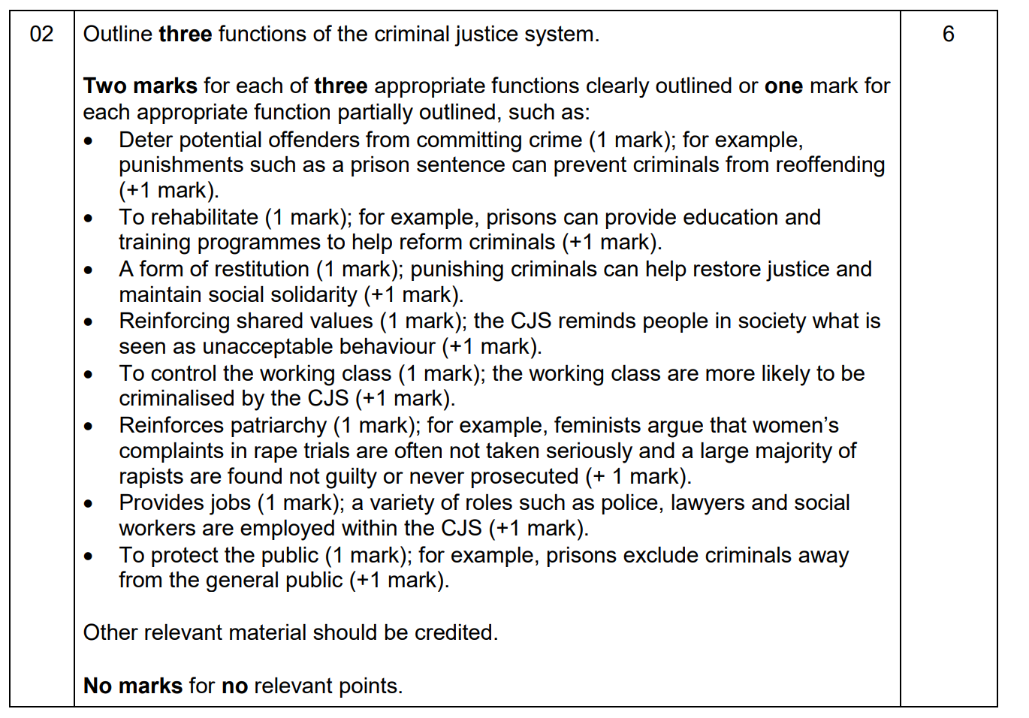

Item A13All societies have systems of punishment for dealing with the deviance, and sociologists have explained the role in a variety of different ways. Some sociologists emphasise the importance of society having shared values. Others argue that punishment may takes the form that it does because it reflects the nature of an unequal Society. Some writers have pointed to the way in which punishment varies according to the type of society in which it is found.

Applying material from item A13, analyse two functions of punishment

The risk of being a victim of crime appears to vary by ethnic group, both in terms of ordinary crimes and racially motivated crimes. This is shown in victim surveys. Surveys are based on the assumption that people are aware of what is happening to them. All suspected crimes have to go through a process of being reported and investigated before they are officially categorised as a crime. The role of police is crucial to this process.

Applying material from item A10, analyse two explanations for the apparent differences in the rates of victimisation of ethnic groups.

