**Upper 5 topics Paper 2**

**The structure and function of the nervous system**

**Nervous system**

The human nervous system consists of:

* the central nervous system – the brain and spinal cord
* the peripheral nervous system – nerve cells that carry information to or from the CNS

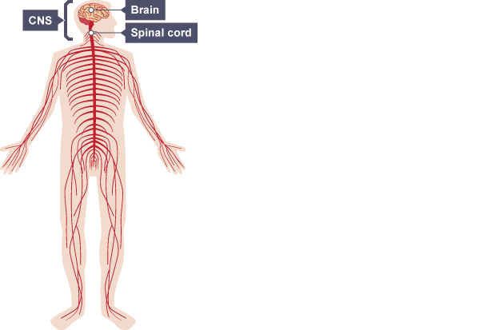

The conditions inside our body must be carefully controlled if the body is to function effectively. The conditions are controlled in two ways with chemical and nervous responses.

All control systems include:

* Cells called receptors, which detect stimuli (changes in the environment).
* The coordination centre, such as the brain, spinal cord or pancreas, which receives and processes information from receptors around the body.
* Effectors bring about responses, which restore optimum levels, such as core body temperature and blood glucose levels. Effectors include muscles and glands, and so responses can include muscle contractions or hormone release.

**Nerve cells**

Nerve cells are called neurones. They are adapted to carry electrical impulses from one place to another.

A bundle of neurones is called a nerve.

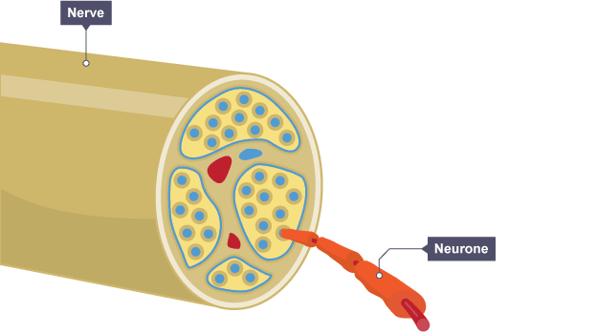

There are three main types of neurone: sensory, motor and relay.

They have some features in common:

* A long fibre (axon) which is insulated by a fatty (myelin) sheath. They are long so they can carry messages up and down the body.
* 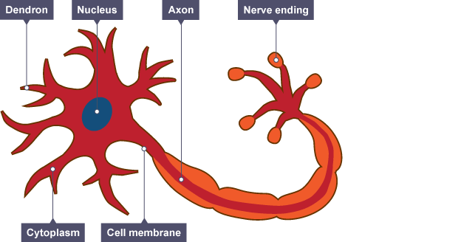Tiny branches (dendrons) which branch further as dendrites at each end. These receive incoming impulses from other neurones.

## Receptors to effectors

* Information from receptors passes along neurones, as electrical impulses to co-ordinators such as the central nervous system or CNS. The CNS is the brain and spinal cord. Muscles contracting or glands secreting hormones are the response of effectors coordinated by the CNS.
* Stimulus → receptor → coordinator → effector → response
* The diagram summarises how information flows from receptors to effectors in the nervous system.

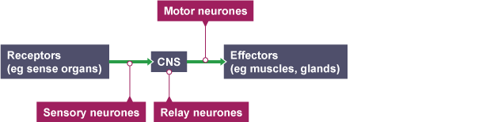

**Receptors**

Receptors are groups of specialised cells. They detect a change in the environment (stimulus) and stimulate electrical impulses in response. Sense organs contain groups of receptors that respond to specific stimuli.

Sense organ Stimulus

Skin Touch, temperature and pain

Tongue Chemicals (in food and drink, for example)

Nose Chemicals (in the air, for example)

Eye Light

Ear Sound and position of head

Effectors

Effectors include muscles and glands - that produce a specific response to a detected stimulus.

For example:

a muscle contracting to move an arm

muscle squeezing saliva from the salivary gland

a gland releasing a hormone into the blood

**Coordination and control - The nervous system**

The nervous system enables humans to react to their surroundings and to coordinate their behaviour. It comprises millions of neurones and uses electrical impulses to communicate very quickly.

**Reflex arc or Reflex actions**

There are different types of neurones that work together in a reflex action.

This creates an automatic and rapid response to a stimulus, which minimises any damage to the body from potentially harmful conditions, such as touching something hot.

A reflex action follows this general sequence and does not involve the conscious part of the brain, which makes it much quicker.

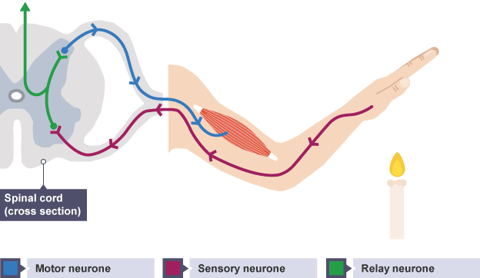The nerve pathway followed by a reflex action is called a reflex arc. For example, a simple reflex arc happens if we accidentally touch something hot.

1. 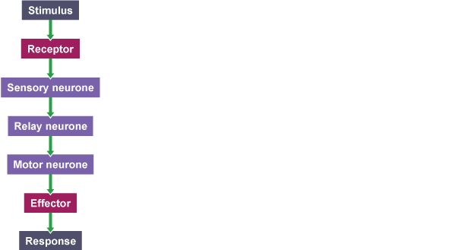**Receptor** in the skin detects a stimulus (the change in temperature).
2. **Sensory neurone** sends electrical impulses to **relay neurone**, which are located in the spinal cord. They connect sensory neurones to motor neurones.
3. **Motor neurone** sends electrical impulses to an effector.
4. **Effector** produces a response (muscle contracts to move hand away).

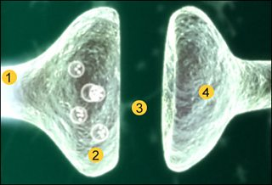Where two neurones meet there is a small gap, a synapse.

1. An electrical impulse travels along the first axon.
2. This triggers the nerve-ending of a neurone to release **chemical messengers** called neurotransmitters.
3. These chemicals **diffuse** across the synapse (the gap) and bind with receptor molecules on the membrane of the second neurone.
4. The receptor molecules on the second neurone bind only to the **specific** **neurotransmitters** released from the first neurone. This **stimulates** the second neurone to transmit the electrical impulse.

**Coordination and control - The human endocrine system**

The endocrine system secretes hormones into the bloodstream from glands throughout the body. Hormones produce an effect on specific target organs in the body.

**Hormones and nerves**

A hormone is a chemical substance, produced by a gland and carried in the bloodstream, which alters the activity of specific target organs. An example of this is the release of the hormone adrenaline, which is released by the adrenal gland. One of its target organs is the heart, where it increases the heart rate.

Once a hormone has been used, it is destroyed by the liver.

Hormones can control the body, and the effects are much slower than the nervous system, but they last for longer.

There are important differences between nervous and hormonal **control**.

|  | **Nervous** | **Hormonal** |
| --- | --- | --- |
| **Type of signal** | Electrical (chemical at synapses) | Chemical |
| **Transmission of signal** | By nerve cells (neurones) | By the bloodstream |
| **Effectors** | Muscles or glands | Target cells in particular tissues |
| **Type of response** | Muscle contraction or secretion | Chemical change |
| **Speed of response** | Very rapid | Slower |
| **Duration of response** | Short (until nerve impulses stop) | Long (until hormone is broken down) |

**Master gland**

The pituitary gland in the brain is known as a 'master gland'. It secretes several hormones into the blood in response to the body's condition, such as blood water levels. These hormones can also act on other glands to stimulate the release of different types of hormones and bring about effects.

**Different hormones**

The body produces a range of different chemical **hormones** that travel in the bloodstream and affect a number of different organs or cells in the body. The diagram below shows this in detail.

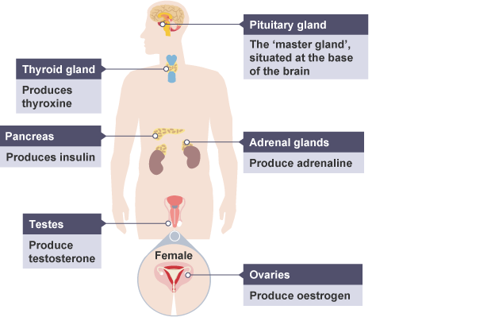

Important hormones released into the bloodstream include ADH (anti-diuretic hormone), adrenaline and insulin.

|  | **Source** | **Organ(s)** | **Role** | **Effects** |
| --- | --- | --- | --- | --- |
| **ADH** | Pituitary gland | Kidneys | Controlling the water content of the blood | Increases reabsorption of water by the collecting ducts |
| **Adrenaline** | Adrenal glands | Several targets including the respiratory and circulatory systems | Preparation for 'fight or flight' | Increases breathing rate, heart rate, flow of blood to muscles, conversion of glycogen to glucose |
| **Insulin** | Pancreas | Liver | Controlling blood glucose levels | Increases conversion of glucose into glycogen for storage |

**Negative feedback systems in hormonal control – Higher**

**Homeostatic control**

In animals, conditions such as water concentration, temperature, and glucose concentration must be kept as constant as possible. Control systems that keep such conditions constant are examples of homeostasis; this is the maintenance of constant internal conditions in an organism.

A negative feedback mechanism is an important type of control that is found in homeostasis. A negative feedback control system responds when conditions change from the ideal or set point and returns conditions to this set point. There is a continuous cycle of events in negative feedback.

**General stages in negative feedback**

In general this works by:

* if the level of something rises, control systems reduce it again
* if the level of something falls, control systems raise it again

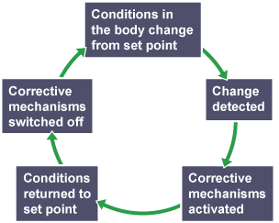

Negative feedback flowchart

An example of negative feedback is the control of body temperature. Body temperature is controlled by the hypothalamus in your brain, and if your body gets too hot, your body begins to sweat to try and reduce it. Conversely if the body gets too cold, it begins to shiver to try and raise the temperature.

**Thyroxine and adrenaline – Higher**

Thyroxine is produced from the thyroid gland, which stimulates the basal metabolic rate. It controls the speed at which oxygen and food products react to release energy for the body to use. Thyroxine plays an important role in growth and development. Thyroxine levels are controlled by negative feedback.

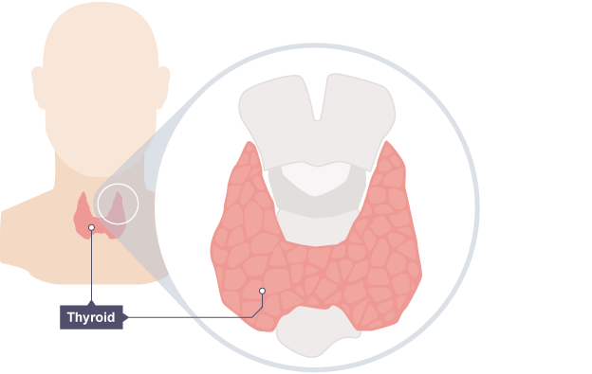

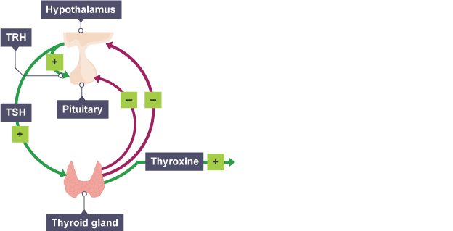

The hypothalamus and pituitary gland have important roles in detecting and controlling thyroxine levels.

1. **Low** thyroxine levels in the bloodstream stimulate the hypothalamus to **release TRH** and this causes the pituitary to **release TSH** so the thyroid **releases more** thyroxine. So blood levels return to normal.
2. **Normal thyroxine levels** in the bloodstream **inhibit TRH**release from the hypothalamus and this inhibits the release of **TSH** from the pituitary, so normal blood levels are maintained.

Adrenaline is produced by the adrenal glands in times of fear or stress. It targets vital organs, increases the heart rate and boosts the delivery of oxygen and glucose to the brain and muscles, preparing the body for 'flight or fight'. Adrenaline is **not** controlled by negative feedback.

When adrenaline is released into the bloodstream it creates multiple effects:

* increases breathing rate, heart rate, and conversion of glycogen to glucose so more energy is released in the muscles
* it diverts blood away from areas, such as the digestive system, towards the muscles

The effects of adrenaline allow the body to prepare for action in situations where a quick response may be essential.

**Control of blood glucose concentration by the pancreas and insulin.**

Regulating blood glucose

Glucose is needed by cells for respiration. It is important that the concentration of glucose in the blood is maintained at a constant level and controlled carefully. Insulin is a hormone - produced by the pancreas - that regulates glucose concentrations in the blood.

If the blood glucose concentration is too high, the pancreas produces the hormone insulin that causes glucose to move from the blood into the cells. In liver and muscle cells excess glucose is converted to glycogen for storage, and will be used at a later date.

Action of insulin

|  | **Low glucose** | **High glucose** |
| --- | --- | --- |
| **Effect on pancreas** | **Insulin not secreted into the blood** | **Insulin secreted into the blood** |
| **Effect on liver** | **Does not convert glucose into glycogen** | **Converts glucose into glycogen** |
| **Effect on blood glucose level** | **Increases** | **Decreases** |

**The diagram illustrates how insulin works in the body:**

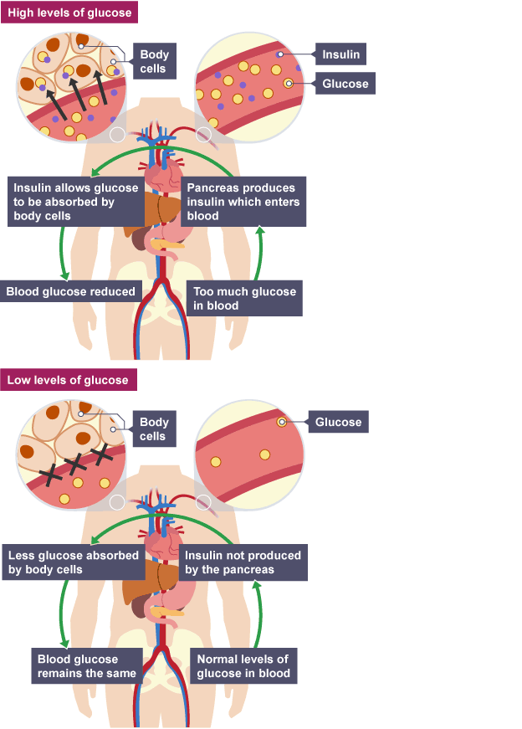

Diabetes is a condition where the blood glucose levels remain too high. It can be treated by injecting insulin. The extra insulin causes the liver to convert glucose into glycogen, which reduces the blood glucose level.

There are two types of diabetes - type 1 and type 2.

**Type 1 diabetes**

Type 1 diabetes is a disorder in which the pancreas fails to produce enough insulin. This can be detected from an early age. It is characterised by uncontrolled high blood glucose levels and it can be controlled by injecting insulin.

People with type 1 diabetes have to monitor their blood sugar levels throughout the day. Their levels of physical activity and their diet affect the amount of insulin needed.

They can *help* to control their blood glucose level by being careful with their diet, and eat foods that will not cause large increases in blood sugar level, and by exercising, which can lower blood glucose levels due to increased respiration in the muscles.

**Type 2 diabetes**

In type 2 diabetes the person's body cells no longer respond to insulin produced by the pancreas. It is more common in older people. It can be controlled by a carbohydrate controlled diet and an exercise regime. Carbohydrate is digested into glucose, which raises the overall blood glucose level. There is a correlation between rising levels of obesity in the general population and increasing levels of type 2 diabetes.

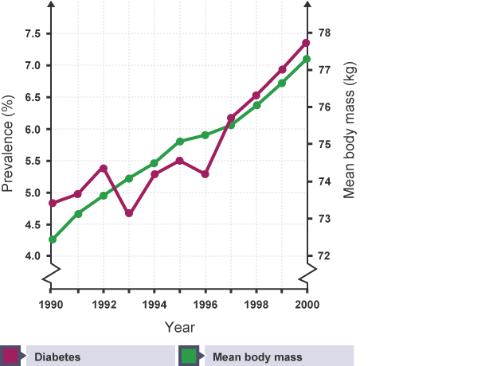

Changes in obesity and type 2 diabetes

**Question**

Describe the pattern in this data.

The graph shows a range of data from 1990 to 2000. Mean body weight has steadily increased from approximately 72.5 kg in 1990, to 75.5 kg in 1997 up to just over 77 kg in 2000.

This matches a general increase in the number of people with type 2 diabetes from 1990 to 2000. For example, the percentage was just below 5% in 1990 up to just below 7.5% in 2000. This shows an overall increase in 2.5% over 10 years.

There are dips and minor peaks within the graph, and these may be due to the introduction of a particular type of food, or other additional factors such as lifestyle.

Tips: Use the labels on the axes to help you describe the relationship between the data in the graphs.

**Role of glucagon in control of blood sugar levels – Higher**

**Negative feedback**

In blood glucose regulation, the hormone insulin plays a key role. When blood sugar rises in the blood, insulin sends a signal to the liver, muscles and other cells to store the excess glucose. Some is stored as body fat and other is stored as glycogen in the liver and muscles. Whereas, if the blood glucose level is too low, the liver receives a message to release some of that stored glucose into the blood. This change is brought about by another hormone produced by the pancreas called glucagon.

This is an example of negative feedback.

