

# GCSE Religious Studies

# Paper 1: The study of religions: Islamic Practices

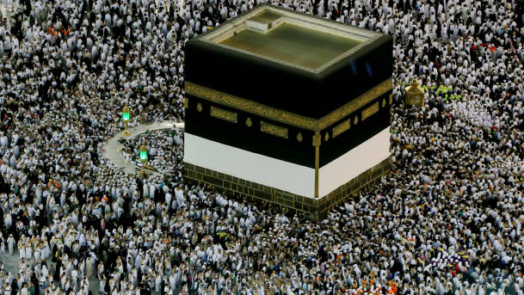

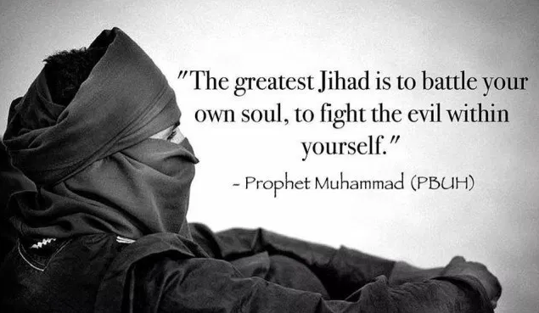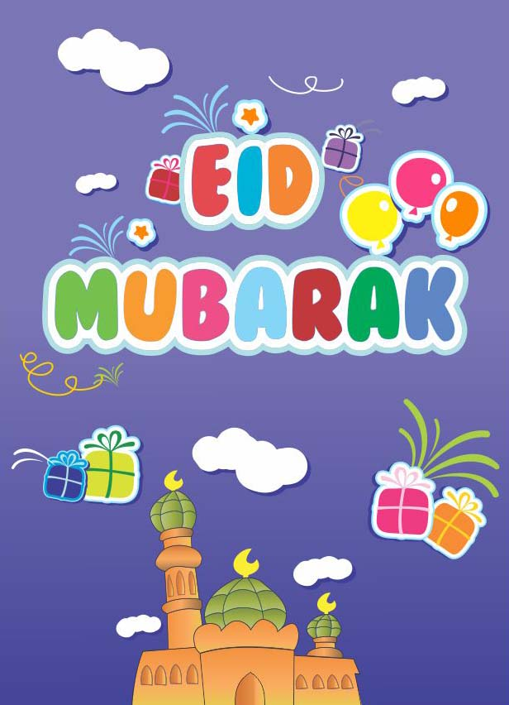

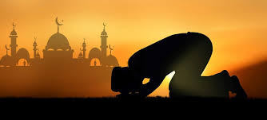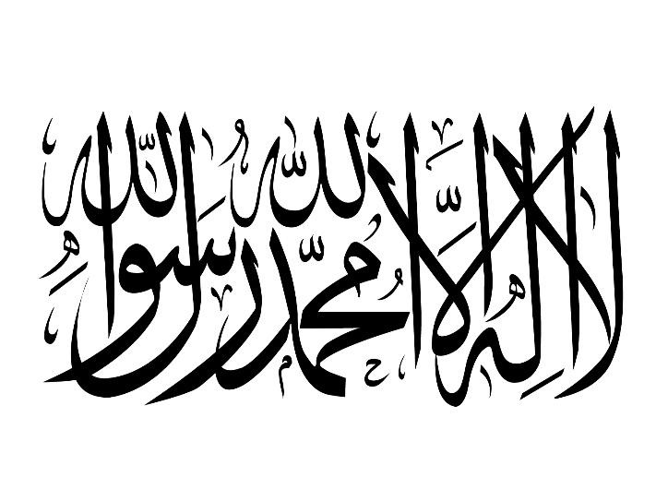

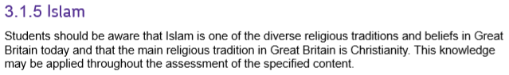

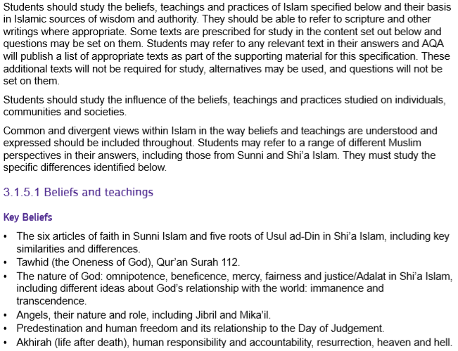

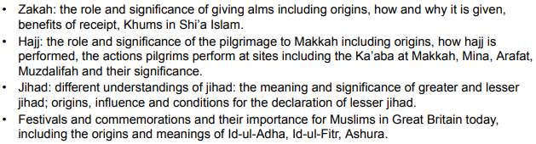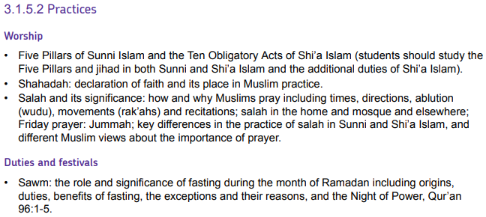

|  |  |
| --- | --- |
| **Key Term** | **Definition** |
| **Day of Ashura** | A festival that is important for Shi’a Muslims in particular, who remember the battle of Karbala and the death of Husayn on this day. |
| **the Five Pillars** | The five most important duties for all Muslims. |
| **Greater Jihad** | The personal inward struggle of all Muslims to live in line with the teachings of their faith. |
| **Hajj** | The annual pilgrimage to Mecca that every Muslim should try to make at least once in their life |
| **Hajji** | Someone who has completed Hajj. |
| **Holy War** | Fighting for a religious cause or God. |
| **Id-ul-Fitr** | A Muslim festival that celebrates the end of Ramadan. |
| **Id-ul-Adha** | A Muslim festival that celebrates the prophet Ibrahim’s willingness to sacrifice his son for God. |
| **Jihad** | A struggle against evil; this may be an inward, personal struggle or an outward, collective struggle. |
| **Jummah Prayer** | A weekly communal prayer performed after midday on Friday, which includes a sermon. |
| **Ka’aba** | The black, cube-shaped building in the centre of the Grand Mosque in Mecca; the holiest place in Islam |
| **Khums** | A 20% tax paid by Shi’a Muslims on their excess income |
| **Lesser Jihad** | The outward struggle to defend one’s faith, family and country. |
| **Mihrab** | A niche in a wall that indicates the direction of Mecca |
| **the Night of Power** | 1. The night when the first revelation of the Qur’an was made to Muhammad;  2. The festival that marks the start of God’s revelation to Muhammad |
| **Pilgrimage** | A journey by a believer to a holy site for religious reasons; an act of worship and devotion. |
| **Prostration** | Kneeling with the forehead, nose, hands, knees and toes touching the floor in submission to God. |
| **Qiblah wall** | The wall in a mosque that contains the mihrab. |
| **Rak’ah** | A sequence of movements in ritual prayer. |
| **Ramadan** | The ninth calendar month of the Muslim calendar, during which Muslims have to fast from dusk to sunset. |
| **Recitation** | Repeating a passage of text from memory. |
| **Sadaqah** | Good actions or voluntary payments that are undertaken for charitable reasons. |
| **Salah** | Prayer with and in worship of God, performed under conditions set by the prophet Muhammad. |
| **Shahadah** | The Muslim declaration of faith. |
| **The Ten Obligatory Acts** | Ten important duties for Shi’a Muslims, including the Five Pillars. |
| **Wudu** | Ritual washing before prayer. |
| **Zakah** | Purification of wealth by giving 2.5% of savings each year to the poor |

**The Five Pillars of Islam**

The Five Pillars are central to Muslim practices and they have a great impact on daily life. Muslims believe that they uphold the main principles and beliefs of Islam, just as pillars support a building. They can be seen as the key to living a perfect Muslim life and help give Muslims an identity as one community who share a faith.

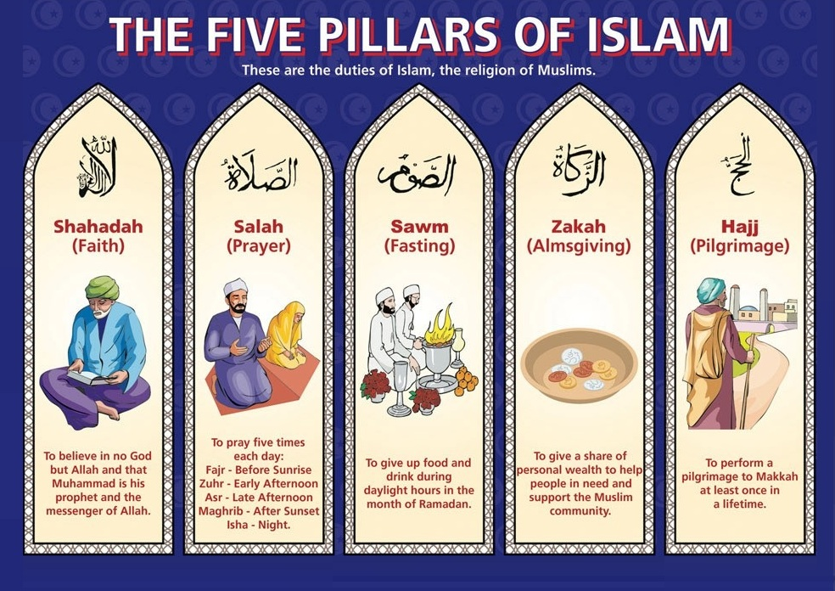

**The Ten Obligatory Acts in Shi’a Islam**

**Shi’a Muslims**, as well as **the Five Pillars** (except Shahadah which is included in some of the additional acts), have 5 additional responsibilities which make the **Ten Obligatory Acts**.

1. Salah – prayer (see pages 6-8)
2. Sawm – fasting (see pages 9 & 10)
3. Zakah – charitable giving (see page 11)
4. **Khums – a 20% tax on income once all expenses are deducted. Half goes to charity and half goes to Shia religious leaders.**
5. Hajj – pilgrimage (see pages 12-14)
6. **Jihad – the struggle to maintain the faith and defend Islam. (see page 15)**
7. **Amr-bil-Maruf – encouraging people to do what is good.**
8. **Nahi Anil Munkar – discouraging people from doing what is wrong.**
9. **Tawallah – to be loving towards the friends of God, including Muhammad and the Imams**
10. **Tabarra – disassociating from the enemies of God.**

**Shahadah**

The basic and most important belief of Islam is expressed in the Shahadah. In English it can be translated to:

*“There is no God but Allah and Muhammad is the Prophet of Allah”*

Sincerely believing and reciting this statement in front of Muslim witnesses is the only requirement for becoming a Muslim and joining the Muslim community. It is included in the daily prayers, it is said when a baby is born, and, if possible, it should be the last words of a Muslim before they die.

As well as being the first of the Five Pillars, the Shahadah provides the foundation for the other four (this also applies to the additional five Obligatory Acts in Shi’a Islam). Carrying out these other requirements are actions that put a Muslim’s faith, expressed in the Shahadah, into practice.

**The Shahadah in Shi’a Islam**

Shi’a Muslims add an extra phrase to the Shahadah:

*“…and Ali is the friend of God”*

This demonstrates their commitment to the belief that Ali, Muhammad’s cousin and son-in-law, was the true successor of Muhammad, and that only he and his descendants know the true meaning of the revelation given to Muhammad.



**Explain two reasons that the Shahadah is important in Islam (4 marks)**

**Salah: The Daily Prayers**

The second pillar of Islam is that **Sunni Muslims** are required to pray and five set times during the day:

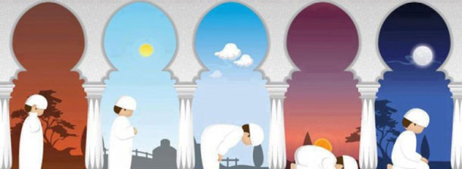

|  |  |  |  |  |
| --- | --- | --- | --- | --- |
| *Salat al-fajr*: dawn, before sunrise | *Salat al-zuhr*: midday, after the sun passes its highest | *Salat al-‘asr*: the late part of the afternoon | *Salat al-maghrib*: just after sunset | *Salat al-‘isha*: between sunset and midnight |

The specific times of these prayers will change depending on the season as sunrise and sunset also vary.

**Shi’a Muslims** combine the midday (al-zuhr) and afternoon (al-‘asr) prayers, and the sunset (al-maghrib) and night (al-‘isha) prayers. So they pray three times a day.

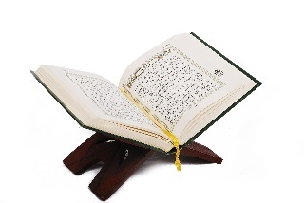**Wudu**

*“You who believe, when you are about to pray, wash your faces and your hands up to the elbows, wipe your heads, wash your feet up to the ankles and, if required, wash your whole body.”* **Qur’an 5:6**

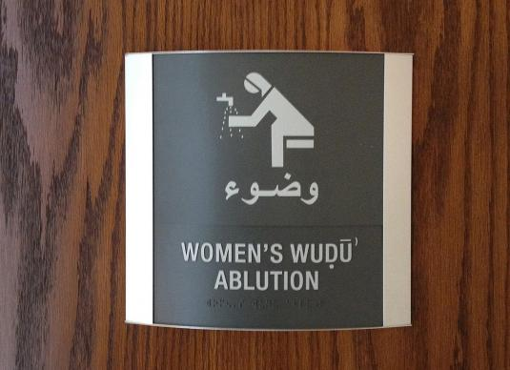

Before praying, Muslims undertake a ritual washing (or ablution) called **wudu**. Muslims follow detailed instructions as outlined in the Qur’an (see above). Mosques have two special rooms set aside to perform wudu, one for men and one for women.

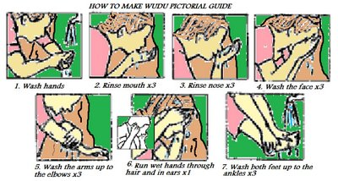

If water is not available, for example in a desert, a dry form of washing is allowed using sand or dust. This shows that it is not physical, but spiritual cleanliness that is required.

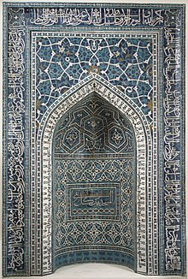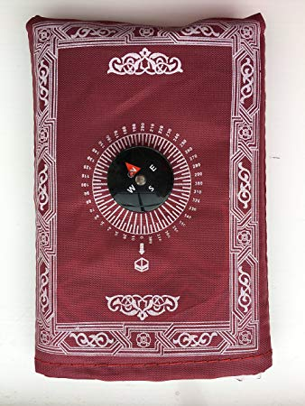All Muslims will face the holy city of Mecca while praying. This means that the whole Muslim community are physically and mentally focusing on one place. If the prayers are taking place in the Mosque, the **Mihrab** in the **Qiblah wall** (see right) shows the direction of Mecca. Many prayer mats will also have a compass on them which will help Muslims face the correct direction when praying elsewhere (see right).

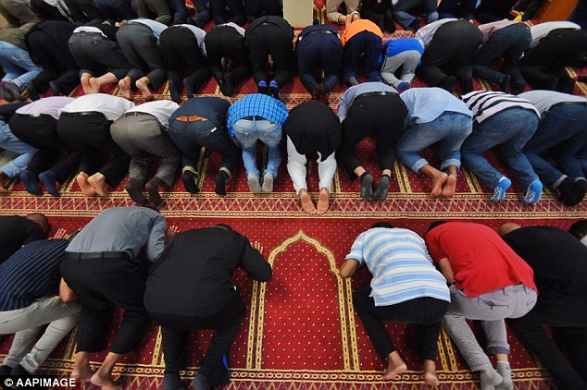Many Mosques have special carpets that look like separate rows of prayer mats facing the mihrab. This gives each person a suitable space to carry out their prayers properly.

The prayers are led by an Imam who is positioned at the front of the congregation but also facing the mihrab. Men and women pray at the same time but in separate spaces, either in different prayer rooms or in the same room separated by a partition or curtain. The voice of the Imam will often be broadcast into the women’s prayer room at the same time so he can lead their prayers also (women cannot be Imams).

**The rak’ah**

The daily prayers are made up of a number of **rak’ah**. This is a set sequence of actions and **recitations.** For example, the morning prayer is made up of two **rak’ah** and the night prayer is made up of four **rak’ah**. The rak’ah changes slightly depending on which prayer it is used in, and whereabouts it occurs in the overall sequence, but it includes the following basic actions:

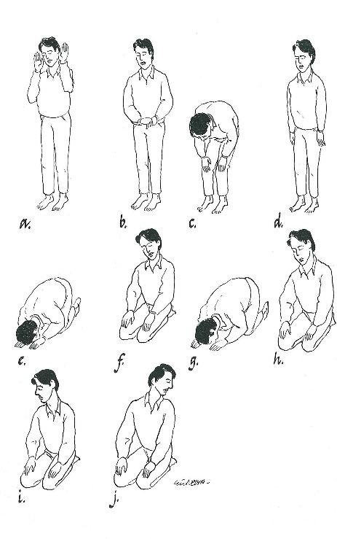a & b) While standing, Muslims recite the first chapter from the Qur’an.

c) While bowing, Muslims say in Arabic ‘Glory be to my Lord who is the very greatest’ three times. The bowing position shows they believe God to be great.

d) Returning to an upright position, they make a recitation praising God.

e) They then kneel with their forehead, nose, hands, knees and toes touching the floor. This is called **prostration** and shows complete obedience to God. They recite ‘How perfect is my Lord the most high’.

f & g) Muslims then sit while reciting ‘God is the greatest’, and after pausing for a few seconds prostrate themselves once more while repeating ‘God is the greatest’.

H, i & j) Once the required number of rak’ah is completed, in a kneeling position Muslims turn their face to the right and then to the left, greeting the angels on each shoulder, reciting in Arabic ‘Peace be upon you, and the mercy and blessings of God.’

Personal prayers (**Du’a** prayers) may be added on to the end of the final rak’ah. These do not have to be in Arabic and do not follow any set form.

**Jummah Prayer**

The midday prayer every Friday is considered to be special and is called the **Jummah prayer**. All male Muslims are expected to attend a mosque for this prayer, and women may do so if they wish. Once the prayer is complete, the Imam will deliver a sermon that teaches Muslims of their obligations and duties to God. Although Friday is not a day of rest, Muslims must leave their work or close their businesses in order to attend the Jummah prayer, and then return to work afterwards.

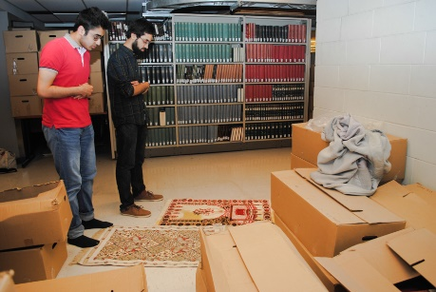**Prayer at home**

Muslims are allowed to pray at home. They must perform **wudu** before prayer but they do not need a special room in their home to pray. Provided the room is clean, it is suitable. Many Muslims will use a prayer mat and will face Makkah in the same way as they would in a mosque.

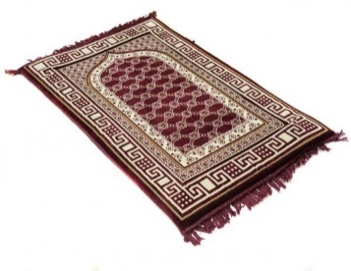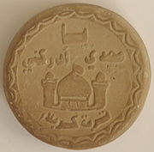 A **turbah** (see left) is a small piece of soil or clay, often a clay tablet, used during salah by **Shi’a Muslims** to symbolize earth. Many Hadith mention the benefits of prostration upon the soil of the earth. The most favoured soil is that of Karbala, the site of the death of Husayn (see page 18) however, soil from anywhere may be used. In the absence of soil, plants or items made from plants may be substituted. This is in contrast to **Sunni Muslims** who may pray in any clean place and often use a prayer mat (see right) to ensure this.

**Why is prayer important to Muslims?**

* It is one of the Five Pillars, it is something God has commanded them to do.
* It creates a greater awareness of God, which in turn motivates them to do God’s will.
* Prayer unites Muslims worldwide because they all pray in the same way: a Muslim can go into any mosque in the world and be able to participate in prayer with fellow Muslims.
* Reciting from the Qur’an during the prayers reminds Muslims of its importance.
* The actions of bowing and prostrating remind Muslim them that God is greater and more important than they are.

**Sawm: fasting during Ramadan**

Ramadan is the ninth month of the Islamic calendar and the most important for Muslims. They believe it was during Ramadan that Qur’an started to be revealed to Muhammad. Many Muslims will recite the whole of the Qur’an, in daily sections, over the 30 days of Ramadan.

During the month of Ramadan, Muslims focus on **fasting**, charity and pleasing God. All adult Muslims must give up the following things during the hours of daylight:

* Food or drink of any sort
* Smoking, including passive smoking
* Sexual activity

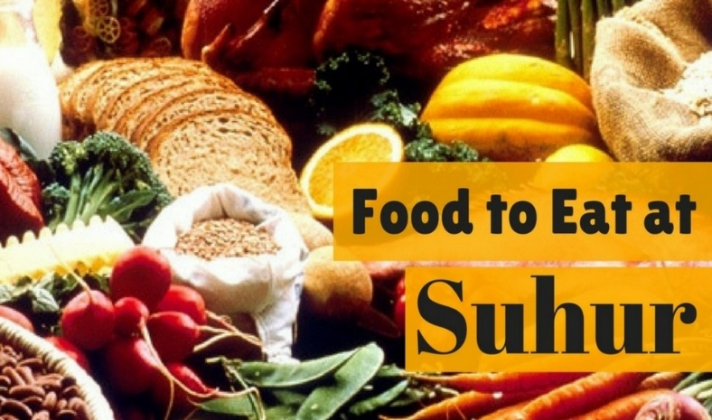During Ramadan, Muslims will get up early, before sunrise, to eat and drink enough to get them through the day. This meal is known as ***Suhur***. Depending on the time of year, Muslims may then go back to bed until it is time to begin their day. In the evening, at sunset, the fast is broken with another meal called ***Iftar*.** This is usually shared with family and friends and followed with extra prayers and readings from the Qur’an.

**Exceptions**

Muslims who are physically or mentally unwell may be excused some of these, as may those who are under twelve years old, the very old, those who are pregnant, breast-feeding, menstruating, or travelling.

If an adult does not fast for the reasons above they should try to make up the fast at a later date, or make a donation to the poor instead.

**Charity**

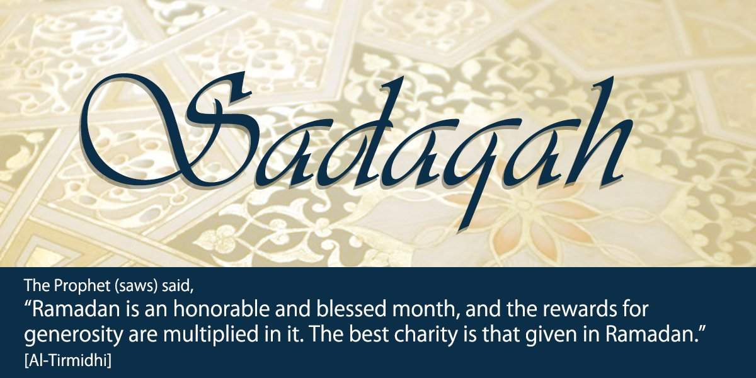One of the positive elements to feeling hungry during Ramadan is that it serves as a reminder of the life of the poor. This greater awareness inspires many Muslims to find ways to help the poor. This may include inviting the poor to share in Iftar in the evening and many Muslims choose to give greater Zakah during Ramadan.

Muslims do not only abstain from physical things during Ramadan. They are also expected to do their best to avoid evil thoughts and deeds as well. Muslims believe that their reward or punishment for their thoughts and actions are doubled during Ramadan because of the holy significance of the month.

The month of Ramadan is significant for Muslims because it:

* Is obeying God
* Learning self-discipline
* Becoming spiritually stronger
* Appreciating God’s gifts to us
* Sharing the sufferings of the poor and developing sympathy for them
* Realising the value of charity and generosity
* Giving thanks for the Holy Qur’an, which was first revealed in the month of Ramadan
* Sharing fellowship with other Muslims

**The Night of Power**

The Night of Power is an important festival that marks the beginning of God’s revelation to Muhammad. The exact date is not agreed on but it is believed to be one of the odd-numbered dates in the second half of Ramadan. The night’s importance is explained within the Qur’an:

*“What will explain to you what the Night of Power is? The Night of Power is better than a thousand months.”*

This means that observing the Night of Power gives Muslims the benefits of worshipping for a thousand months. Because of this, many Muslims try to stay awake throughout the night on each of the possible dates, devoting themselves to prayer and studying the Qur’an.

**Zakah: Almsgiving**

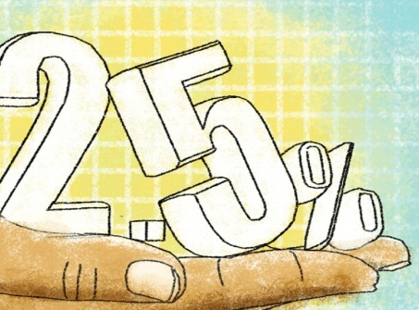The third pillar of Islam is **Zakah** (sometimes spelt Zakat). This means giving alms (money to the poor). It is compulsory for all Muslims to give 2.5% of their savings (whatever is left once you have paid for your own essentials such as housing, food, clothing etc.) This can be done monthly or in one go. Many Muslims work out how much they should pay for the year and give the money at the end of Ramadan.

Zakah is often given directly to a charity such as Islamic Relief or Muslim Aid. Alternatively, it can be put into a collection box at the Mosque to be distributed among the poor. The Qur’an is very clear about who should receive Zakah:

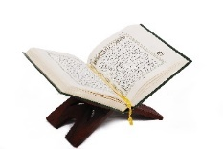 *“Alms are meant only for the poor, the needy, those who administer them, those whose hearts need winning over, to free slaves and help those in debt, for God’s cause, and for travellers in need.”*

Muslims consider Zakah important because:

* They are fulfilling a duty imposed by God.
* It teaches them a good attitude towards money.
* It strengthens the community be redistributing wealth.
* It puts their concern for others into action.

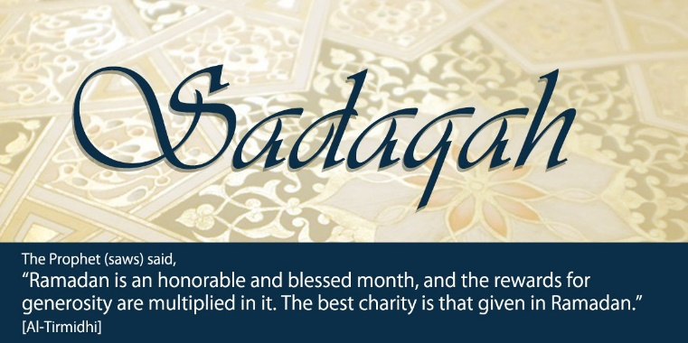

Charitable giving is not limited to Zakah and Muslims are encouraged to give voluntarily at any point of the year. This is called **Sadaqah**.

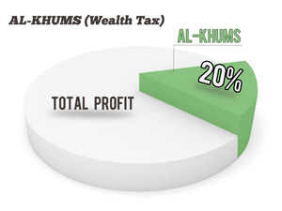**Khums**

In addition to Zakah, **Shi’a Muslims** also practice Khums which literally means ‘fifth’. Shi’a Muslims give 20% of their excess income to the Shi’a religious leaders to be spent on behalf of God on things considered necessary for religious matters. Any left over is given to the poor.

**Hajj**

Hajj is a pilgrimage to the holy city of Makkah that all Muslims should complete at least once in their lifetime, provided they are healthy and wealthy enough to do so. There are many Muslim communities that will help to provide financial support for someone to complete Hajj if they cannot afford it.

*“Pilgrimage to the House* (of Islam, Makkah) *is a duty owed to God by people who are able to undertake it.”*

Hajj originates in a story 4,000 years ago when the prophet Ibrahim (Abraham) was told by God to take his wife Hajira (Hagar) and son Ishmael to Arabia. He was then told to leave Hajira and Ishmael on their own with some supplies but, after a few days, these supplies ran out and they began to starve and dehydrate. Looking for help, Hajira ran up and down two hills, Safa and Marwah, before collapsing beside her son. She prayed to God for help and Ishmael dug his heel into the ground. This cause water to gush up from the earth and they were able to drink and trade water for food and other supplies. This well is now known as the Zam Zam well.

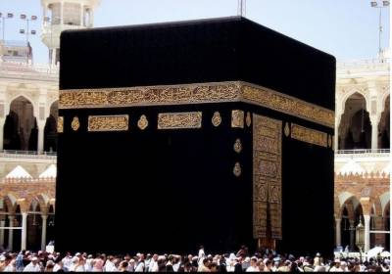

When Ibrahim returned, he was told by God to build a shrine dedicated to him. This became the Ka’aba. Ibrahim was told to make the Ka’aba a pure place of worship and to call people to perform Hajj there.

Many centuries later, the city of Makkah was established but over the years, the people of Makkah turned to worshipping idols, many of which were stored in the Ka’aba. In 628CE, Muhammad journeyed from Madinah to Makkah with a large group of followers, in what is now seen as the first Hajj, and in 630CE the Ka’aba was returned to the worship of God alone. As God commanded Ibrahim, the city is now preserved as a pure place of worship to the point where non-Muslims may not enter. 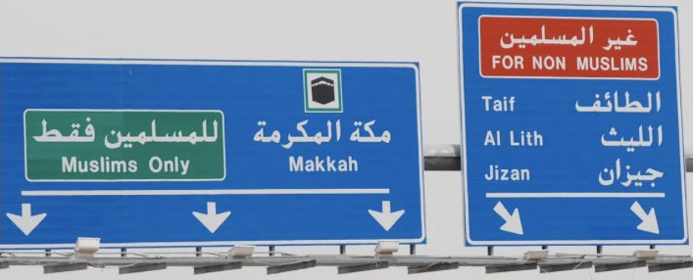

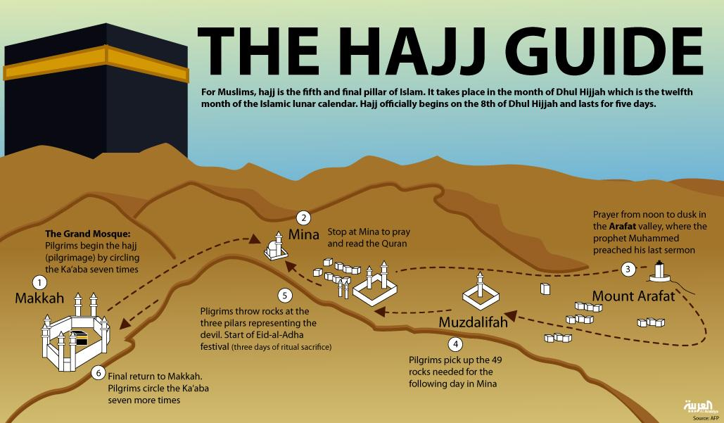

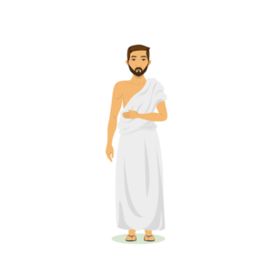Below, explain the significance of each of the stages of Hajj:

Before you start: Ihram

1. Tawaf

1-2. Sa’ey (Travelling between the hills of Safa and Marwah.)

2. Mina

3. Arafat

4 & 5. Muzdalifah & Stoning the devil

6. Tawaf again

**The Significance of Hajj**

* It can bring about a deep spiritual transformation that makes the Hajji a better person.
* It teaches sincerity and humility in a person’s relationship with God.
* It produces inner peace.
* It shows self-discipline: the physical and mental demands it imposes are great, not all are able to complete it.
* It emphasises unity and equality

Jihad

The Arabic word **‘Jihad’** translates as ‘to strive or struggle in the way of Allah’. Jihad therefore refers to striving to improve themselves and their society. When we hear this word used on the news, it is usually in reference to what Muslims call **‘lesser Jihad’**. This is the outward struggle to defend Islam, often taking the form of Holy War.

There is no specific theory of just war in Islam but Muslims tend to accept the conditions put forward by Aquinas. The Qur’an states though that Muslims may not start a war, it can only be justified in defensive terms:



*“And fight for the cause of Allah those who fight you. But do not be aggressive, surely Allah does not like the aggressors.”*

Qur’an 2:190

The first Islamic Caliph (leader), Abu Bakr, added some additional rules to govern how Muslim armies must engage in war:

*“Know that the evil of war is swift, and its taste bitter.”*

Hadith

* Children, women and old men must not be killed
* Dead bodies must not be mutilated
* Natural resources of the enemy must not be destroyed because they will be needed in the future.
* Animals must not be harmed unless for food.

Although fighting can be justified under these conditions, Muslims believe that avoiding war will always be preferable (see right).

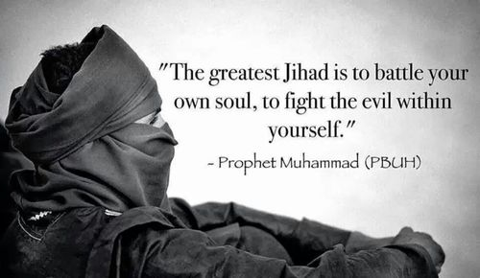**Greater Jihad**

By contrast, the Prophet Muhammad teaches that the **‘greater Jihad’** is the personal spiritual struggle or effort of every Muslim to follow the teachings of Allah (God) in their own lives e.g. overcoming things such as anger greed, pride and hatred; forgiving someone who has hurt them; working for social justice etc.



**Explain how Muslims would practise greater Jihad.**

**Festivals**

**Origins of Id-ul-Fitr and Id-ul-Adha**

When Muhammad arrived in Madinah, he noticed that people were celebrating two specific days with entertainment and festivities. When he asked about this he was told that before Islam came to their city, they had celebrated two grand carnivals each year. Muhammad replied that God has appointed two other days that are the better two celebrate, the days of **Id-ul-Fitr** and **Id-ul-Adha**.

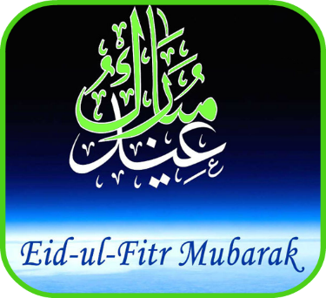**Id-ul-Fitr**

Id-ul-Fitr means ‘festival of breaking the fast’ because it marks the end of the month of Ramadan. It is sometimes referred to as lesser Id. Muslims celebrate the end of fasting but also thank God for the strength and help he has given them throughout the month. Muslims also give thanks for the guidance and wisdom of the Qur’an which was first revealed in the month of Ramadan.

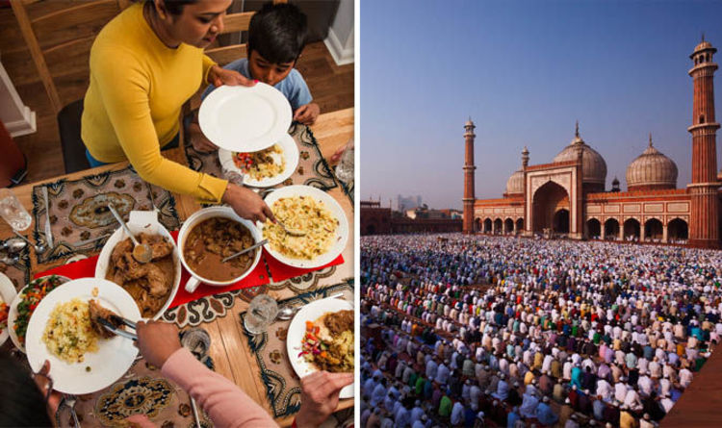Id-ul-Fitr may be celebrated for up to three days. Muslims gather together in mosques or large outdoor areas to say special prayers. The Imam’s sermon will remind Muslims that they should forgive and forget any differences or disputes that have occurred during the year and focus instead on helping the poor.

Muslims will wear their best/new clothes for the occasion and homes are decorated. Special foods are eaten and often processions take place through the street. There is a festive atmosphere, and cards and presents may be exchanged.

**Id-ul-Adha**

Id-ul-Adha is the festival of sacrifice and is often known as Greater Id. It is celebrated on the 10th day of the month of Dhul-Hijjah and lasts for four days marking the end of Hajj.

This festival remembers and honours the prophet Ibrahim who was willing to sacrifice his son Ishmael on God’s command. Ibrahim had a recurring dream in which God told him he must sacrifice his son. Eventually Ibrahim informed Ishmael who replied that God’s will must be done. However, as Ibrahim was about to carry out the sacrifice God stopped him and provided a ram to sacrifice instead. He had passed the test of being willing to carry out God’s commands.

The festival forms part of Hajj but is celebrated all across the world, not just Hajjis. It is a time of celebration when people visit family and friends and enjoy festive meals. It begins with prayers in the mosque where the Imam preaches a sermon about sacrifice and reminds those who attends of the significance of the festival.

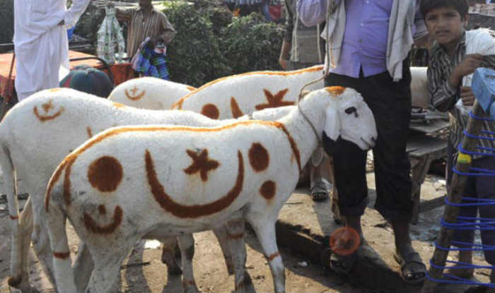During Id-ul-Adha animals are slaughtered to remember Ibrahim’s sacrifice. On Hajj, many pilgrims sacrifice an animal or can pay for the animal to be sacrificed on your behalf. Similarly, in Britain, where animal sacrifice is not allowed, British Muslims may buy an animal from their local slaughterhouse that has been killed in accordance with Islamic law. The family usually keeps a third of the meat, gives a third to relatives, friends and neighbours, and the final third is given to the poor. Some Muslims prefer to give money the poor instead of meat.

Similar to Id-ul-Fitr, cards and presents are given and community celebrations are organised. Muslims will invite those who live on their own to share meals with them. Those in hospital receive lots of visitors as every effort is made to ensure no one is left out.

**The Festival of Ashura**

**Sunni view of Ashura**

Many Sunni Muslims also observe Ashura but they refer to it as the Day of Atonement and remember it as the day when the Israelites were freed from slavery. Other Sunni Muslims believe that traditionally Ashura remembers the day Nuh (Noah) left the Ark after the flood. After going to Madinah, Muhammad nominated Ashura as a day of fasting from sunset to sunset, and it is still a voluntary fast day for Sunni Muslims.

As well as voluntarily fasting, on Ashura, many Sunni Muslims will:

* give to charity
* show kindness to their family and to the poor
* recite prayers
* learn from Islamic scholars.

It is not such an important festival or as solemn an occasion as it is for Shi’a Muslims.

**Shi’a Festival of Ashura**

Although observed by some Sunnis, the Day of Ashura is a major **Shi’a** festival. To Shi’a Muslims, Ashura is a day of great sorrow because of the tragic events of Karbala. The festival remembers the death of Husayn, son of Imam Ali and grandson of Muhammad the battle Karbala, Iraq. It is a day of mourning for the martyrdom of Husayn.

The battle was fought between Husayn and his supporters, including 70 men as well as women and children, against the army of Caliph Yazid and his much larger army. The battle lasted all day until eventually, Husayn was defeated. Their camp was set on fire and their bodies were trampled by the horses of the enemy. The men, including Husayn, were killed and the women were taken as slaves.

This event had a profound effect on the surviving relatives and followers of Husayn. Poems were written to tell the story and it is remembered by Shi’a Muslims with much sorrow. Husayn’s martyrdom is widely seen as a symbol of the struggle against injustice, tyranny and oppression.

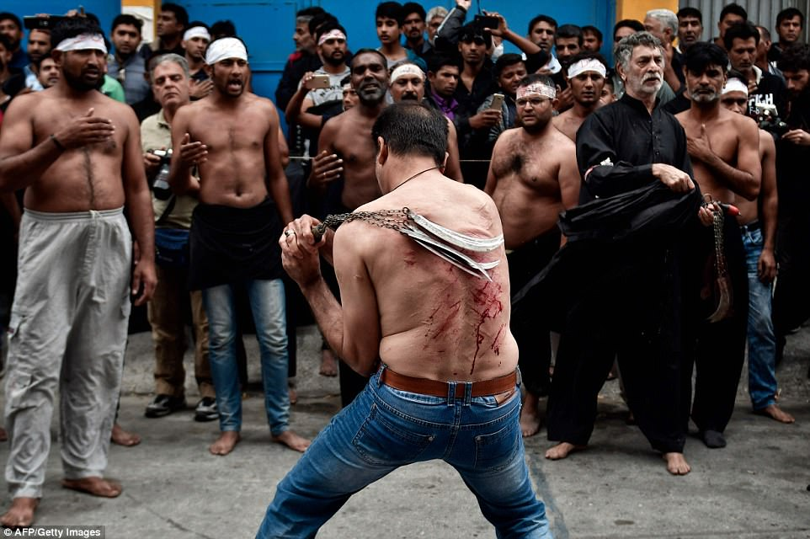During the Day of Ashura, Shi’a Muslims take part in a public expression of grief and mourning. Some even go so far as to beat or cut themselves with weapons in an attempt to connect with Husayn’s sufferings and death. This has been condemned by some Shi’a religious authorities but it is still practised across the Shi’a world. For those Shi’a Muslims who believe they should shed blood to remember Husayn, some religious leaders have encouraged donating their blood for medical purposes instead.

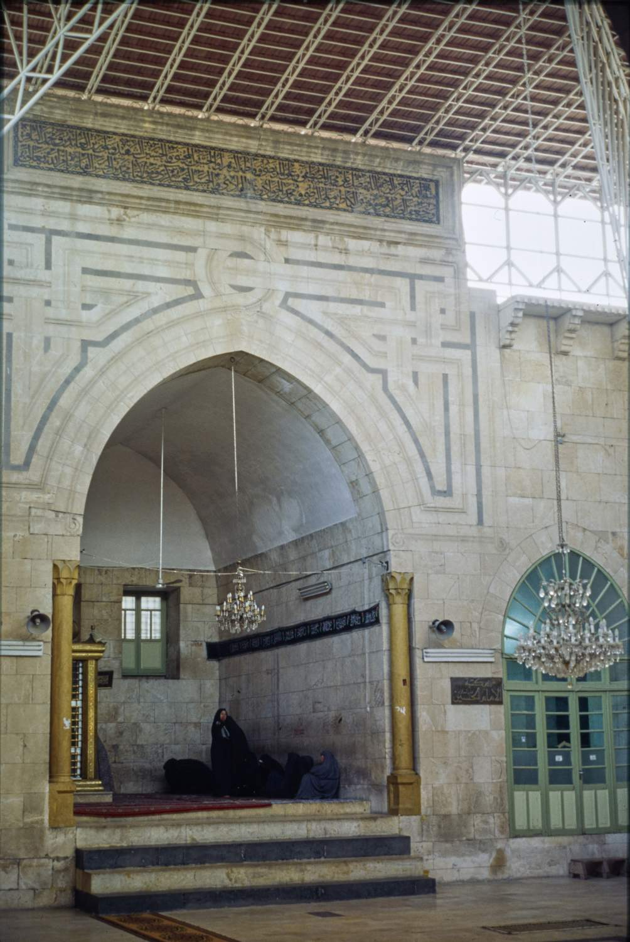

In Iraq, many Shi’a pilgrims go to the Mashhad al-Husayn, the shrine in Karbala which is believed to house the tomb of the martyr Husayn.

Possible exam questions

Question 1: (1 mark)

1) Which word is the religious tax paid by Shi’a Muslims?

1) Which is the month in which Muslims must fast?

Question 2: (2 marks)

2) Give two rituals that Muslims perform during Salah.

2) Give two ways in which Shi’a Muslims celebrate the festival of Ashura.

Question 3: (4 marks)

3) Explain two contrasting understandings of Jihad.

3) Explain two contrasting understandings of Salah.

3) Explain two contrasting Muslim beliefs about giving alms.

Question 4: (5 marks)

**You must** refer to scripture or sacred writings in your answer.

4) Explain two ways in which the Ka’aba is important in the Muslim Hajj (pilgrimage).

4) Explain two ways in which the celebration of the festival of Id-ul-Adha is important to Muslims.

4) Explain two ways in which the Shahadah influences Muslims today.

Question 5: (12 marks)

Evaluate the statement. In your answer you should:

• refer to Muslim teaching

• give developed arguments to support this statement

• give developed arguments to support a different point of view

• reach a justified conclusion.

5) ‘‘Completing the Hajj is the most important duty for a Muslim.’

5) ‘The best way for Muslims to understand God is to practise Salah.’

5) ‘The Friday prayer (Jummah) is more important than the daily prayers.’