**3.1.11 - Electrode potential & electrochemical cells**

**AS Link:**

**3.1.7 – Redox**

***Watch: RI Christmas lecture 2016 - part 3: Supercharged – Fuelling the Future, Fully Charged***

**Redox equations**

Summary:

* OILRIG
* Oxidation states or numbers – complex ions (ligands)
* Half-equations
* Overall redox equations



**OIL**

**RIG**

***Definitions***:

**Oxidation** is loss of electrons

**Reduced** is gain of electrons

Therefore:

***Definitions***:

**Reducing agent** is an electron donor

**Oxidising agent** is an electron acceptor

Oxidation states

The idea of **oxidation states** is used to identify what has been oxidised and reduced in a redox reaction. Oxidation states are also called **oxidation numbers**. Each element in a compound is given an oxidation state. It shows the **distribution** of **electrons** between the elements, depending on their **electronegativity**. The **more** **electronegative** element is given the **negative** **oxidation** **state**.

Rules for finding oxidation states

|  |  |  |
| --- | --- | --- |
| **Species** | **Oxidation state** | **Example** |
| Element | 0 | O2 |
| Simple ions | The charge of the ion |  |
| Group 1 | +1 | Na+ |
| Group 2 | +2 | Mg2+ |
| Aluminium | +3 | Al3+ |
| Fluorine | -1 | F- |
| Chlorine (except with F & O) | -1 | Cl- |
| Oxygen (except peroxides) | -2 | O2- |
| Oxygen in peroxides | -1 | H2O2 |
| Hydrogen (except metal hydrides) | +1 | H+ |
| Hydrogen in metal hydrides | -1 | H- |
| Neutral compounds | Sum of all oxidation states totals zero |  |
| Ions | Sum of all oxidation states totals the charge of the ion |  |

* The **more positive** a number, the **more** the element has been **oxidised**.
* The **more negative** a number, the **more** the element has been **reduced**.

**Example**

Answer

Determine the oxidation state of chromium in complex ion Cr2O72-

Cr2O72-

7x-2 = -14 = -2 so 2 x Cr must be +12 therefore **Cr =** **+6**

Complex ions

Metal ions form complexes in aqueous solutions where the metal ions are bonded to ligands. The ligands can be neutral molecules or charged ions. Knowing their charges is a quick way of working out the oxidation number of the metal ion. Complex ions and ligands will be covered in topics **3.2.5 Transition metals** and **3.2.6 Reactions of ions in aqueous solution**.

|  |  |  |
| --- | --- | --- |
| **Name of ligand** | **Ligand** | **Overall charge** |
| Water | H2O | 0 |
| Ammonia | NH3 | 0 |
| Hydroxide | OH- | -1 |
| Chloride | Cl- | -1 |
| Cyanide | CN- | -1 |
| Ethane-1,2-diamine | H2NCH2CH2NH2 | 0 |
| Ethanedioate | C2O42- | -2 |
| Bis[di(carboxymethyl)amino]ethane | EDTA4- | -4 |

Construction of half-equations

Each **half-equation only shows the species involved in the reaction**. Only the initial and final species in a redox equation are needed to construct half-equations.

When constructing a half-equation for reactions occurring in **aqueous solutions water provides a source of oxygen** and any **surplus oxygen** is **converted** into **water** by **reaction** with **hydrogen** ions from an **acid**.

Rules:

* Write down initial and final species - only one element in each half-equation
* Balance for atoms
* Add oxidation numbers
* Balance for charge (add electrons)
* Balance oxygens (add water)
* Balance hydrogens (add H+)

**Example p31**

Deduce the half-equation for the reduction, in acid solution, of VO3- to V2+ in acid solution.

Answer

VO3- → V2+

+5 +2

Oxidation state of vanadium changes from +5 to +2, so vanadium is reduced so 3 electrons are added to balance the charge

VO3- + 3e- → V2+

+5 -3 +2

6 hydrogen ions combine with 3 oxygen atoms to make water

VO3- + 3e- + 6H+ → V2+ + 3H2O

Constructing overall equations for redox reactions

**Overall equations** for any redox reaction can be obtained by **adding the 2 half-equations** together so that the number of **electrons given** by the reducing agent exactly **balances** the number of **electrons accepted** by the oxidising agent. There may be a need to **cancel** for **water** or **hydrogen ions**.

**Example**

In acidic conditions dichromate(VI) ions, Cr2O72-, can be reduced to chromium(III), Cr3+, by sulphite ions, SO32-, which are oxidised to sulphate ions, SO42-. Deduce the half-equations and use these to construct an equation for the overall reaction.

Answer

The half equation for the reduction of chromium(VI) is:

Cr2O72- + 6e- + 14H+ → 2Cr3+ + 7H2O

+6 OA +3

The half equation for the oxidation of sulphite ions is:

SO32- + H2O → SO42- + 2e- + 2H+

+4 RA +6

Make sure the electrons balance, so they will cancel out:

Cr2O72- + 6e- + 14H+ → 2Cr3+ + 7H2O

SO32- + H2O → SO42- + 2e- + 2H+ x 3

3SO32- + ~~3H~~~~2~~~~O~~ + Cr2O72- + 8~~14~~H+ → 3SO42- + ~~6H~~~~+~~ + 2Cr3+ + 4~~7~~H2O

3SO32- + Cr2O72- + 8H+ → 3SO42- + 2Cr3+ + 4H2O

***Sheet: AS Redox recap***

***Starter: 12.1 - Redox reactions***

**Electrode potentials**

|  |  |  |
| --- | --- | --- |
| ***Task: Construct a lemon battery***  *-* *lemon - 2 x strip of copper - 2 x strip of zinc - a voltmeter*  *- crocodile clips*  *- leads* |  | **Oxidation** and **reduction** is taking place between the different metals and so a **current is generated**. |

***Video clip: RI Lemon clock world record***

The same thing happens if two **different metals** are placed in a **salt solution**, connecting them together will produce a **current** with **electrons flowing** from the **more reactive** metal to the **less reactive** one, so a **redox reaction** occurs. This is called an **electrochemical cell** and is the basis of all **batteries**. A voltmeter will show the voltage produced, this is called the **cell potential** or **electromotive force** (EMF), **Ecell**.

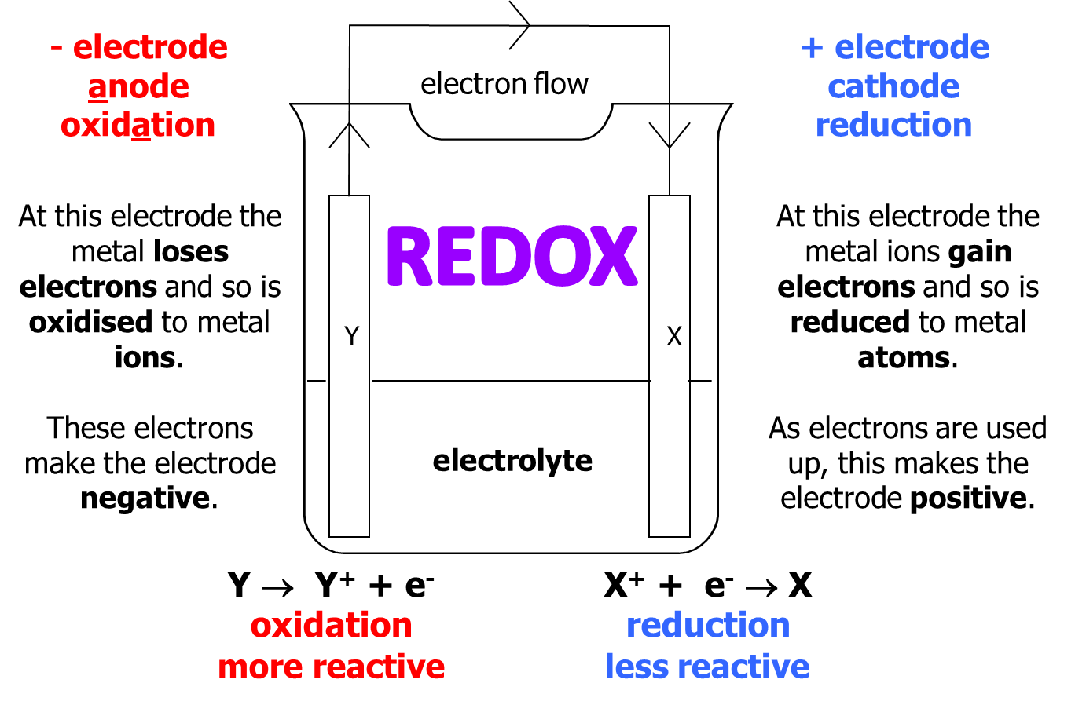

|  |  |
| --- | --- |
| **Batteries** work in the same way. They are a device that **stores chemical energy** ready to **convert into electrical energy**. They **produce electricity** in an electrochemical cell. |  |

Inside a cell:

|  |  |  |  |
| --- | --- | --- | --- |
| Carbon-zinc |  | Nickel-cadmium |  |

Half-equations can be used to represent the reactions at each electrode.

Half cells

Dipping a metal rod into a solution of its own ions sets up an **equilibrium**. This can be shown with a **half-equation**.

E.g. Zn(s) ⇌ Zn2+ (aq) + 2e-

The equilibrium will be **far to the right**, as it **acquires a negative charge**. It gains a **negative potential** and is called an **electrode**.

|  |  |
| --- | --- |
|  |  |

If the **potential** could be measured it would indicate how **readily electrons are released** by the metal, how good a **reducing agent** it is. However, electrical potential **cannot be measured directly** only **potential difference** (the **voltage**). So **if two different electrodes** are connected together the **potential difference** can be measured with a **voltmeter**.

Electrochemical cells

An **electrochemical cell** contains two **electrodes** (conductors) immersed in an **electrolyte** (ionic conductor), either as an ionic solution or a molten salt. The electrode and electrolyte form an **electrode compartment** or **half-cell**.

|  |  |
| --- | --- |
| N.B. anode is negative electrode |  |

|  |  |
| --- | --- |
| Sometimes the electrode **share one compartment**, if they can be in **two compartments** then a **salt bridge** is needed to connect them.   The **salt bridge completes the electrical circuit**; **allowing transfer of mobile ions** between the two compartment.   **Electrons move** through the **metals**. |  |

The simplest form of **salt bridge** is a piece of filter paper soaked in **potassium nitrate** or **potassium chloride** solution. It must be a **soluble unreactive salt**. Other salt bridges use agar jelly in a glass tube soaked in KNO3 or KCl. Using a metal wire would introduce further metal/ion potentials to the circuit and so would not work.

Zinc and copper electrochemical cell

|  |  |
| --- | --- |
| By connecting the **zinc and copper** electrodes to a voltmeter then a **voltage of 1.10V** will be measured but only if the **solutions are 1.0 mol dm-3** and the **temperature 298K**.  This indicates that the **zinc electrode** has a **more negative potential**, it loses **electrons more readily** than copper  – **zinc** is a **better reducing agent**. |  |

Electrode reactions

Within each electrode compartment there is a **different half-reaction**. So, **oxidation** occurs in one and **reduction** in the other. The **electrons released by oxidation** are made available to **drive the reduction** in the other compartment by **flowing through the external metal circuit**.

In the zinc/copper example the following changes will occur:

* **Zinc** would dissolve to **form zinc ions**, **releasing electrons** and increasing the concentration of zinc ions.
* The **electrons** will **flow** through the **wire** to the copper
* The **copper ions** in solution will **combine with the electrons** to **form copper atoms**, so decreasing the concentration of copper ions.

Half-equations:

Redox reaction:

Zn(s) oxidised

Cu2+(aq) reduced

Zn (s) → Zn2+ (aq) + 2e-

and Cu2+ (aq) + 2e- → Cu (s)

..............................................................................

adding Zn (s) + Cu2+ (aq) + ~~2e~~~~-~~ → Zn2+ (aq) + Cu (s) + ~~2e~~~~-~~

gives Zn (s) + Cu2+ (aq) → Zn2+ (aq) + Cu (s)

This combination of electrodes is called a Daniell cell.

The **reactions** that occur at **each electrode** are **reversible** and which **direction** they go in **depends** on **how easily** each metal **loses electrons**, i.e. how easily it is **oxidised**.

***Required practical 8***: Measuring the EMF of an electrochemical cell

Focus eLearning cell animations: <https://www.focuselearning.co.uk/s/2ajs4u8h572y>



**The standard electromotive force (Eθ)**

Under **standard conditions** (**zero current, 1.00 mol dm-3, 298K, 100kPa**) the cell potential is known as the **standard e.m.f. of the cell**.

***Definition***

The **standard electromotive force** (e.m.f.) is the **potential difference** between the electrodes of a standard electrochemical cell measured under **zero-current** conditions.

To **compare** the **tendency** of different electrodes to **release electrons** (i.e. be oxidised) there needs to be a **standard to which it can be connected** for comparison. That standard is the hydrogen electrode, known as the **standard hydrogen electrode** (**SHE**).

Standard Hydrogen Electrode (SHE)

SH**E** is a reference electrode

Always on L**E**FT

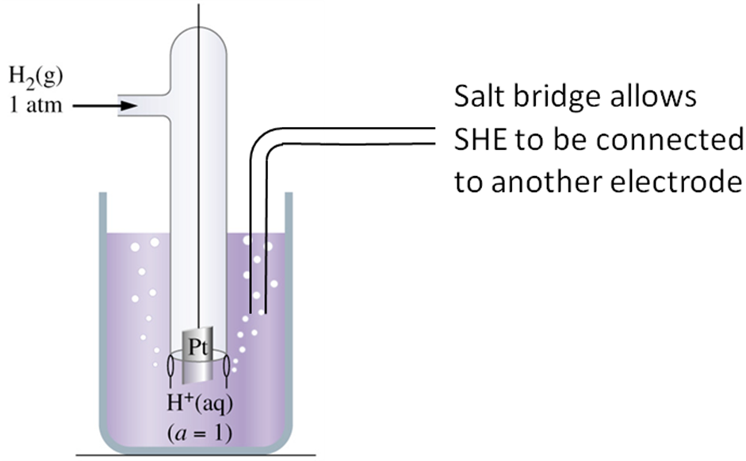

It’s impossible to measure the potential of a single electrode on its own, so if **one electrode** is **assigned a value of zero**, the other **electrode potentials** can be **established** **relative** to the standard. The half-cell chosen as the **standard is the standard hydrogen electrode**.

Hydrogen gas is bubbled into a solution of hydrogen ions (acid). Hydrogen doesn’t conduct so **electrical contact** is made via a piece of **unreactive platinum metal** (coated with finely divided platinum to increase the surface area and allow for a rapid reaction). It is used under **standard conditions**.

There is a convention for showing the configuration of electrodes, the SHE is written as:

Pt(s) │H2(g, 100 kPa) │H+(aq, 1.00 mol dm-3) Eθ = 0 at 298 K

***Definition***

The potential, Eθ (SHE), of the **standard hydrogen electrode** is **zero**

Standard electrode potential

If the potential of the **standard hydrogen electrode is zero** then by connecting to another electrode the **voltage or e.m.f. can be measured** and this **gives a standard electrode potential** for the other cell. The **SHE** is always the **left** electrode and the **unknown** is the **right** electrode. They must be determined under **standard conditions**.

The electrode with a **more negative Eθ** are **better at releasing electrons** (more easily oxidised and so better reducing agents) **than hydrogen**.

More negative Eθ More positive Eθ

more easily gives electrons (oxidised) more easily attracts electrons (reduced)

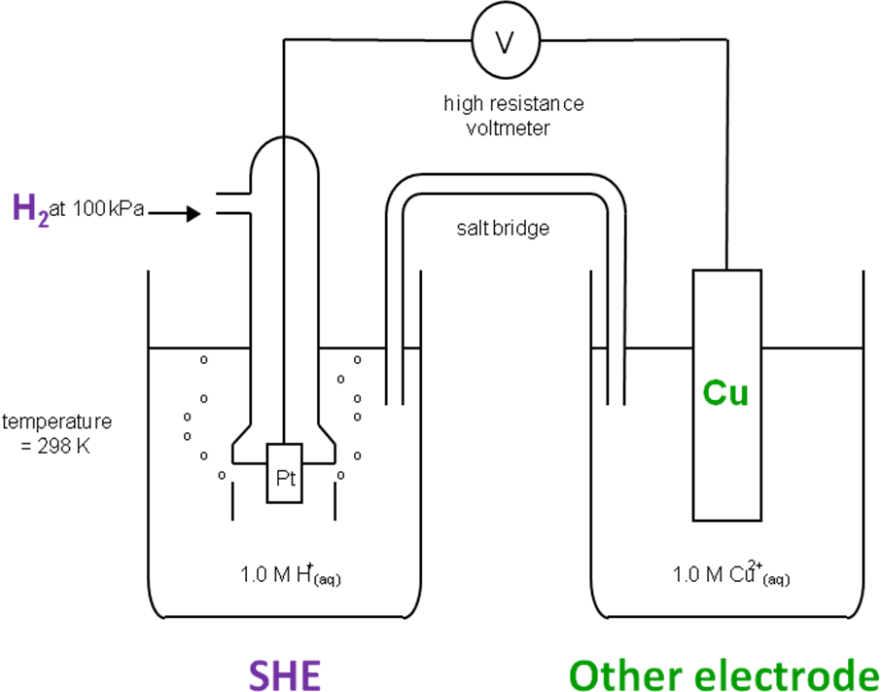

***Sheet: The standard hydrogen electrode***

***Application: CGP85 PQ1***

***Fact recall: CGP85 Q1-4***

Types of electrodes

1. **Metal electrodes** – simplest. Consists of a **metal in equilibrium with a solution of its ions**. For example the copper electrode with redox couple Cu2+ / Cu, depending on its position compared to other electrodes would as:

*Left electrode*  Cu(s) │Cu2+(aq) or Cu2+(aq) │ Cu(s)  *Right electrode*

R O O R

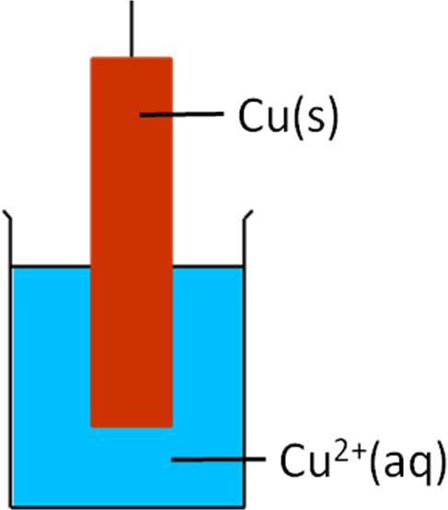

Most reactions involve Cu2+ being reduced

2. **Gas electrode**. Consists of an **inert metal** (usually platinum) **surrounded by a gas in equilibrium with a solution of its ions**. The inert metal acts as a source or sink of electrons.

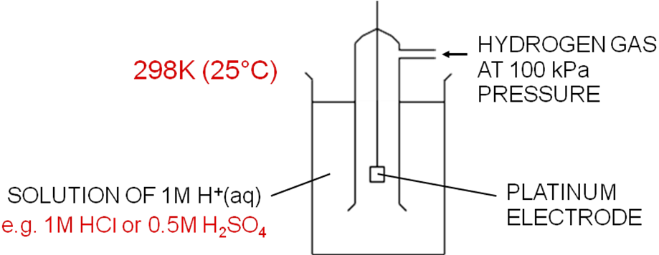

The hydrogen electrode has the redox couple H+ / H2 and the electrode is donated as:

*Left electrode*  Pt(s) │H2(g) │H+(aq) or H+(aq) │ H2(g) │Pt(s) *Right electrode*

R O O R

N.B. **Pt** is **next** to the **reduced** form and it’s **not balanced** in cell diagram. The two **phase boundaries** (solid-gas and gas-liquid) are shown by **vertical** **bars**.

This is balanced

The reduction half-equation: 2H+(aq) + 2e- → H2(g)

3. **Redox electrode**. Consists of a solution in which **two oxidation states** of a given element undergo a **reduction** reaction at the **surface of an inert metal**, such as platinum.

Example – redox couple Fe3+ / Fe2+

This has a **reduction half-reaction** with the following reduction **half-equation**:

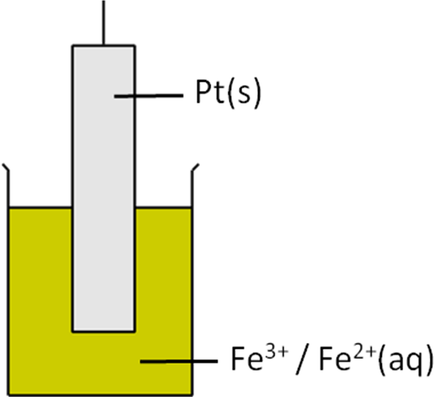

Fe3+(aq) + e- → Fe2+(aq)

They are in the same state so commas are used and because there is no solid metal a platinum electrode is needed.

*Left* Pt(s) │ Fe2+(aq), Fe3+ (aq) or Fe3+ (aq), Fe2+ (aq)│Pt(s) *Right*

*electrode*  R O O R *electrode*

Example – redox couple MnO4-, H+ / Mn2+

This has a reduction half-reaction with the following reduction half-equation:

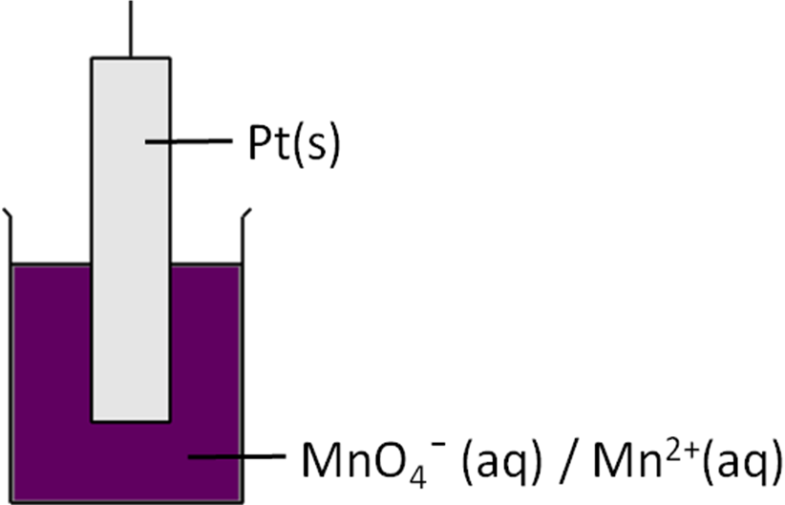

+7 +2

MnO4-(aq) + 8H+ + 5e- → Mn2+(aq) + 4H2O(l)

*Left* Pt(s) │ Mn2+(aq), MnO4-(aq), H+(aq) or MnO4-(aq), H+(aq), Mn2+(aq)│Pt(s) *Right*

*electrode*  R O O R *electrode*

**Electrochemical series**

Standard electrode potentials **measured relative to hydrogen** can be placed in a list, either in descending (convention) or ascending order. The **SHE electrode** is used to establish the **electrode potentials (Eθ)** of different species. This gives the **electrochemical series** which shows the **electrode potential for different half-cells**. The **number of electrons** involved in the half-reaction **has no effect** on the **potential**.

IUPAC convention for half-equations

The equilibria are written as **reductions** (i.e. show **reduced** element gaining electrons on the **RHS**) and with **state symbols**. Remember these are reversible reactions.

***Definition***

The **electrochemical series** is a list of **reduction half-reactions** written in order of **electrode potential**.

|  |  |
| --- | --- |
|  | **More positive potential**  – good oxidising agents  – more easily reduced  – form positive electrode on RHS |
|  |
|  |

|  |  |  |  |
| --- | --- | --- | --- |
| **Reduction half-equations** | | | **Eθ / V** |
| OXIDISED FORM | F2(g) + 2 e– ⇌ 2 F–(aq) | REDUCED FORM | +2.87 |
| MnO4-(aq) + 8 H+(aq) + 5 e– ⇌ Mn2+(aq) + 4 H2O(l) | +1.51 |
| Cr2O72-(aq) + 14 H+(aq) + 6 e– ⇌ 2 Cr3+(aq) + 7 H2O(l) | +1.33 |
| ½ O2(g) + 2 H+ + 2 e– ⇌ H2O(l) | +1.23 |
| Ag+(aq) + 1 e– ⇌ Ag(s) | +0.80 |
| Fe3+(aq) + 1 e– ⇌ Fe2+(aq) | +0.77 |
| O2(g) + 2 H+(aq) + 2 e– ⇌ H2O2(aq) | +0.68 |
| MnO42-(aq) + 2 H2O(l) + 2 e– ⇌ MnO2(s) + 4 OH–(aq) | +0.59 |
| MnO4-(aq) + 1 e– ⇌ MnO42-(aq) | +0.56 |
| I2(s) + 2 e– ⇌ 2 I–(aq) | +0.54 |
| Cu+(aq) + 1 e– ⇌ Cu(s) | +0.52 |
| Cu2+(aq) + 2 e– ⇌ Cu(s) | **+0.34** |
| **2 H+(aq) + 2 e– ⇌ H2(g)** | **0.00** |
| V3+(aq) + 1 e– ⇌ V2+(aq) | –0.26 |
| Fe2+(aq) + 2 e– ⇌ Fe(s) | –0.44 |
| Zn2+(aq) + 2 e– ⇌ Zn(s) | **–0.76** |
| Mg2+(aq) + 2 e– ⇌ Mg(s) | –2.38 |
| Ca2+(aq) + 2 e– ⇌ Ca(s) | –2.87 |
| Li+(aq) + 1 e– ⇌ Li(s) | –3.03 |

|  |  |
| --- | --- |
| **More negative potential**  – good reducing agents  – more easily oxidised  – form negative electrode on left hand side (LHS) |  |
|  |
|  |

* **Strongest oxidising agents** accept electrons **easily** (**reduced**) and have **more positive potentials**
* **Strongest** **reducing** **agents** lose electrons **easily** (**oxidised**) and have **more negative** **potentials**
* Half-equations with **more positive potentials gain electrons** (reduction reaction) and go **easily** from **left to right**
* Half-equations with **more negative potentials lose electrons** (oxidation reaction) and go **easily** from **right to left**

Since the reactions are written as reductions the **species** written **on the LHS** is an **oxidising agent** accepting electrons to form a **reducing agent** on the **RHS**.

**Example** Fe2+ (aq) + 2e- ↔ Fe (s) Eθ = -0.44 V RA therefore oxidised

OA RA

Br2 (g) + 2e- ↔ 2Br- (aq) Eθ = +1.07 V OA therefore reduced

OA RA

Redox: Br2 + Fe → 2Br- + Fe2+

A **reduction half-equation** can be **shortened** and written as a **redox couple**. The convention is to write the **oxidised** species (**LHS**) first separated by the **reduced** species (**RHS**) with a **forward slash**, **without state symbols**.

This is simply a **short-hand way to write a half-equation** (include balancing) it’s not used in cell diagram notations.

E.g. Fe3+ (aq) + 3e- ↔ Fe (s) written as Fe3+ / Fe

Cell representation (Also called cell diagram)

The electrodes can be represented by a **cell diagram** showing one or two electrodes.

|  |  |  |  |
| --- | --- | --- | --- |
|  | Eθ = -0.76 V |  | Eθ = 0.34 V |
| Zn(s) │Zn2+(aq) | || | Cu2+(aq) │ Cu(s) |
| **R** **O** |  | **O**  **R** |
| -  oxidation  electrons lost |  | +  reduction  electrons gained |
| more negative  oxidation  left electrode |  | more positive  reduction  right electrode |

* The species are **not balanced**

Reduced form – has gained the electrons

Oxidised form – has lost the electrons

* Show **state symbols**
* A **vertical bar** represents the **boundary** between **different phases**
* Species are in the **same phase** they are separated by a **comma**E.g. Ni(s) | Ni2+(aq) || Sn4+(aq), Sn2+(aq) | Pt(s)
* If there is **no solid metal** then an **inert metal** **electrode** (usually platinum) must be used to complete the circuit, this is always shown on the **far left** or **right** **next to the reduced form**, separated by a **vertical bar** (or sometimes vertical dashed bars)
* If a **salt bridge** is used this is shown as a **double vertical bar** separating the two electrodes
* **Left electrode** shows **reduced** form **then oxidised** form
* **Right electrode** shows **oxidise** form **then reduced** form
* When they are put **together** they go in this order **ROOR**
* The **reduction half-equation** (most positive electrode potential) will always be written on the **right hand side.**

Combining half-reactions into cell diagrams, and writing cell equations

A **cell diagram** is constructed by writing **two electrodes side by side** and joining them with a **junction** across which there is **no potential difference** (no voltage difference), it’s usually a **salt bridge**

**State symbols** are shown.

The **metal** is always written on the **outside**.

For the **electrode on the right** (more positive) the electrode components are written in **the same order as the redox** couple (**oxidised/reduced**) with the more negative used as the **left electrode** shown in reverse order (**reduced/oxidised/**). So, when reading through a cell from left to right it’s always in this order:

**Red/Ox/Ox/Red** or **ROOR** this shows that **electrons will flow** from the **LH to the RH** electrode

RHS

* most positive electrode potential
* positive electrode
* more powerful oxidising agent
* gains electrons

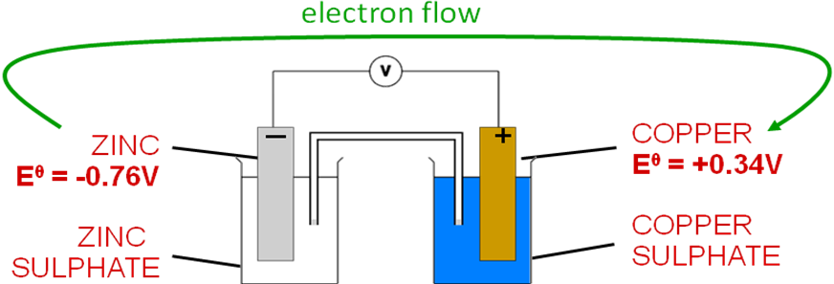

E.g. Zn(s) │Zn2+(aq)║ Cu2+(aq) │ Cu(s)

R O O R

***Cell convention***:

The **cell diagram** is written with the **more positive electrode** (more positive electrical potential & the one at which reduction occurs) shown as the **right-hand electrode**.

In the above example the more **positive** electrode (Cu/Cu2+) is on the **right** hand side, it **accepts electrons** more easily so is itself **reduced**.

From 2 half-equations the **redox equation** and **cell diagram** can be derived.

**Clock method:**

* Write the **2 half-equations** as **reductions** (with **same number of electrons**)
* The one with the **more positive electrode potential** must be on **top** (where reduction happens)
* Draw the **arrows** in a **clockwise** direction to show the **flow of electrons**:
  + **Reactants** at the **tail** of the arrows
  + **Products** at the **heads** of the arrows
* **Put together** the reactants (tails) and the products (heads) to give the **redox equation**
* **Cell diagram** can be constructed from half-equations – place in **ROOR order & reduction on RHS (most positive)**
  + **Constructing from redox equation** – **LHS** of **cell diagram** comes **from reduced** **form** on **LHS** of **redox** equation with corresponding oxidised form

**Example**

|  |  |
| --- | --- |
| **2 half-equations as reduction reactions**  **More positive electrode potential on top** | Cu2+(aq) + 2e- → Cu(s) (+0.34V)  Zn2+(aq) + 2e- → Zn(s) (-0.76V) |
| **Identify oxidation (more –ve) & reduction (more +ve)**  **Add arrows** (shows direction of electrons)  **Reactants at the tail ( )**  **Products at the heads ( )** | Cu2+(aq) + 2e- → Cu(s) reduction  Zn2+(aq) + 2e- → Zn(s) oxidation |
| **Put together – redox equation**  **Balance for electrons**  **Tails together - reactants**  **Heads together - products** | Cu2+(aq) + Zn(s) → Cu(s) + Zn2+(aq)  O R R O |
| **Cell diagram**  **ROOR order**  **Reduction on RHS (most positive)** | Zn(s) | Zn2+(aq) || Cu2+(aq) | Cu(s)  R O O R |

It **confirms** that the **reaction** actually **goes**, zinc displaces copper from solution.

***Cell reactions***

With the more positive electrode (one at which reduction occurs) shown as the RH electrode, the cell reaction goes in the forward direction, as written.

***Task: The two half-equations below show the reactions taking place in an electrochemical cell:***

***Sn2+(aq) + 2e- → Sn(s) (-0.14 V)***

***Fe3+(aq) + 3e- → Fe(s) (+0.77 V)***

***Write the redox equation for this reaction.***

***Draw the conventional representation of this cell***

|  |  |
| --- | --- |
| **2 half-equations as reduction reactions**  **More positive electrode potential on top** | Fe3+(aq) + 3e- → Fe(s) (+0.77 V)  Sn2+(aq) + 2e- → Sn(s) (-0.14 V) |
| **Identify oxidation (more –ve) & reduction (more +ve)**  **Add arrows** (shows direction of electrons)  **Reactants at the tail ( )**  **Products at the heads ( )** | Fe3+(aq) + 3e- → Fe(s) x2 reduction  Sn2+(aq) + 2e- → Sn(s) x3 oxidation |
| **Put together – redox equation**  **Balance for electrons**  **Tails together - reactants**  **Heads together - products** | 2Fe3+(aq) + 3Sn(s) → 2Fe(s) + 3Sn2+(aq)  O R R O |
| **Cell diagram**  **ROOR order**  **Reduction on RHS (most positive)** | Sn(s) | Sn2+(aq) || Fe3+(aq) | Fe (s)  R O O R |

***Task: Select any two pairs from electrochemical series and using clock method deduce a redox equation and cell diagram***

Cell potential

In an electrochemical cell a **potential difference** (voltage, V) is set up between the electrodes. By convention the **LH** electrode is more **negative**, relative to the **RH** electrode, which is more **positive**. The **overall cell potential** is the **difference** between the **potentials of the individual electrodes**.

**Factors that affect cell potential:**

* **Cell current** – the true **cell potential** can be **measured** under **zero-current conditions** (using a high-resistance digital voltmeter). This is called the **electromotive force** or **e.m.f**.
* **Cell concentration** – solution concentrations affect the cell potential. Standard concentration is **1.00 mol dm-3**.
* **Cell temperature** – temperature affects cell potential. Standard temperature is **298 K**.
* **Cell pressure** – pressure affects cell potential, but not significantly unless a gas electrode is used. Standard pressure is **100 kPa** (1 bar).

Calculating Eθ for an electrode from the cell e.m.f.

To determine the overall cell reaction the **LH electrode potential** (for the cell at which **oxidation** takes place, **more positive** e.m.f) is **subtracted** from the **RH electrode potential** (for the cell at which **reduction** takes place, more **negative** e.m.f).

e.m.f. > 0

Reaction feasible

in forward direction

***Cell e.m.f = E* θ *(Right) – E* θ *(Left)***

Quote to 2 d.p.

***Cell e.m.f = E* θ *(Reduction) – E* θ *(Oxidation)***

**So if LH electrode is the SHE with Eθ = 0 then Eθright = cell e.m.f**

To ensure the reaction goes in the forward direction, the **more negative potential** is put on the left and is **subtracted from the right** one, giving e.m.f >0. So if the **cell potential is positive,** the cell **reaction goes in the foreword** direction and **reduction** occurs as shown by the cell equation.

**Example**

Calculate the standard e.m.f. of a cell with a silver electrode (Ag+ / Ag, Eθ = +0.80 V) and a copper electrode (Cu2+ / Cu, Eθ = +0.34 V), each in its own solution of 1.0 mol dm-3 silver(I) or 1.0 mol dm-3 copper(II) ions connected by a salt bridge.

|  |  |  |
| --- | --- | --- |
| Method  The more positive potential (Ag+ / Ag) is made the right-hand electrode (reduction).  Answer  cell e.m.f. = Eθ (R) – Eθ (L)  cell e.m.f. = +0.80 – (+0.34) = **+0.46 V** | 2Ag+(aq) + 2e- → 2Ag(s) x 2 +0.80 V (R)  Cu2+(aq) + 2e- → Cu(s) +0.34 V (O) | |
| 2Ag+(aq) + Cu(s) → 2Ag(s) + Cu2+(aq) | |
| Cu(s) | Cu2+(aq) || Ag+(aq) | Ag(s)  R O O R | |
| Cell set up like this is feasible | oxidation | reduction |

***Task: Calculate the e.m.f. of a cell with the standard Ag+/Ag electrode (Eθ = +0.80 V) as the LH electrode and the Fe2+/Fe electrode (Eθ = -0.44 V) as the RH electrode.***

|  |  |
| --- | --- |
| Method  cell e.m.f. = E θ (R) – E θ (L)  Answer  cell e.m.f. = -0.44 - (+0.80) = **-1.24 V**  Comment  The cell e.m.f is **negative** so the reaction **will not go in the forward direction**.  So cell set up like this will not work:  Ag(s) | Ag+ (aq) || Fe2+ (aq) | Fe(s)  The reverse reaction will occur:  2AgCl(s) + Fe(s) → 2Ag(s) + Fe2+(aq) + 2Cl-(aq) | 2Ag+(aq) + e- → 2Ag(s) x 2 +0.80 V (R)  Fe2+(aq) + 2e- → Fe(s) -0.44 V (O) |
| 2Ag+(aq) + Fe(s) → 2Ag(s) + Fe2+(aq) |
| Fe(s) | Fe2+(aq) || Ag+(aq) | Ag(s)  R O O R |
| This is how the cell woul dneed ot be set up to be feasible |

***Task: Calculate the standard electrode potential of an unknown metal M, which, in a standard solution of its own ions Mn+(aq), gives a cell e.m.f. of +0.48 V when acting as the RH electrode in a standard cell with tin Sn2+/Sn Eθ = -0.14 V) as the LH electrode.***

|  |  |
| --- | --- |
| Method  cell e.m.f. = Eθ (R) – Eθ (L)  Rearrange  Eθ (R) = cell e.m.f. + E θ (L)  Answer  Eθ (R) = +0.48 + (-0.14) = **+0.34 V**  Identify the electrode from its electrode potential  Cu2+ / Cu | Mn+(aq) + ne- → M(s) +0.34 V (R)  Sn2+(aq) + 2e- → Sn(s) -0.14 V (O) |
| Mn+(aq) + Sn(s) → M(s) + Sn2+(aq) |
| Sn(s) | Sn2+(aq) || Mn+(aq) | M(s)  R O O R |

***Starter: 12.3 – Calculations involving electrochemical cells***

***Sheet: Electrode potentials***

***Application: CGP83 PQ1-3***

***Fact recall: CGP83 Q1-3***

Using potential values to predict the feasibility of simple redox reactions

**Standard electrode potentials** can be used to **predict** the **feasibility** of a reaction. When **pairs of electrodes** are connected the **electrons will flow** from the **more negative** to the **more positive** and not in the opposite direction.

Consider the following:

**+**

**-**

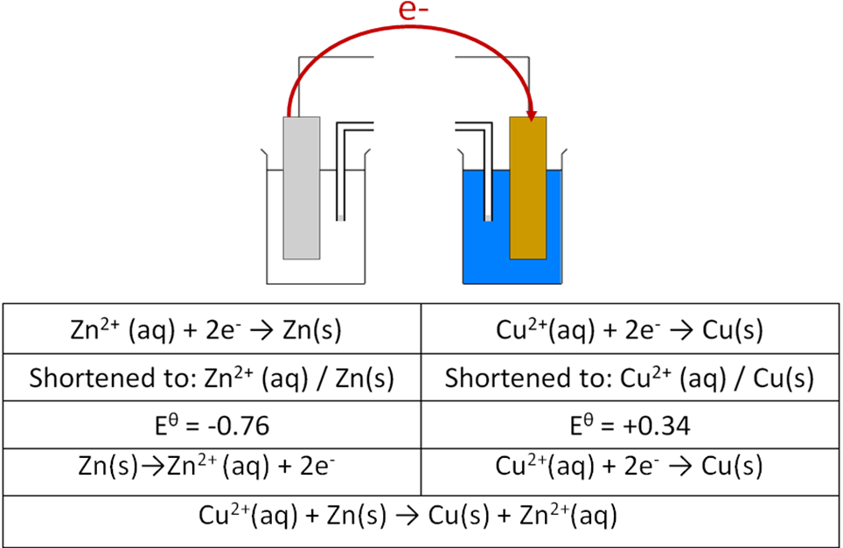

If they are **connected** together the **electrons will tend to flow from zinc** (more negative) **to copper** (more positive).

This tells which way the **two half reactions must go** and so the **overall redox reaction**

Cu2+(aq) + Zn(s) → Cu(s) + Zn2+(aq) **is feasible** and the reverse reaction is not feasible.

A **cell reaction** is **represented** by a **cell equation** and will occur in the **forward direction** if the **RH electrode** is the site of **reduction**. In this case the **RH electrode** will have a **more** **positive potential** than the LH electrode. So **Eθright (reduction) - Eθleft (oxidation)** will always be **positive**.

***The direction of redox reactions***

A cell reaction **goes forwards**, in the direction written, if, and only if, the corresponding **cell e.m.f is positive**

A **half-reaction** with a **more positive** potential **oxidises** (gains electrons) one with a **more negative** potential.

A **feasible** reaction will have **negative ΔG** or **positive cell e.m.f**.

So the **spontaneous direction** of a reaction (left to right or right to left) **involving pairs of half-reactions** can be summarised:

|  |  |
| --- | --- |
| ***Cell e.m.f.*** | ***Spontaneous direction*** |
| + ve | forwards |
| - ve | backwards |

Electrochemical series and cell e.m.f.

**Predictions** about redox reactions can be made **using the half-reactions**, there are 2 methods.

Method 1 – the clock method

|  |  |
| --- | --- |
| Half-equations  **Most positive on top** | Ag+(aq) + e- → Ag(s) **x 2** +0.80 V (R)  Zn2+(aq) + 2e- → Zn(s) -0.76 V (O) |
| Half-equation with **more positive Eθ** becomes **positive electrode**, with **electrons arriving** (reduction).  So half-reaction goes **forward**.  **Silver ions** are **oxidising agents** and become **reduced**. | 2Ag+(aq) **+ 2e-** → 2Ag(s) |
| Half-equation with **less positive Eθ** becomes **negative electrode**, with **electrons leaving** (oxidation).  So half-reaction goes **backwards**.  **Zinc atoms** are **reducing agents** and become **oxidised**. | Zn(s) → Zn2+(aq) **+ 2e-** |
| **Overall equation** obtained by **adding two new half-equations** so that the electrons cancel. | 2Ag+(aq) + Zn(s) → 2Ag(s) + Zn2+(aq) |
| Cell diagram with **more positive on RHS** | Zn(s) | Zn2+(aq) || Ag+(aq) | Ag(s)  R O O R |
| cell e.m.f. = Eθ (R) – Eθ (O) | cell e.m.f. = +0.80 - (-0.76) = **+1.56 V**  Therefore **feasible** |

Method 2 – the outline sketch approach

Some of the steps in the method above can be represented as a diagram

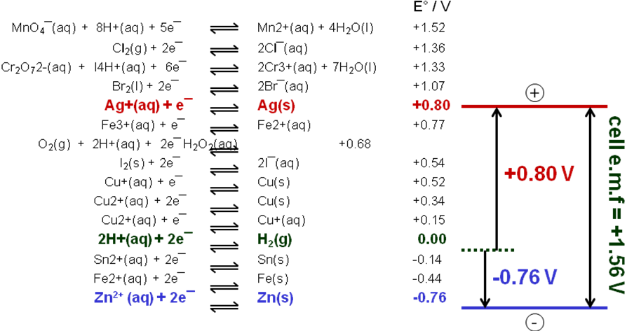

|  |  |
| --- | --- |
| Using the **electrochemical series** a **sketch** is made of the 2 electrodes in question, including the standard hydrogen electrode. |  |
| Drawing is simplified by sketching it **horizontally**, increasing from left to right.  Follows rule of **positive electrode on right.**  Half-equations **abbreviations** used. |  |
| **Cell diagram** can be written from outline sketch.  Remember **ROOR** | Zn(s) | Zn2+(aq) || Ag+(aq) | Ag(s)  R O O R |
| **Spontaneous cell reaction** is:  Positive electrode (RHS)  Negative electrode (LHS)  Overall | Ag+(aq) + e- → 2Ag(s) **x 2** +0.80 V (R)  Zn2+(aq) + 2e- → Zn(s) -0.76 V (O) |
| 2Ag+(aq) + Zn2+(aq) → 2Ag(s) + Zn2+(aq) |
| cell e.m.f. = Eθ (R) – Eθ (O) | cell e.m.f. = +0.80 - (-0.76) = **+1.56 V**  Therefore **feasible** because positive |

**Example**

Use data below to predict whether magnesium will reduce vanadium(III) ions to vanadium(II) ions. Write the representation of a standard cell in which the reaction would occur and determine its e.m.f.

V3+(aq) + e- → V2+(aq) Eθ = -0.26 V

Mg2+(aq) + 2e- → Mg(s) Eθ = -2.36 V

Method 1

Clock

|  |  |
| --- | --- |
| Half-equations  **Most positive on top** | V3+(aq) + e- → V2+(aq) x 2 Eθ = -0.26 V (R)  Mg2+(aq) + 2e- → Mg(s) Eθ = -2.36 V (O) |
| Half-equation with **more positive Eθ** becomes **positive electrode**, with **electrons arriving** (gained). | 2V3+(aq) + 2e- → 2V2+(aq) |
| Half-equation with **less positive Eθ** becomes **negative electrode**, with **electrons leaving** (lost). | Mg(s) → Mg2+(aq) + 2e- |
| **Overall equation** obtained by **adding two new half-equations** so that the electrons cancel. | 2V3+(aq) + Mg(s) → 2V2+(aq) + Mg2+(aq) |
| Cell diagram with **more positive on RHS** | Mg(s) | Mg2+(aq) || V3+(aq), V2+(aq)| Pt(s)  R O O R |
| cell e.m.f. = Eθ (R) – Eθ (O) | cell e.m.f. = -0.26 - (-2.36) = **+2.10 V**  Therefore **feasible** |

Method 2

Outline sketch

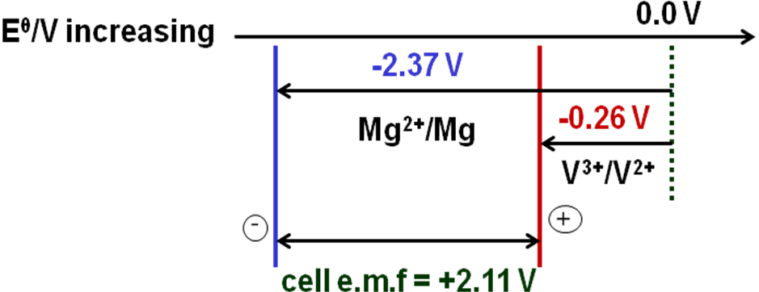

Cell representation: Mg(s) | Mg2+(aq) || V3+(aq), V2+(aq) | Pt(s)

R O O R

Cell reaction: Mg(s) + 2V3+(aq) → Mg2+(aq) + 2V2+(aq)

Cell e.m.f. = -0.26 – (-2.36) = **+2.10 V**

Comment

It’s a feasible reaction, V3+/V2+ couple react in the **forward** direction since it is **more** **positive** than the Mg2+/Mg couple. So, Mg will reduce V3+ to V2+. **Positive** electrode **gains electrons** (**reduction**). **Negative loses** electrons (**oxidation**).

***Task: Use electrochemical series to determine whether chlorine can oxidise Fe(II) ions to Fe(III) ions. Write the representation of a standard cell in which this reaction might occur and determine its e.m.f.***

Cl2(g) + 2e- → 2Cl-(aq) Eθ = +1.36 V

Fe3+(aq) + e- → Fe2+(aq) Eθ = +0.77 V

|  |  |
| --- | --- |
| Half-equations | Cl2(g) + 2e- → 2Cl-(aq) Eθ = +1.36 V (R)  Fe3+(aq) + e- → Fe2+(aq) x 2 Eθ = +0.77 V (O) |
| Positive electrode RHS (R) | Cl2(g) + 2e- → 2Cl-(aq) |
| Negative electrode LHS (O) | 2Fe2+(aq) → 2Fe3+(aq) + 2e- |
| Overall equation | Cl2(g) + 2Fe2+(aq) →2Cl-(aq) + Fe3+(aq) |
| Cell diagram | Pt(s) | Fe2+(aq), Fe3+(aq) || Cl2(g) | Cl-(aq) | Pt(s)  R O O R |
| cell e.m.f. = Eθ (R) – Eθ (O) | cell e.m.f. = +1.36 – 0.77 = **+0.59 V**  **Feasible** –the Cl2/Cl- couple reacts in the forward direction because it’s more positive than the Fe3+/Fe2+ couple. So Cl2 will oxidise Fe2+. It will be reduced gaining electrons |

***Task: Use electrochemical series to determine whether manganate(VI) ions in aqueous solution disproportionate into manganese(VII) and manganese(IV) species. Write the representation of a standard cell in which the reaction might occur and determine its e.m.f.***

+6 +4

MnO42-(aq) + 4H+ + 2e- → MnO2(s) + 2H2O Eθ = +1.55 V

+7 +6

MnO4-(aq) + e- → MnO42-(aq) Eθ = +0.56 V

|  |  |
| --- | --- |
| Half-equations | MnO42-(aq) + 4H+ + 2e- → MnO2(s) + 2H2O Eθ = +1.55 V (R) MnO4-(aq) + e- → MnO42-(aq) x 2 Eθ = +0.56 V (O) |
| Positive electrode | MnO42-(aq) + 4H+ + 2e- → MnO2(s) + 2H2O |
| Negative electrode | 2MnO42-(aq) → 2MnO4-(aq) + 2e- |
| Overall equation | **3**MnO42-(aq) + 4H+ → MnO2(s) + 2MnO4-(aq) + 2H2O |
| Cell diagram | Pt(s) | MnO42-(aq), MnO4-(aq) || MnO42-(aq) | MnO2(s) , Pt(s)  R O O R |
| cell e.m.f.  = Eθ (R) – Eθ (O) | cell e.m.f. = +1.55 – 0.56 = **+0.99 V**  **Feasible** –the MnO42-/MnO2 couple reacts in the forward direction because it’s more positive than the MnO42-/MnO4-couple. So manganate(VI) **can disproportionate** manganese(VII) and manganese(IV). |

***Sheet: Redox equilibria***

***Prac: Redox predictions***

***Sheet: Rusting – Stretch & challenge***

***Application: CGP89 PQ1-5***

***Fact recall: CGP89 Q1-4***

**Electrochemical cells**

The modern world would not be the same without **batteries or cells**, whether **rechargeable** or **single** **use**. All **batteries** are based on the principles of **electrochemical cells**. A **battery** strictly speaking is a **series of cells** connected together.

|  |
| --- |
|  |

Any cell with an **e.m.f. > 0** in which the **spontaneous reaction** can be used to **provide** electric **current to** an **external** **circuit** is called a **galvanic cell**.

An **electrolytic cell** has an **e.m.f < 0**, which means the **forward reaction** is **impossible**. But is **made possible** by the **flow** of an electronic **current** **from** an **external source**.

**3 Types: Primary, Secondary and Fuel**

***Definition***

A **primary cell** is **irreversible** and is **not** intended to be **recharged** by an electric current

A **secondary cell** is **reversible** and is specially designed to be **rechargeable** by an electric current

A **fuel cell** generates electricity from the continuous **oxidation** of an external source of **fuel**

Primary cells – non-rechargeable, irreversible and disposable

Function of a primary cell is to **provide current to an external circuit** **whilst discharging**; once it is discharged the cell has to be **discarded,** they are **disposable**.

**Example CGP90**

Zinc-carbon dry cell batteries have a zinc positive electrode and a mixture of manganese dioxide and carbon for a negative electrode. In between the electrodes is a paste of ammonium chloride, which acts as an electrolyte.

Half-equations:

Zn (s) → Zn2+ (aq) + e- Eθ = -0.76V

2MnO2(s) + 4NH4+(aq) + 2e- → 2Mn2O3(s) + 2NH3(aq) + H2O(l) Eθ = +0.75V

Ecell = ER – EO 0.75 – (-0.76) = **+1.51V**

Secondary cells – rechargeable, reversible

These can be **recharged by reversing the cell reactions** by **applying** an **external voltage**, usually from the mains. They **combine galvanic** action (providing a current to an external source) **with electrolytic** action (use the current from an external source while charging).

Common examples include lead-acid (car) batteries and more portable lithium ion (mobile phone, iPads) batteries.

**Example CGP90**

One type of lithium cell is made up of a lithium cobalt oxide (LiCoO2) electrode and a graphite electrode. The electrolyte is a lithium salt in an organic solvent.

Half-equations:

Li+ (aq) + CoO2(s) + e- ↔ Li+[CoO2](s) Eθ = +0.56V

Li(s) ↔ Li+(aq) + e- Eθ = -3.04V

So the reactions which occur when the battery provides power are:

Negative electrode: Li(s) → Li+(aq) + e-

Positive electrode: Li+ (aq) + CoO2(s) + e- → Li+[CoO2](s)

Ecell = ER – EO 0.56 – (-3.04) = **+3.60V**

Other examples include NiCad (nickel-cadmium) and lead-acid, found in cars.

To **recharge** these batteries a **current** is **supplied** to **force** the **electrons** to **flow** in the **opposite direction** around the circuit and **reverse the reactions**. This is possible because none of the substances in the re-chargeable battery escape or are used up.

Hydrogen fuel cells

In most cells the chemicals that generate the electricity are contained in the electrodes and the electrolyte that forms the cell. In a **fuel** **cell** the **chemicals** are **stored** separately **outside** the **cell** and fed in when electricity is required.

**Hydrogen fuel** cells use a supply of **hydrogen** and **oxygen** to provide a **source of electrical power**. The simplest fuel cell uses energy from the reaction of hydrogen with oxygen, the energy (**enthalpy of combustion**) released from the reaction is **converted into electrical** **energy**, which could be used to **power a car**.

It consists of:

* Gaseous **hydrogen** and **oxygen** is bubbled **into the cell** **continuously** from opposite sides;
* **Porous electrodes** are **impregnated** with a **catalyst** (platinum or silver) to speed up the reaction and provide higher currents;
* **Electrodes** are **separated** by an **anion-exchange membrane** which **allows anions** (OH- ions) and **water** to **pass through**, but **stops** **hydrogen** and **oxygen** gases;
* The **electrolyte** is an aqueous solution of **potassium** or **sodium hydroxide**;
* **Hydrogen** gas enters at the **negative** electrode (anode) and **oxygen** gas enters at the **positive** electrode (cathode).

|  |  |
| --- | --- |
|  |  |
| YouTube video: <https://www.youtube.com/watch?v=oy8dzOB-Ykg> | |

At the **negative electrode, hydrogen** gas **reacts** with **hydroxide** **ions** in the electrolyte and **releases electrons** which **flow** through an **external circuit** to the positive electrode.

At the **positive electrode,** **oxygen** enters and **accepts electrons** to **form hydroxide ions**, which replace the hydroxide ions from the electrolyte.

The **half-equations** involved are:

**Negative electrode**: H2(g) + 2OH-(aq) → 2H2O(l) + 2e- (x2) Eθ = -0.83 V

**Positive electrode**: O2(g) + 2H2O(l) + 4e- → 4OH-(aq) Eθ = +0.40 V

The **overall reaction** looks like this:

**2H2(g) + O2(g) → 2H2O(l)** Eθ = +1.23 V

**Hydrogen** gas could be used **directly** as a **fuel** in an engine to provide power through **combustion**. The **advantage** of using hydrogen in a **fuel** **cell** is that **a greater proportion of the energy is available,** given out as electrical energy. A little heat is evolved but the **temperature is only about 85OC,** which is **far below the temperature at which nitrogen oxide form**. This is another advantage of hydrogen fuel cells being use in motor engines.

**Fuel cells**

| **Advantages** | **Disadvantages** |
| --- | --- |
| More efficient, converting more of their available energy into kinetic energy that moves the car. | Limited use under standard conditions because diffusion rate of oxygen into porous electrodes is poor and so current is low.  To overcome an operating temp of 200oC is used, to increase the kinetics and hence current. |
| Lower engine running temperatures prevents formation of nitrogen oxides. | Use of increased temperature act against the cell because reaction is exothermic and so the e.m.f. falls.  So an increase pressure is used to compensate as it favours the forward reaction and give an increased e.m.f. |
| Main product is water, other gases that contributes to the greenhouse effect and global warming are not produced. | Hydrogen needs to be manufactured by reacting natural gas with steam and carbon monoxide with steam – both **require an input of energy**, plus it produces carbon dioxide.  The natural gas is sourced from crude oil - so it’s not a totally carbon- neutral alternative. |
| Continuous supply of hydrogen and oxygen, so there is no stopping to recharge. | An infra-structure of hydrogen filling stations would need to be built.  Storage and transportation issues – hydrogen is a **highly flammable** and **explosive** gas. Hydrogen is compressed and stored as a liquid under pressure. |

***Application: CGP92 PQ1-2***

***Fact recall: CGP92 Q1-4***

***Exam questions: Oxford p56-57 Q1-3***