

**Higher IGCSE (9 – 1) Revision Pack**

**3D Trigonometry**

**Name --------------------------------**

**Questions**

**Q1.**

The diagram shows a triangular prism.

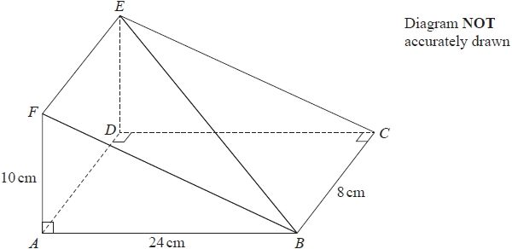

*AF* = 10 cm, *AB* = 24 cm and *BC* = 8 cm.   
Angle *FAB* = angle *ADC* = angle *BCD* = 90°

Work out the size of the angle between the line *BE* and the plane *ABCD*.   
Give your answer correct to 1 decimal place.

........................................................... °

**(Total for question = 3 marks)**

**Q2.**

The diagram shows a solid prism *ABCDEFGH*.

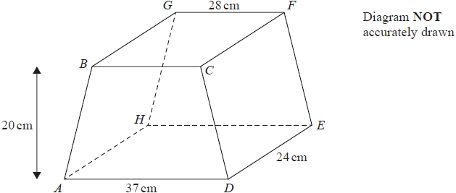

The trapezium *ABCD*, in which *AD* is parallel to *BC*, is a cross section of the prism.   
The base *ADEH* of the prism is a horizontal plane.   
*ADEH* and *BCFG* are rectangles.   
The midpoint of *BC* is vertically above the midpoint of *AD* so that *BA* = *CD*.

*AD* = 37 cm          *GF* = 28 cm          *DE* = 24 cm

The perpendicular distance between edges *AD* and *BC* is 20 cm.

(a)  Work out the total surface area of the prism.

........................................................... cm2

**(4)**

(b)  Calculate the size of the angle between *AF* and the plane *ADEH*.   
      Give your answer correct to one decimal place.

........................................................... °

**(3)**

**(Total for question = 7 marks)**

**Q3.**

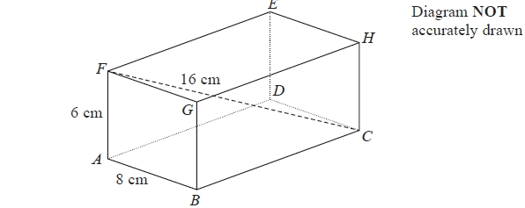

The diagram shows a cuboid *ABCDEFGH*.   
*AB* = 8 cm, *AF* = 6 cm and *FC* = 16 cm.

(a)   Find the length of *BC*.   
Give your answer correct to 3 significant figures.

*BC* = ........................................................... cm

**(3)**

(b)   Find the size of the angle between the line *FC* and the plane *ABGF*.   
Give your answer correct to 1 decimal place.

........................................................... °

**(2)**

**(Total for Question is 5 marks)**

**Q4.**

The diagram shows cuboid *ABCDEFGH*.

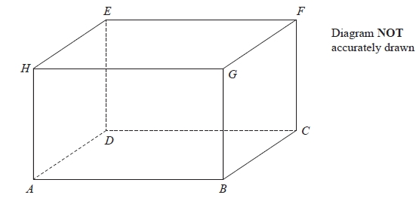

For this cuboid

the length of *AB* : the length of *BC* : the length of *CF* = 4 : 2 : 3

Calculate the size of the angle between AF and the plane *ABCD*.   
Give your answer correct to one decimal place.

........................................................... °

**(Total for question = 3 marks)**

**Q5.**

The diagram shows a cuboid *ABCDEFGH*.

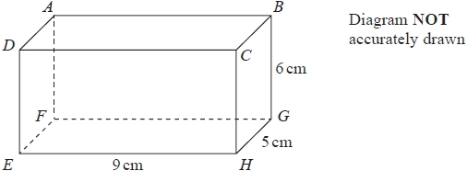

*EH* = 9 cm, *HG* = 5 cm and *GB* = 6 cm.

Work out the size of the angle between *AH* and the plane *EFGH*.   
Give your answer correct to 3 significant figures.

........................................................... °

**(Total for question = 4 marks)**

**Q6.**

The diagram shows cuboid *ABCDEFGH*.

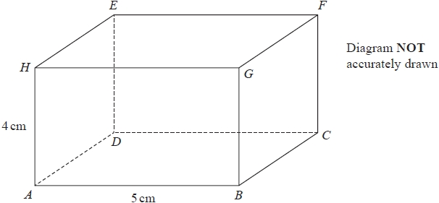

*AB* = 5 cm   
*AH* = 4 cm   
The size of the angle between *CH* and the plane *ABCD* is 35°

Calculate the volume of the cuboid.   
Give your answer correct to 3 significant figures.

........................................................... cm3

**(Total for question = 5 marks)**

**Q7.**

The diagram shows a pyramid with a horizontal rectangular base *PQRS*.  
*PQ* = 16 cm.  
*QR* = 10 cm.  
*M* is the midpoint of the line *PR*.  
 The vertex, *T*, is vertically above *M*.  
*MT* = 15cm.

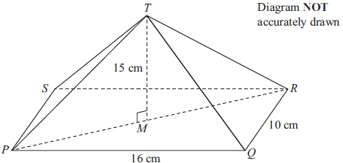

Calculate the size of the angle between *TP* and the base *PQRS*.  
 Give your answer correct to 1 decimal place.

...........................................................°

**(Total for question = 4 marks)**

**Q8.**

The diagram shows a cube *ABCDEFGH*.  
 The sides of the cube are of length 5 cm.

Calculate the size of the angle between the diagonal *AH* and the base *EFGH*. Give your answer correct to 1 decimal place.

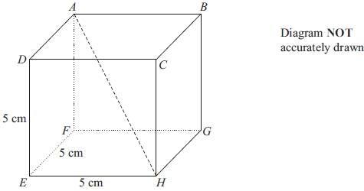

...........................................................°

**(Total for question = 4 marks)**

**Q9.**

The diagram shows a triangular prism with a horizontal rectangular base *ABCD*.  
*AB* = 10 cm. *BC* = 7 cm.  
*M* is the midpoint of *AD*.  
The vertex *T* is vertically above *M*.  
*MT* = 6 cm.

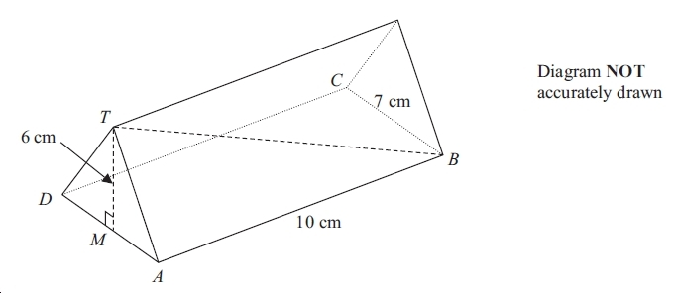

Calculate the size of the angle between *TB* and the base *ABCD*.

Give your answer correct to 1 decimal place.

..............................................°

**(Total for question = 4 marks)**

**Q10.**

The diagram shows a cuboid *ABCDEFGH*.

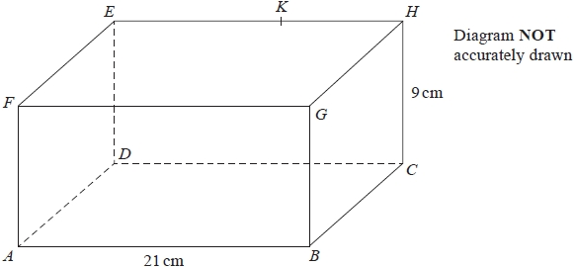

*AB* = 21 cm and *CH* = 9 cm.   
*K* is the point on *EH* such that angle *AKB* = 68° and *BK* = 16.5 cm.

(a)  Calculate the size of angle *BAK*.

Give your answer correct to 1 decimal place.

........................................................... °

**(3)**

(b)  Calculate the size of the angle between the line *BK* and the plane *ABCD*.

Give your answer correct to 1 decimal place.

........................................................... °

**(2)**

**(Total for question = 5 marks)**

**Q11.**

The diagram shows a prism.

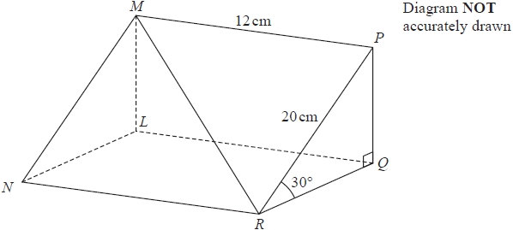

Triangle *PQR* is a cross section of the prism.

*PR* = 20 cm   
*MP* = 12cm   
Angle *PRQ* = 30°   
Angle *PQR* = 90°

Calculate the size of the angle that the line *MR* makes with the plane *RQLN*.   
Give your answer correct to 1 decimal place.

........................................................... °

**(Total for question = 5 marks)**

**Q12.**

A pyramid has a horizontal square base *ABCD* with sides of length 230 metres.   
*M* is the midpoint of *AC*.   
The vertex, *T*, is vertically above *M*.   
The slant edges of the pyramid are of length 218 metres.

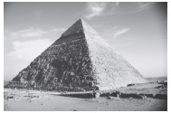

Calculate the height, *MT*, of the pyramid.   
Give your answer correct to 3 significant figures.

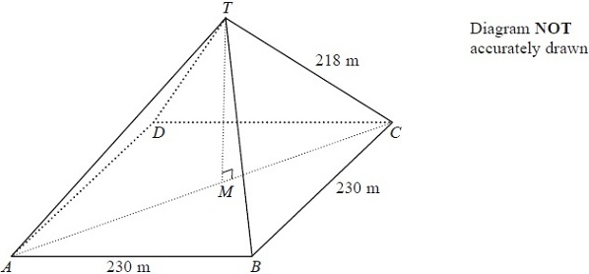

........................................................... m

**(Total for Question is 5 marks)**

**Q13.**

The diagram shows a triangular prism with a horizontal base *ABCD*.

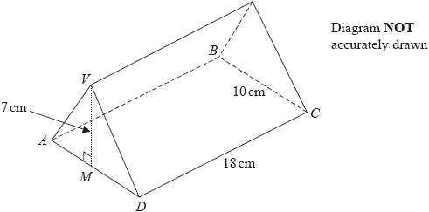

*M* is the midpoint of *AD*.   
The vertex *V* is vertically above *M*.

*DC* = 18 cm,    *BC* = 10 cm,    *MV* = 7 cm.

Calculate the size of the angle between *VC* and the plane *ABCD*.   
Give your answer correct to 3 significant figures.

........................................................... °

**(Total for question = 4 marks)**

**Q14.**

*ABCDE* is a square-based pyramid.

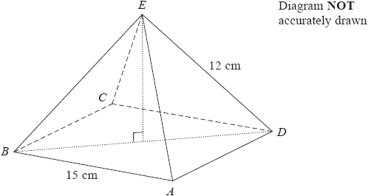

*AE* = *BE* = *CE* = *DE* = 12 cm   
*AB* = 15 cm   
  
Calculate the size of angle *DEB*.   
Give your answer to the nearest degree.

........................................................... °

**(Total for question = 4 marks)**

**Q15.**

*ABCDEFGH* is a cuboid.

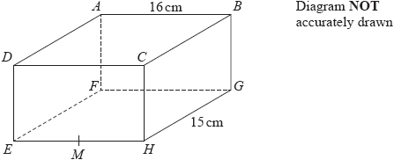

*AB* = 16 cm and *HG* = 15 cm.   
*M* is the midpoint of *EH*.

*BM* makes an angle of 24° with the base *EFGH*.

Calculate the height, *BG*, of the cuboid.   
Give your answer correct to 3 significant figures.

........................................................... cm

**(Total for question = 4 marks)**

**Q16.**

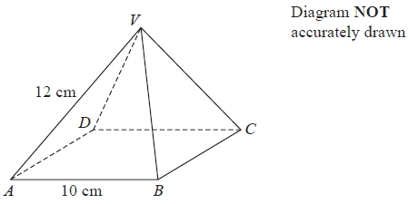

*ABCD* is the square base of the pyramid *VABCD*.

*AB* = *BC* = *CD* = *DA* = 10 cm.   
*VA* = *VB* = *VC* = *VD* = 12 cm.

Calculate the height of the pyramid.   
Give your answer correct to 3 significant figures.

........................................................... cm

**(Total for question = 4 marks)**

**End of questions**