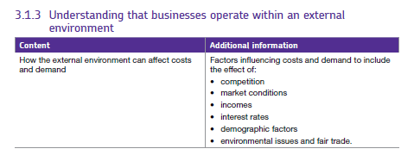3.1.3 External environment of business.

## What is the external environment?

This refers to the factors affecting the business which are out of its control.

Businesses are said to operate in markets e.g. Clarks operates in the footwear market and Puregym operates in the leisure market. Some businesses operate to supply other businesses and these are in **B2B markets**, other firms operate to supply consumers and these are in **B2C markets**.

There are many factors which can affect the costs of businesses and the demand for products in their markets.

Some of these factors include:

## Market Conditions

Market conditions relate to the attractiveness of the overall market in which a business operates. Often we think of this as the **economic climate** in which the business operates, whether there is growth or there is a recession. Market conditions tend to affect all businesses in an industry, although their ability to take advantage or, or respond to changes in market conditions will vary.

Two key indicators of market conditions are:

1. Economic Growth (GDP)
2. Market Demand

## Economic Growth (GDP)

Economic growth measures the value of output (activity) in the economy.

**GDP stands for Gross Domestic Product** – a measure of how much money the country is making – for itself and from all its trade (including that with other countries). **The total value of the goods and services produced within the UK**.

[BBC economy tracker](http://www.bbc.co.uk/news/10613201) Video - [what is GDP and why does it matter?](http://www.bbc.co.uk/news/business-22290374)

This can be shown as a line graph so we can see how the country has performed over a period of time.

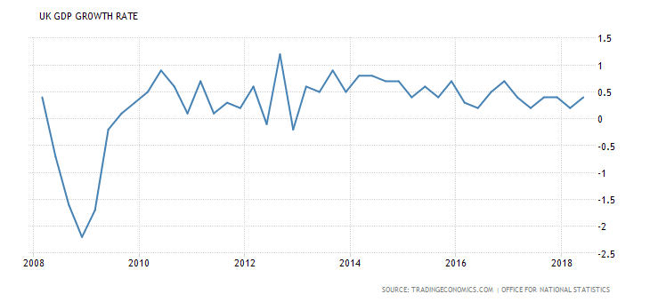

## Market demand

The level of demand in most markets is influenced by the rate of economic growth

Market demand measures how much of a good or service a consumer wants – and is able to pay for. For a business, high market demand turns into revenues (sales). Demand is influenced by many factors, a key one being disposable income – how much money people have to spend.

## Real Incomes

Real incomes measure the amount of **disposable income** available to consumers (e.g. households & individuals).

There are significant differences in household disposable incomes by region in the UK. E.g. in 2019 London had the highest income per head, where the average person had £27, 825 available to save or spend. Wales had the lowest @ £15,754. The UK average was £19,514.

[](https://www.bing.com/images/search?view=detailV2&ccid=GthBJ0bc&id=32B06155A501CF9DE9D7259158AD6709BD4D33D7&thid=OIP.GthBJ0bcFTjVN7QPFlXitgEgDY&q=aldi&simid=608000876464639575&selectedIndex=2&adlt=strict)In general, when people have less money they will substitute more expensive products for cheaper ones meaning demand will fall for some products but rise for others.

We can see this by looking at the rise of the low-cost supermarkets from 2008 onwards as people had less real income and chose to shop in cheaper retailers such as Aldi and Lidl.

[](https://www.bing.com/images/search?view=detailV2&ccid=b3F8A0SK&id=E9CD232D7441E0D232FA04A2EDDD97047E58D929&thid=OIP.b3F8A0SKpzK61tPx4W2UqgDtEs&q=sainsburys+basics+ready+salted+crisps&simid=607986681611223066&selectedIndex=0&adlt=strict)

However, there are products which have falling sales when people have more real income to spend – these products are known as **inferior goods** for example some people, when they have more money will stop buying Sainsbury’s basics and start buying Walkers crisps – Sainsbury’s basics crisps are an inferior good.

Real incomes are closely linked to market demand (market conditions), since they are an important factor that affects demand. These factors include:

* **Real Disposable Income** (how much households have available to spend)
* **Employment and Job Security** (when the jobs market is improving, consumer confidence and incomes will improve)
* **Household Wealth** (e.g. house prices & share prices) – a rise in wealth can increase consumer demand)
* **Market Interest Rates** (interest rates affect both the incentive to save and the cost of borrowing)

## Price inflation

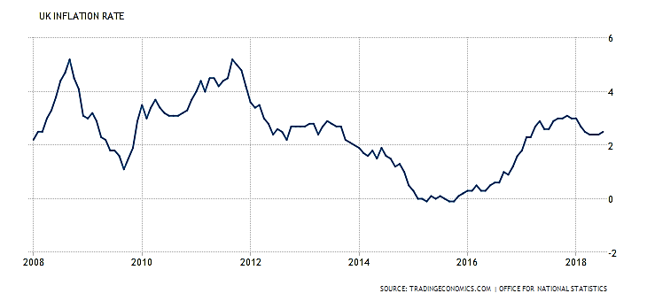This is the rate at which prices are rising. can have a significant effect on consumer spending as, if prices are rising, consumers may try to save more ‘just in case’ or may cut back on buying more expensive items such as cars as they become less affordable.

Here we can see that inflation has fluctuated considerably between 2008 and 2017 but more recently it has been lower meaning prices are relatively stable.

## Interest Rates

An interest rate is the **reward for saving** and the **cost of borrowing** expressed as a percentage of the money saved or borrowed.

At any one time there are a variety of different interest rates operating within the external environment; for example:

* Interest rates on savings in bank and other accounts
* Borrowing and mortgage interest rates
* Credit card interest rates and pay day loans

The Bank of England uses policy interest rates to help regulate the economy and meet economic policy objectives.  The Bank of England Base Rate has been very low and stable for several years.

So, we need to think about what might happen if interest rates start to rise… the possible effects might be:

* Cost of repaying loans / debt is reduced – boosting spending power
* Consumer confidence should increase leading to more spending
* Effective disposable income rises – lower mortgage costs
* Business investment should be boosted e.g. prospect of rising demand

### Demographic Factors

Demography is concerned with the **size and composition of a population**. Changes in population dynamics occur slowly but can be significant for businesses.

Two key demographic changes in the UK that impact on many businesses are:

### Ageing Population:

***Some possible business implications are:***

Greater demand for services to support older people (e.g. healthcare)

Increasing disposable incomes of older people reflected in higher demand for goods and services (e.g. holidays)

### High levels of net immigration:

***Some possible business implications are:***

Higher costs of (but greater demand for) public services (e.g. education, health, housing)  
Increase in size of labour force – potentially keeping wage rates low, businesses able to grow faster with a larger supply of labour (particularly in the agricultural and service sectors)

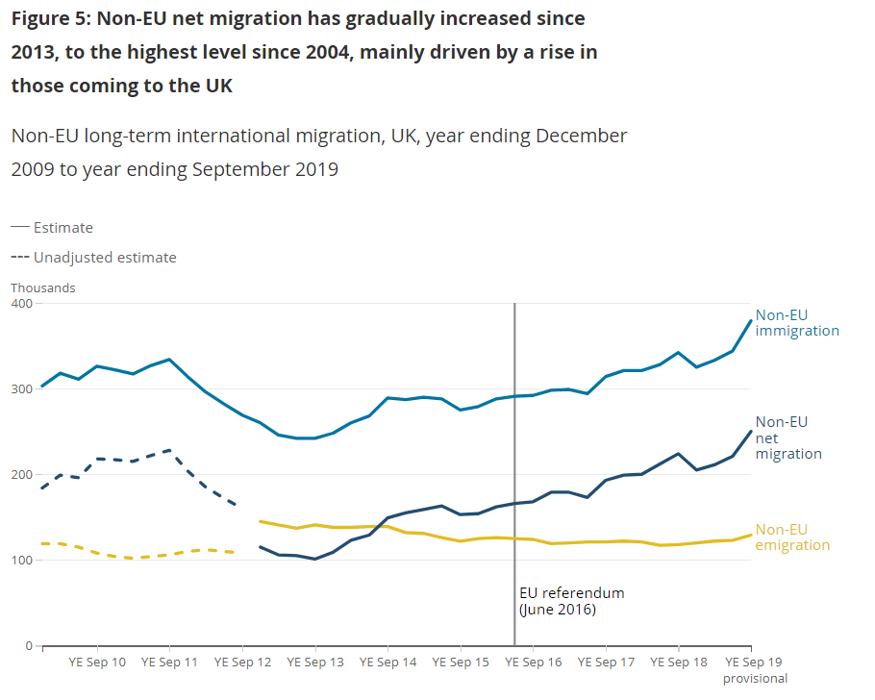

Other factors affecting demand might include competition.

Competition can increase and decrease frequently. In the last few years many industries have seen competition increase due to disruptive change – a new firm has entered the market offering something completely different. This can often be due to technology e.g. Airbnb have significantly changed the overnight accommodation market because they do not operate in the same way as other providers and can be significantly cheaper.