**3.3.6 Organic analysis**

**AS Link:**

**3.1.1 – Atomic structure** (mass spectroscopy)

**3.1.3 – Bonding**

**3.2.3 – Group 7** (testing halides)

**3.3.1 – Introduction to organic chemistry** (functional groups)

**3.3.5 – Alcohols** (test for alcohols, aldehydes & ketones)

**Identification of functional groups by test tube reactions**

When identifying organic compounds you need to know the functional group present.

There are some **general observations** which can be helpful:

* **Solid** – long hydrocarbon chain or ionic bonding
* **Liquid** – medium hydrocarbon chain or polar or hydrogen bonding
* **Gas** – short hydrocarbon chain, little or no polarity
* **Soluble** **in water** – polar
* **Insoluble in water** – non-polar

Specific chemical tests

|  |  |  |  |
| --- | --- | --- | --- |
| **Functional group** | **Test** | **Result** | **Picture** |
| Alkene  ─ C = C ─ | Bromine water  *Electrophilic addition reaction*  alkene + bromine → dihalogenoalkane | Orange turns colourless |  |
| Halogenoalkane  R ─ X | 1. NaOH (aq) & warm 2. HNO3 (aq) 3. AgNO3 (aq) 4. *Nucleophilic substitution* 5. *Test for halides*   Ag+ + X- → AgX(s) | AgCl – white ppt  AgBr – cream ppt  AgI – yellow ppt |  |
| Alcohol  All classifications  R ─ OH | Sodium metal  2CH3CH2OH + 2Na  → 2CH3CH2ONa + H2(g)  sodium ethoxide | Effervescence |  |
| 1o & 2o alcohol | **Acidified** potassium dichromate(VI)  Reduction:  Cr2O72+ + 14H+ + 6e-  → 2Cr3+ + 7H2O  Oxidation:  1o alcohol + [O]  → carboxylic acid + H2O  2o alcohol + [O]  → ketone + H2O | Orange turns green |  |
| 1o alcohol  R ─ OH  Aldehyde  R ─ CHO | Tollens’ reagent  Reduction:  Ag+ (aq) + e- → Ag (s)  Oxidation:  1o alcohol + [O]  → carboxylic acid + H2O  aldehyde + [O]  → carboxylic acid | Silver mirror |  |
| Fehling’s reagent  Reduction:  Cu2+ (aq) + e- → Cu+(s)  Oxidation:  1o alcohol + [O]  → carboxylic acid + H2O  aldehyde + [O]  → carboxylic acid | Blue solution to red precipitate |  |
| Carboxylic acid  R ─ COOH | NaHCO3 (s)  CH3COOH + NaHCO3 → CH3COONa + H2O + CO2(g)  sodium ethanoate | Effervescence |  |

***Required practical 6:*** Tests for alcohol, aldehyde, alkene and carboxylic acid

***Application: CGP245 PQ1-5***

***Fact recall: CGP246 Q1-3***

**Mass spectrometry**

**AS Link:**

**3.1.1 – Atomic structure** (mass spectroscopy)

The mass spectrometer is the most useful instrument for accurate determination of the **relative atomic mass of atom, Ar**.

It can also be used to measure the **relative atomic mass of organic compounds, Mr**.

It works on the following principles:

* **Ionisation** –formation of positive ions
* **Acceleration** –through the flight tubethen separatedaccording to the **ratio of their charge to their mass (*m/z*)**
* **Detection** –abundance and m/z of each molecule determined

***Starter: 10.1.2 – Isotopic abundance***

Ionisation time of flight (TOF) instrument

|  |  |  |  |
| --- | --- | --- | --- |
| **Ionisation** | **Electron impact**:   * sample vaporised * high energy electrons fired at sample from **electron gun** * **electron knocked out** of sample to give **positive ion** | | |
|  | | |
| ***Elements***:  X(g) → X+(g) + e-  It’s possible to remove 2 electrons giving ions with a 2+ charge - usingthe **minimum energy required** helps to prevent this  ***Diatomic*** molecular elements:  X2(g) → X2+(g) + e- | | ***Low mass molecules***:  XY4(g) → XY4+(g) + e-  X2+/XY4+ referred to as molecular ion  Molecules can fragment giving peaks with mass lower than m/z of molecular ion |
| **Electrospray ionisation**:   * dissolved in volatile solvent (water or methanol) * injected through a fine hypodermic needle giving a fine mist /aerosol * tip of needle has high voltage power supply * each molecule gains a proton from the solvent as it leaves the needle | | |
| ***High mass molecules***:  M(g) + H+→ MH+(g)  Known as a soft technique as molecules aren’t fragmented | | |
|  | | |
| **Separation** | **Acceleration**:   * **positive ions** are **attracted** towards a **negatively charged electric field**, forming a beam which is accelerated along the flight tube to the detector * the **positive ions** all have the **same kinetic energy** (KE) * the **velocity of each particle depends on its mass**   + lighter ions have a faster velocity   + heavier ions have a slower velocity   This is explained by this equation:  KE = ½ mv2 *KE = kinetic energy* *m = mass v = velocity*  v = √2KE/m | | |
| **Flight tube**:   * positive ions pass through hole in negatively charged plate * **time of flight depends on velocity which depends on the mass**   + lighter ions travel faster   + heavier ions travel slower   This is explained by this equation:  t = d/v *t = time of flight (s)* *d = length of flight tube (m)*  substitute velocity with v = √2KE/m gives t = d  √2KE/m  Re-arrange: t = d√m/2KE  **Shows time of flight is dependent on length of flight tube (constant) to the square root of the mass of the ions divided by their kinetic energy (constant)** | | |
|  | | |
| **Detection** | * **positive ions hit a negatively charged plate** * **accept an electron** from the plate * this generates a movement of electrons and hence an **electric current** that is measured * **size** of the **current** gives a **measure** of the **number** of **ions** hitting the plate   + greater abundance gives bigger current generating bigger peak * signal produces a peak on spectrum | | |
|  | | |
| **Spectrum** | **Electron impact**  Element e.g. Mg (24Mg, 25Mg, 26Mg)  Ar isotope = m/z  Ar element = mass x abundance of isotopes  total abundance isotopes | | **Electrospray ionisation**  Molecule e.g. protein  Mr molecule = m/z – 1 (loss of H+)  molecular ion |
|  | Molecule e.g. propane  Mr molecule = m/z (molecular ion) | | Small peak with m/z 1 mass unit greater than molecular ion is due to molecules containing either 2H or 13C isotopes |
| fragmentation peaks | molecular ion |  |

Low resolution

Often masses are measured to the nearest whole number; this is called **low resolution** mass spectrometers. The output from the mass spec is presented as a **graph** of **relative abundance** (y-axis) against **mass/charge ratio** (x-axis), this is called a **spectrum** (plural spectra).

Mass spectrum of **octane** shows **many lines** not just one.

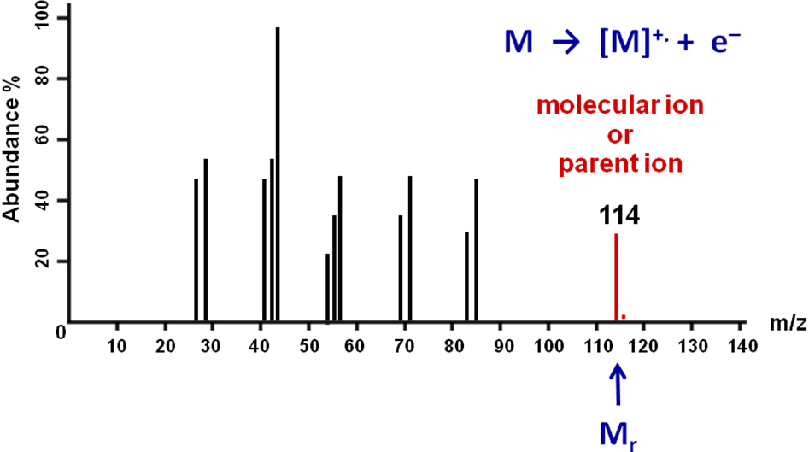

Octane is **ionised** to form the ion **C8H18+** (CH3CH2CH2CH2CH2CH2CH2CH3+). This is called the **molecular or parent ion** and represents the peak with the **largest *m/z* value**. It is given this representation **M+•**, it is a **cation** and also a **free radical**, since the covalent bond has lost one of its two electrons. The **value of *m/z*** for this ion is **equal** to the **relative molecular mass**, Mr. Hence for **octane the Mr is 114**.

**Formation of molecular ion**: **M → [M]+• + e–**

There is always a **small peak at M+1**(115 for octane) due to the natural abundance (about 1%) of **carbon-13**. The **height of this peak** relative to that for the molecular ion **depends** on the **number of carbon** atoms in the **molecule**. The **more carbons** present, the **larger** the **M+1 peak**.

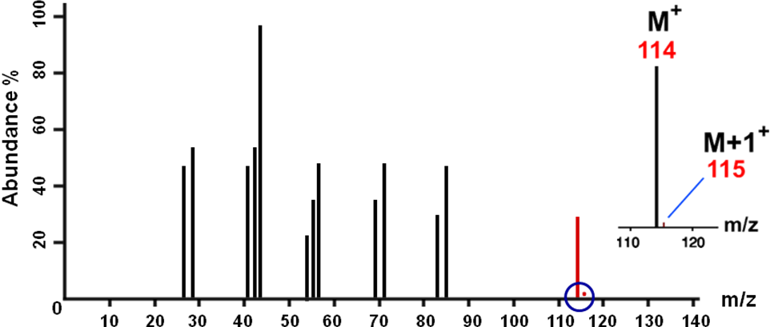

***Starter: 10.1.3 – Molecular mass spectrometry***

High resolution mass spectrometers

Mass specs that can measure relative atomic masses to **several decimal places** are called **high resolution** mass spectrometers. These allow **molecules** to be **identified** with **greater precision** using the **exact masses** of their atoms.

This **allows** the **molecular formula** of the **parent** **ion** to be **worked** **out**. It uses the fact that **isotopes** of atoms **don’t have exactly whole number atomic masses**. **Only carbon-12**, by definition has a **whole number** atomic mass of **exactly 12.0**.

For example:

H= 1.0078

C = 12.000

O= 15.994

***Task: Work out the relative molecular mass of the following to the nearest whole number***

C10H16O4 200

C11H4O4 200

C11H20O8 200

Many molecules had same **integral mass,** but adding up the **accurate atomic masses** gives the following:

C10H16O4 200.1008

C11H4O4 200.0072

C11H20O8 200.1380

So the **more precise** *m/z* to 3 or 4 decimal places can **distinguish** between such **molecules**.

**Example CGP246**

On a high resolution mass spectrum, a compound has a molecular ion peak *m/z* = 98.0336. What is its molecular formula?

A C5H10N2 B C6H10O C C7H14 D C5H6O2

Use these precise masses to work out your answer:

1H = 1.0078 12C = 12.0000 14N = 14.0031 16O = 15.9949

C5H10N2 Mr = (5 x 12.0000) + (10 x 1.0078) + (2 x 14.0031) = 98.0842

C6H10O Mr = (6 x 12.0000) + (10 x 1.0078) + 15.9949 = 98.0729

C7H14 Mr = (7 x 12.0000) + (14 x 1.0078) = 98.1092

C5H6O2 Mr = (5 x 12.0000) + (6 x 1.0078) + (2 x 15.9949) = 98.0336

Therefore it is compound **D, C5H6O2**

***Sheet: High resolution mass spectroscopy***

***Extension sheet: Mass spectrometry***

***Application: CGP247 PQ1-2***

**Infra-red spectroscopy**

Electromagnetic spectrum

The **electromagnetic spectrum** consists of electric and magnetic fields, which form electromagnetic radiation. The visible region makes up only a small part.

|  |  |  |
| --- | --- | --- |
| higher  frequency  lower  wavenumber |  | lower  frequency  higher  wavenumber |

**Atoms, molecules and ions can absorb** (or emit) electromagnetic **radiation** of **specific** **frequencies** and this can be **used to identify them**. This give rise to different analytical techniques:

|  |  |  |
| --- | --- | --- |
| **Electromagnetic radiation absorbed** | **Energy is used for** | **Spectroscopy technique** |
| Ultra-violet / visible | Movement of electrons to higher energy levels | Ultra-violet spectroscopy  Visible spectroscopy |
| Infra-red | To vibrate bonds | Infra-red spectroscopy |
| Radio waves | To change nuclear spin | NMR spectroscopy |

Bond vibration

A **pair of atoms** in a molecule are **joined** by a **chemical bond** which is **always vibrating** like 2 balls attached by a spring.

|  |  |  |
| --- | --- | --- |
| A bond can vibrate in 2 different ways, either **bending or stretching** |  |  |

Only molecules with **polar bonds** will **absorb IR radiation**. Changes in the dipole moment of bonds allow the IR to be absorbed. Molecules with the same atoms don’t absorb IR radiation, e.g. O2 and N2.

The **frequency depends** on the **mass** of the atoms in the bond, the **bond strength**, and the **type** of **vibration**. Every bond has its own **natural frequency** that is in the **infra-red (IR) region** of the **electromagnetic** **spectrum**.

If IR radiation is passed through a molecule, the bonds can absorb energy form the radiation and vibrate more. However, a **bond will only absorb radiation** at **same frequency** as the **natural frequency** of bond. Therefore some **radiation** will be **absorbed** and **some** will **passes through**, resulting in a series of peaks.

Infra-red spectrophotometer

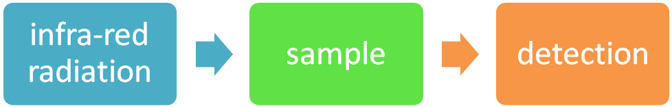

How it works:

* A **beam** IR radiation with a **spread of frequencies** is passed through the sample
* The **radiation** that **emerges** is **missing** the **frequencies** that **correspond** to the types of **bonds** found in the sample
* The instrument **plots** a graph of the **intensity** of the **radiation** **emerging**, called the **transmittance**, **against** the **frequency** of the radiation

**Wavenumbers** (cm-1) are used as a measure of the **wavelength** **or frequency** of the absorption.

Units: cm-1

wavenumber = 1

wavelength (cm)

The **position** of the **peak** position **depends** on **bond strength** and the **masses** of the atoms joined by the bond.

|  |  |
| --- | --- |
| stronger bonds & lighter atoms | weaker bonds & heavier atoms |
| higher frequency | lower frequency |
| lower wavenumber | higher wavenumber |

So:

* **strong bonds** and **light atoms** absorb at **higher frequencies (lower wavenumbers**)
* **weak bonds** and **heavy atoms** absorb at **lower frequencies** (**higher wavenumbers**)

Its **main uses** are:

* **identify unknown** compounds
  + identifying specific bonds (functional groups)
  + matching to spectra of known substances
* determine if a compound is **pure** or impure
  + identifying unusual peaks

***Video clip: Infra-red spec***

IR spectra

|  |  |
| --- | --- |
| A typical graph shows **dips**, they are confusingly **called peaks**, which **represent** particular **bonds**. |  |

* **Vertical** axis **Absorbance** (the stronger the absorbance the larger the peak)
* **Horizontal** axis **Frequency** or **wavenumber** (waves per centimetre) / cm-1

Frequencies:

* **above 1500 cm-1** are used to identify **functional groups**
* **below 1500 cm-1** is used for **fingerprinting**

Functional groups

**Specific** types of **bonds** will **absorb** in a particular **range of frequencies**, which allows them to be identified in different compounds.

|  |  |
| --- | --- |
| This give rise to **data tables** relating bonds to frequencies.  The **same bond** can have **slightly different frequencies** depending on the **type of molecule** it is in, for example an O-H in an alcohol or carboxylic acid.  **Bond frequencies** are listed in **data tables**. |  |

The **same** type of **bond** can exist in **different compounds**, they will absorb around the same frequency but in **different environments** the **range will be slightly different**.

* O⎯H bond
  + Alcohol (3230-3550 cm-1)
  + Carboxylic acids (2500-3000cm-1)
* C=O bond (1680-1750 cm-1)
  + Aldehydes
  + Ketones
  + Carboxylic acids

**Spectra showing same bonds in different molecules**

|  |  |
| --- | --- |
| Cyclohexane |  |
| Cyclohexene |  |
| Butanal |  |

**Comparing spectrum for an alcohol, aldehyde and carboxylic acid.**

Hydroxyl and carbonyl groups give very characteristic peaks.

|  |  |
| --- | --- |
| Ethanol |  |
| Ethanal |  |
| Ethanoic acid |  |

***Starter: 10.2 – Infra-red spectroscopy***

***Power point: Infra-red example problems***

***Sheet: Infra-red spectroscopy problems 1 & 2***

Fingerprint region

Organic molecules have a lot of **C-C** and **C-H** bonds within their structure so the spectra obtained will have **many peaks** **below 1500 cm-1**; this is called the **fingerprint region**. The peaks are due to complex vibrations of whole molecule; this gives a **unique pattern** and so is used to **identify** the compound. This is particularly useful for **isomers** such as propan-1-ol & propan-2-ol.

|  |  |
| --- | --- |
|  |  |
| Whole spectra | Fingerprint region |

Identifying impurities

Infra-red can also be used to identify **impurities**. It can reveal **peaks** that should **not** **be** **there**. The fingerprint region can also be used to check if a compound is pure.

**Example – caffeine**

A **pure sample** of caffeine extracted from tea is shown. If the tea is **impure** if would show a **broad peak** around 3000cm-1 due to an **O-H** stretch caused by **water** in the sample that has not completely dried.

In practice a range of analytical techniques are used to identify unknown substances.

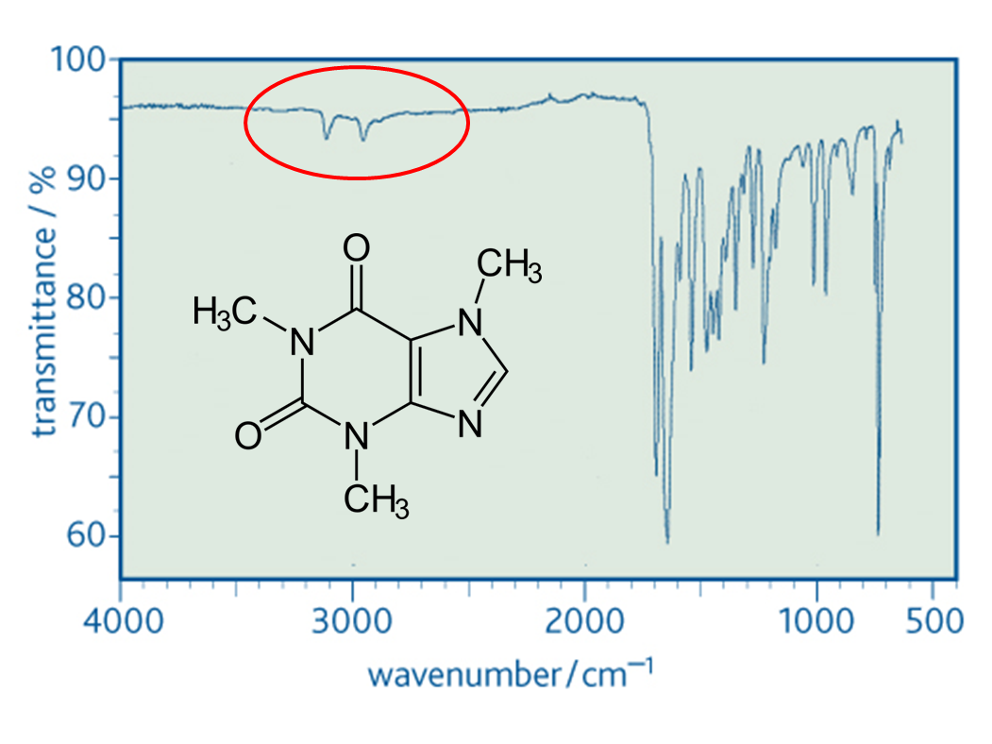

***Sheet: AS Analytical techniques questions***

***Practical sheet: Analytical techniques***

**Absorbing of infra-red radiation and global warming**

**AS Link:**

**3.3.2 – Alkanes**(polluting gases)

|  |  |  |
| --- | --- | --- |
| There are 3 main **greenhouse gases**:   * Carbon dioxide * Water * Methane  (cattle, decomposition & rice fields)   Carbon dioxide and water **occur naturally** in the atmosphere. |  |  |
| **polar bonds** |

**Ultra-violet** and **visible** **light** from the sun is **absorbed** by the **Earth** and **emitted** at much longer wavelengths as **infra-red radiation**. This **radiation** is **absorbed** by **polar molecules** in the **atmosphere** which **absorbs** the **energy** and prevent it escaping. Those gases which absorb infra-red are called **greenhouse gases**.

|  |  |
| --- | --- |
|  | It acts like a greenhouse. |
|  |

The **reasons** these particular gases have their effect and not gases such as nitrogen and oxygen, which are in much higher abundances is because of their **structures** and the **bonds** they contain. The **vibrational energies** of the **O-H** bonds in **water**, the **C=O** bonds in **carbon dioxide** and the **C-H** bonds in **methane** correspond to energies in the **infra-red** region.

So when **infra-red radiation passes through** these gases, **energy is absorbed** and the **bonds stretch** and **bend**. When these **molecules collide** with each other they **pass** **on** some of the **energy** they have absorbed, this results in an **increase in the average** **energy** of the **molecules** in the **atmosphere** and hence, **global warming**.

**Carbon dioxide is more efficient** at absorbing infra-red radiation, **but** because it **only** makes up a **small percentage** of the atmosphere, it’s **not the most important**. **Water vapour**, which is present in **much larger quantities**, is responsible for **most** of the infra-red **energy** **absorbed**.

***Extension sheet: What causes the greenhouse effect?***

***Application: CGP250 PQ1-2***

***Fact recall: CGP250 Q1-2***

***Exam questions: Oxford p250-251 Q1-3***