How does the stomach break down food?

What are enzymes?

**Digestive system and enzymes**

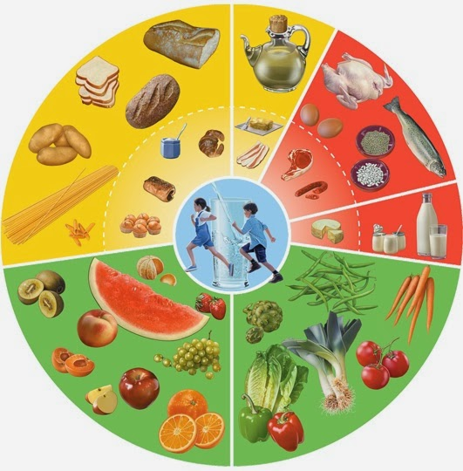

Why do we need a balanced diet?

What does the liver do?

Label the food wheel!

What does the oesophagus do?

What does the pancreas do?

What does the gall bladder do?

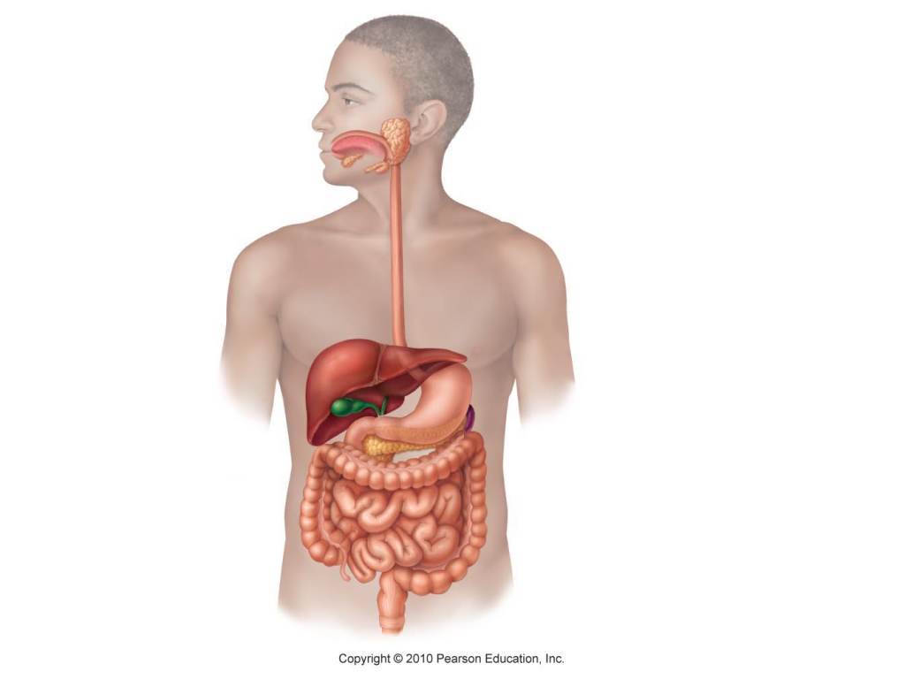

How can you destroy (denature) an enzyme?

What happens in the large intestine?

What happens to nutrients in the small intestine?

What do the three enzymes do?

1.

2.

3.