

**Higher IGCSE (9 – 1) Revision Pack**

**Sequences and Series (Part 2)**

**Name --------------------------------**

**Q1**

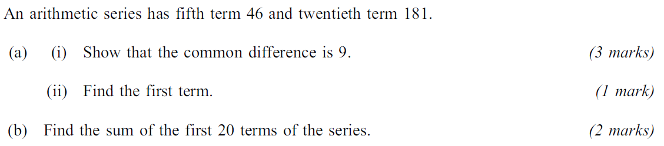

**Q2**

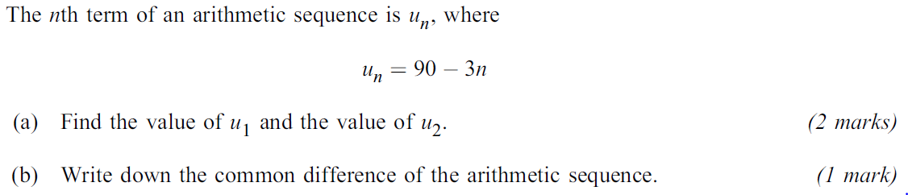

**Q3**

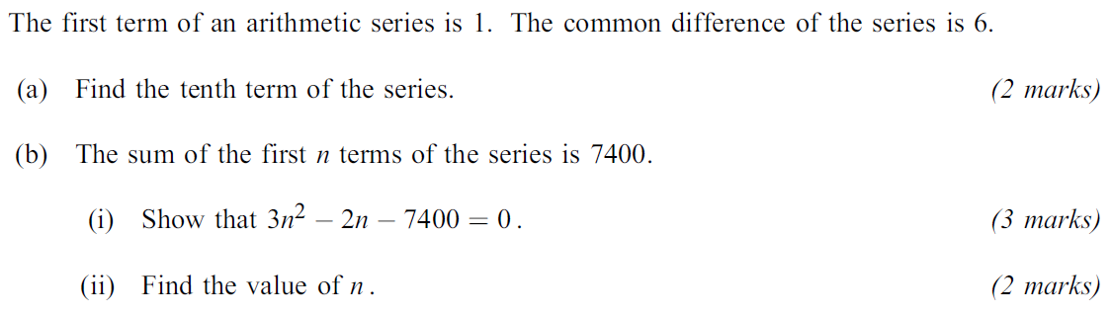

**Q4**

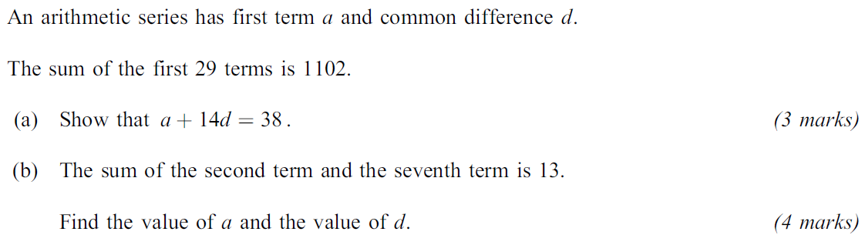

**Q5**

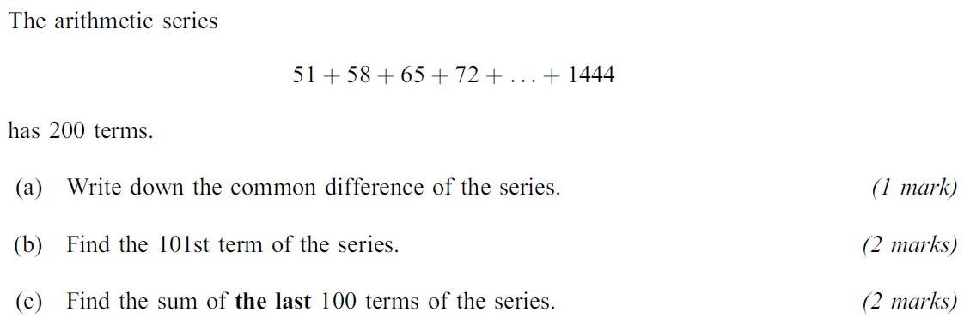

**Q6**

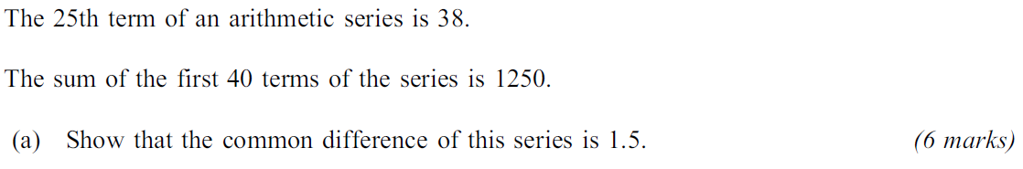

**Q7**

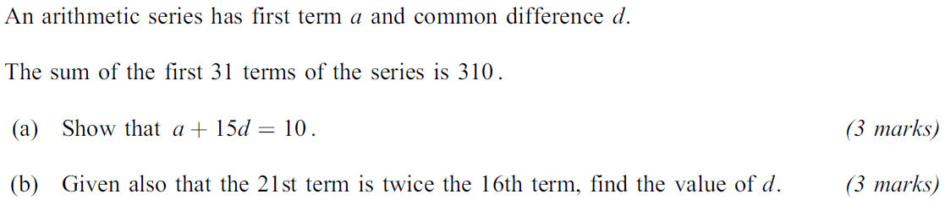

**End of questions**