**3.7 Analysing the strategic position of a business**

**3.7.1 Mission, corporate objectives and strategy**

**Corporate objectives** are medium to long-term goals established to coordinate the business.

A **mission statement** sets out a business’s overall purpose to direct and stimulate the entire organisation.

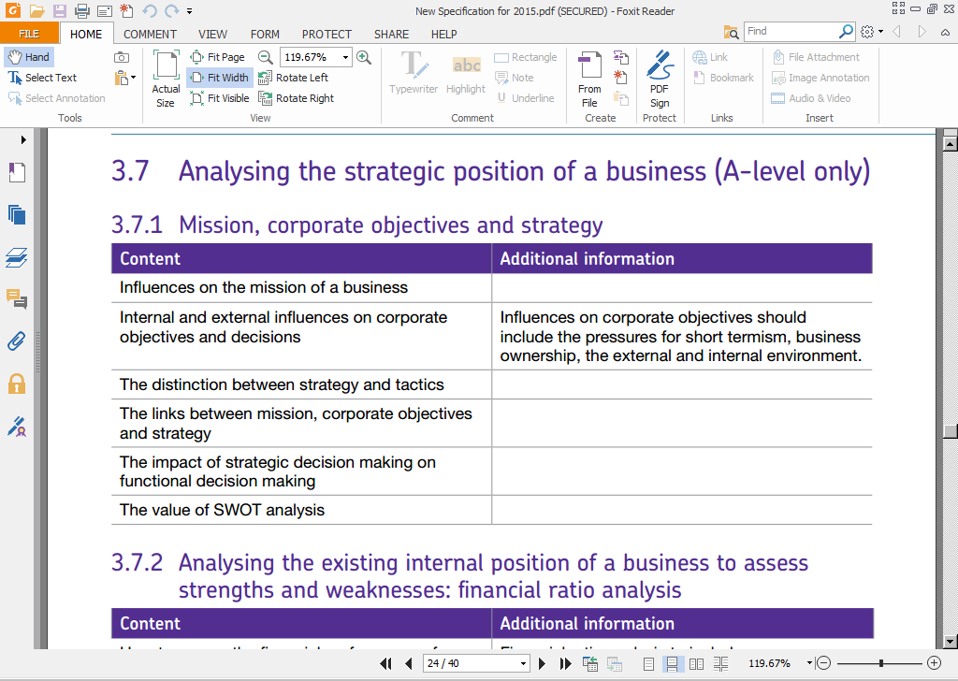

**SWOT** analysis is a management technique used to identify a business’s strengths and weaknesses, as well as the opportunities and threats to which it will be exposed.

**Strategic decisions** are judgements made by senior managers that are long-term, involve a major commitment of resources and are difficult to reverse.

A **strategy** is a medium to long-term plan detailing how the company intends to achieve its corporate objectives.

Whereas **tactics** involve meeting short-term targets, require fewer resources to implement and may be easy to reverse.

**Lesson 1**

**The links between mission, corporate objectives and strategy**

It is important to understand how corporate objectives 'fit in' with the mission and strategies.

* 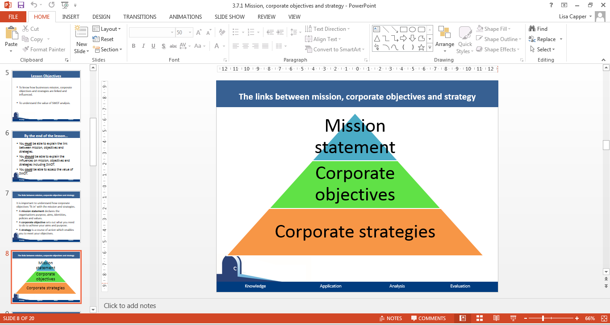A mission statement declares the organisations purpose, aims, identities, policies and values.
* A corporate objective sets out what you need to do to achieve your aims and purpose.
* A strategy is a course of action which enables you to meet your objectives.

**Influences on the mission of a business and on corporate objectives and decisions**

The mission of a business will be influenced by a range of factors, including the value of the founders, the values of the employees, the industry of which the business is part of, society’s views and the ownership of the business.

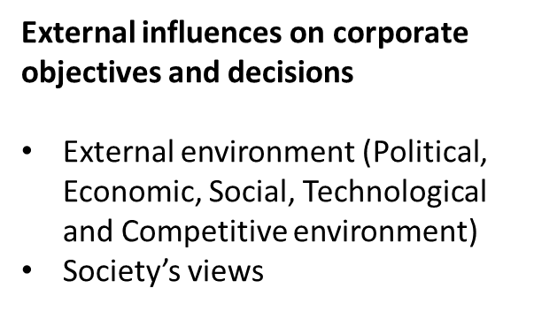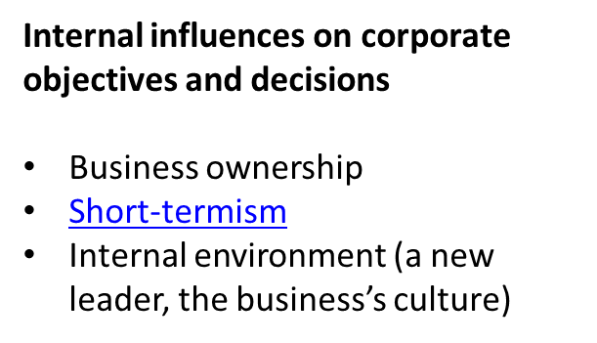

1. Watch the video clip and explain how short-termism may influence corporate objectives and decisions.

………………………………………………………………………………………………………………………………………………………………………………………………………………………………………………………………………………………………………………………………………………………………………………………………………………………………………………………………………………………………………………………………………………………………………………………………………………………………………………………………………………………………………………………………………………

1. Choose one external and one internal influence and explain how it may influence a business’s corporate objective/decision.

Internal influence ………………………………………………………………………………………………………………… ………………………………………………………………………………………………………………………………………………………………………………………………………………………………………………………………………………………………………………………………………………………………………………………………………………………………………………………………………………………………………………………………………………………………………………………………………………………………………………………………………………………………………………………………………………

External influence ………………………………………………………………………………………………………………… ………………………………………………………………………………………………………………………………………………………………………………………………………………………………………………………………………………………………………………………………………………………………………………………………………………………………………………………………………………………………………………………………………………………………………………………………………………………………………………………………………………………………………………………………………………

**The distinction between strategy and tactics**

A strategy is a medium to long-term plan detailing how the company intends to achieve its corporate objectives. These will inform strategies across all functional areas and are often based on the outcome of a SWOT analysis. Strategies are likely to involve a significant investment in terms of time and resources, which makes them difficult to change.

Tactics involve meeting short-term targets, require fewer resources to implement and may be easy to reverse. They are often taken on a functional level by middle management.

*Which is the strategy and which is the tactic for the two businesses outlined below?*

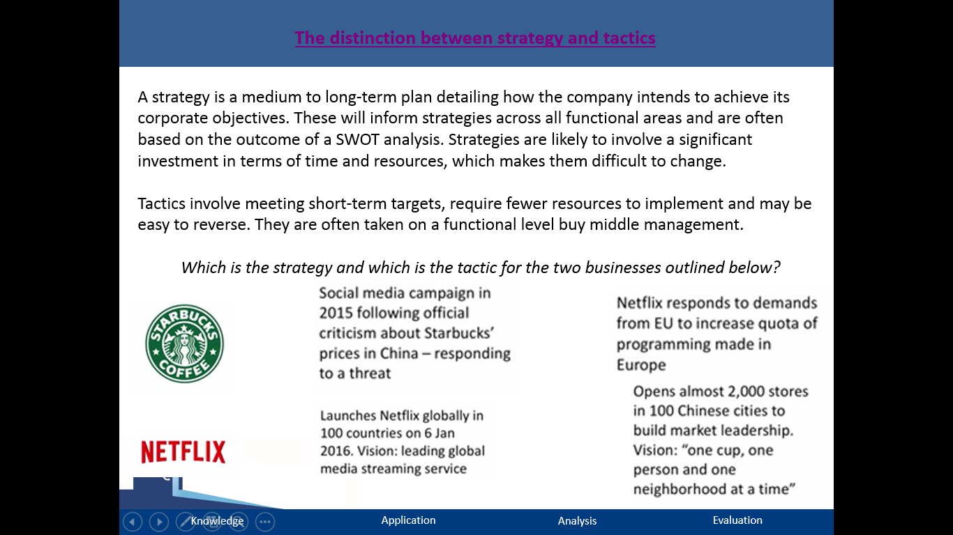

**The impact of strategic decision making on functional decision making**

The relationship between corporate objectives and functional objectives and strategies. All of these functional strategies & objectives should help achieve the corporate objective.

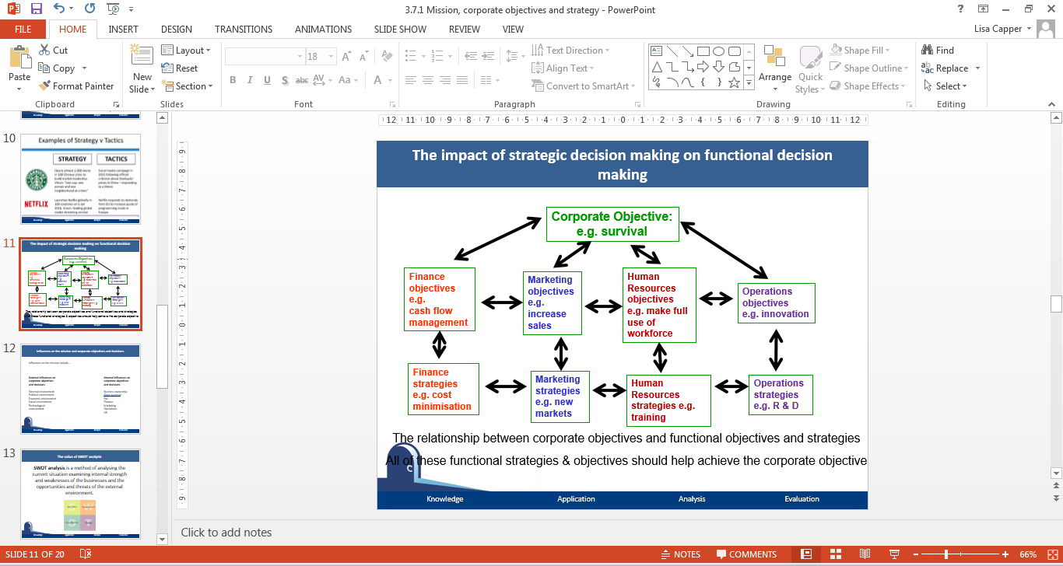

**The value of SWOT analysis**

SWOT analysis is a method of analysing the current situation examining internal strength and weaknesses of the businesses and the opportunities and threats of the external environment.

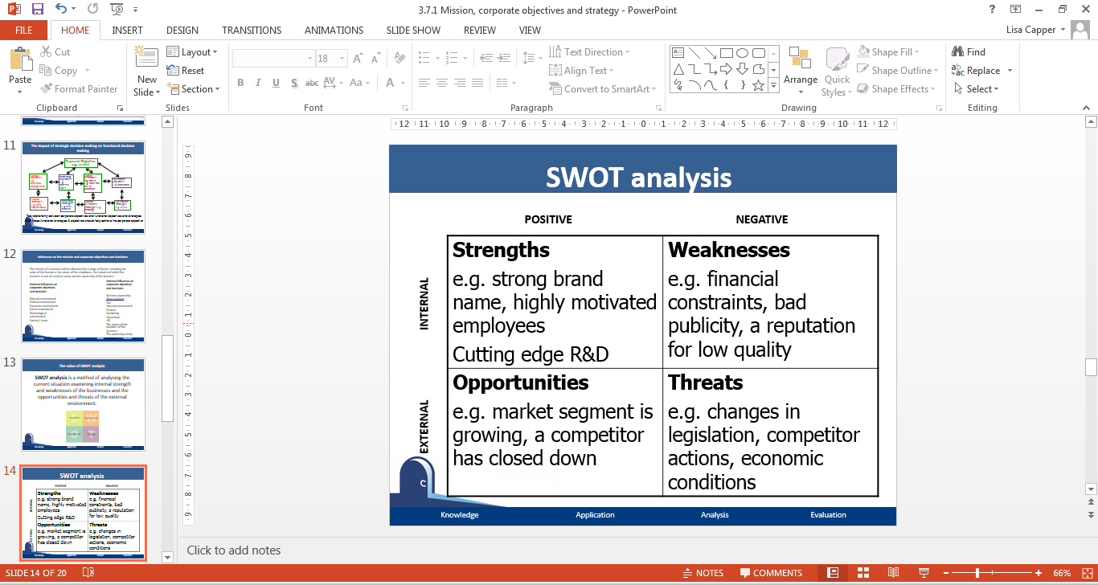

**Independent Activity - Categorise the following for a new independent Italian restaurant**

* A lot of competition locally from national chains and other independents
* Located just off a main road with little passing traffic
* Makes high quality pizzas from a huge, blazing wood-fired oven
* Struggles to retain staff
* Has a distinctive brand name and logo
* Prices are quite high, so takings may suffer in a recession
* Aims to open 5 other outlets over the next 12 months, in better locations
* Takings on Thurs to Sun evenings are good but trade at lunchtimes has not yet been developed
* Menu is targeted at adults, with little for their children, yet the local residents are mainly families
* Home delivery accounts for 35% of takings, was originally budgeted at 60%

SWOT analysis is a useful tool when examining a business’s internal and external environment. It can be used to inform decision making and set corporate objectives and strategies. However, there is no point producing a SWOT analysis unless it is actioned! SWOT analysis should be more than a list - it is an analytical technique to support strategic decisions. Strategy should be devised around strengths and opportunities.

**Independent Activity - Read the article on Virgin Galactic then complete a SWOT analysis on this venture.**

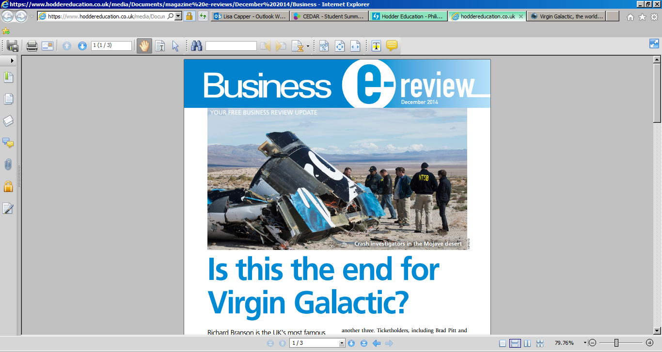

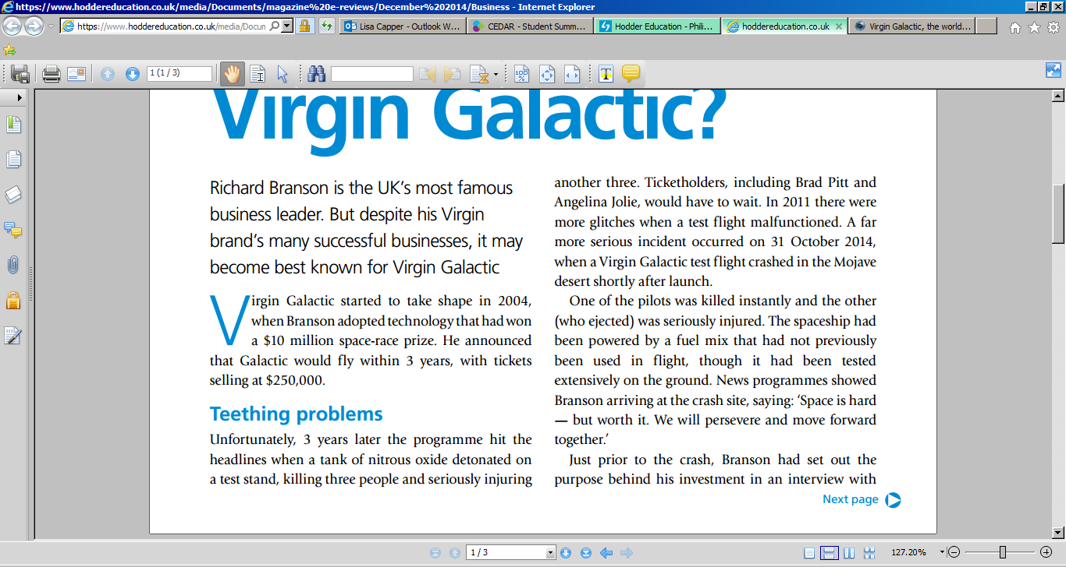

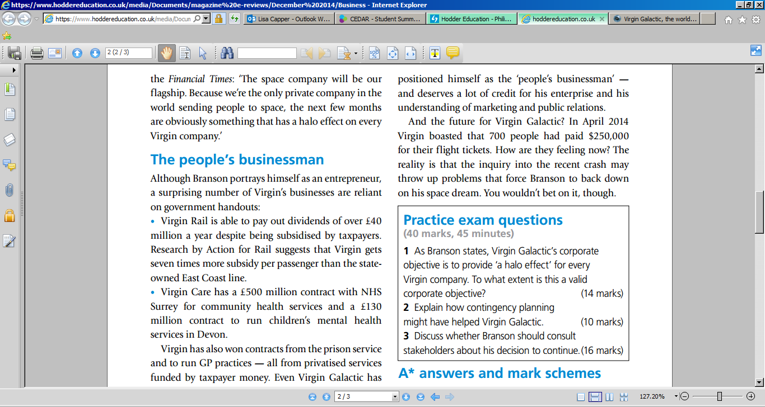

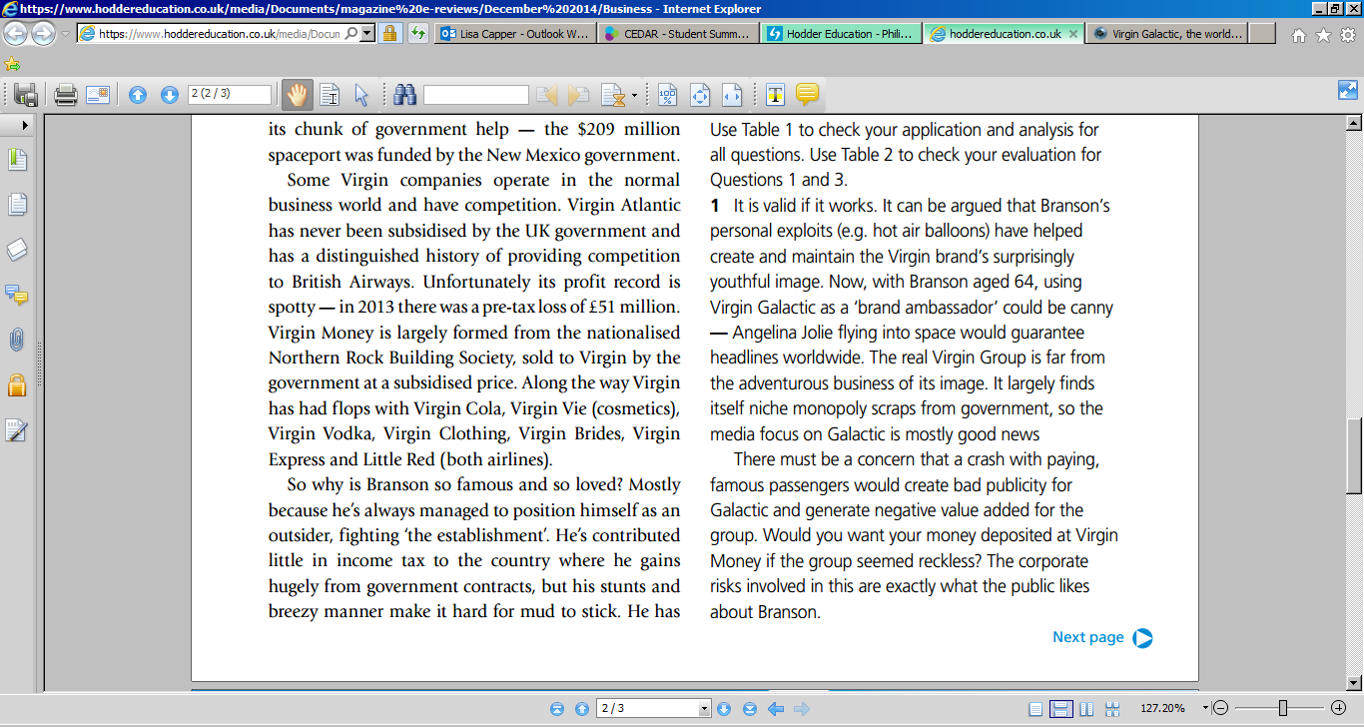

S -

W -

O -

T -

**Lesson 2**

|  |  |  |  |  |  |  |  |  |  |
| --- | --- | --- | --- | --- | --- | --- | --- | --- | --- |
| Q1 | **Match it! Match the key term to its correct meaning** | | | | | | | | |
|  | **Meaning** | | | |  | **Key Term** | | | |
| (i) | Decision-making which tends to be short to medium-term and is concerned with a particular sector of the business | | | | (a) | Mission | | | |
| (ii) | Concerns the general direction and overall policy of the business | | | | (b) | Strategic decision-making | | | |
| (iii) | The means by which a strategy is carried out; can be made up of multiple parts | | | | (c) | Functional decision-making | | | |
| (iv) | An organisation’s aims or long term intentions | | | | (d) | Tactics | | | |
| **(i)** | |  | **(ii)** |  | **(iii)** | |  | **(iv)** |  |

|  |  |  |  |
| --- | --- | --- | --- |
| Q2 | **Mission statement in action! Answer the questions, based on the following mission statement…** | | |
|  | **Toyota Motor Company** “…. Toyota will lead the way to the future of mobility, enriching lives around the world with the safest and most responsible ways of moving people.  Through our commitment to quality, constant innovation and respect for the planet, we aim to exceed expectations and be rewarded with a smile.”  **2.1** Who is the mission statement above written for?  **2.2** What is its purpose? | | |
| Q3 | **Circle the external influences and underline the internal influences on corporate objectives & decisions** | | |
|  | Changes in economic policy | Business culture | Business ownership |
|  | Business’s attitude towards ethics | Pressure from institutional investors | Actions of competitors |
|  | Environmental factors | Management goals | Demographic factors |

|  |  |
| --- | --- |
| Q1 | **Fill in the gaps** |
| The acronym SWOT stands for _______________, ___________________, ___________________ and _________________. Strengths provide an analysis of a firm’s advantages over its __________________, whereas weaknesses identify areas where the firm is at a competitive _________________________. Both factors are ________________ to the business. On the other hand, opportunities and threats are ____________________ factors. As a result organisations have limited ________________ over them, but must be aware of these factors, so that ___________________ can be successfully exploited and the risk of threats ____________________.  Businesses use SWOT analysis as part of the ____________________ planning process. | |
|  | ***Choose from:*** *minimised; internal; threats; disadvantage; control; opportunities; weaknesses; competitors; opportunities; strengths; strategic; external* |

|  |  |
| --- | --- |
| Q2 | **Which is which?** |
|  | **2.1** Label each area of the SWOT Analysis template below.   |  |  | | --- | --- | |  |  | |  |  |   **2.2** Place the following items in the most appropriate section of the SWOT template for a leading multinational fast food burger chain.   |  |  |  | | --- | --- | --- | | a) Brand awareness | b) Falling revenues | c) Declining market share | | d) Demotivated franchisees | e) Multiple locations | f) Changing consumer tastes | | g) Demand for locally sourced food/high quality ingredients | h) Perceived as a lower class establishment | i) Significant % of revenue generated from outside its home country | | j) Healthy eating campaigns | k) Rise of new competitors | l) Loyal customer base | |
| Q4 | **True or False** |
|  | **4.1** A SWOT analysis is only useful if the data it is based upon is up to date and reliable. |
|  | **4.2** A SWOT analysis always clearly identifies solutions to weaknesses and threats. |
|  | **4.3** A SWOT analysis cannot be combined with other management techniques such as PEST to develop a firm’s strategy. |
|  | **4.4** A SWOT analysis is simple to use and practical to conduct. |
|  | **4.5** A SWOT analysis may provide too much and/or irrelevant information |
|  | **4.6** Strong management teams should be prepared for both unexpected and expected changes in the external environment. |

|  |  |
| --- | --- |
| Q5 | **Briefly explain two reasons…** |
|  | **5.1** why it is important for a team of people, outside of the strategic management team, to be involved in conducting a SWOT analysis. |
|  | **5.2** when it is not a good idea to involve a team of people in compiling a SWOT analysis. |
|  | **5.3** why it is important to conduct a SWOT analysis on a regular basis. |

**Highly Brill SWOT analysis**

Using the information on the following page, complete a SWOT analysis for Highly Brill Leisure Centre.

[](https://www.google.co.uk/url?sa=i&rct=j&q=&esrc=s&source=images&cd=&cad=rja&uact=8&ved=0ahUKEwi0_eSnwp_WAhVJaRQKHdXwCa0QjRwIBw&url=https://communityactionmk.org/2017/02/08/badminton-essentials-course-bletchley-leisure-centre/&psig=AFQjCNFWbv9ke5IxdWS5q-RC9B_FZ4mXYw&ust=1505301248120716)

|  |  |
| --- | --- |
| **Strengths** | **Weaknesses** |
| **Opportunities** | **Threats** |

1. The Centre is located within a two-minute walk of the main bus station, and is a fifteen-minute ride away from the local railway station.
2. There is a competition standard swimming pool; although it has no wave machines or whirlpool equipment as do competing local facilities.
3. It is located next to one of the largest shopping centres in Britain.
4. It is one of the oldest centres in the area and needs some cosmetic attention.
5. Due to an increase in disposable income over the last six years, local residents have more money to spend on leisure activities.
6. There has been a substantial decrease in the birth rate over the last ten years.
7. In general [people](http://www.marketingteacher.com/people-marketing-mix/) are living longer and there are more local residents aged over fifty-five now than ever before.
8. After a heated argument with the manager of a competing leisure centre, the leader of a respected local scuba club is looking for a new venue.
9. The local authority is considering privatizing all local leisure centres by the year 2000.
10. Press releases have just been issued to confirm that Highly Brill Leisure Centre is the first centre in the area to be awarded quality assurance standard BS EN ISO 9002.
11. A private joke between staff states that if you want a day-off from work that you should order a curry from the Centre’s canteen, which has never made a profit.
12. The Centre has been offered the latest sporting craze.
13. Highly Brill Leisure Centre has received a grant to fit special ramps and changing rooms to accommodate the local disabled.
14. It is widely acknowledged that Highly Brill has the best-trained and most respected staff of all of the centres in the locality.

**Electric car expansion**

Recently, there has been a major surge in demand for electric vehicles providing many opportunities and threats to businesses. Using the article snippets below and the information on the QR code given along with your own knowledge, complete a SWOT analysis for the car manufacturer, Ford.

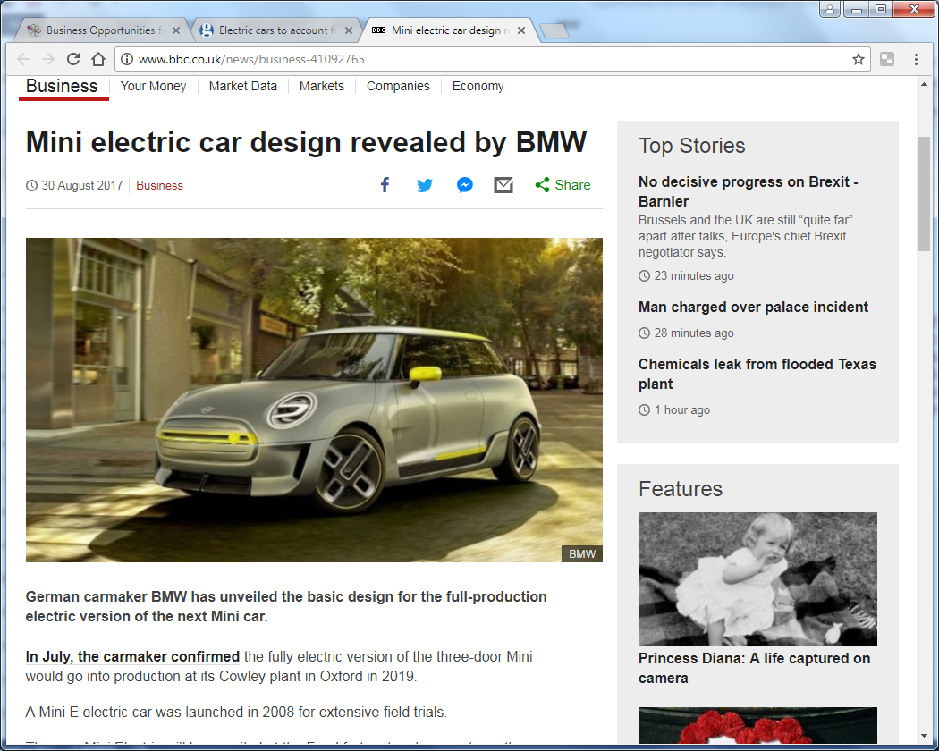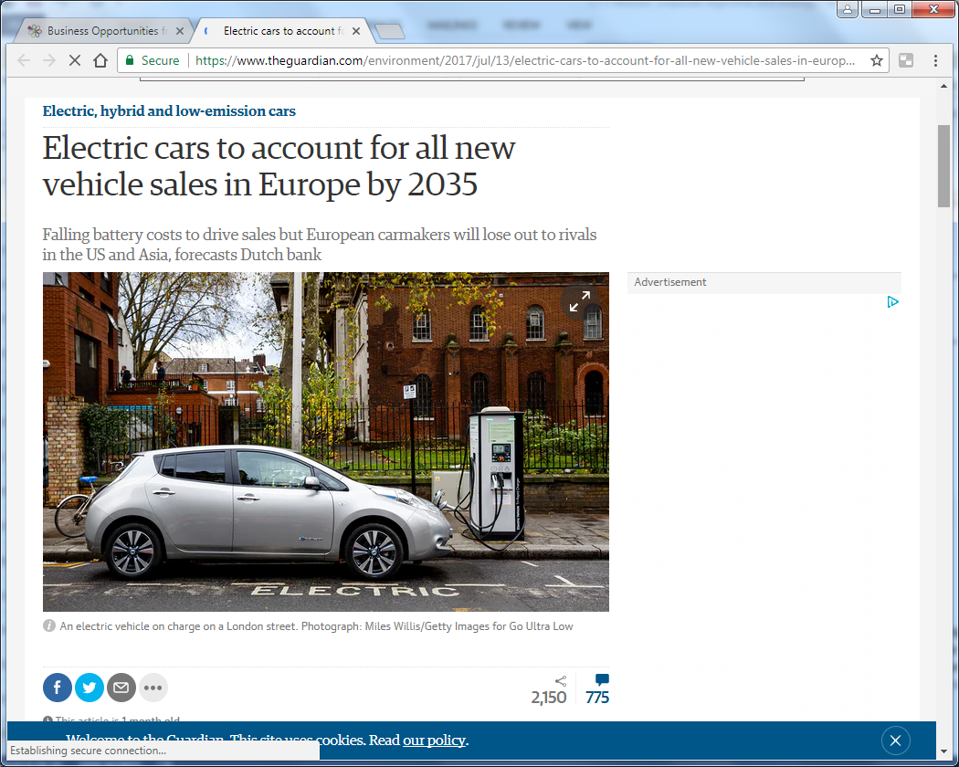

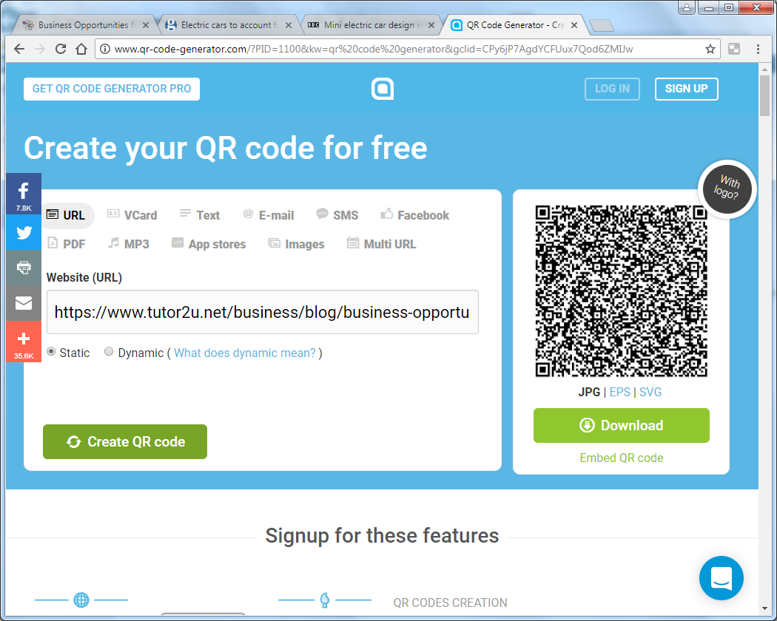

|  |  |
| --- | --- |
| **Strengths** | **Weaknesses** |
| **Opportunities** | **Threats** |

## Case Study: Black Friday – too big an opportunity to miss?

Black Friday falls on the last Friday in November and is a growing phenomenon in the UK. Originally a US retailing sensation, it has become so popular in the UK that for some retailers Black Friday has extended not only over the “Black Friday weekend” incorporating “Cyber Monday,” but in some cases, periods before or after this. Black Friday now symbolises for many, the unofficial start of the Christmas shopping season.

The importance of Black Friday for UK retailers cannot be underestimated. Last year UK retail sales for the day amounted to £810 mn, whereas this year sales increased by 36% to £1.1 bn, the first time over £1 billion had been spent in one day. Amazon experienced its busiest ever day of UK sales, with 7.4 million items sold, amounting to 86 items every second. John Lewis processed 8 000 items every hour on Black Friday compared to 2 000 on a typical Friday in September. Cyber Monday takings amounted to approximately £843 mn, a 31% increase in sales on last year.

So, is Black Friday too big an opportunity to miss? And if so, why have some retailers expressed reservations or opted out of the day altogether? Asda this year, decided not to participate in Black Friday at all, deciding instead to offer its own set of deals throughout the Christmas period. Could this be due to the backlash of bad press from the previous year, where the store was criticised for poor organisation and security, after customers were fighting over in store purchases? Similarly, Jigsaw chose to boycott the event, believing its brand “stood for something”, rather than being subjected to indiscriminate bulk discounting generating little brand loyalty. John Lewis also expressed concerns about the event. However, the retailer felt that it had no choice but to be part of it. With their slogan “never knowingly undersold” and so many discounts offered in the market, this would prove to be a huge pricing challenge for them. Profitability is also a key concern. How does Black Friday affect a retailer’s bottom line when clearly some of the purchases made on this day would inevitably be made at a later more profitable date? This is problematic when retailers, such as John Lewis, make 50% of their profits in the three month lead up to Christmas.

The real retail winners on Black Friday will be those who continue to plan ahead with precision. Although significant, price is not the only factor that influences buyer behaviour. Stock availability, the fulfilment of orders on time and the ease of ordering in the first place affects where sales are made. With shopping patterns moving away from the bricks and mortar stores to online or click and collect purchases, customers have little patience with retailers who experience technical difficulties with websites, deliveries or returns. The reputation of a retailer can easily be damaged in a few minutes, with a bad on line experience.

Whether retailers choose to opt in to Black Friday or whether they choose to recognise their most valued customers through personalised promotions throughout the festive period, is an individual choice – but what is definitely clear is that Black Friday has found a fixed place on the UK retail calendar!

## Exam-style questions

1. Andy Graham, MD at John Lewis, needs to decide whether the business will continue to participate in Black Friday and has requested a SWOT analysis is drawn up. Analyse the benefits of conducting a SWOT analysis to help him with this decision (12 marks)
2. Do you agree that Black Friday is too big an opportunity to miss? Justify your view (20 marks)