**Upper 5 Triple topics.**

**The brain**

The brain controls complex behaviour. It is made of billions of interconnected neurones and has different regions that carry out different functions.

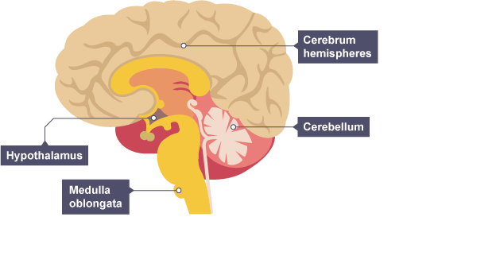

There are four main areas in the brain:

* The **cerebrum** (the outer layer is called the cerebral cortex), which is split into two hemispheres and is highly folded. It controls intelligence, personality, conscious thought and high-level functions, such as language and verbal memory.
* The **cerebellum**, which controls balance, co-ordination of movement and muscular activity.
* The **medulla**, which controls unconscious activities such as heart rate and breathing rate,
* The hypothalamus, which is the regulating centre for temperature and water balance within the body.

**Investigating the brain - Higher**

Modern science has allowed scientists to discover how different parts of the brain function. Neuroscientists have been able to map various regions of the brain to particular functions by studying patients with brain damage, electrically stimulating different parts of the brain and using MRI scanning techniques.

**Brain damage**

A well-documented example of brain damage is of Phineas Gage, who in 1848 had a serious accident whilst laying railway tracks and an iron rod went through his skull.

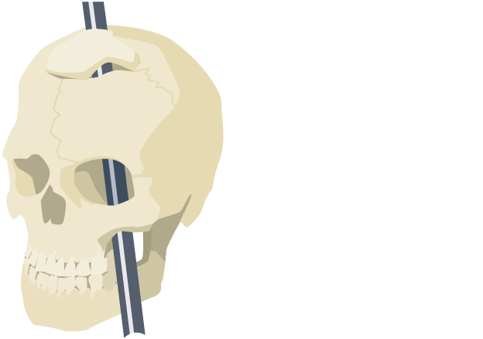

Phineas survived the accident, but it was documented that his personality changed following it. It was noted that he lost his inhibitions socially and emotionally.

Doctors realised the changes in Phineas were due to the damage in the particular parts of the brain that the iron rod had passed through. This important case allowed scientists to examine the effect of the injuries on his brain activity.

Non-invasive brain procedures include:

**Electrical stimulation**

Scientists have stimulated different parts of the brain with a weak electrical current and asked patients to describe what they experienced. If the motor area is stimulated, the patient makes an involuntary movement. If the visual area is stimulated, they may see a flash of colour. EEGs (Electroencephalograms) can be created and studied, to observe the electrical activity in the brain.

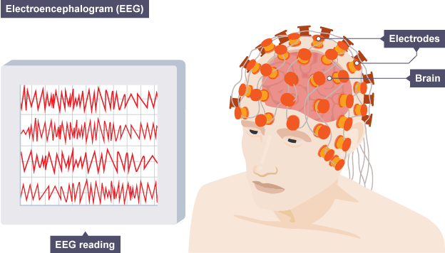

**MRI brain scans**

Modern imaging methods such as MRI (Magnetic Resonance Imaging) scans, use strong magnetic fields and radio waves to show details of brain structure and function. Patients are asked to perform various tasks and, by looking at the scan, scientists can see which parts of the brain are active when the task is carried out.

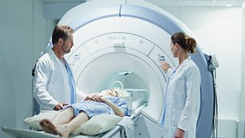

**Risks**

Brain surgery may be needed to remove a tumour or excess fluid, such as blood. All surgery carries a level of risk, but due to the complexity and delicacy of the brain, investigating and treating brain disorders can be very difficult. If surgery is undergone more damage or side-effects may be created, which could affect the patients' quality of life. Serious considerations about the risks involved against the benefits need to be undertaken first.

**The eye**

The eye is a sense organ containing receptors sensitive to light intensity and colour.

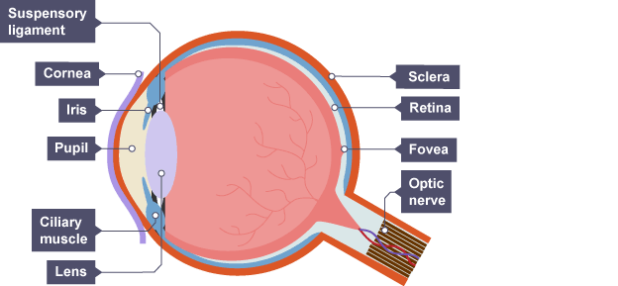

| **Structure** | **Function** |
| --- | --- |
| Cornea | Refracts light - bends it as it enters the eye |
| Iris | Controls how much light enters the pupil |
| Lens | Further refracts light to focus it onto the retina |
| Retina | Contains the light receptors |
| Optic nerve | Carries impulses between the eye and the brain |
| Sclera | Tough white outer layer of the eye. It helps protect the eye from injury |

**The retina**

Light passes through the eyeball to the retina. There are two main types of light receptors - **rods** and **cones**. Rods are more sensitive to light than cones so they are useful for seeing in dim light. There are three different types of cone cells which produce colour vision.

A photograph of a human retina seen through the eye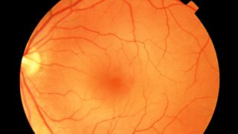

**The pupil reflex**

The amount of light entering the eye is controlled by a reflex action. The size of the **pupil** changes in response to bright or dim light. This is controlled by the muscles of the iris.

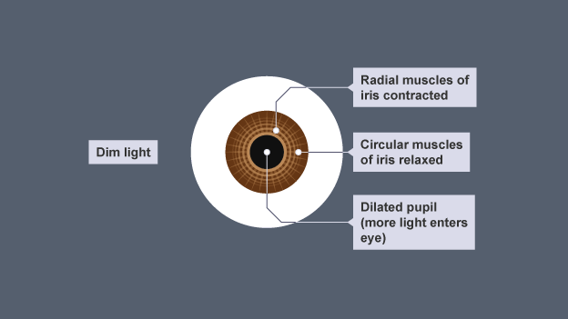

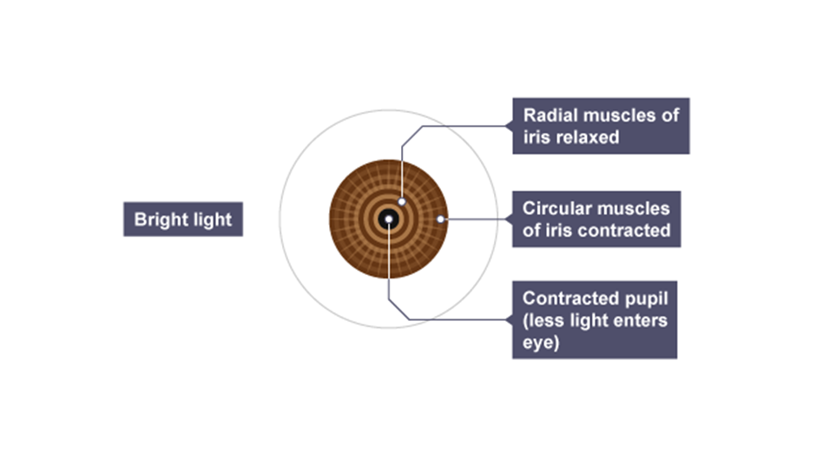

**How the eye works – Higher**

Accommodation is the process of changing the shape of the lens to focus on near or distant objects.

To focus on a **near** object – the lens becomes **thicker**, this allows the light rays to refract (bend) more strongly.

To focus on a **distant** object – the lens is pulled **thin**, this allows the light rays to refract slightly.

| **Position** | **Ciliary muscles** | **Suspensory ligaments** | **Muscle tension** | **Lens shape** | **Refraction** |
| --- | --- | --- | --- | --- | --- |
| Near | Contract | Slacken/loosen | Low | Fat/thicker | Light is refracted strongly |
| Distant | Relax | Stretched/tighten | High | Thin | Light is only refracted slightly |

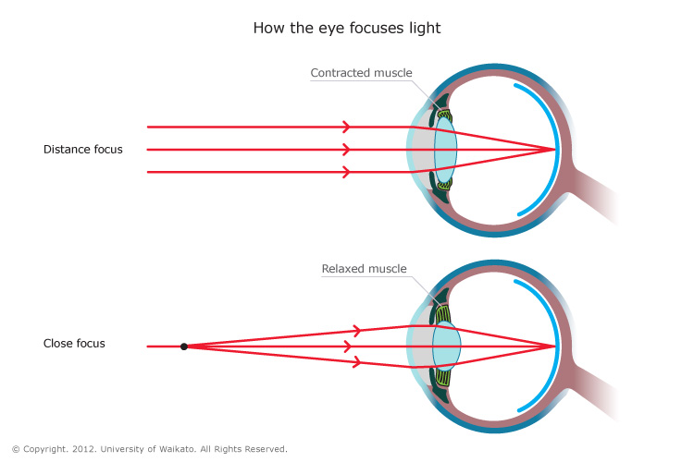

**Common defects of the eye and how they can be overcome**

**Correcting vision defects**

Two common defects of the eyes are myopia (short-sightedness) and hyperopia (long-sightedness). In both cases rays of light do not focus on the retina so a clear image is not formed.

These two defects are treated with spectacle lenses, which refract (bend) the light rays so that they do focus on the retina.

**Short sight**

Someone with **short-sight** can see near objects clearly, but cannot focus properly on distant objects.

Short sight is caused by one of the following:

* The eyeball being elongated - so that the distance between the lens and the retina is too great.
* The lens being too thick and curved - so that light is focused in front of the retina.

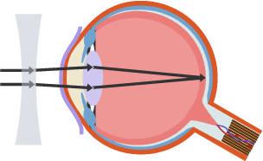Short-sightedness can be corrected by placing a concave lens in front of the eye, as shown in the diagrams below.

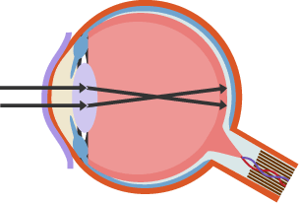

Myopia - short-sightedness. Concave lens cures short-sightedness

**Long-sight**

Someone who is **long-sighted** can see distant objects clearly, but they cannot focus properly on near objects.

Long-sightedness is caused by one of the following:

* the eyeball being too short - so the distance between the lens and retina is too small
* a loss of elasticity in the lens - meaning it cannot become thick enough to focus (which is often age-related)

As a result, the lens focuses light behind the retina instead of onto it. Long-sightedness is corrected by putting a convex lens in front of the eye, as shown in the diagrams below.

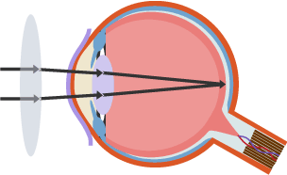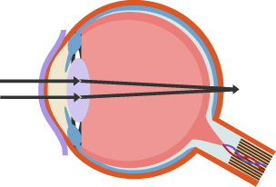

Long-sightedness (Hyperopia). A convex lens corrects long-sightedness, allowing an image to focus on the retina.

New technologies have provided alternatives to wearing spectacle lenses: the hard and soft contact lenses, laser surgery to change the shape of the cornea and a replacement lens in the eye. **Contact lenses** – work by being in 'contact' with your eye. They float on the surface of the cornea. They work like spectacle lenses, by focusing and refracting the light.

* **Laser surgery** – reshapes the cornea surgically. Common for myopia but can be used for some hyperopia conditions.
* **Replacement lens** – implanting artificial lenses is a recent development, and can placed in front of the original lens, through a small cut in the cornea, to correct an eye defect.

**Body temperature and the thermoregulatory centre**

**Homeostasis**

The conditions inside our body must be carefully controlled if it is to function effectively. Homeostasis is the maintenance of a constant internal environment in the body. The nervous system and hormones are responsible for controlling this.

The body control systems are all automatic, and involve both nervous and chemical responses. It has many important parts, including:

* Receptors detect a stimulus, which is a change in the environment, such as temperature change.
* Coordination centres in the brain, spinal cord and pancreas. They receive information from the receptors, process the information and instigate a response.
* Effectors, such as muscles or glands create the response. Glands often release a hormone, which would restore the optimum condition again.

Body temperature

Body temperature is one of the factors that are controlled during homeostasis. The human body maintains the temperature that enzymes work best, which is around 37°C. This process is controlled by the thermoregulatory centre, which is contained in the hypothalamus in the brain, and it contains receptors sensitive to the temperature of the blood. The skin also has temperature receptors and sends nervous impulses back to the thermoregulatory centre.

**Too hot**

When we get too hot:

* Sweat glands in the skin release more sweat. The sweat evaporates, transferring heat energy from the skin to the environment.

Blood vessels leading to the skin capillaries become wider - they dilate - allowing more blood to flow through the skin, and more heat to be lost to the environment. This is called vasodilation.

**Too cold**

When we get too cold:

* Skeletal muscles contract rapidly and we shiver. These contractions need energy from respiration, and some of this is released as heat. Blood vessels, which lead to the skin capillaries, become narrower - they constrict – which allows less blood to flow through the skin and conserve the core body temperature. This is called vasoconstriction.

The hairs on the skin also help to control body temperature. The hairs lie flat when we are warm, and rise when we are cold.

If we are too cold nerve impulses are sent to the hair erector muscles which contract. This raises the skin hairs and traps a layer of insulating air next to the skin.

Skin hairs lie flat when we are hot and stand upright when we are cold

The control of body temperature is an example of a negative feedback mechanism. It regulates the amount of:

* shivering (rapid muscle contractions release heat)
* sweating (evaporation of water in sweat causes cooling)
* blood flowing in the skin capillaries

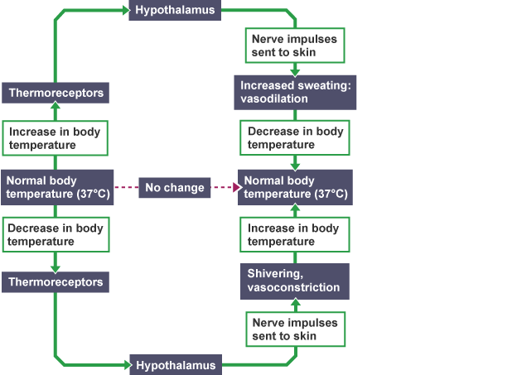

**Vasoconstriction and vasodilation**

The amount of blood flowing through the skin capillaries is altered by vasoconstriction and vasodilation.

|  | **Too cold** | **Too hot** |
| --- | --- | --- |
| **Process** | Vasoconstriction | Vasodilation |
| **Arterioles** | Get narrower | Get wider |
| **Blood flow in skin capillaries** | Decreases | Increases |
| **Heat loss from skin** | Decreases | Increases |

These diagrams show the processes that take place when vasoconstriction and vasodilation occur.

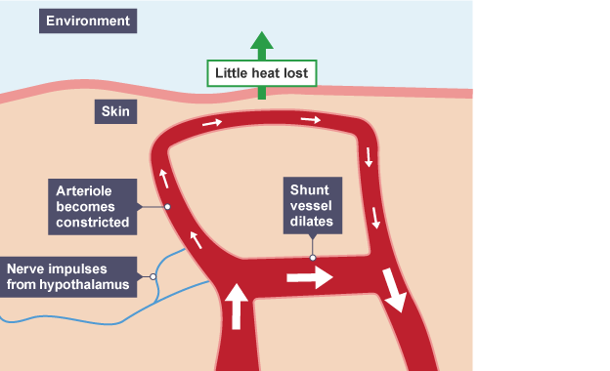

**Vasoconstriction – a response to being too cold**

Generally when the body temperature is too low a variety of processes happen: vasoconstriction, sweating stops and shivering starts.

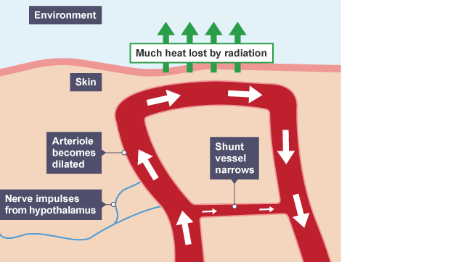

**Vasodilation – a response to being too hot**

When the temperature is too high, different processes happen: Vasodilation, sweat production, which both transfer energy from skin to the environment, resulting in a cooling effect.

**Importance of water balance in the body**

**Water content**

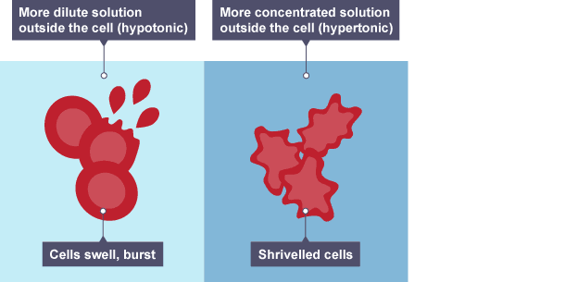

Osmoregulation is the control of water levels and mineral salts in the blood.

Water levels and mineral salts in the blood are controlled to protect cells by stopping too much water from entering or leaving them, as the concentrations of water and salts is the same inside and outside the cells. If body cells lose or gain too much water by osmosis, they do not function efficiently.

If the concentration of water is the same inside and out the cells, they remain in their normal state. If the water concentration is too high outside, water enters the cell by osmosis and they may burst.

On the other hand, if the water concentration is too low outside compared to the inside of the cells, water will leave by osmosis and the cells may shrivel. If body cells lose or gain too much water by osmosis they do not function efficiently.

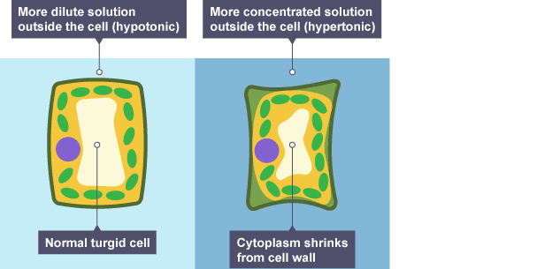

Plants also undergo the process of osmosis, in the same way that animals cells do. Cell walls are turgid or firm, when they are full of water. If cell walls lose water, they become flaccid and the cytoplasm shrinks away from the cell wall.

**Human excretory organs**

The organs of excretion in humans include the skin, lungs and kidneys.

Water is lost from the body as:

* urine from the kidneys
* sweat from the skin
* water vapour, from the lungs when we exhale

**Skin**

Sweat glands in the **skin** produce **sweat**. Water, ions and urea are lost from the skin as they are contained in sweat.

**Lungs**

Water leaves the body via the lungs when we exhale as well as excess carbon dioxide.

We cannot control the level of water, ion or urea loss by the lungs or skin. For example, in a hot climate, your body sweats to help keep you cool. In the same way, when we breathe out we lose water vapour, and we cannot alter the amount we lose.

**Kidneys**

The kidneys are organs of the urinary system - which removes excess water, salts and urea.

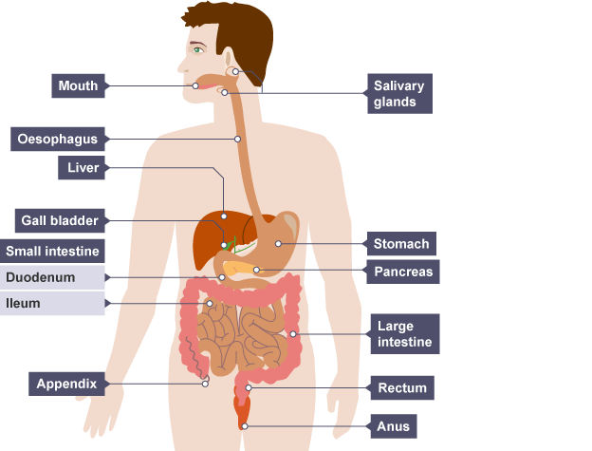

Once we have eaten our food, it is then digested by the body. The digestion of proteins is broken down by protease enzymes into amino acids in the stomach and small intestine.

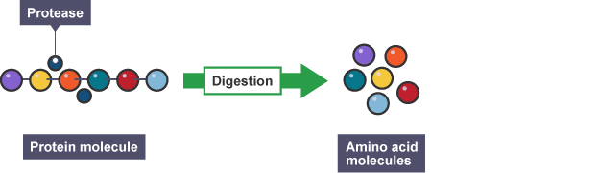

When excessive amounts of protein are eaten, the excess amino acids produced from digesting proteins are transported to the liver from the small intestine. The liver controls the amino acid concentration in the body, as excess amino acids which need to be excreted safely. The body is unable to store proteins or amino acids.

In the liver ammonia is formed by the deamination of amino acids. It is highly toxic and cannot be allowed to accumulate in the body. Excess ammonia is converted to urea. Urea and water are released from the liver cells in to the bloodstream and transported to the kidneys where the blood is filtered and the urea is passed out of the body in the urine.

**Maintaining water balance in the body**

The kidneys are organs of the urinary system - which remove excess water, salts and urea.

The urinary system

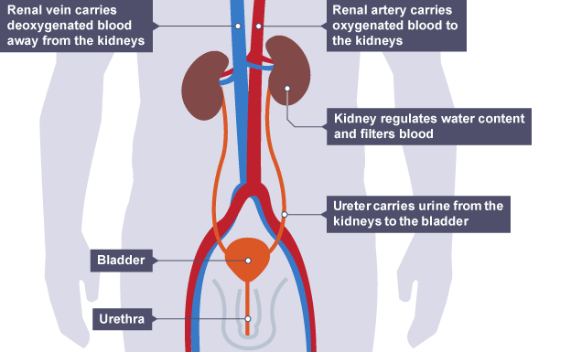

Blood is transported to the kidney through the renal artery. The blood is filtered at a high pressure and the kidney selectively reabsorbs any useful materials such as glucose, salt ions and water. After it has been purified, the blood returns to the circulatory system through the renal vein.

The kidneys produce urine and this helps maintain water balance. The urine is taken from the kidneys to the bladder by the ureters. The bladder stores the urine until it is convenient to expel it from the body.

Note that **'ureter'** differs from the word **'urethra'**. The ureters are tubes that carry urine from the kidneys to the bladder, whereas the urethra is the tube that carries urine out of the body.

**Urine**

Urine contains water, **urea** and salts. Urea is produced in the liver when excess amino acids are broken down. Urea is the main waste product removed in the urine, as it is not reabsorbed in the kidney.

**The role of the kidney**

Each kidney contains over one million microscopic filtering units called nephrons. Each nephron is made of a tubule and is responsible for 'cleaning' the blood by removing urea and excess water and mineral ions.

The kidney works in a number of different stages:

**Stage 1 - Filtration**

Blood passes through the nephron inside the kidneys, there are many capillaries inside the kidney, and the blood is under high pressure at the start of the nephron, which aids the ultrafiltration of the blood. Small molecules are filtered out and pass into the nephron tubule. These small molecules include ureas, **water, ions, and glucose**. However, large molecules, such as blood proteins, are too big to fit through the capillary wall and remain in the blood.

**Stage 2 - Selective reabsorption**

Having filtered out small essential molecules from the blood - the kidneys must reabsorb the molecules which are needed, while allowing those molecules which are not needed to pass out in the urine. Therefore, the kidneys selectively reabsorb only those molecules which the body needs back in the bloodstream.

The reabsorbed molecules include:

* all of the glucose which was originally filtered out
* as much water as the body needs to maintain a constant water level in the blood plasma
* as many ions as the body needs to maintain a constant balance of mineral ions in the blood plasma

**Stage 3 - The formation of urine**

The molecules which are not selectively reabsorbed (the urea, excess water and ions) continue along the nephron tubule as **urine**. This eventually passes down to the bladder.

In carrying out these processes, the kidney is able to fulfil its functions of regulating the water and ion balance of the blood plasma, as well as keeping the level of urea low.

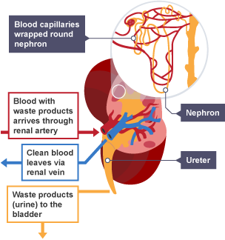

**Scientific calculations - Translate tables and bar charts**

An example of an exam questions showing data of substances in the blood plasma.

The concentration of the substances in the fluids is measured in grams per dm3:

| **Substance** | **Blood plasma** | **Filtrate in the kidney tubules** | **Urine** |
| --- | --- | --- | --- |
| Water | 850.0 | 850.0 | 900.0 |
| Protein | 75.0 | 0.0 | 0.0 |
| Glucose | 0.9 | 0.9 | 0.0 |
| Amino acids | 0.4 | 0.4 | 0.0 |
| Urea | 0.3 | 0.3 | 22.0 |
| Sodium ions | 2.7 | 2.7 | 3.6 |

**Question**

Describe the similarities and differences between the levels of substances within the three different fluids in the table. Include at least three examples of substances in your answer.

Answer

Certain substances remain the same in a number of different fluids such as water (850 g/dm3), glucose (0.9 g/dm3), amino acids (0.4 g/dm3), urea (0.3 g/dm3) and sodium ions (2.7 g/dm3) in the blood plasma and filtrate.

When comparing the three fluids, a number of substances differ such as water, protein, glucose, amino acids, and urea and sodium ions. The water is more concentrated in the urine (900 g/dm3) than in the filtrate (850 g/dm3); the protein in the plasma is at 75 g/dm3 but at 0 g/dm3 in the urine. The glucose is at 0.9 g/dm3 in the plasma and filtrate but 0.0 g/dm3 in the urine.

**The effect of ADH on tubule permeability and in water balance – Higher**

**ADH**

Two important areas inside the brain are the hypothalamus, which detects changes in the blood plasma, and the pituitary gland, which regulates the release of the anti-diuretic hormone, known as ADH.

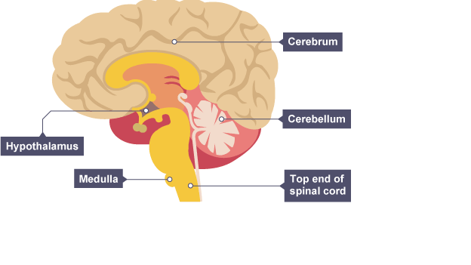

Different amounts of ADH are released into the bloodstream according to the concentration of water in the blood plasma. ADH is released by the pituitary gland when the blood is too concentrated and it causes the kidney tubules to become more permeable. This allows more water to be reabsorbed back into the blood during selective reabsorption.

If a person has consumed a large volume of water and has not lost much as sweat, too much water might be detected in the blood plasma. If this occurs, less ADH will be released, which results in less water being reabsorbed and a dilute and larger volume of urine will be produced.

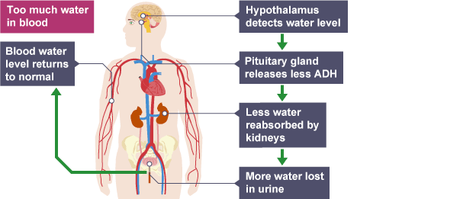

If a person becomes too hot and sweats a lot, but doesn't drink enough water to replace what was lost, too little water might be detected in the blood plasma. More ADH will be released, which results in water being reabsorbed and a more concentrated but smaller volume of urine will be produced.

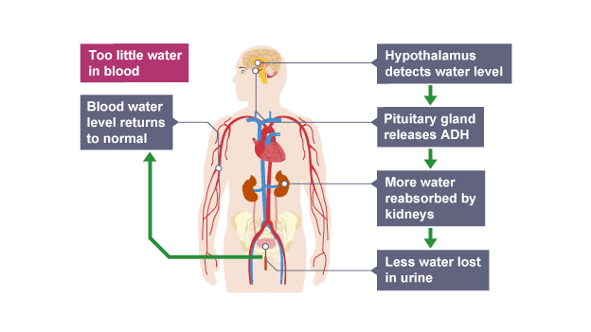

This type of control is an example of the negative feedback mechanism. It aims to keep the concentration of the blood plasma constant.

| **Plasma** | **Problem** | **ADH release** | **Effect of ADH** | **Effect on urine** |
| --- | --- | --- | --- | --- |
| High concentration | Too little water | Increases | More water reabsorbed by nephrons | More concentrated |
| Low concentration | Too much water | Decreases | Less water reabsorbed by nephrons | More dilute |

A negative feedback control system responds when conditions change from the ideal or set point and returns conditions to this set point. There is a continuous cycle of events in negative feedback.

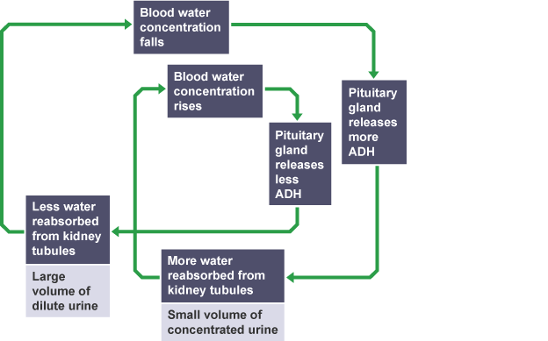

**Treating kidney failure by dialysis**

**Water and waste**

**The consequences of kidney damage or disease**

The kidney is responsible for the removal of waste products from the blood. Damage from accidents or disease can lead to a build-up of poisonous wastes in the body. Humans can survive with one kidney, but for people who suffer from total kidney failure this would be fatal if not treated. Treatment is available for kidney failure and can be by organ transplant or by using kidney dialysis.

In this procedure, patients are connected to a dialysis machine which acts as an artificial kidney to remove most of the urea and restore/maintain the water and ion balance of the blood.

Patients with kidney failure can be kept alive by using kidney dialysis until a transplant becomes available, but they have several disadvantages:

* they are expensive
* the patient must have his or her blood connected to the machine for several hours every week
* patients must follow a very rigid diet to avoid complications
* they only work for a limited time for a patient

**How dialysis works**

How dialysis works

Unfiltered blood that is high in urea is taken from a blood vessel in the arm, mixed with blood thinners or an anti-coagulant to prevent clotting, and pumped into the dialysis machine. Inside the machine the blood and dialysis fluid are separated by a partially permeable membrane the blood flows in the opposite direction to dialysis fluid, allowing exchange to occur between the two where a concentration gradient exists.

Dialysis fluid contains:

* a glucose concentration similar to a normal level in the blood
* a concentration of ions similar to that found in normal blood plasma
* no urea

As the dialysis fluid has no urea in it, there is a large concentration gradient - meaning that urea moves across the partially permeable membrane, from the blood to the dialysis fluid, by diffusion. This is very important as it is essential that urea is removed from the patients' blood.

As the dialysis fluid contains a glucose concentration equal to a normal blood sugar level, this prevents the net movement of glucose across the membrane as no concentration gradient exists. This is very important as the patients' need to retain glucose for respiration.

And, as the dialysis fluid contains an ion concentration similar to the ideal blood plasma concentration, movement of ions across the membrane only occurs where there is an imbalance.

* If the patient's blood is too **low in ions**, they will diffuse from the dialysis fluid into the blood, restoring the ideal level in the blood.
* If the patient's blood is **too high in ions**, the excess ions will diffuse from the blood to the dialysis fluid.

**Advantages of dialysis**

Kidney dialysis allows a person with kidney failure to maintain their health.

The overall effect of this is that the blood leaving the machine and returning into the patient's arm will have:

* greatly reduced levels of urea – it is 'cleaned blood'
* no overall change in blood glucose levels
* the correct water and ion balance maintained or restored (with only excess ions removed)

**Disadvantages of dialysis**

Kidney dialysis requires highly specialised and expensive machinery. The patient must be connected to this machinery 2-3 times a week for periods (on average) of between 4-6 hours at a time. This is time consuming and restrictive, as this mainly happens in hospital.

As the filtration only works when they are connected, kidney patients must monitor their diet carefully in between dialysis sessions. They need to avoid eating foods with a high salt content or a high protein content as excess amino acids are broken down into urea. This again can be difficult to control and monitor, but will help maintain the health of the patient.

Finally, dialysis will only work for a limited amount of time before a transplant is needed, and sadly many patients will die before a suitable one is found.

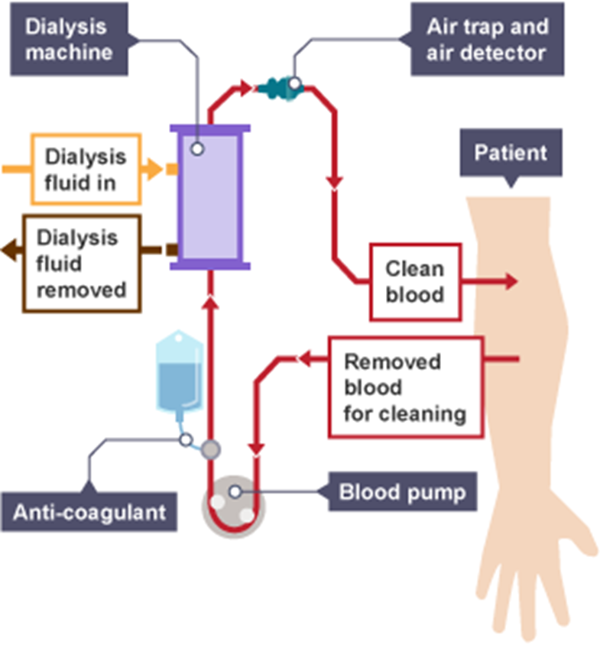

**Treating kidney failure by transplant**

**Kidney transplants**

Kidney transplantation is an alternative method for treating kidney failure and can save a patient's life. This procedure involves implanting a kidney from an organ donor into the patient’s body to replace the damaged kidney. This is better than using a restrictive dialysis machine, as the recipient can lead a normal life afterwards.

As with all cells, the donor kidney cells will have protein antigens on their surface. Antigens are unique to each of us (with the exception of identical twins), and allow our body to identify our own cells from those of potential pathogens.

Differences in the antigens of the donor kidney cells and those of the patient receiving the transplant would mean that the patient’s immune system would quickly form antibodies against the kidney cell antigens, and would ultimately destroy the kidney. This is known as **organ** rejection. This is potentially very harmful for the patient.

**Precautions against rejection**

Two precautions can be taken to reduce organ rejection:

1. **Tissue typing** - a kidney is given to patients who have antigens that are very similar to the antigens of the donor kidney. This can lead to long waits for transplants while compatible donors become available - during which time patients must undergo dialysis, and in some cases they will die before a match is found.
2. **Immuno-suppressant drugs** – these drugs must be taken by transplant patients for the rest of their lives. They suppress the immune system, greatly reducing the immune response against the donor kidney. The negative effect of this is that it also suppresses the immune response against pathogens which enter the body, increasing the risk of infections.

Even with these two precautions, most donor kidneys will only survive for an average period of 8-9 years before the patient will require a further transplant or a return to dialysis.

**Transplants versus dialysis**

The table below shows some of the pros and cons for both kidney dialysis and kidney transplants

|  | **Advantages** | **Disadvantages** |
| --- | --- | --- |
| **Transplants** | Patients can lead a more normal life without having to watch what they eat and drink | Must take immune-suppressant drugs which increase the risk of infection |
|  | Cheaper for the NHS overall. | Shortage of organ donors |
|  |  | Kidney only lasts 8-9 years on average |
|  |  | Any operation carries risks |
| **Dialysis** | Available to all kidney patients (no shortage) | Patient must limit their salt and protein intake between dialysis sessions |
|  | No need for immune-suppressant drugs | Expensive for the NHS |
|  |  | Regular dialysis sessions - impacts on the patient's lifestyle |