**Human Endocrine System**

**Endocrine System Structure & Function**

* Students should be able to describe the principles of hormonal coordination and control by the human endocrine system
* The human endocrine system is composed of glands which secrete chemicals called hormones directly into the bloodstream
* The blood carries the hormone around the body, and when it reaches a target cell/organ it produces an effect
* Compared to the nervous system the effects of hormones are slower but they act for longer
* Important structures in the endocrine system are:
  + Pituitary gland: a ‘master gland’ making hormones such as **FSH** and **LH**
  + Pancreas: produces **insulin** which regulates the blood glucose level
  + Thyroid: produces **thyroxine**which controls metabolic rate and affects growth
  + Adrenal glands: produces **adrenaline**
  + Ovaries (females): produce **oestrogen**
  + Testes (males): produce **testosterone**

[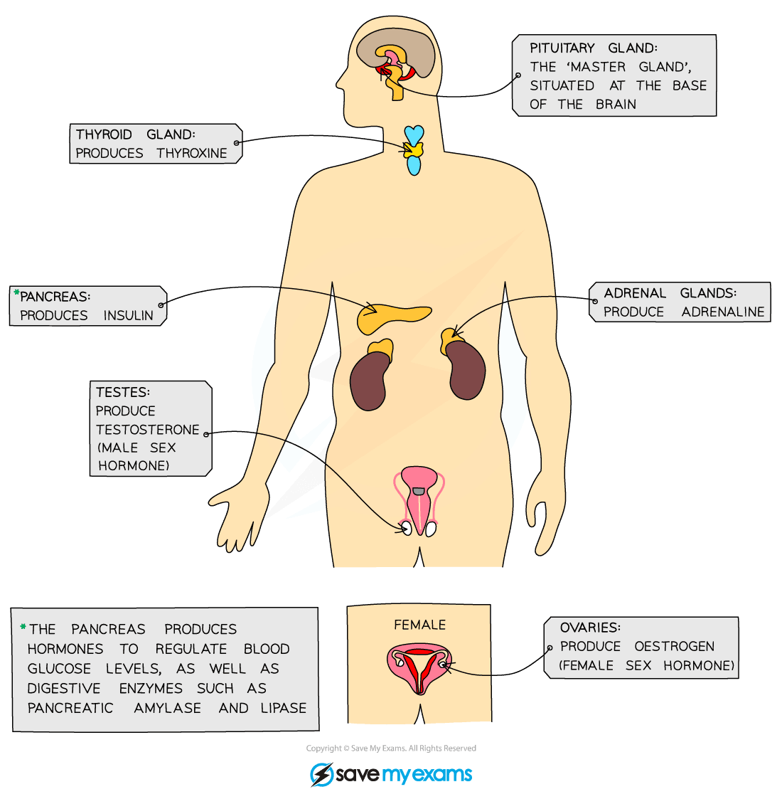](https://cdn.savemyexams.co.uk/wp-content/uploads/2020/01/The-major-endocrine-glands-in-the-body.png)

***The major endocrine glands in the body secrete hormones which circulate around the body in the bloodstream***

**Exam Tip**

Make sure you can recognise the structures listed in the diagram above in the exam.

**Pituitary Gland**

* The pituitary gland in the brain is a ‘master gland’ which secretes several hormones into the blood in response to body conditions
* These hormones in turn act on other glands to stimulate other hormones to be released to bring about effects
  + For example, in certain conditions, the pituitary gland makes and secretes**thyroid-stimulating hormone (TSH)**which stimulates the thyroid to release thyroxine

[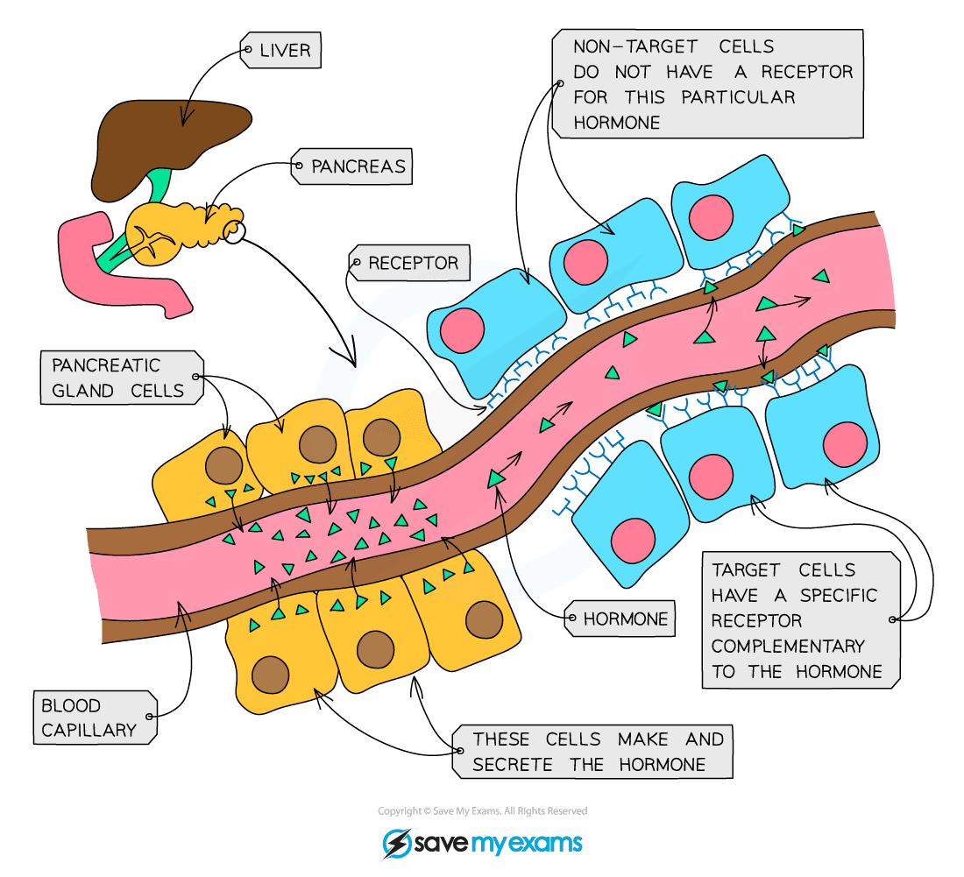](https://cdn.savemyexams.co.uk/wp-content/uploads/2020/02/How-hormones-work.png)

**Hormones are synthesized and released into the bloodstream from a gland (such as the pituitary gland) and circulate in the bloodstream, having an effect on target cells**

**Control of Blood Glucose Concentration**

**Control of Blood Glucose**

* **Blood glucose concentration** is monitored and controlled by the **pancreas**
* The pancreas is an **endocrine gland** (making and secreting hormones into the bloodstream) and it also plays a vital (but separate) role in **digestion** (making and secreting enzymes into the digestive system)
* Blood glucose concentration must be kept within a narrow range, so it’s another example of **homeostasis** (like temperature control)
* Eating foods containing carbohydrate results in an increase of glucose into the bloodstream
* If the blood glucose concentration is too high, the pancreas produces the hormone **insulin** to bring it back down
  + Too high a level of glucose in the blood can lead to cells of the body losing water by osmosis, which can be dangerous
* Insulin stimulates cells to take in glucose from the bloodstream (particularly liver and muscle cells)
* In **liver and muscle cells** excess glucose is converted into **glycogen** (a polymer of glucose) for storage

**Diabetes**

* **Type 1 diabetes** is a disorder in which the pancreas fails to produce sufficient insulin to control blood glucose levels
  + Scientists think this is a result of a person’s own immune system destroying the cells of the pancreas that make insulin during development
* Type 1 diabetes is characterised by uncontrolled high blood glucose levels and is normally treated with insulin injections
* In **Type 2 diabetes** the body cells no longer respond to insulin produced by the pancreas – the person still makes insulin but their cells are resistant to it and don’t respond as well as they should
* This can also lead to uncontrolled high blood glucose levels
* A carbohydrate-controlled diet and an exercise regime are common treatments for Type 2 diabetes
* Obesity is a big risk factor for Type 2 diabetes; probably because a person who is obese may consume a diet high in carbohydrates, and over-production of insulin results in resistance to it developing

**Comparing Type 1 & Type 2 diabetes**

[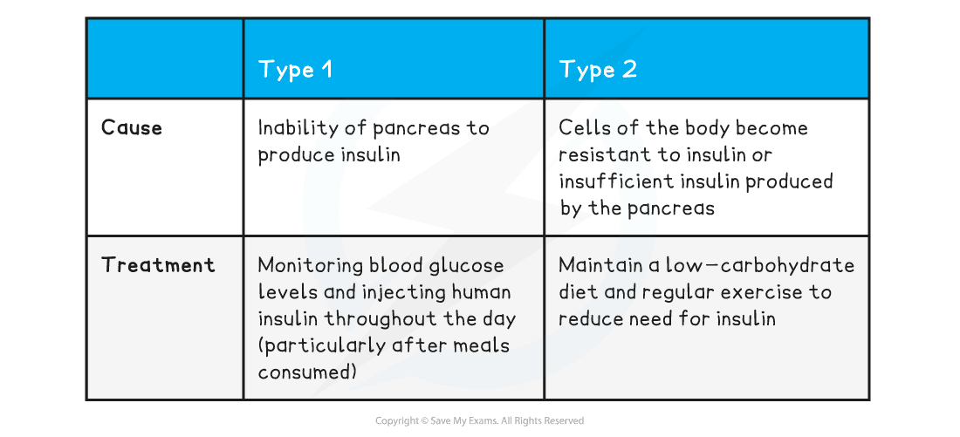](https://cdn.savemyexams.co.uk/wp-content/uploads/2020/08/Comparing-Type-1-Type-2-diabete.png)

**Interpreting Information about Blood Glucose Levels**

**Exam Tip**

You should be able to extract information and interpret data from graphs that show the effect of insulin on blood glucose levels in both people with diabetes and people without diabetes.

**Higher Tier Only**

**Negative Feedback Control of Blood Glucose**

* If the blood glucose concentration is too low, the pancreas produces the hormone **glucagon** that causes glycogen to be converted into glucose and released into the blood.
* Glucagon and insulin interact as part of a negative feedback cycle to control blood glucose (sugar) levels in the body:
  + **Insulin** is produced when **blood** **glucose** **rises** and stimulates liver and muscle cells to convert excess **glucose** into **glycogen** to be stored – this reduces the blood glucose level
  + **Glucagon** is produced when **blood** **glucose** **falls** too low and stimulates liver and muscle cells to convert stored **glycogen** into **glucose** to be released into the bloodstream – this increases the blood glucose level

[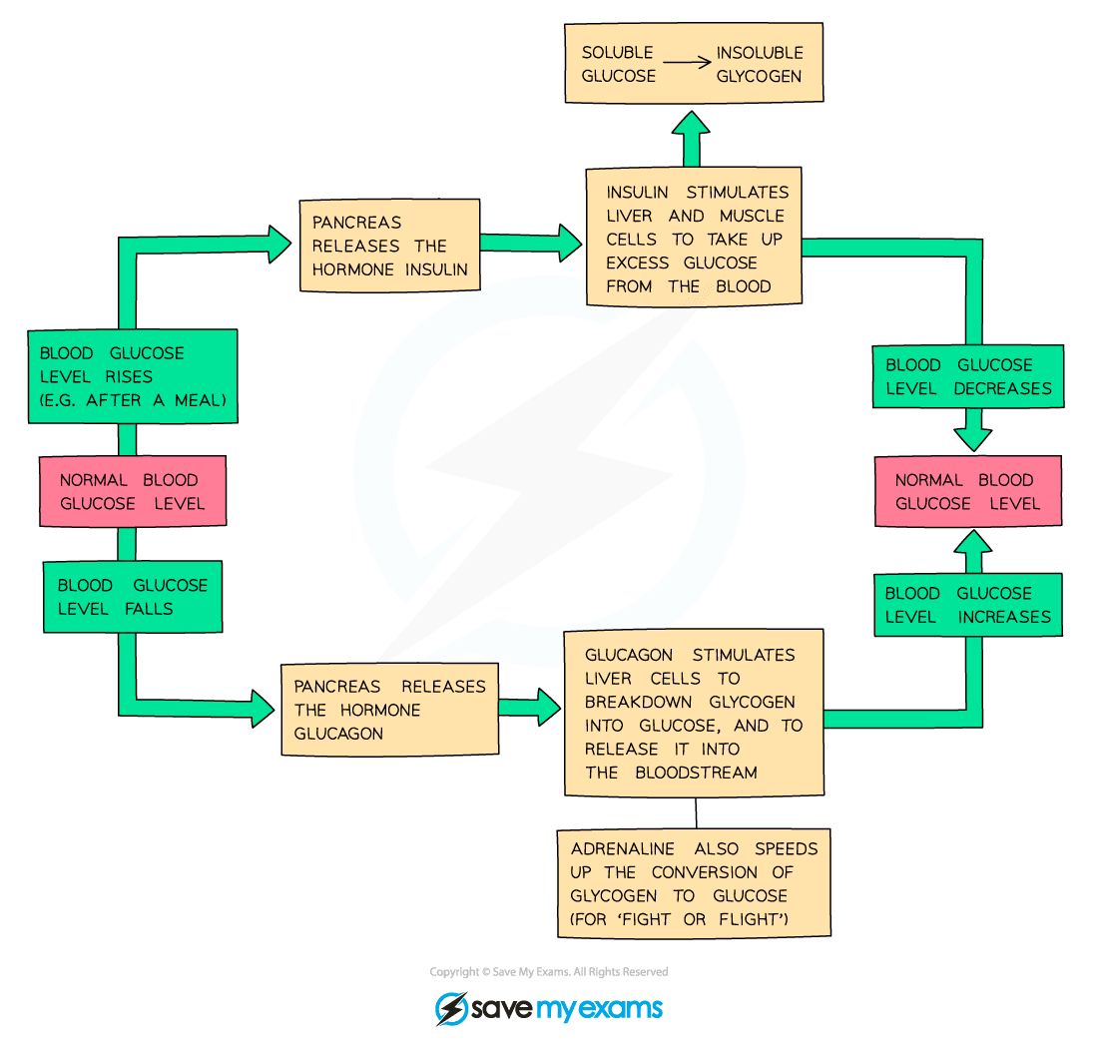](https://cdn.savemyexams.co.uk/wp-content/uploads/2020/01/Negative-feedback-regulation-of-blood-glucose-levels.png)

**Negative feedback regulation of blood glucose levels**

**Exam Tip**

The terms glucagon and glycogen are very often mixed up by students as they sound similar. Remember:

* Glucagon is the **hormone**
* Glycogen is the polysaccharide **glucose is stored as**

Learn the differences between the spellings and what each one does so you don’t get confused in the exam!

SOURCE: https://www.savemyexams.co.uk/notes/gcse-combined-science-trilogy-biology-aqa-new/5-homeostasis-response/5-3-hormones-maintaining-blood-homeostasis/5-3-1-human-endocrine-system/