

**IGCSE (9 – 1) Revision Pack**

**Percentages**

**Name --------------------------------**

**Questions**

**Q1.**

Lisa sees a dress in a sale.   
The normal price of the dress is $45   
The price of the dress is reduced by 12% in the sale.

(a)  Work out the price of the dress in the sale.

$...........................................................

**(3)**

Lisa's weekly pay increases from $525 to $546

(b)  Calculate her percentage pay increase.

...........................................................%

**(3)**

**(Total for question = 6 marks)**

**Q2.**

In a sale, normal prices are reduced by 35%   
The normal price of a bed is $1200

Work out the sale price of the bed.

$ ...........................................................

**(Total for question = 3 marks)**

**Q3.**

Amit invests 15000 rupees.



At the end of one year, his investment has increased by 7 %

(a)  Work out the value of Amit's investment at the end of one year.

........................................................... rupees

**(2)**

Priya invests a sum of money at an interest rate of 8% per year.   
At the end of one year, the interest she receives is 1800 rupees.

(b)  Work out the value of Priya's investment at the end of one year.

........................................................... rupees

**(3)**

**(Total for question = 5 marks)**

**Q4.**

Toy cars are made in a factory.

300 cars per hour are made in the factory.



Cars are made in the factory for hours each day.

8% of the cars made in the factory are faulty.   
The rest of the cars made in the factory are **not** faulty.

Work out how many of the cars made each day are **not** faulty.

**(Total for question = 4 marks)**

**Q5.**

Jenny invests $8500 for 3 years in a savings account.   
She gets 2.3% per year compound interest.

How much money will Jenny have in her savings account at the end of 3 years?   
Give your answer correct to the nearest dollar.

$................

**(Total for question = 3 marks)**

**Q6.**

On 1st January 2016 Li bought a boat for $170 000   
The value of the boat depreciates by 8% per year.

Work out the value of the boat on 1st January 2019   
Give your answer correct to the nearest dollar.

$ ...........................................................

**(Total for question = 3 marks)**

**Q7.**

Chao bought a boat for HK$160 000   
The value of the boat depreciates by 4% each year.

(a)  Work out the value of the boat at the end of 3 years.

Give your answer correct to the nearest HK$.

HK$ ...........................................................

**(3)**

Jalina gets a salary increase of 5%   
Her salary after the increase is HK$252 000

(b)  Work out Jalina's salary before the increase.

HK$ ...........................................................

**(3)**

**(Total for question = 6 marks)**

**Q8.**

In 1981, the population of India was 683 million.   
Between 1981 and 1991, the population of India increased by 163 million.

(a)  Express 163 million as a percentage of 683 million.   
Give your answer correct to 3 significant figures.

........................................................... %

**(2)**

In 2001, the population of India was 1028 million.   
Between 2001 and 2011, the population of India increased by 17.6%

(b)  Increase 1028 million by 17.6%   
Give your answer to the nearest million.

........................................................... million

**(3)**

**(Total for question = 5 marks)**

**Q9.**

Here is a rectangle made from centimetre squares.

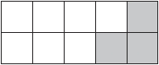

(a)  Find the area of this rectangle.

........................................................... cm2

**(1)**

(b)  What percentage of the rectangle is shaded?

........................................................... %

**(1)**

60% of a triangle is shaded.

(c)  What percentage of the triangle is not shaded?

........................................................... %

**(1)**

(d)  Write 60% as a decimal.

...........................................................

**(1)**

(e)  Change 60% to a fraction.

Give your answer in its simplest form.

...........................................................

**(2)**

**(Total for question = 6 marks)**

**Q10.**

Some of the land in the Netherlands is used to grow bulbs.   
The table shows the percentages of this land used to grow the different types of bulbs.

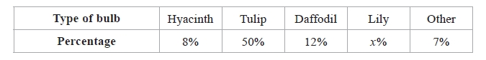

(a)  Work out the value of *x*.

*x* = ..........................................................

**(1)**

The area of land used to grow bulbs for hyacinths is 1200 hectares.

(b)  Work out the area of land used to grow bulbs for daffodils.

.......................................................... hectares

**(2)**

**(Total for question = 3 marks)**

**Q11.**

In January 2007, the population of Canada was 32 million.   
7 million of these Canadians spoke French as their first language.

(a) Express 7 million as a percentage of 32 million.   
Give your answer correct to 1 decimal place.

........................................................... %

**(2)**

Between January 2007 and January 2009, the population of Canada increased by 4%.

(b) Increase 32 million by 4%.   
Give your answer correct to the nearest million.

........................................................... million

**(3)**

**(Total for question is 5 marks)**

**Q12.**

Helen's savings increased from £155 to £167.40   
Work out the percentage increase in Helen's savings.

........................................................... %

**(Total for Question is 3 marks)**

**Q13.**

The table gives some information about the average price of a litre of petrol in England.

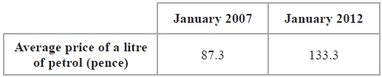

Work out the percentage increase in the average price of a litre of petrol in England between January 2007 and January 2012.   
Give your answer correct to 3 significant figures.

........................................................... %

**(Total for Question is 3 marks)**

**Q14.**

In 2014, Donald's weekly pay was $640   
In 2015, Donald's weekly pay was $668.80

(a)  Work out the percentage increase in Donald's pay between 2014 and 2015

........................................................... %

**(3)**

In 2015, Donald's weekly pay was 95% of his weekly pay in 2016

(b)  Work out Donald's weekly pay in 2016

$ ...........................................................

**(3)**

**(Total for question = 6 marks)**

**Q15.**

(a)   Work out 40% of 20

...........................................................

**(2)**

Here are four numbers.

0.43        3⁄7        43.8%        7⁄16

(b)   Write these numbers in order of size.   
Start with the smallest number.

...........................................................

**(2)**

**(Total for Question is 4 marks)**

**Q16.**

Joseph travels to work each day by train.  
 The weekly cost of his train journey is £45  
 Joseph's weekly pay is £625

(a) Work out 45 as a percentage of 625

...........................................................%

**(2)**

(b) The weekly cost of his train journey increases by 8%.   
Increase £45 by 8%.

£...........................................................

**(3)**

(c) Joseph's weekly pay increases to £640   
Calculate the percentage increase from 625 to 640

...........................................................%

**(3)**

(d) Joseph decides to cycle to work.   
He cycles 18 km to work.  
His journey to work takes 1 hour 20 minutes.

Calculate his average speed in kilometres per hour.

...........................................................km/h

**(3)**

**(Total for question = 11 marks)**

**Q17.**

The table shows information about the time, in minutes, spent on homework by each of  
 32 pupils in one night.

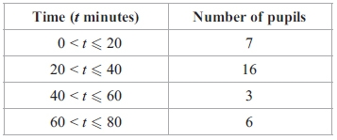

(a) Calculate the percentage of the 32 pupis who spent more than 60 minutes on their   
homework.

...........................................................%

**(2)**

(b) Calculate an estimate for the total time spent on homework by the 32 pupils.

...........................................................minutes

**(3)**

**(Total for question = 5 marks)**

**Q18.**

Calvin and Jenny are planning a holiday together.

The total cost of the flights is £1190

Calvin and Jenny share the cost of the flights so that

the money that Calvin pays : the money that Jenny pays = 2 : 5

(a)  How much more money does Jenny pay than Calvin?

£ ...........................................................

**(3)**

The cost of the villa for their holiday is £3500

They have to pay a deposit of 12% of this cost.   
The rest of the cost of the villa is to be paid in monthly instalments of £220

(b)  How many monthly instalments must be paid?

...........................................................

**(3)**

**(Total for question = 6 marks)**

**Q19.**

(a) (i) What percentage of this shape is shaded?

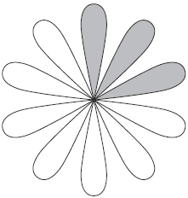

...........................................................%

(ii) What percentage of this shape is unshaded?

...........................................................%

**(2)**

(b) Shade 3/4 of this shape.

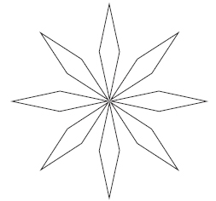

**(1)**

**(Total for question = 3 marks)**

**Q20.**

An airline increases the prices of its flights by 8%.

(a) Before the increase, the price of a flight to Cairo was £475

Work out the price of a flight to Cairo after the increase.

£ ...........................................................

**(3)**

(b) The increase in price of a flight to Mumbai was £48

Work out the price of a flight to Mumbai after the increase.

£ ...........................................................

**(3)**

**(Total for question = 6 marks)**

**Q21.**

(a)  Dilip buys a painting for $ 675

Later, he sells it and makes a percentage profit of 12%.

Work out the price for which Dilip sells the painting.

$ ...........................................................

**(3)**

(b)  Renuka sells her car.

She makes a loss of $ 2162

Her percentage loss is 23%.

Work out the price for which Renuka sells her car.

$ ...........................................................

**(3)**

**(Total for Question is 6 marks)**

**Q22.**

The table shows the cost, in euros, of Brigitte's car insurance in each of the years 2016,   
2017 and 2018

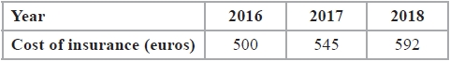

Brigitte says,

"The percentage increase in the cost of my car insurance from 2017 to 2018 is more than   
the percentage increase in the cost of my car insurance from 2016 to 2017"

(a)  Is Brigitte correct?   
You must show how you get your answer.

**(4)**

Henri wants to insure his car.

He gets a discount of 15% off the normal price.   
Henri pays 952 euros for his car insurance after the discount.

(b)  Work out the discount that Henri gets.

........................................................... euros

**(3)**

**(Total for question = 7 marks)**

**Q23.**

A box contains 80 tea bags.

The table shows information about the weight of each tea bag.

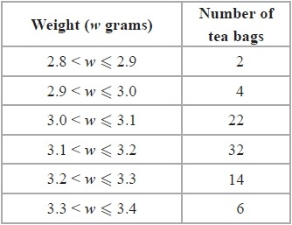

(a)  Work out the percentage of the 80 tea bags that weigh more than 3.1 grams.

.......................................................... %

**(2)**

(b)  Work out an estimate for the total weight of the 80 tea bags.

Use halfway values of 2.85 grams, 2.95 grams, ...

........................................................... grams

**(3)**

**(Total for Question is 5 marks)**

**Q24.**

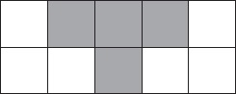

(i)  What percentage of this shape is shaded?

........................................................... %

(ii)  Write your answer to part (i) as a decimal.

...........................................................

**(Total for Question is 2 marks)**

**Q25.**

In 2018, Salman saved 120 riyals each month.

At the start of 2019, Salman increased 120 riyals by 7.5%   
He then saved this new amount each month during 2019

Work out how much money Salman saved in total in 2019

........................................................... riyals

**(Total for question = 3 marks)**

**Q26.**

(a) Work out 35% of 80

...........................................................

**(2)**

Work out 7/8 of 48

...........................................................

**(2)**

**(Total for question = 4 marks)**

**Q27.**

Gopal is paid 20 000 rupees each month.   
Jamuna is paid 19 200 rupees each month.

Gopal and Jamuna are both given an increase in their monthly pay.   
After the increase, they are both paid the same amount each month.

Gopal was given an increase of 8%

Work out the percentage increase that Jamuna was given.

........................................................... %

**(Total for question = 4 marks)**

**Q28.**

In a sale, all normal prices are reduced by 15%.

(a)   The normal price of a washing machine is 270 dollars.   
Work out the sale price of the washing machine.

........................................................... dollars

**(3)**

(b)   The normal price of a food processor is reduced by 13.50 dollars.   
Work out the normal price of the food processor.

........................................................... dollars

**(3)**

**(Total for Question is 6 marks)**

**Q29.**

**Write your answers in the spaces provided.**

**You must write down all the stages in your working.**

The table gives information about the price of gold.

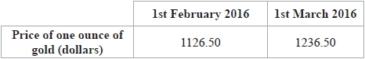

(a)  Work out the percentage increase in the price of gold between 1st February 2016 and 1st March 2016

Give your answer correct to 3 significant figures.

%

**(3)**

The price of one ounce of gold on 1st February 2016 was 1126.50 dollars.   
The price of gold increased by 19% from 1st February 2016 to 1st July 2016

(b)  Work out the price of one ounce of gold on 1st July 2016

Give your answer correct to the nearest dollar.

**dollars**

**(3)**

**(Total for question = 6 marks)**

**Q30.**

Sam takes an English exam.   
There are two papers in the exam.   
Each paper has a maximum mark of 80

To pass the exam, Sam needs to get at least 60% of the total marks.

Sam gets 55% of the 80 marks in paper 1

Work out the least number of marks that Sam must get in paper 2 to pass the   
English exam.

...........................................................

**(Total for question = 4 marks)**

**Q31.**

In a sale, normal prices are reduced by 15%.  
 The normal price of a television was $640

Work out the sale price of the television.

$ ...........................................................

**(Total for question = 3 marks)**

**Q32.**

(a)  What fraction of this shape is shaded?

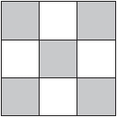

...........................................................

**(1)**

(b)  Shade 25% of this shape.

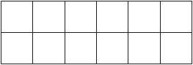

**(1)**

(c)  Write as a decimal.



...........................................................

**(1)**

(d)  Write as a percentage



...........................................................%

**(2)**

**(Total for question = 5 marks)**

**Q33.**

A clothes shop has a sale.

In the sale, normal prices are reduced by 12%   
The normal price of a shirt is £30

(a)  Work out the sale price of the shirt.

£ ...........................................................

**(3)**

The price of a coat is reduced by £9 in the sale.

(b)  Work out the normal price of the coat.

£ ...........................................................

**(3)**

**(Total for question = 6 marks)**

**Q34.**

On 1st May 2012, the cost of 5.7 grams of gold was 15 960 rupees.

(a)  Work out the cost, in rupees, of 4.6 grams of gold on the same day.

........................................................... rupees

**(2)**

The cost of gold decreased by 7.5% from 1st May 2012 to 1st May 2013

(b)  Work out the cost, in rupees, of 5.7 grams of gold on 1st May 2013

........................................................... rupees

**(3)**

**(Total for question = 5 marks)**

**Q35.**

In a sale, normal prices are reduced by 8%

(a)  The normal price of a jacket is £28

Work out the price of the jacket in the sale.

£ ...........................................................

**(3)**

(b)  In the sale, the price of a shirt decreases by £3

Work out the normal price of the shirt.

£ ...........................................................

**(3)**

**(Total for question = 6 marks)**

**Q36.**

In a sale, all normal prices are reduced by 20%

(a)  The normal price of a television set is 485 euros.   
Work out the sale price of the television set.

........................................................... euros

**(3)**

(b)  In the sale, the normal price of a tablet computer is reduced by 79 euros.   
Work out the normal price of the tablet computer.

........................................................... euros

**(3)**

**(Total for question = 6 marks)**

**Q37.**

The price of 1 kg of silver on 1st January 2010 was $607   
By 1st January 2015, the price of 1 kg of silver had decreased by 9.4%

(a)  Work out the price of 1 kg of silver on 1st January 2015.

Give your answer correct to the nearest dollar ($).

$ ...........................................................

**(3)**

Between 1st January 2010 and 1st January 2015, the price of 1 tonne of copper decreased by 20%

This was a decrease of $1320

(b)  Work out the price of 1 tonne of copper on 1st January 2010.

$ ...........................................................

**(3)**

**(Total for question = 6 marks)**

**Q38.**

Eloy's height was 125 cm when his age was 7 years.   
His height was 153 cm when his age was 12 years.

(a)   Work out the percentage increase in Eloy&#146;s height between the ages of 7 and 12 years.

...........................................................%

**(3)**

Eloy's height at the age of 12 years was 85% of his height at the age of 20 years.

(b)   Work out Eloy's height when his age was 20 years.

...........................................................cm

**(3)**

**(Total for question = 6 marks)**

**Q39.**

In 2011, the population of Uganda was 34 million.

In 2011, 48% of the population of Uganda had a mobile phone.

(a)  Work out how many people did **not** have a mobile phone in Uganda in 2011

........................................................... million

**(3)**

(b)  Write 48% as a fraction.

...........................................................

**(1)**

(c)  Write 48% as a decimal.

...........................................................

**(1)**

**(Total for question = 5 marks)**

**Q40.**

(a) 22% of the population of Kenya belong to the Kikuyu tribe.

What percentage of the population does not belong to the Kikuyu tribe?

...........................................................%

**(1)**

(b) The population of Kenya is 41 million.

Work out 22% of 41 million.  
 Give your answer correct to the nearest million.

...........................................................million

**(2)**

(c) 6% of the population of Kenya belong to the Meru tribe.

Write 6% as a decimal.

...........................................................

**(1)**

**(Total for question = 4 marks)**

**Q41.**

(a)  Shade 70% of this shape.

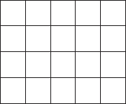

**(1)**

(b)  Write 23% as a fraction.

...........................................................

**(1)**

(c)  Write 6% as a decimal.

...........................................................

**(1)**

14% of the workers in a factory work part time.

(d)  What percentage of the workers in the factory do **not** work part time?

...........................................................%

**(1)**

(e)  Work out 14% of 350

...........................................................

**(2)**

**(Total for question = 6 marks)**

**Q42.**

Trina collects eggs from her hens.   
She labels their eggs small or medium or large.

20% of the eggs she collected in May were small.   
24% of the eggs she collected in May were large.

(a)   What percentage of the eggs she collected in May were medium?

...........................................................%

**(2)**

(b)   Express 24% as a fraction.   
       Give your fraction in its simplest form.

...........................................................

**(2)**

Trina collected 75 eggs in May.

(c)  Work out 20% of 75

...........................................................

**(2)**

**(Total for question = 6 marks)**

**Q43.**

A shop, *Furniture 4U*, had a sale.

(a) In the sale, normal prices were reduced by 15%.

(b) (i) Work out the mean number of letters in the first names of the 50 people.

(i) The normal price of a table was $280

Work out the sale price of the table.

$...........................................................

(ii) The normal price of a chair was reduced in the sale by $24

Work out the normal price of the chair.

$...........................................................

**(6)**

(b) Ruth, Suha and Yasmin went to the sale.   
The amounts of money spent by Ruth, Suha and Yasmin were in the ratios 2 : 3 : 7  
Ruth and Suha spent a total of $320 in the sale.

Work out the amount of money Yasmin spent in the sale.

$...........................................................

**(3)**

**(Total for question = 9 marks)**

**Q44.**

A lion is 224 cm long.

Simon makes a scale model of the lion.   
He uses a scale of 1 : 8

(a)  Work out the length of the scale model.

........................................................... cm

**(2)**

In 2010, there were 411 Asiatic lions in India.   
In 2015, there were 523 Asiatic lions in India.

(b)  Work out the percentage increase in the number of Asiatic lions in India from 2010 to 2015   
       Give your answer correct to 1 decimal place.

........................................................... %

**(3)**

**(Total for question = 5 marks)**

**Mark Scheme**

Q1.

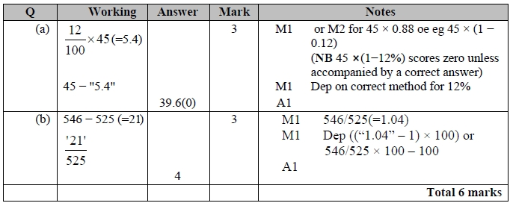

**Q2.**

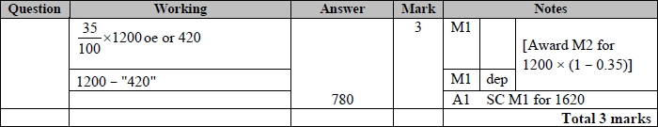

**Q3.**

The correct answer, unless clearly obtained by an incorrect method, should be taken to imply a correct method.

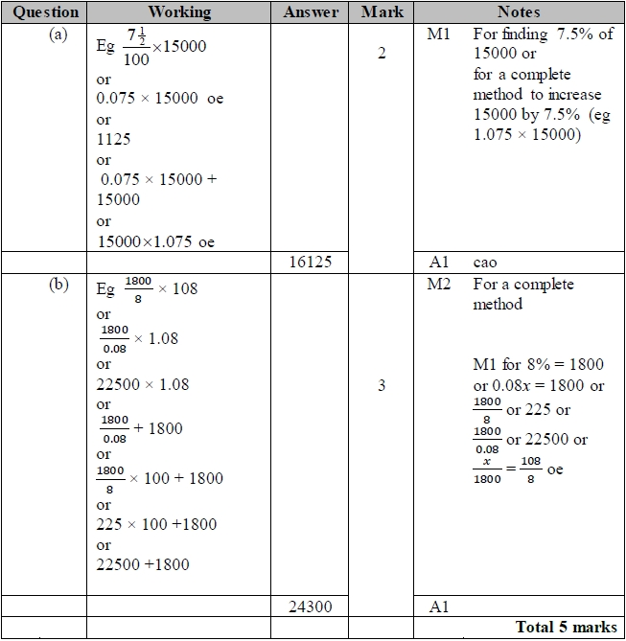

**Q4.**

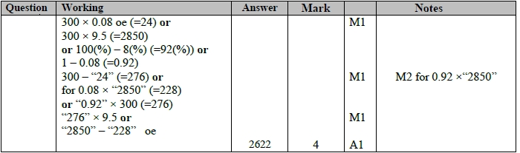

**Q5.**

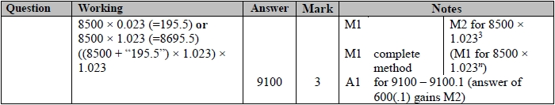

**Q6.**

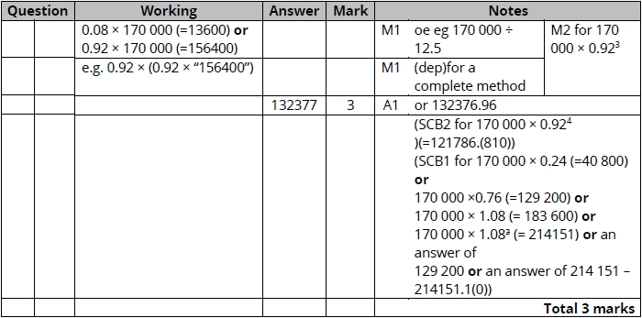

**Q7.**

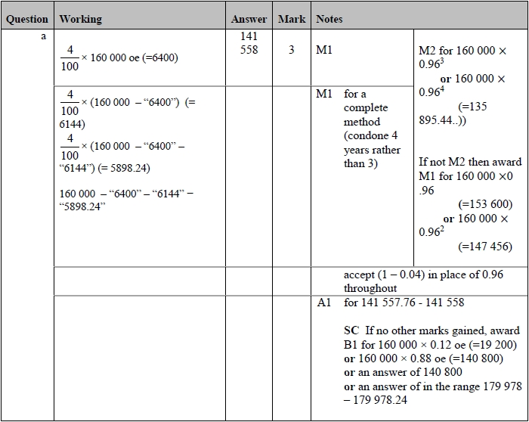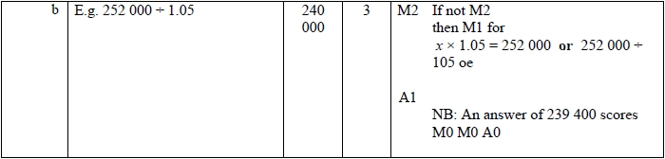

**Q8.**

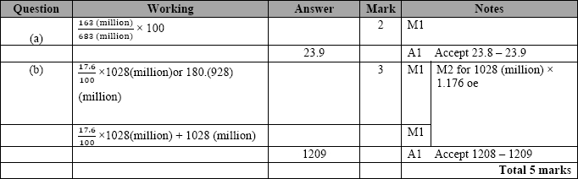

**Q9.**

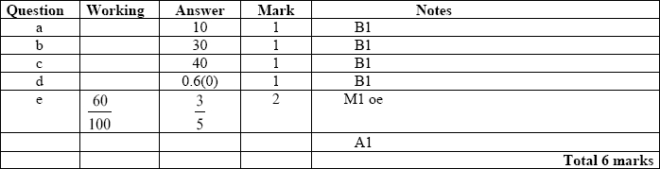

**Q10.**

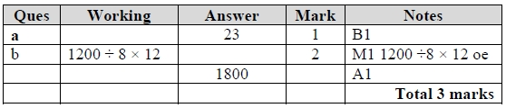

**Q11.**

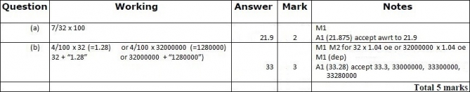

**Q12.**

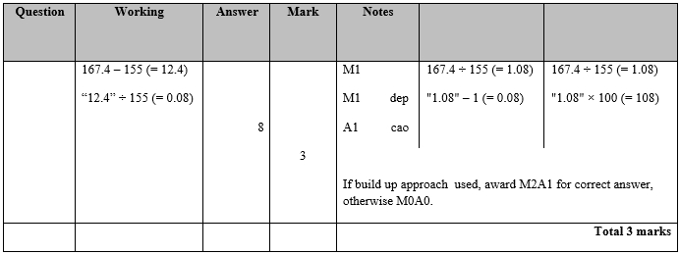

**Q13.**

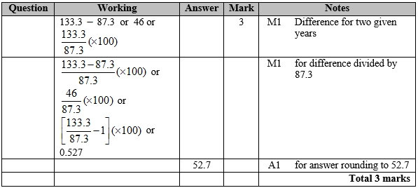

**Q14.**

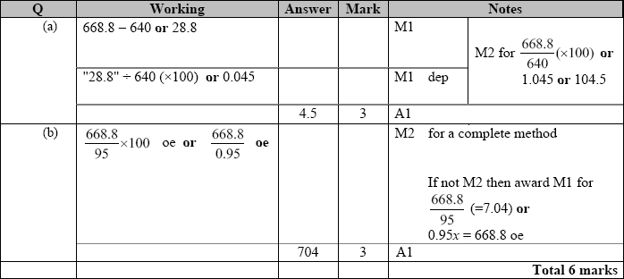

**Q15.**

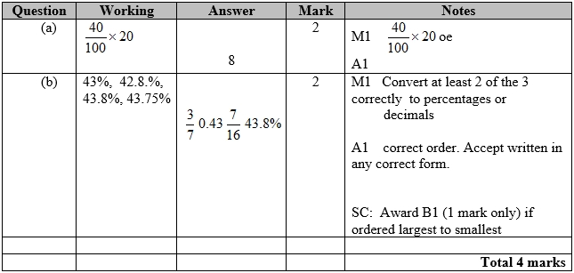

**Q16.**

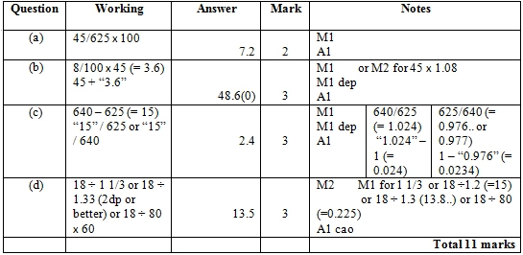

**Q17.**

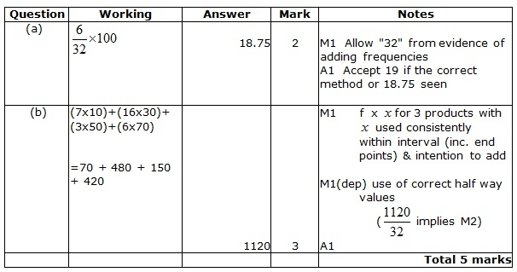

**Q18.**

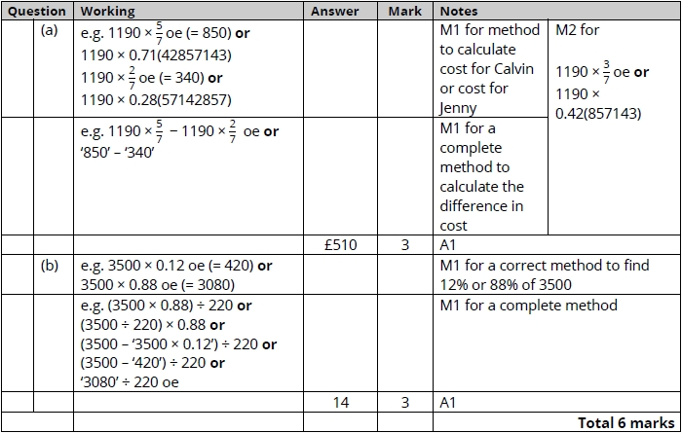

**Q19.**

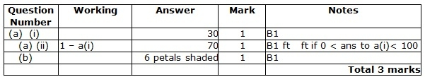

**Q20.**

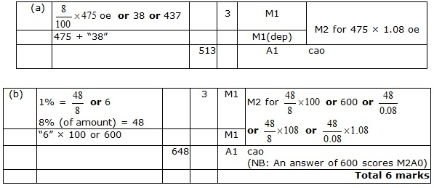

**Q21.**

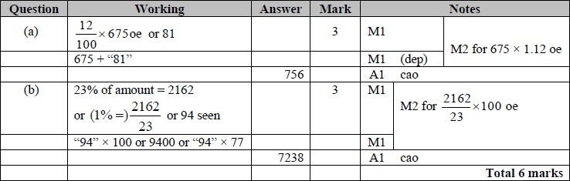

**Q22.**

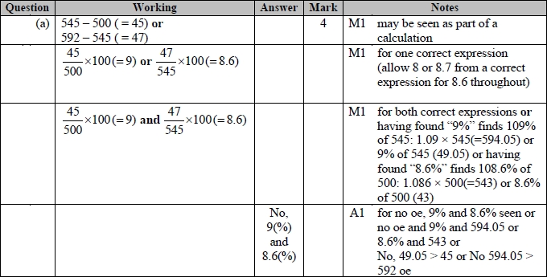

**Q23.**

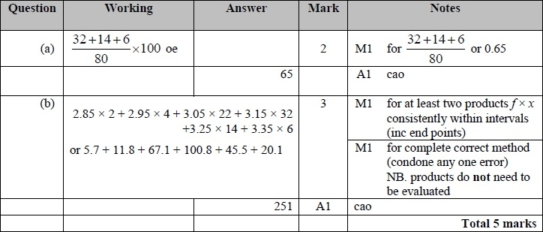

**Q24.**

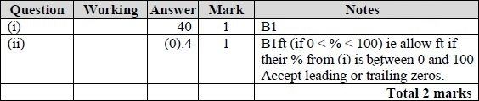

**Q25.**

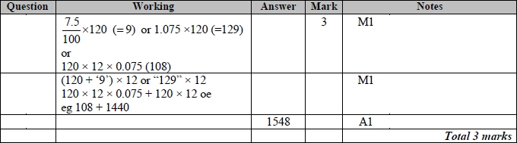

**Q26.**

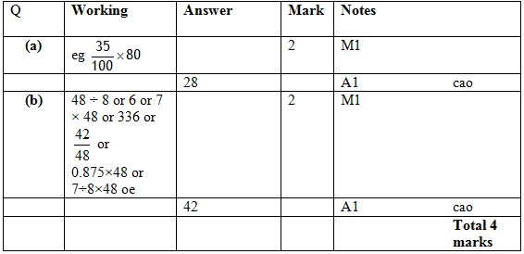

**Q27.**

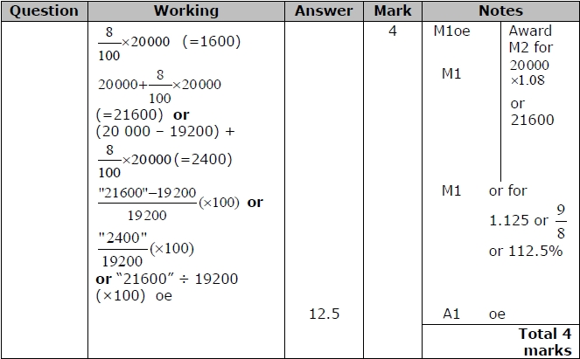

**Q28.**

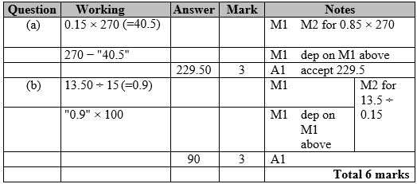

**Q29.**

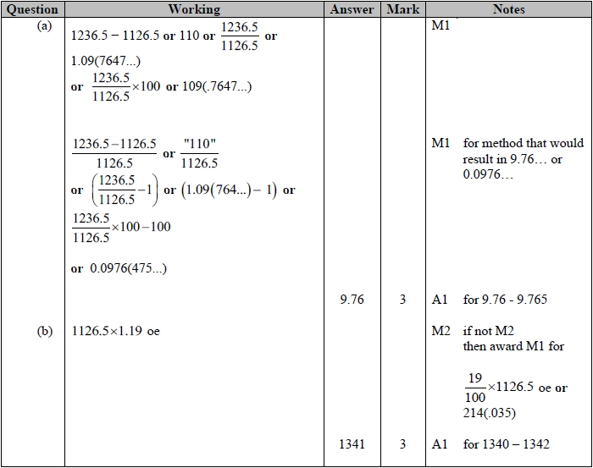

**Q30.**

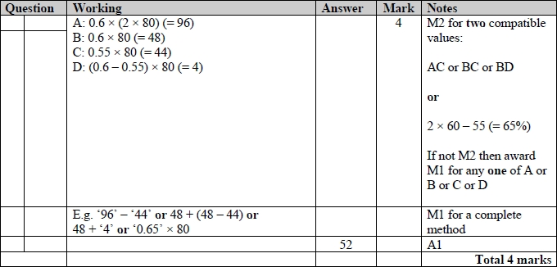

**Q31.**

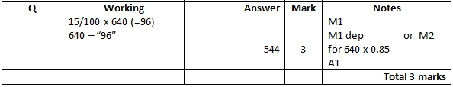

**Q32.**

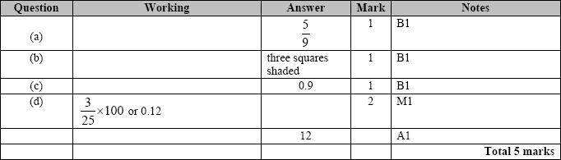

**Q33.**

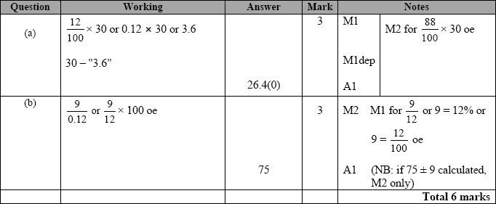

**Q34.**

For all questions, the correct answer, unless clearly obtained by an incorrect method, should be taken to imply a correct method.

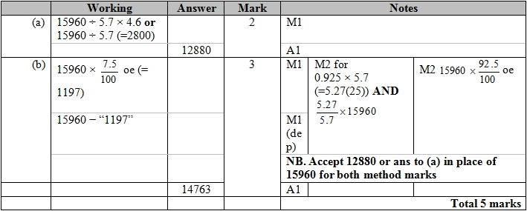

**Q35.**

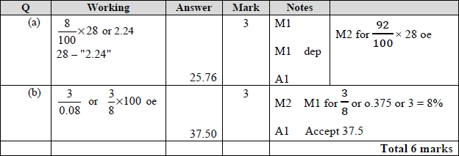

**Q36.**

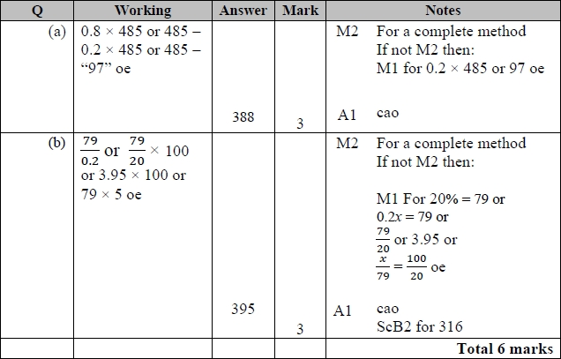

**Q37.**

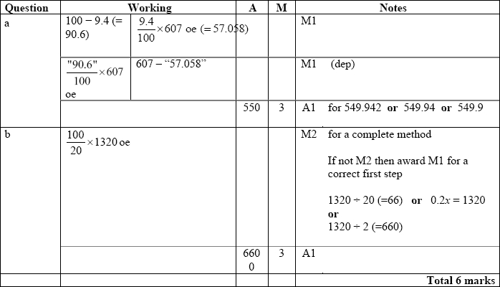

**Q38.**

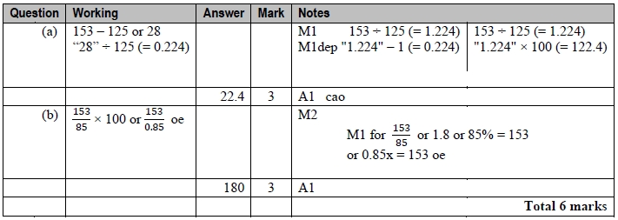

**Q39.**

For all questions, the correct answer, unless clearly obtained by an incorrect method, should be taken to imply a correct method.

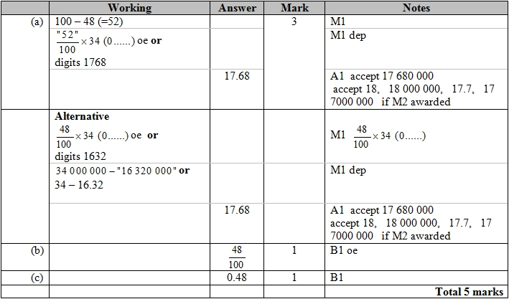

**Q40.**

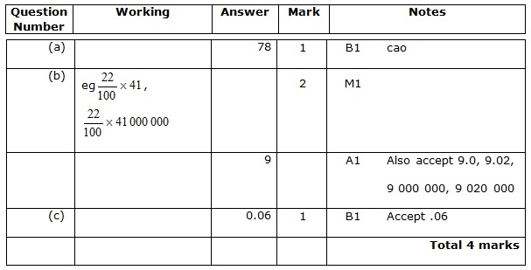

**Q41.**

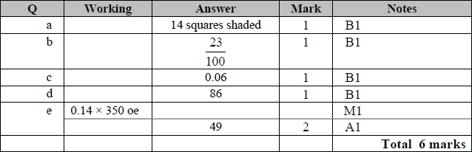

**Q42.**

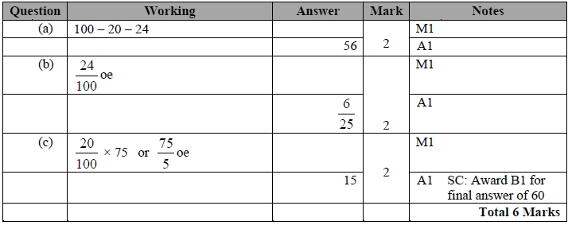

**Q43.**

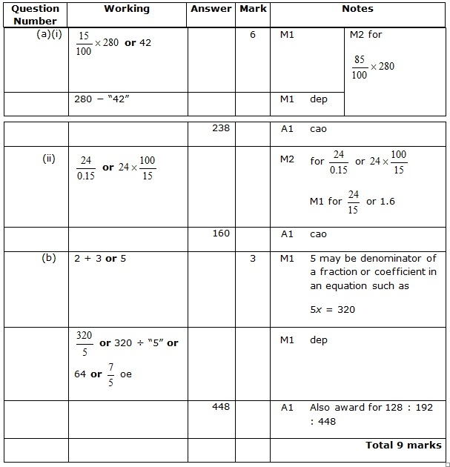

**Q44.**

