

**Marking Scheme**

**Graphs (Foundation)**

**Q1.**

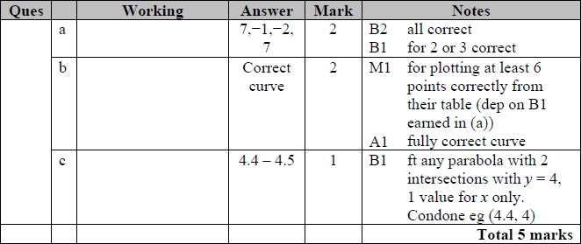

**Q2.**

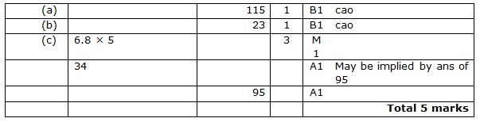

**Q3.**

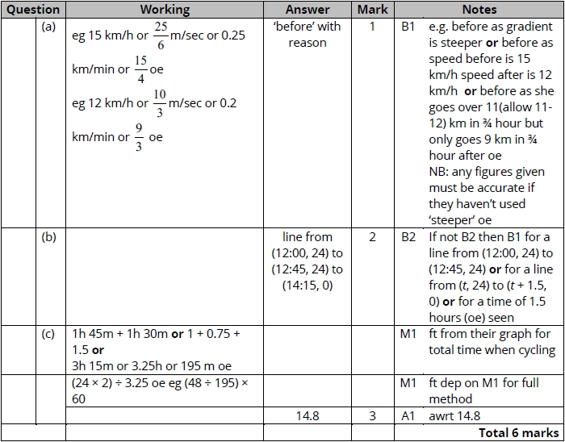

**Q4.**

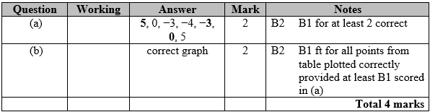

**Q5.**

Apart from question 18c where the mark scheme states otherwise, the correct answer, unless clearly obtained by an incorrect method, should be taken to imply a correct method.

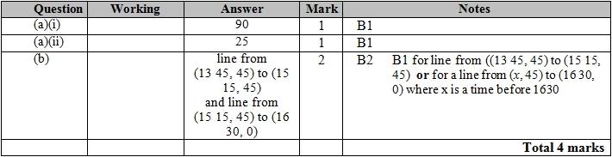

**Q6.**

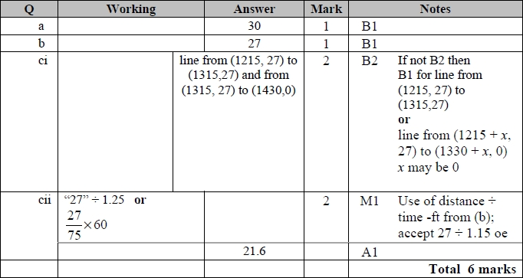

**Q7.**

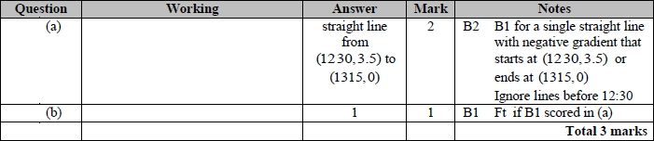

**Q8.**

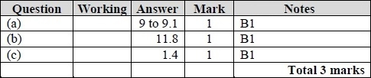

**Q9.**

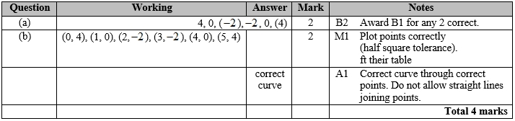

**Q10.**

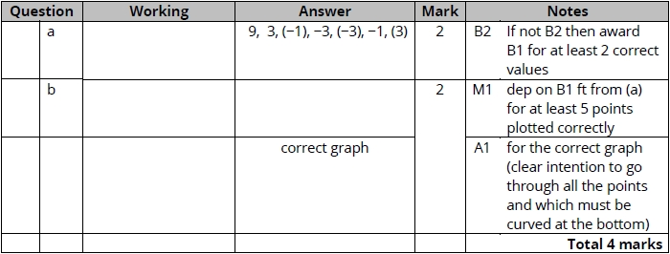

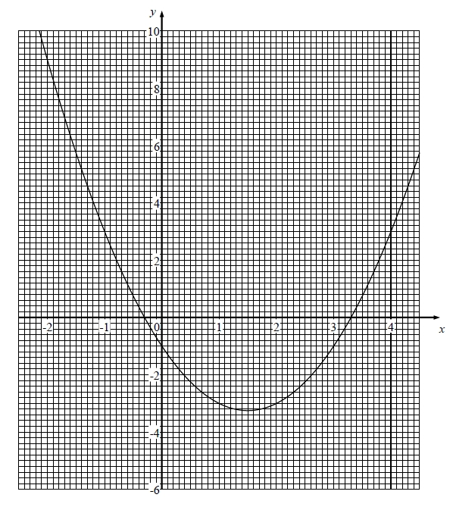

**Q11.**

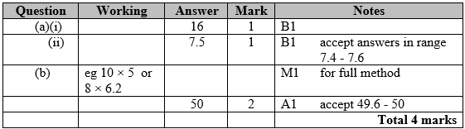

**Q12.**

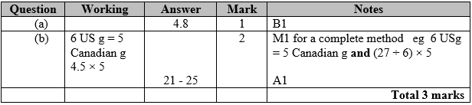

**Q13.**

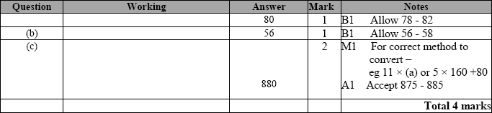

**Q14.**

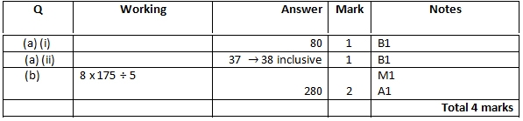

**Q15.**

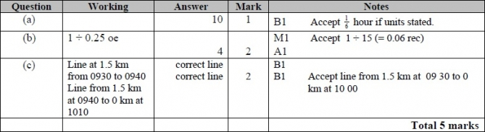

**Q16.**

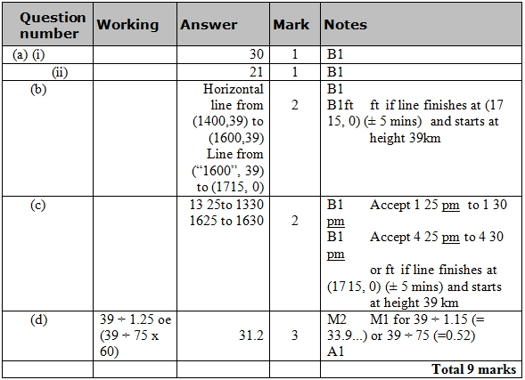

**Q17.**

 