3.4.1 Setting operational objectives

3.4.2 Analysing operational performance

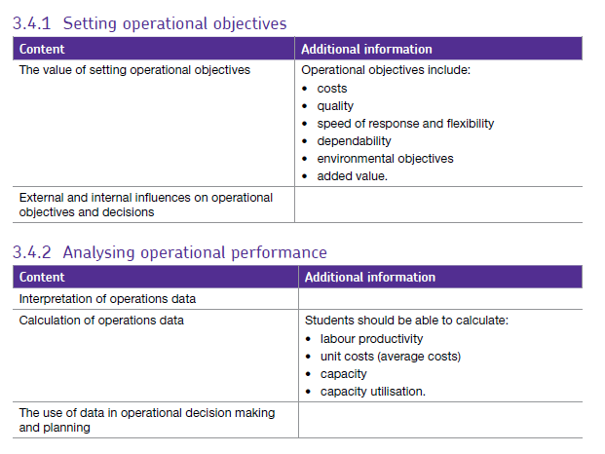

## Introduction

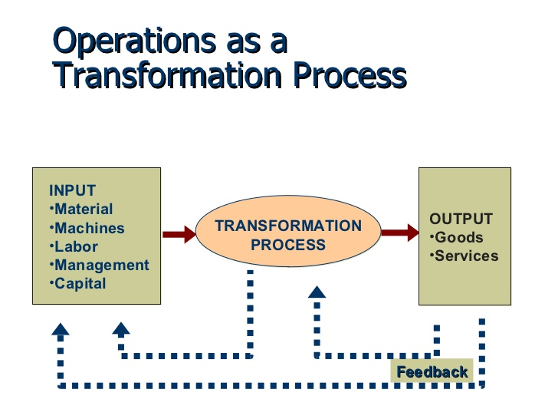Operations is one of the functions (departments) in a business and is responsible for the actual production of the good or service. *Operations management* involves managing the process of converting inputs into outputs by transforming resources into goods and services.

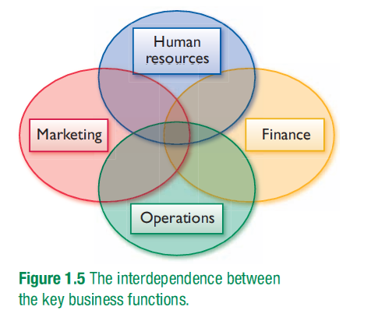

However, the operations function does not exist in isolation and that it is affected by and is dependent upon other areas in the business.

As with all aspects of a business, operations management involves choices and decisions.

For example:

* The level of output the business needs and is able to produce.
* The range of products the business is able to offer.
* How best to produce the goods or services. Should manufacture be labour intensive or capital intensive?
* How best provide or deliver the good or service to the customer.
* Where should the business source their raw materials?
* How much should they be concerned with quality and costs?

Operations covers a range of activities from when they first buy raw materials to delivery to their customers, this is known as their **supply chain**.

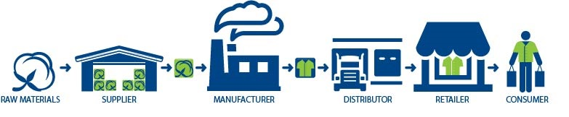

## The value of setting operational objectives and decisions

* Setting objectives for any functional area is very important and the following reasons could be applied to any functional area. The reasons are:
* To act as a focus for decision making and effort.
* To provide criteria against which success or failure can be measured.
* To improve coordination by giving teams and departments a common purpose.
* To improve efficiency by examining the reasons for success or failure.
* A range of specific operational objectives are used to assess operational performance and these will be looked at in turn:

## Costs

In order to remain competitive, a business will try to reduce the cost of production. Lowering costs will enable the business to either increase their profit margin or reduce the selling price of the product or service. Costs targets can involve:

Reducing fixed costs – e.g through **downsizing** i.e. selling less profitable parts of the business, unused buildings / machinery etc. this may also involve redundancies. Reducing fixed costs also involves **rationalisation** of activities e.g. removing any duplicated tasks.

Reducing variable costs – this may be achieved by finding cheaper suppliers or cheaper and more efficient ways of manufacturing.

## Image result for qualityQuality

It is important that a business meets the *expectations* the customer has with regard to quality and it does so *consistently*.

Meeting high quality standards is a good way for the business to differentiate itself from other competitors (unique selling point) and allow the business to charge a premium price for the product.

Examples of measures of quality are:

* Customer satisfaction rate – a survey of customers can reveal whether or not customers are happy with the product or service.
* Customer complaints – this calculates the number of customer complaints as a percentage of total customers. It is very important to identify any problems as soon as possible; dissatisfied customers can ruin the reputation of the business.
* Level of production returns – if customers return a high percentage of goods that they have purchased, it is a sign of dissatisfaction with that good.
* Scrap rate – this measures the number of items rejected during the production process. Rejected products will also increase the costs of production so it is important to keep scrap rates as low as possible.
* Punctuality – this measures the degree to which a business delivers its products or services on time.

## Speed of response

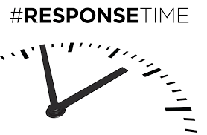

This is usually measured as the difference in time between a customer requesting a good or service and the time at which they receive that good or service.

However, it can also be used to measure how long it takes to answer the phone to a customer or how long it takes to respond to a customer email.

A quick response will lead to good customer satisfaction, repeat business and customer loyalty. A quick speed of response can also reduce costs. For example, dispatching a customer order quickly can save on storage costs.

## Flexibility

Flexibility can take many different forms such as:

* Product flexibility – being able to switch production from one product to another.
* Volume flexibility – being able to change the level of output of a product in accordance with changes in customer demand.
* Mix flexibility – being able to provide a wide range of alternative versions of a particular good or service.
* Delivery flexibility – being able to adapt quickly to changes in the timing and volume of deliveries to customers; additional costs are likely to be incurred if changes are made at short notice.

Each of these different types of flexibility enables a business to adapt to changes in customer requirements. As with other operational objectives, this should increase the volume of sales and also lead to a decrease in costs. However, flexibility can also increase costs; product and mix flexibility both require sophisticated machinery on the production line.

## Dependability

As with quality and flexibility, dependability can have different meanings. In a service context, dependability may be applied to consistency of quality or the punctuality of delivery.

In manufacturing, dependability can be measured in terms of whether the product is durable, long lasting and unlikely to break down.

If a business does not provide its product or service on time, it is likely to lose customers. It is also highly likely to negatively impact on the reputation of the business.

## Environmental objectives

Environmental objectives are becoming a much more important aspect of operations management for several reasons:

* Many businesses recognise that they have responsibility for the environment.
* Business stakeholders such as the local community want the business to protect the environment.
* A business can attract more customers and workers if they can demonstrate a positive attitude towards improving the environment.
* Many environmental objectives, such as recycling, will allow the business to save on costs.
* Typical environmental objectives include:
* Reducing water pollution by a certain percentage
* Reducing the business’s carbon footprint or reducing carbon dioxide omissions
* Reducing noise levels
* Reducing the use of energy
* Minimising waste products or energy
* Increase levels of recycling
* Making products that can easily be recycled
* Achieving self-sufficiency in energy use by using wind turbines for example
* Reducing the use of non-renewable inputs
* Replacing resources that have been extracted or used

## Image result for added valueAdded value

Adding value is the process of increasing the worth of resources by modifying them.

The production process itself in the main source of value added. For example, the transformation of various components into a finished product such as a car adds value since customers place a higher value on the finished car than the individual components it is made up of.

Adding value can also involve clever marketing including packaging, excellent customer service and developing strong branding. Customers are prepared to pay a higher price for the product or service if they perceive the product or service to be of good quality.

# Assessing the internal influences on operational objectives

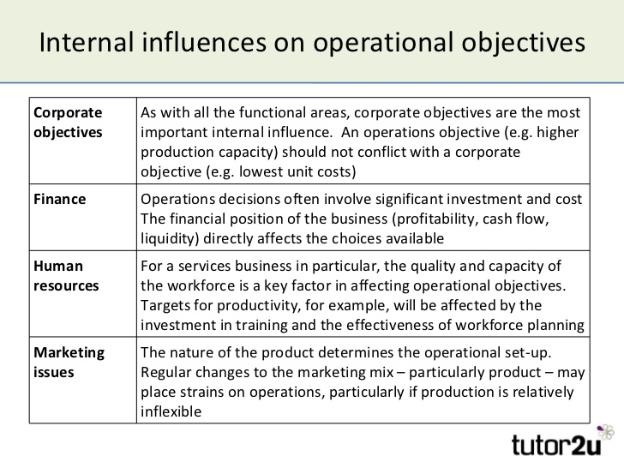Internal factors affecting operational objectives are those which originate from within the business itself.

## **Internal factors on operations objectives include**:

The product and its manufacturing process on the environment will also vary according to the nature of the product. All these factors need to be taken into account when the business is setting its operational objectives.

## Assessing external influences on operations objectives

External factors are those outside the business such as the state of the economy or the actions of competitors.

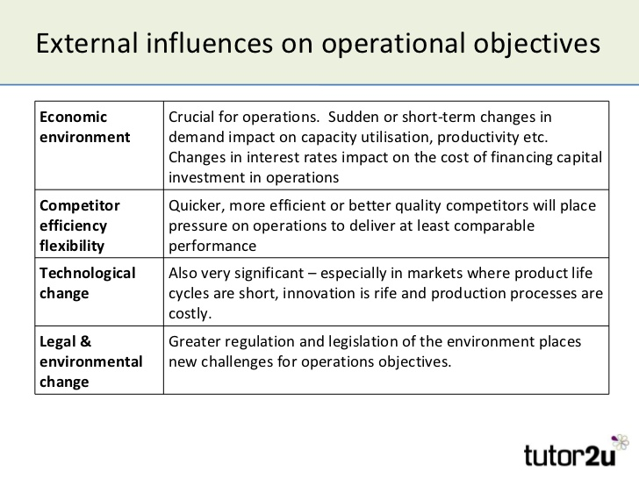**External factors on corporate objectives include:**

# Operations data.

Operations data is quantitative information which tells the firm how efficiently its resources are being used.

These resources include people and machines and involves looking at average costs which fall as the firm becomes more efficient.

# Labour productivity

Labour productivity is concerned with the amount (volume) of output that is obtained from each employee. This matters because

* Labour costs are usually a significant part of total costs
* Business efficiency and profitability closely linked to productive use of labour
* In order to remain competitive, a business needs to keep its unit costs down
* Achieving higher labour productivity is not a simple task. Several factors influence how productive the workforce is: e.g.
* Extent and quality of fixed assets (e.g. equipment, IT systems)
* Skills, ability and motivation of the workforce

## How can labour productivity be measured?

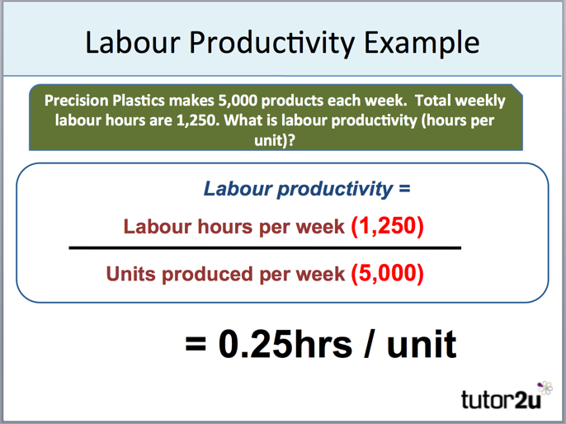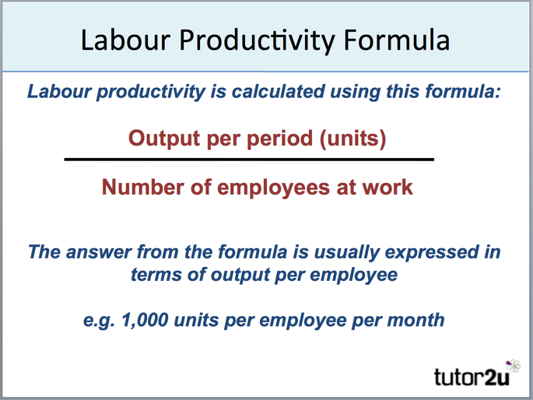Productivity is measured as:

## How can a business improve its labour productivity?

There are many possible approaches:

* Measure performance and set targets – it is often claimed that "what gets measured, gets done!"
* Streamline production processes
* Invest in capital equipment (automation + computerisation)
* Invest in employee training
* Make the workplace conducive to productive effort

The most suitable approach depends on the firm and the nature of the workers and their work.

# Capacity.

Capacity can be defined as: t**he maximum output that a business can produce in a given period with the available resources**

Capacity is usually measured in production units (e.g. 1,000 cars per month). Productive capacity can change (e.g. when a machine is having maintenance, capacity is reduced), and is linked to workforce planning: e.g. (by working more production shifts, capacity can be increased). In addition to this, capacity needs to take account of seasonal or unexpected changes in demand, e.g. Chocolate factories need capacity to make Easter Eggs in November and December before shipping them to shops after Christmas or Ice-cream factories in the UK needed to quickly increase capacity during a heat wave

# Capacity utilisation.

Capacity utilisation is a measure of the extent to which the productive capacity of a business is being used. It can be defined as: t**he percentage of total capacity that is actually being achieved in a given period**

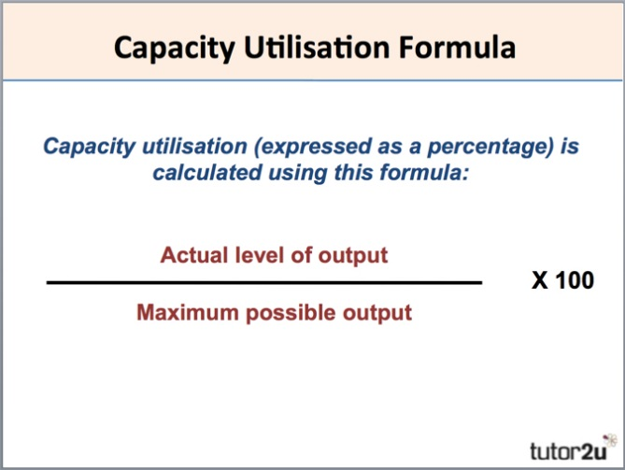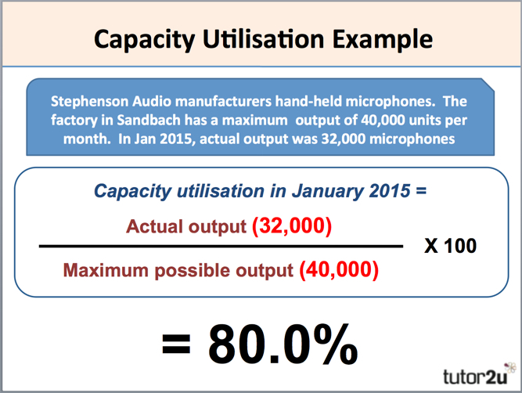Capacity utilisation (expressed as a percentage) is calculated as:

Capacity utilisation is an important concept as it is often used as a measure of productive efficiency

Average production costs tend to fall as output rises – so higher utilisation can reduce unit costs, making a business more competitive so firms usually aim to produce relatively close to full capacity (100% utilisation)

There are several reasons why businesses operate at less than 100% capacity utilisation:

***Lower demand:***

* General reduction in overall market demand
* Loss of market share
* Seasonal variation in demand

***Increase in capacity not yet matched by increased demand:***

* Possibly new technology introduced
* Provide some "slack"

***Inefficiency (a problem = less competitive unit costs)***

* Poor maintenance, quality, employee disruption
* When a business is operating at less than 100% capacity, it is said to have "**spare capacity".**
* Sometimes spare capacity is not the problem – a business finds itself with **excess demand** (i.e. it cannot produce enough to meet demand). In such circumstances, what can it do to operate at higher than 100% normal capacity? It can often:
* Increase workforce hours (e.g. extra shifts; encourage overtime; employ temporary staff)
* Sub-contract some production activities (e.g. assembly of components)
* Reduce time spent maintaining production equipment

However, there are some potential pitfalls with operating at very high capacity (i.e. around 100%):

***Negative effect on quality (possibly)***

* Production is rushed
* Less time for quality control

***Employees suffer***

* Added workloads & stress
* De-motivating if sustained for too long

***Loss of sales***

* Less able to meet sudden or unexpected increases in demand
* Production equipment may require repair