**3.1.4 Energetics**

**Exothermic and endothermic reactions**

***Demo: Energy in reactions – glow sticks & barium hydroxide + ammonium chloride (3:1)***

***Categories them as exothermic or endothermic***

Thermodynamics is the study of heat changes during reactions. The fundamental law id that energy can’t be created or destroyed but transfers from one form to another.

Most chemical reactions **give out** or **take in energy**, as different forms of energy; chemical energy in reactants transfers to light, electrical, sound, heat or chemical energy in products. These are called **exothermic** or **endothermic** reactions.

|  |  |
| --- | --- |
|  |  |

***Video clips: Exothermic & endothermic***

***Sheet: Exothermic & endothermic reactions***

**Energy changes** cause **temperature changes** but the reaction isn’t finished until it has **returned to the temperature it started at.**

|  |  |
| --- | --- |
|  | **Exothermic** – the reaction is over when the products have cooled back to 298K so they **gives out heat** to the surrounds in order to do this and the immediate **temperature** change is **increased.**  **Example CGP100: Oxidation**  CH4(g) + O2(g) → CO2(g) + H2O(l)  **Endothermic** – reaction is over when the products have warmed to 298K so they have to **take in energy** from their surroundings to do this and the immediate **temperature** change is **decreased.**  **Example CGP100: Thermal decomposition**  CaCO3(s) → CaO(s) + CO2(g) |

**Temperature** is the **average kinetic energy of particles** in a system, i.e. how fast the particles are moving. As the particles move faster the kinetic energy increases so the temperature increases, this is **independent of the number of particles present.** Temperature is measured with a **thermometer**.

**Heat energy** is the measure of **total energy of all particles** in a given amount of substance; it is dependent **on the number of particles present.** So a warm bath has much heat as a red hot nail because there are so many particles in it. Heat always flows from high to low temperature.

***Circus: Energy in reactions***

***Lab books – aim, apparatus diagram, results table, conclusion***

***Activity: Exothermic & endothermic?***

**Applications of energy changes in reactions:**

* Combustion fuels – vehicles, power stations, cooking heating
* Ice packs – endothermic dissolving of potassium nitrate – absorbs heat from water
* Hand warmers - generate heat through exothermic crystallisation of super cooled molten materials (usually sodium acetate) and are reusable. These can be recharged by boiling the warmers and allowing them to cool. Heating of the pads is triggered by snapping a small metal device buried in the pad which generates shock waves to initiate crystallisation.
* Non-reusable warmers are available - contain cellulose, iron, water, activated carbon (evenly distributes heat), vermiculite (water reservoir) and salt (catalyst) and produce heat from the exothermic [oxidation](https://en.wikipedia.org/wiki/Oxidation) of iron when exposed to [air](https://en.wikipedia.org/wiki/Air).

**Enthalpy change**

There are different forms of energy in reactions the change in heat can be calculated. The amount of **heat** given out or taken in the **enthalpy change** and it **depends on the quantities of reactants**, so it is measured **in kJ mol-1**. It is given the notation **ΔH, enthalpy** has the symbol **H** and **change** is represented by the Greek letter **Δ** (delta).

The **amount of energy** given out/taken in by a reaction **varies with conditions**: temperature, pressure, concentration of solutions etc. This means that the **conditions must be stated**, this is usually at constant atmospheric pressure.

***Definition***: **Enthalpy change** is the **heat change at constant** **pressure** under **standard conditions** (pressure 100 kPa and temperature 298 K.)

***Video clip: Enthalpy changes***

**The standard conditions are:**

* Pressure **100** **kPa** (normal atmospheric pressure)
* Temperature **298** **K** (normal room temperature, 25OC)

Enthalpy changes **under standard conditions** are written **ΔHθ298**, although the 298 is often left out so **ΔHθ**is written.

Physical states of reactants and products

The **physical states** (gas, liquid or solid) of the reactants and products also **affect the enthalpy change of a reaction**. This is because heat must be put in to change a solid to a liquid to a gas and it is given out when a gas changes to a liquid to a solid. So the **state symbols** of the reactants and products **must be shown**.

Elements and compounds are said to be in their **standard state** if they are in their **normal, stable state at 298 K and 100 kPa**. If a substance can be either a gas or a liquid under standard conditions than the state must be shown by using state symbols.

E.g. water H2O(s) H2O(l) H2O(g)

Standard state of water at 298K and 100 kPa is **liquid**

When elements can exist as **allotropes**, the particular allotrope should be stated.

E.g. C(diamond) C(graphite)

Standard state of carbon at 298K and 100 kPa is **graphite**

If the allotrope is not stated then it is assumed it’s in the **most stable form**, in the case of carbon this is graphite.

Enthalpy level diagrams

The first law of thermodynamics states that **energy is conserved; it can be neither created nor destroyed**. All **elements** and **compounds** **contain a specific amount** of **chemical energy**, so when reactants change into products the amount of chemical energy associated with them will change.

Changes in heat energy or enthalpy can be shown on **enthalpy** or **energy level diagrams**.

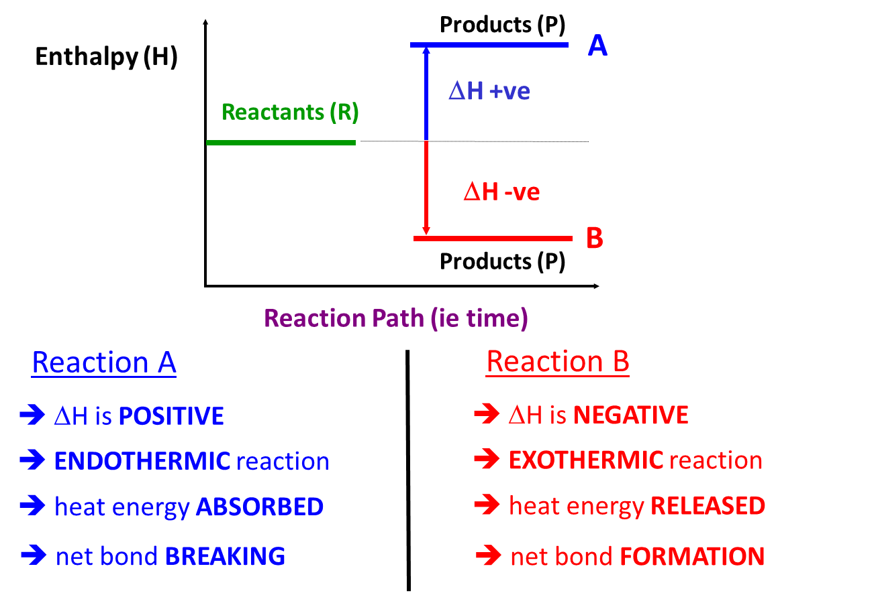

In chemical reactions the **bonds** of the **reactants** must be **broken**; this requires an **input** of **energy**, so is **endothermic**. Then new **bonds** are **made** in the **products**, these results in the **release** of **energy**, so is **exothermic**. So the **enthalpy change** for the overall reaction is **dependent on the net energy change**, i.e. the amount of energy needed to break the bonds in the reactants compared to the amount released when the bonds in the products are formed.***Sheet: Energy level diagrams - exothermic or endothermic?***

|  |  |
| --- | --- |
| **Exothermic** | **Endothermic** |
|  |  |

***Fact recall: CGP100 Q1-2***

**Different types of enthalpy changes**

***Definition***: **Standard enthalpy of reaction** **ΔHθr** is the enthalpy change, under standard conditions, when **a reaction occurs** in the **molar quantities** shown in the **chemical equation** with all **reactants and products in their standard states.**

E.g. HCl(aq) + NaOH(aq) → NaCl(aq) + 2H2O(l)

**Bond enthalpies**

If the **enthalpy of combustion** (ΔHθc) is plotted **against number carbon atoms** in straight chain alkane the graph produces a **straight line**.

|  |  |
| --- | --- |
|  | This shows that the **enthalpy of combustion changes by the same amount** for each extra carbon in the chain. Each alkane differs from the previous one by one CH2 unit, so there is one extra C-C bond and two extra C-H bonds. So this suggests that there is a **definite** **amount of energy** for **each particular bond**. This is called **bond enthalpy.** |

To **break** a covalent **bond**, energy has to be put in, it’s an **endothermic** change. When the same bond is made the **same amount of energy will be given out**.

***Definition***: **Bond dissociated** **enthalpy** is the enthalpy change required to break a covalent bond with all species in the **gaseous sate**.

The **same bond** in **different molecules** may have a **slightly different bond enthalpy** due to the effect of other neighbouring bonds. So, it is usual to use an **average value**. This is called the **mean bond enthalpy** (or bond enthalpy). It’s calculated from the average of several bond dissociation enthalpy values.

***Definition:* Mean bond enthalpy** is the enthalpy change to break **1 mole** of bonds **averaged** a **range** of different molecules.

Since enthalpy changes using bond enthalpies **use average values** the **calculations** will **give an approximate** value. Mean bond enthalpies can be found in data books.

**Example** **– CGP101**

Water has two O-H bonds, it takes a different amount of energy to break each of the bonds.

1st bond: H-OH E(H-OH) = +492 kJ mol-1

2nd bond: H-O E(H-O) = +428 kJmol-1

It takes less energy to break the second bond because breaking the H-O bond in OH- has extra repulsion, so less energy is required.

The mean bond enthalpy for the O-H bond in water is:

(492 + 428) / 2 = +460 kJ mol

Calculating enthalpy changes using mean bond enthalpies

In all chemical reactions energy is absorbed to break bonds and given out when bonds are formed, the difference is the overall enthalpy change.

**Learn**:

**ΔH = ∑ (mean bond enthalpy of bonds broken) ̶ ∑ (mean bond enthalpy of bonds formed)**

Hint: It can be helpful to draw the molecules showing all the bonds

**ΔH = ∑ΔHb  ̶ ∑ΔHf**

This equation can also be **used to calculate the mean bond enthalpy of any bond** in a reactants or product as long as the overall enthalpy change of the reaction is known.

**Example**

The enthalpy change for the reaction methane with chlorine can be calculated from mean bond energy values.

CH4 (g) + Cl2 (g) → CH3Cl (g) + HCl (g)

|  |  |
| --- | --- |
| Looking at the displayed formula |  |

∑ΔHb  = (4 C-H) + (1 Cl-Cl) = (4 x 412) + 242 = 1890 kJ mol-1

∑ΔHf  = (3 C-H) + (1 C-Cl) + (1 H-Cl) = (3 x 412) + 338 + 431 = 2005 kJ mol-1

ΔH = ∑ΔHb - ∑ΔHf = 1890 – 2005 = **-115 kJ mol-1**

A short cut can be used by only calculating the bonds broken and made, not all of them.

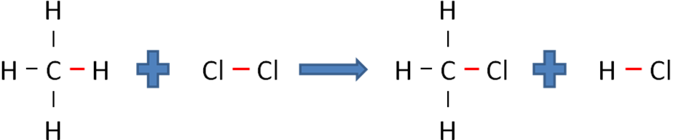

∑ΔHb  = (1 C-H) + (1 Cl-Cl) = 412 + 242 = 654 kJ mol-1

∑ΔHf  = (1 C-Cl) + (1 H-Cl) = 338 + 431 = 769 kJ mol-1

ΔH = ∑ΔHb - ∑ΔHf = 654 – 769 = -115 kJ mol-1

***Task: Calculate the enthalpy change for the following reaction   
(mean bond enthalpy values CGP103)***

N2(g) + 3H2(g) → 2NH3(g)

∑ΔHb  = (1 N≡N) + (3 H-H) = 945 + (3 x 436) = 2253 kJ mol-1

∑ΔHf  = (6 N-H) = (6 x 391) = 2346 kJ mol-1

ΔH = ∑ΔHb - ∑ΔHf = 2253 – 2346 = **-93 kJ mol-1**

***Task: Calculate the enthalpy change for the following reaction***

H2(g) + 1/2O2(g) → H2O(g)

∑ΔHb  = (1 H-H) + (1/2 O=O) = 436 + (1/2 x 498) = 685 kJ mol-1

∑ΔHf  = (2 O-H) = (2 x 464) = 928 kJ mol-1

ΔH = ∑ΔHb - ∑ΔHf = 685 – 928 = **-243 kJ mol-1**

***Starter: 6.4 – Using bond enthalpies Q1&2***

***CGP103 PQ1-4 (Q4 example of calculating mean bond enthalpy value)***

***Fact recall: CGP103 Q1-2***

***Sheet: Hess’s Law - Using bond enthalpies***

**Measuring enthalpy change**

Enthalpy changes in reactions can be measured using equipment called **calorimeters**. **Calor** is the Latin for **heat**, so a calorimeter is an instrument that allows **changes in heat to be measured**. Three things need to be known; temperature change, mass and number of moles of the substance.

There are various types:

* Simple calorimeter
* Flame calorimeter
* Bomb calorimeter

**Simple calorimeter** – it is assumed all the heat remains in the polystyrene cup or all the heat from the fuel goes into the water.

|  |  |
| --- | --- |
| For **solutions** or solids added to solutions a **polystyrene cup and lid** is used with a thermometer placed through the middle. The polystyrene cup and lid **prevent** too much **heat being lost** or **gained** during the reaction.  Sources of **errors**:   * **heat loss to the surroundings** (main error) * heat absorbed by the container |  |
|  |  |
| For **combustion** reactions in fuels then a **metal cup** is used, in which is placed a mass of water and the **heat released** from the buring fuel is **absorbed by the water** and the temperaure rise can be measured. The mass of fuel burnt is also measured. A ***heat shield*** is used to ***prevent heat lost*** to the surroundings.  Sources of **errors**:   * **heat loss to the surrounding** * heat loss to equipment * incomplete combustion * evaporation of volatile liquid |  |

To **minimise these errors** an improved calorimeter can be used for combustion reactions.

|  |  |
| --- | --- |
| **Flame** **colorimeter** – this improved version has these features to **reduce heat loss**:   * Spiral chimney made of copper * Flame enclosed by water to minimise heat loss * Fuel burns in pure oxygen rather than air to ensure complete combustion   **Bomb** **colorimeter** – this is the most accurate method. |  |
|  |  |

Types of errors

Errors in results can arise from different sources; they can be **random** or **systematic**.

**Random errors**

These cause reading to be **spread about the true value** due to results varying in an unpredictable way. They can‘t be corrected because they are random. These are minimised by repeating an experiment and finding the mean helps deal with random errors.

**Systematic**

These cause each **reading to be different to the true reading by the same amount**, they **shift all results**. They can be **caused by the set-up or the equipment being used**. For example a burette may actually measure 9.95 cm3 each time instead of 10.0 cm3. Repeating experiments won’t remove systematic errors the best way to **minimised** them is to make sure your **equipment is calibrated**. This means **checking** the reading of a piece of equipment **against a standard**.

Any measurement will have **errors** or **uncertainties** due to the **limits** of the **sensitivity** of the **equipment**. The error will be different for different pieces of equipment.

**% Apparatus error** = error or uncertainty x 100

reading

The experimental error can be calculated if the true value is known.

Ignore any negative signs

**% Experimental error** = experimental value - known value x 100

known value

***Sheet: Errors – Measuring enthalpy changes***

***Sheet: More on significant figures & precision – Measuring enthalpy changes***

Measuring enthalpy changes of combustion

The heat energy given out when the fuel burns is used to heat up a known volume of water.

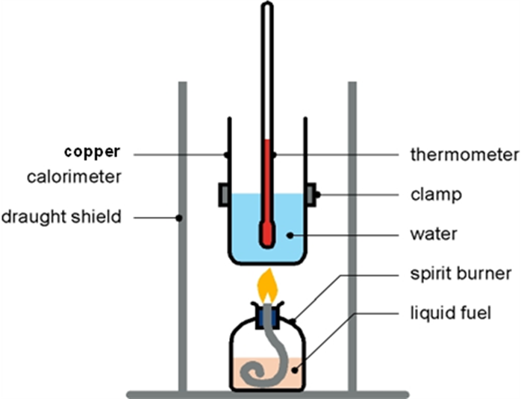

***Demo: Enthalpy change of combustion of ethanol***

***Prac: PSA9 - Enthalpy change of combustion***

***Notes: Calorimetry***

Measuring enthalpy changes using calorimetry

**Enthalpy change** is **heat** given **out** or taken **in** as a **reaction proceeds**. No instrument is able to measure this directly so the heat is transferred into a particular mass of a substance – water in the case of a fuel burning or a solution in other reactions. The **temperature change** can then be measured.

**Need to know 3 things:**

1. Mass of substance being heated up or cooled down, **m (g)**  
     
   N.B. This is the mass of solution or water being heated in combustion reactions
2. Specific heat capacity of the substance, **c** - amount of heat needed to raise the temperature of 1g of substance by 1K – units **J g-1 K-1**   
     
   **Specific heat capacity of water is 4.18 J g-1 K-1**

Since 1K = 1OC there is no need to convert Celsius to Kelvin when the temperature change is used.

1. Temperature change, **ΔT (K)**

The heat energy required to change the temperature of a substance can be calculated:

**Heat energy = mass of substance x specific heat capacity x temperature change**

N.B. Convert J to kJ (J x 10-3)

q = mcΔT units J

Volume water = mass

Density H2O = 1cm3 g-1

**Enthalpy change can then be calculated** from q, using:

Don’t round up too early!

ΔH = q/n units kJ mol-1

Method:

1. Calculate amount heat energy lost or gained

q = mcΔT   
Remember to convert to kJ (J x 10-3)

1. Calculate number of moles of fuel burnt or solution reacted

n = m/Mr or n = cv

1. Calculate enthalpy change

ΔH = q/nRemember to add a sign to q to show whether it is exothermic or endothermic

**Example: Combustion CGP105**

In an experiment, 1.16g of an organic liquid fuel was completely burnt in oxygen. The heat formed during the reaction raised the temperature of 100g of water from 295.3 K to 357.8 K. Calculate the standard enthalpy of combustion of the fuel. Its Mr is 58.0.

1. q = mcΔT

q = 100 x 4.18 x 62.5 = 26125 J so 26.125 kJ

1. n = m/Mr

n = 1.16 / 58.0 = 0.02 moles fuel

1. ΔH = q/n

ΔH = -26125 x 10-3 / 0.02 = **-1306.25 kJ mol-1** 3 s.f. Exothermic

The actual enthalpy of combustion for this fuel is -1615 kJ mol-1, so the experimental valise shows heat has been lost to the surrounding.

***Task: Calculate the experimental error & comment on the sources of error***

% Experimental error = experimental value - known value x 100

known value

% Experimental error = 1306 - 1615 x 100

1615

% Experimental error = **19.1%**

***Task: In an experiment, 1.00g methanol (CH3OH) was burned in air and the flame was used to heat 100g of water, which rose in temperature by 42.0oC. Give your answer to the appropriate number of significant figures.***

CH3OH(l) + 3/2O2(g) → CO2(g) + 2H2O(g)

Answer

q = mcΔT 100 x 4.18 x 42.0 = 17556 J 17.556 kJ

nCH3OH = m/Mr  1.00 / 32.0 = 0.03125 mol

ΔH = q/n -17556 x 10-3 / 0.031253 = **-562 kJ mol-1** 3 s.f.

**Example: Solution CGP106**

In an experiment, 50 cm3 of 1.0 mol dm-3 NaOH was added to 50 cm3 of 1.0 mol dm-3 HCl. The temperature rose by 6.9oC. Calculate the enthalpy change of neutralisation.

NaOH(aq) + HCl(aq) → NaCl + H2O

1. q = mcΔT N.B. Assume all solutions have the same specific heat capacity as water

q = 100 x 4.18 x 6.9 = 2884.2 J so 2.8842 kJ

1. n = cv

n = 1.0 x 50 x 10-3 = 0.05 moles

1. ΔH = q/n

ΔH = -2.8842 x 10-3 / 0.05 = **-58 kJ mol-1** 2 s.f. Exothermic

***Task: In an insulated container, 50 cm3 of 2.00 mol dm-3 HCl at 293 K were added to 50.0 cm3 of 2.00 mol dm-3 NaOH also at 293K. After reaction, the temperature of the mixture rose to 307 K. Give your answer to the appropriate number of significant figures.***

HCl(aq) + NaOH(aq) → NaCl(aq) + H2O(l)

Answer

q = mcΔT 100 x 4.18 x (307-293) = 5852 J 5.852 kJ

n = cv 2.00 x 50.0 x 10-3 = 0.100 mol

ΔH = q/n -5.852 x 10-3 / 0.100 = **-58.5 kJ mol-1** 3 s.f.

***CGP107 PQ1-3***

***Fact recall: CGP107 Q1-4***

***Sheet: Calorimetry calculations***

Measuring enthalpy changes of reactions in solution

The heat generated in the solution when they react is measured. It has to be **kept in the container** so **polystyrene** cups are often used as they are **good insulators** and have a **low heat capacity** so **absorb very little** themselves. The **specific heat capacity** of **solutions** is usually taken as that for **water**.

|  |  |
| --- | --- |
| **Some heat** will still be **lost** from the sides and top. This can be allowed for by **plotting a cooling curve**. Before the experiment all the solutions are stood in the lab to ensure they are the same temperature, then during the experiment:   * Take the **temperature** of the solution at the **start** to confirm it is at room temperature * Record **temperatures** at time intervals for a period of time **as it** **cools** * **Extrapolate** back to find **best estimate** of the **temperature** immediately **after reacting** |  |

***Required practical 2:*** Enthalpy change

***Starter: 6.2 – Calorimetry***

**Hess’s Law**

The **enthalpy change in some reactions can’t be measured directly**, so an **indirect** **approach** must be **used**. So enthalpy changes that can be measured are used to calculate those that cannot. Enthalpy changes that can be **easily measured** are **enthalpy of combustion** and **enthalpy of formation**.

This is based on the 1st law of thermodynamics.

***Definition***: **First law of thermodynamics** states that energy cannot be created or destroyed it can **only be converted from one form to another**.

A Swiss born Russian called Germain Hess used this to developed Hess’s law.

***Definition***: **Hess’s law** states that the enthalpy change of a reaction **depends only on the initial and final states of the reaction** and is **independent of the route** by which the reaction occurs.

This means that providing the **starting** and **finish points** are the **same** the **energy change** must be the **same**.

|  |  |
| --- | --- |
| So **ΔHroute 1 = So ΔHroute 2** |  |

By showing the different routes in a reaction a **thermochemical cycle** can be produced.

|  |  |
| --- | --- |
|  | If they **cycle follows the arrow** the enthalpy **values** are **added**, as in this example. |
|  |  |
|  | If they **cycle goes against the direction of the arrow** the enthalpy **values** are **taken away**, as in this example. |
|  |  |
|  | Or this example. |

**Example** – ethyne (C2H2) converted to ethane (C2H6) by 2 routes

Route 1: Direct C2H2 (g) + 2H2 (g) → C2H6 (g) ΔH1 = ?

Route 2: Two steps a C2H2 (g) + H2 (g) → C2H4 (g) ΔH2 = -176 kJ mol-1

b C2H4 (g) + H2 (g) → C2H6 (g) ΔH3 = -137 kJ mol-1

|  |  |
| --- | --- |
| Thermochemical cycle: |  |

Another way of representing the energy changes associated with the different routes is to use an **enthalpy diagram** or **energy level diagram**.

|  |  |
| --- | --- |
| Enthalpy diagram or energy level diagram: |  |

***Task: Use Hess’s Law to calculate the enthalpy change for route 1 of the reaction shown.***

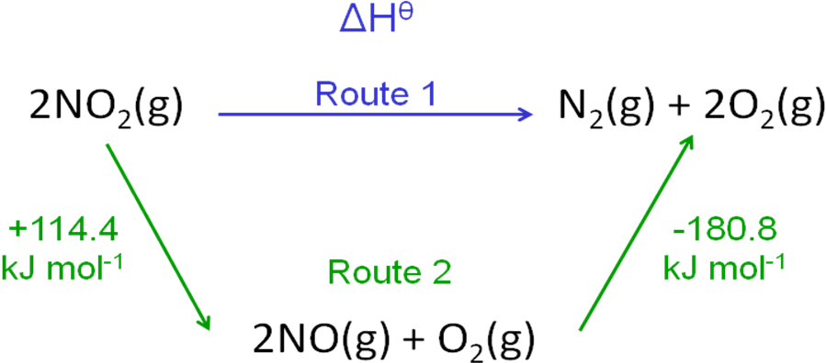

Route 1 = Route 2

∆Hθ = (+114.4) + (-180.8) = **-66.4 kJ mol-1**

By using enthalpy changes that can be **easily measured**, such as the **enthalpy of combustion** and the **enthalpy of formation** the enthalpy change of any reaction can be calculated.

**Using enthalpy of formation, ΔHθf**

***Definition***: **Standard enthalpy of formation** **ΔHθf** is the enthalpy change, under standard conditions, when **1 mole** of compound is **formed from its elements**, with all **reactants and products in their standard states.**

E.g. C(s) + 2H2(g) → CH4(g)

For **any reaction** a **theoretical alternative route** could be **via** the **formation** of the **reactants** and **products** **from** their **elements**.

For elements the enthalpy of formation is zero, **ΔHθf (elements) = 0**

|  |  |
| --- | --- |
|  | Use this method when the **data given is enthalpy of formation**  N.B. Both arrows go **up**  ΔHθ = - ∑ΔHθf (reactants) + ∑ΔHθf (products) |

**Learn**: **ΔHθ = ∑ΔHθf (products) - ∑ΔHθf (reactants)**

**Example**

Calculating the standard enthalpy for the reaction:

3CO (g) + Fe2O3 (s) → 2Fe (s) + 3CO2 (g)

Enthalpy values:

3C (s) + 1½ O2 (g) → 3CO (g) ΔHθf = 3 x -111 kJ mol-1

3/2O2 (g) + 2Fe (s) → Fe2O3 (s) ΔHθf = -822 kJ mol-1

3C (s) + ½ O2 (g) → 3CO2 (g) ΔHθf = 3 x -394 kJ mol-1

Fe(s) ΔHθf = 0 (element)

|  |  |
| --- | --- |
| Thermochemical cycle: | Enthalpy diagram |
|  |  |

Calculation:

ΔHθ = ∑ΔHθf (products) - ∑ΔHθf (reactants)

ΔHθ = (3 x -394) – ((3 x -111) + (-822))

= (-1182) – (-1155)

**= -27 kJ mol-1**

***Task: Calculate ΔHθ for this reaction using the data given***

|  |  |  |
| --- | --- | --- |
| SO2(g) + 2H2S(g) → 3S(s) + 2H2O(l) | **Compound** | **ΔHθf / kJ mol-1** |
| SO2(g) | -297 |
| H2S(g) | -20.6 |
| H2O(l) | -286 |

Thermochemical cycle:

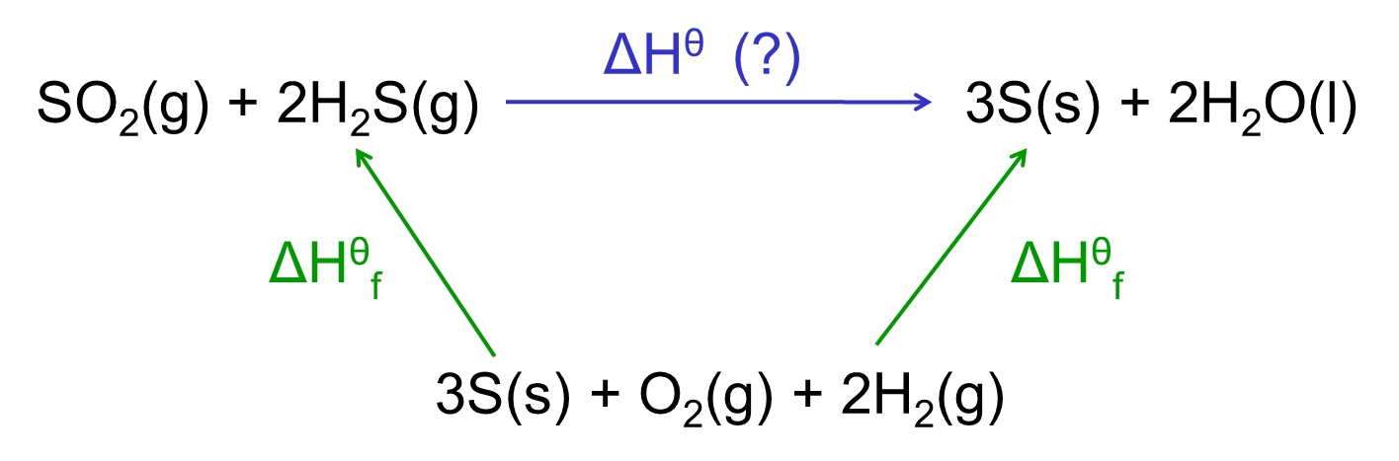

Calculation:

ΔHθ = ∑ΔHθf (products) - ∑ΔHθf (reactants)

(2 x -286) - [(-297) + (2 x -20.6)] = (-572) – (-338.2) = **-233.8 kJ mol-1**

***Sheet: Hess’s Law - Using enthalpy of formation***

**Using enthalpy of combustion, ΔHθc**

***Definition***: **Standard enthalpy of combustion** **ΔHθc** is the enthalpy change, under standard conditions, when **1 mole** of substance is **burned completely in oxygen**, with all **reactants and products in their standard states.**

E.g. CH4(g) + 2O2(g) → CO2(g) + 2H2O(l)

For **any reaction** a **theoretical alternative route** could be **via** the **combustion** of the **reactants** and **products**.

**Example: Combustion of a compound**

N.B. 1 mole of compound burnt

CH4(g) + 2O2(g) → CO2(g) + H2O(l) ΔHθc = -890 kJ mol-1

|  |  |
| --- | --- |
|  | Use this method when the **data given is enthalpy of combustion**  N.B. Both arrows go **down**  ΔHθ = ∑ΔHθf (reactants) - ∑ΔHθf (products) |

**Learn**: **ΔHθ = ∑ΔHθc(reactants) - ∑ΔHθc(products)**

**Example**

Calculating the standard enthalpy of formation of methane from enthalpy of combustion

Enthalpy values:

CH4 (g) + 2O2 (g) → CO2 (g) + 2H2O (g) ΔHθc = -890 kJ mol-1

C (s) + O2 (g) → CO2 (g) ΔHθc = -393 kJ mol-1

2H2 (g) + O2 (g) → 2H2O (g) ΔHθc = 2 x -285 kJ mol-1

|  |  |
| --- | --- |
| Thermochemical cycle: | Enthalpy diagram |
|  |  |

Calculation:

ΔHθ = ∑ΔHθc (reactants) - ∑ΔHθc (products)

ΔHθ = (2 x -285) + (-393) - (-890)

= **-73 kJ mol-1**

***Task: Calculate ΔHθf of ethanol using the data given***

|  |  |  |
| --- | --- | --- |
| 2C(s) + 3H2(g) + 1/2O2(g) → C2H5OH(l) | **Substance** | **ΔHθc / kJ mol-1** |
| C(s) | -394 |
| H2(g) | -286 |
| C2H5OH(l) | -1367 |

Thermochemical cycle:

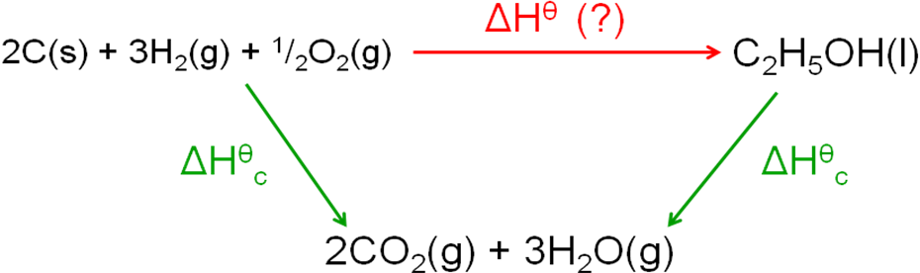

Calculation:

ΔHθ = ∑ΔHθc (reactants) - ∑ΔHθc (products)

[(2 x -394) + (3 x -286)] - (-1367) = (-1646) – (-1367) = **-279 kJ mol-1**

***CGP107 PQ1-3***

***Starter: 6.1 – Definitions***

***Starter: 6.3 – Hess’s law***

***Sheet: Hess’s Law - Using enthalpy of combustion***

***Sheet: Enthalpy calculations***

***Sheet: Energetics PPQ 1-5***

***Homework: Oxford p94-95 EPQ1-4***