**Iliad Book 8 – The Gods**

*Around the pictures of the gods and goddesses, write down what roles they play in this book. Between them, you can draw arrows and label them to show how they interact with one another:*

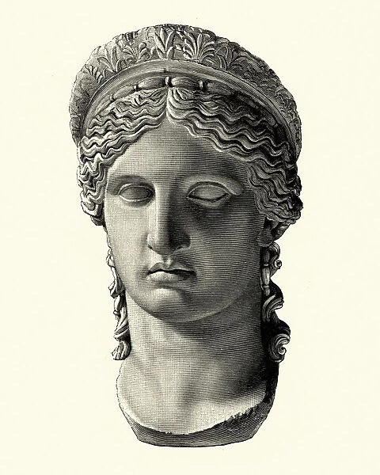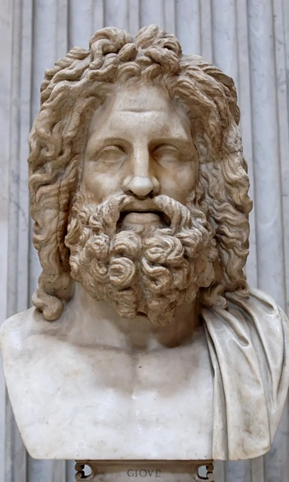

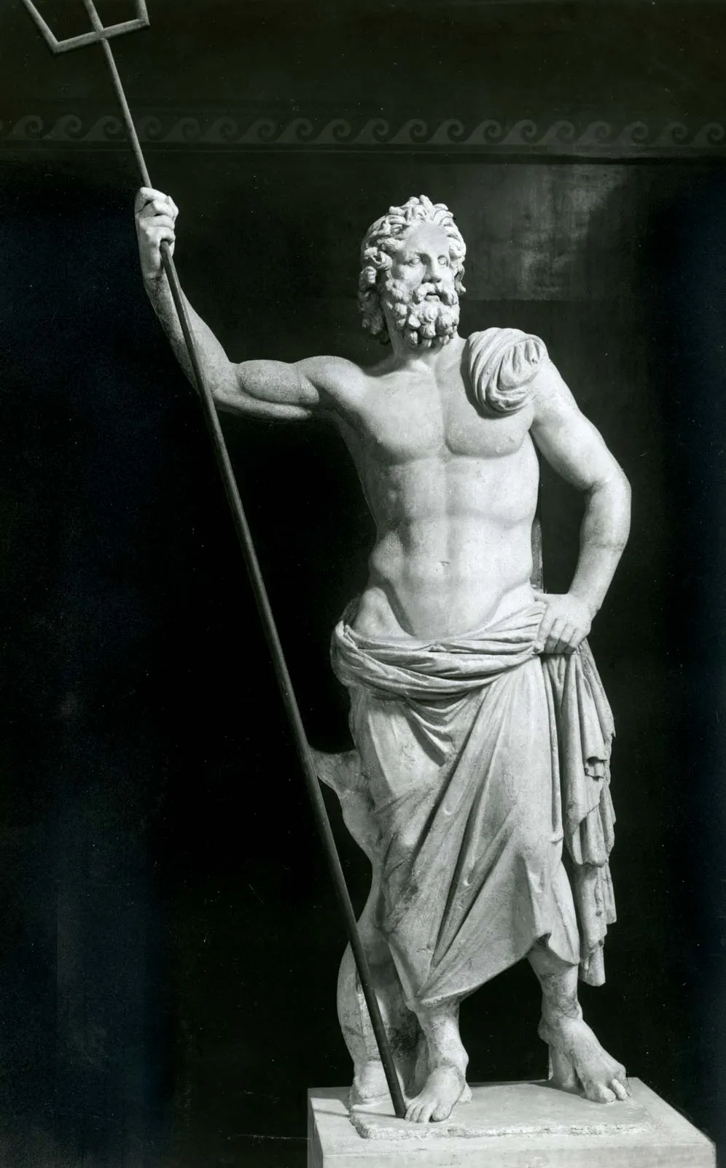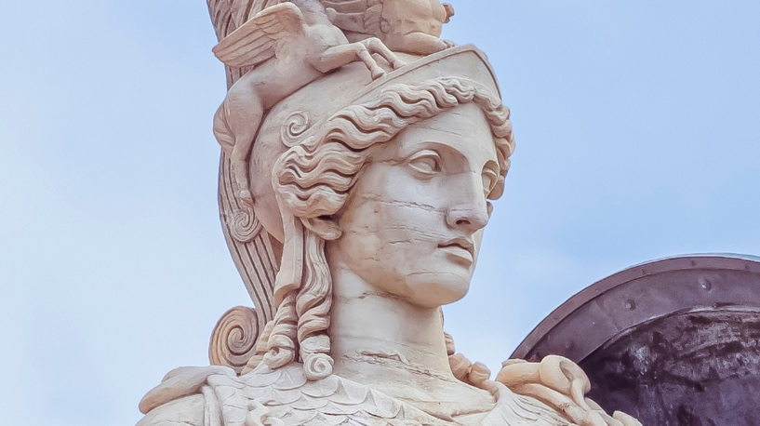

**Poseidon**

**Athena**

**Hera**

**Zeus**