Gateways School

**Amines & Amino acids &   
Polymers & DNA**

**Revision PPQ**

51 marks

**Name: ______________________________ Date: __________**

**Q1.**

(a)     The compound H2C=CHCN is used in the formation of acrylic polymers.

(i)      Draw the repeating unit of the polymer formed from this compound.

(ii)     Name the type of polymerisation involved in the formation of this polymer.

______________________________________________________________

**(2)**

(b)     When the dipeptide shown below is heated under acidic conditions, a single amino acid is produced.



(i)      Name this amino acid.

______________________________________________________________

(ii)     Draw the structure of the amino acid species present in the acidic solution.

**(2)**

(c)     The repeating unit of a polyester is shown below.



(i)      Deduce the empirical formula of the repeating unit of this polyester.

______________________________________________________________

(ii)     Draw the structure of the acid which could be used in the preparation of this polyester and give the name of this acid.

*Structure* ______________________________________________________

*Name* ________________________________________________________

(iii)     Give **one** reason why the polyester is biodegradable.

______________________________________________________________

______________________________________________________________

**(4)**

**(Total 8 marks)**

**Q2.**

(a)     Methylamine is a weak Brønsted-Lowry base and can be used in aqueous solution with one other substance to prepare a basic buffer.

(i)      Explain the term *Br*ø*nsted-Lowry base* and write an equation for the reaction of methylamine with water to produce an alkaline solution.

*Brønsted-Lowry base* ____________________________________________

*Equation* ______________________________________________________

(ii)     Suggest a substance that could be added to aqueous methylamine to produce a basic buffer.

______________________________________________________________

(iii)     Explain how the buffer solution in part (a)(ii) is able to resist a change in pH when a small amount of sodium hydroxide is added.

______________________________________________________________

______________________________________________________________

______________________________________________________________

**(5)**

(b)     Explain why methylamine is a stronger base than ammonia.

___________________________________________________________________

___________________________________________________________________

___________________________________________________________________

**(2)**

(c)     A cation is formed when methylamine reacts with a large excess of bromoethane. Name the mechanism involved in the reaction and draw the structure of the cation formed.

*Name of mechanism* __________________________________________________

*Structure*

**(2)**

**(Total 9 marks)**

**Q3.**

The amide or peptide link is found in synthetic polyamides and also in naturally  
occurring proteins.

(a)     (i)      Draw the repeating unit of the polyamide formed by the reaction of propanedioic acid with hexane-1,6-diamine.

**(2)**

(ii)     In terms of the intermolecular forces between the polymer chains, explain why polyamides can be made into fibres suitable for use in sewing and weaving, whereas polyalkenes usually produce fibres that are too weak for this purpose.

______________________________________________________________

______________________________________________________________

______________________________________________________________

______________________________________________________________

______________________________________________________________

______________________________________________________________

**(3)**

(b)     (i)      Name and outline a mechanism for the reaction of CH3CH2COCl with CH3NH2

Name of mechanism ____________________________________________

Mechanism

**(5)**

(ii)     Give the name of the product containing an amide linkage that is formed in the reaction in part (b) (i).

______________________________________________________________

**(1)**

(c)     The dipeptide shown below is formed from two different amino acids.

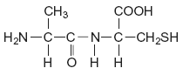

Draw the structure of the alternative dipeptide that could be formed by these two amino acids.

**(1)**

(d)     The amino acids serine and aspartic acid are shown below.

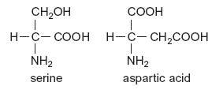

(i)      Give the IUPAC name of serine.

______________________________________________________________

**(1)**

(ii)     Draw the structure of the species formed when aspartic acid reacts with aqueous sodium hydroxide.

**(1)**

(iii)     Draw the structure of the species formed when serine reacts with dilute hydrochloric acid.

**(1)**

(iv)    Draw the structure of the species formed when serine reacts with an excess of bromomethane.

**(1)**

**(Total 16 marks)**

**Q4.**

(a)     Synthetic polyamides are produced by the reaction of dicarboxylic acids with compounds such as H2N(CH2)6NH2

(i)      Name the compound H2N(CH2)6NH2

______________________________________________________________

(ii)     Give the repeating unit in the polyamide nylon 6,6.

______________________________________________________________

**(2)**

(b)     Synthetic polyamides have structures similar to those found in proteins.

(i)      Draw the structure of 2-aminopropanoic acid.

(ii)     Draw the organic product formed by the condensation of two molecules of 2-aminopropanoic acid.

**(2)**

(c)     Compounds like H2N(CH2)6NH2 are also used to make ionic compounds such as **X**, shown below.

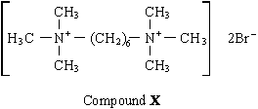

(i)      **X** belongs to the same type of compound as (CH3)4N+Br–Name this **type** of compound.

______________________________________________________________

(ii)     State a reagent which could produce **X** from H2N(CH2)6NH2 and give a necessary condition to ensure that **X** is the major product.

*Reagent* _______________________________________________________

*Condition* ______________________________________________________

(iii)     Name the mechanism involved in this reaction to form **X**.

______________________________________________________________

**(4)**

**(Total 8 marks)**

**Q5.**

The anticancer drug cisplatin operates by reacting with the guanine in DNA.

**Figure 1** shows a small part of a single strand of DNA. Some lone pairs are shown.

**Figure 1**

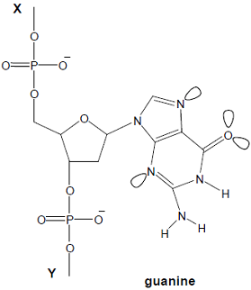

(a)     The DNA chain continues with bonds at **X** and **Y**.

State the name of the sugar molecule that is attached to the bond at **X**.

___________________________________________________________________

**(1)**

(b)     Messenger RNA is synthesised in cells in order to transfer information from DNA. The bases in one strand of DNA pair up with the bases used to synthesise RNA.

**Figure 2** shows two bases used in RNA.

**Figure 2**

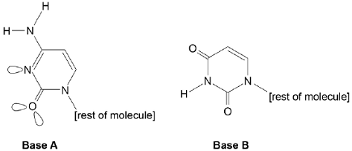

Suggest which of the bases **A** and **B** forms a pair with guanine in **Figure 1** when messenger RNA is synthesised.  
Explain how the base that you have chosen forms a base pair with guanine.

___________________________________________________________________

___________________________________________________________________

___________________________________________________________________

___________________________________________________________________

___________________________________________________________________

___________________________________________________________________

___________________________________________________________________

___________________________________________________________________

**(4)**

(c)     Cisplatin works because one of the atoms on guanine can form a co-ordinate bond with platinum, replacing one of the ammonia or chloride ligands. Another atom on another guanine can also form a co-ordinate bond with the same platinum by replacing another ligand.

On **Figure 1**, draw a ring round an atom in guanine that is likely to bond to platinum.

**(1)**

(d)     An adverse effect of cisplatin is that it also prevents normal healthy cells from replicating.

Suggest **one** way in which cisplatin can be administered so that this side effect is minimised.

___________________________________________________________________

___________________________________________________________________

___________________________________________________________________

**(1)**

**(Total 7 marks)**

**Q6.**

A drug is designed to simulate one of the following molecules that adsorbs onto the active site of an enzyme.

Which molecule requires the design of an optically active drug?

**A**                            

**B**                        

**C**                        

**D**                       

**(Total 1 mark)**

**Q7.**

Terylene is made by reacting benzene-1,4-dicarboxylic acid and ethane-1,2-diol.

Terylene is

**A**       an addition polymer.

**B**       a polyamide.

**C**       a polyester.

**D**       a nylon.

**(Total 1 mark)**

**Q8.**

The correct name for the alkene monomer which forms the polymer shown below is

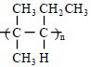

**A**       2-methyl-3-ethylpropene

**B**       2-methylpent-2-ene

**C**       2-methylpent-3-ene

**D**       4-methylpent-2-ene

**(Total 1 mark)**