Gateways School

**Synthesis & NMR & Chromatography**

**Revision PPQ**

50 marks

**Name: ______________________________ Date: __________**

**Q1.**

N.m.r. spectroscopy can be used to study the structures of organic compounds.

(a)     Compound **J** was studied using 1H n.m.r. spectroscopy.

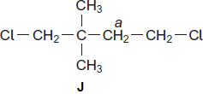

(i)      Identify a solvent in which **J** can be dissolved before obtaining its 1H n.m.r. spectrum.

______________________________________________________________

**(1)**

(ii)     Give the number of peaks in the 1H n.m.r. spectrum of **J**.

______________________________________________________________

**(1)**

(iii)    Give the splitting pattern of the protons labelled *a*.

______________________________________________________________

**(1)**

(iv)    Give the IUPAC name of **J**.

______________________________________________________________

**(1)**

(b)     Compound **K** was studied using 13C n.m.r. spectroscopy.

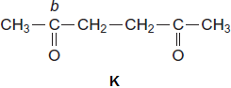

(i)      Give the number of peaks in the 13C n.m.r. spectrum of **K**.

______________________________________________________________

**(1)**

(ii)     Use **Table 3** on the Data Sheet to suggest a δ value of the peak for the carbon labelled *b*.

______________________________________________________________

**(1)**

(iii)    Give the IUPAC name of **K**.

______________________________________________________________

**(1)**

**(Total 7 marks)**

**Q2.**

This question concerns isomers of C6H12O2 and how they can be distinguished using n.m.r. spectroscopy.

(a)     The non-toxic, inert substance TMS is used as a standard in recording both 1H and 13C n.m.r. spectra.

(i)      Give **two** other reasons why TMS is used as a standard in recording n.m.r. spectra.

Reason 1 ______________________________________________________

______________________________________________________________

Reason 2 ______________________________________________________

______________________________________________________________

**(2)**

(ii)     Give the structural formula of TMS.

**(1)**

(b)     The proton n.m.r. spectrum of compound **P** (C6H12O2) is represented in **Figure 1**.

**Figure 1**

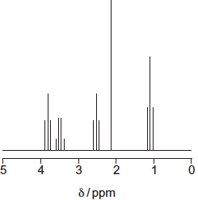

The integration trace gave information about the five peaks as shown in **Figure 2**.

**Figure 2**

|  |  |  |  |  |  |
| --- | --- | --- | --- | --- | --- |
| δ / ppm | 3.8 | 3.5 | 2.6 | 2.2 | 1.2 |
| Integration ratio | 2 | 2 | 2 | 3 | 3 |

(i)      Use **Table 2** on the Data Sheet, **Figure 1** and **Figure 2** to deduce the structural fragment that leads to the peak at δ 2.2.

**(1)**

(ii)     Use **Table 2** on the Data Sheet, **Figure 1** and **Figure 2** to deduce the structural fragment that leads to the peaks at δ 3.5 and 1.2.

**(1)**

(iii)    Use **Table 2** on the Data Sheet, **Figure 1** and **Figure 2** to deduce the structural fragment that leads to the peaks at δ 3.8 and 2.6.

**(1)**

(iv)    Deduce the structure of **P**.

**(1)**

(c)     These questions are about different isomers of **P** (C6H12O2).

(i)      Draw the structures of the two esters that both have only two peaks in their proton n.m.r. spectra. These peaks both have an integration ratio of 3:1.

Ester 1

Ester 2

**(2)**

(ii)     Draw the structure of an optically active carboxylic acid with five peaks in its 13C n.m.r. spectrum.

**(1)**

(iii)    Draw the structure of a cyclic compound that has only two peaks in its 13C n.m.r. spectrum and has no absorption for C = O in its infrared spectrum.

**(1)**

**(Total 11 marks)**

**Q3.**

(a)     A chemist discovered four unlabelled bottles of liquid, each of which contained a different pure organic compound. The compounds were known to be propan-1-ol, propanal, propanoic acid and 1-chloropropane.

Describe four **different** test-tube reactions, one for each compound, that could be used to identify the four organic compounds.  
Your answer should include the name of the organic compound, the reagent(s) used and the expected observation for each test.

___________________________________________________________________

___________________________________________________________________

___________________________________________________________________

___________________________________________________________________

___________________________________________________________________

___________________________________________________________________

___________________________________________________________________

___________________________________________________________________

___________________________________________________________________

___________________________________________________________________

___________________________________________________________________

___________________________________________________________________

**(8)**

(b)     A fifth bottle was discovered labelled propan-2-ol. The chemist showed, using infrared spectroscopy, that the propan-2-ol was contaminated with propanone.

The chemist separated the two compounds using column chromatography. The column contained silica gel, a polar stationary phase.

The contaminated propan-2-ol was dissolved in hexane and poured into the column.  
Pure hexane was added slowly to the top of the column. Samples of the eluent (the solution leaving the bottom of the column) were collected.

•        Suggest the chemical process that would cause a sample of propan-2-ol to become contaminated with propanone.

•        State how the infrared spectrum showed the presence of propanone.

•        Suggest why propanone was present in samples of the eluent collected first (those with shorter retention times), whereas samples containing propan-2-ol were collected later.

___________________________________________________________________

___________________________________________________________________

___________________________________________________________________

___________________________________________________________________

___________________________________________________________________

___________________________________________________________________

___________________________________________________________________

___________________________________________________________________

___________________________________________________________________

**(4)**

**(Total 12 marks)**

**Q4.**

Synthetic dyes can be manufactured starting from compounds such as 4-nitrophenylamine.

A synthesis of 4-nitrophenylamine starting from phenylamine is shown below.

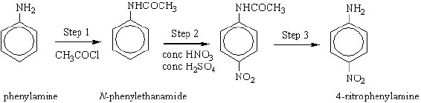

(a)     An equation for formation of *N*-phenylethanamide in Step 1 of the synthesis is shown below.

2C6H5NH2 +   CH3COCl   →   C6H5NHCOCH3   +   C6H5NH3Cl  
*N*-phenylethanamide

(i)      Calculate the % atom economy for the production of *N*-phenylethanamide  
(*M*r = 135.0).

______________________________________________________________

______________________________________________________________

______________________________________________________________

______________________________________________________________

______________________________________________________________

______________________________________________________________

**(3)**

(ii)     In a process where 10.0 kg of phenylamine are used, the yield of *N*-phenylethanamide obtained is 5.38 kg.

Calculate the percentage yield of *N*-phenylethanamide.

______________________________________________________________

______________________________________________________________

______________________________________________________________

______________________________________________________________

**(2)**

(iii)     Comment on your answers to parts (i) and (ii) with reference to the commercial viability of the process.

______________________________________________________________

______________________________________________________________

______________________________________________________________

______________________________________________________________

**(2)**

(b)     Name and outline a mechanism for the reaction in Step 1.

___________________________________________________________________

___________________________________________________________________

___________________________________________________________________

___________________________________________________________________

___________________________________________________________________

___________________________________________________________________

___________________________________________________________________

___________________________________________________________________

___________________________________________________________________

___________________________________________________________________

**(5)**

(c)     The mechanism of Step 2 involves attack by an electrophile. Write an equation showing the formation of the electrophile. Outline a mechanism for the reaction of this electrophile with benzene.

___________________________________________________________________

___________________________________________________________________

___________________________________________________________________

___________________________________________________________________

___________________________________________________________________

___________________________________________________________________

___________________________________________________________________

___________________________________________________________________

**(4)**

**(Total 16 marks)**

**Q5.**

How many peaks will be observed in the low-resolution proton n.m.r. spectrum of (CH3)2CHCOO(CH2)3CH3?

**A**       4

**B**       5

**C**       6

**D**       7

**(Total 1 mark)**

**Q6.**

This question concerns the preparation of the plastic poly(methyl 2-methylpropenoate) (*Perspex*), starting from propanone.

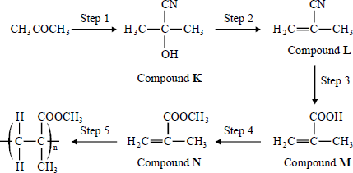

Which one of the following sets of reagents is **not** suitable for the step indicated?

**A**       Step 1 HCN (NaCN then dilute HCl)

**B**       Step 2 hot ethanolic KOH

**C**       Step 3 warm aqueous H2SO4

**D**       Step 4 CH3OH with an acid catalyst

**(Total 1 mark)**

**Q7.**

Propene reacts with hydrogen bromide to form a mixture of saturated organic products. The proton n.m.r. spectrum of the major organic product has

**A**       3 peaks with relative intensities 3 : 2 : 2

**B**       2 peaks with relative intensities 3 : 4

**C**       3 peaks with relative intensities 3 : 1 : 3

**D**       2 peaks with relative intensities 6 : 1

**(Total 1 mark)**

**Q8.**

Which one of the following types of reaction mechanism is **not** involved in the above sequence?

CH3CH2CH3   (CH3)2CHCl   (CH3)2CHCN



     (CH3)2CHCH2NHCOCH3   (CH3)2CHCH2NH2

**A**       free-radical substitution

**B**       nucleophilic substitution

**C**       elimination

**D**       nucleophilic addition-elimination

**(Total 1 mark)**