**The Odyssey – Book 19**

**Read lines 1-52**

Compare Odysseus’ plan in book 16 to its execution here:

|  |  |
| --- | --- |
| Plan | Reality |
| Odysseus will give a nod to signal to Telemachus |  |
| Telemachus will remove all the weapons from the hall |  |
| Telemachus will use the excuses given to him by Odysseus to fob off the suitors. |  |
| Some of the weapons will be left behind for Odysseus and Telemachus to use. |  |

Why do you think these two sections differ?

How do Odysseus and Telemachus use cunning in this passage?

The parallel lines 1-2 and 51-52 are called a ***ring-composition***. Why do you think this is and why is it used here?

**Read lines 53-99**

Collect quotes that show the ominous sense of irony surrounding Melantho:

|  |  |
| --- | --- |
| Quote | Explanation |
|  |  |
|  |  |
|  |  |
|  |  |
|  |  |

**Read lines 100-172**

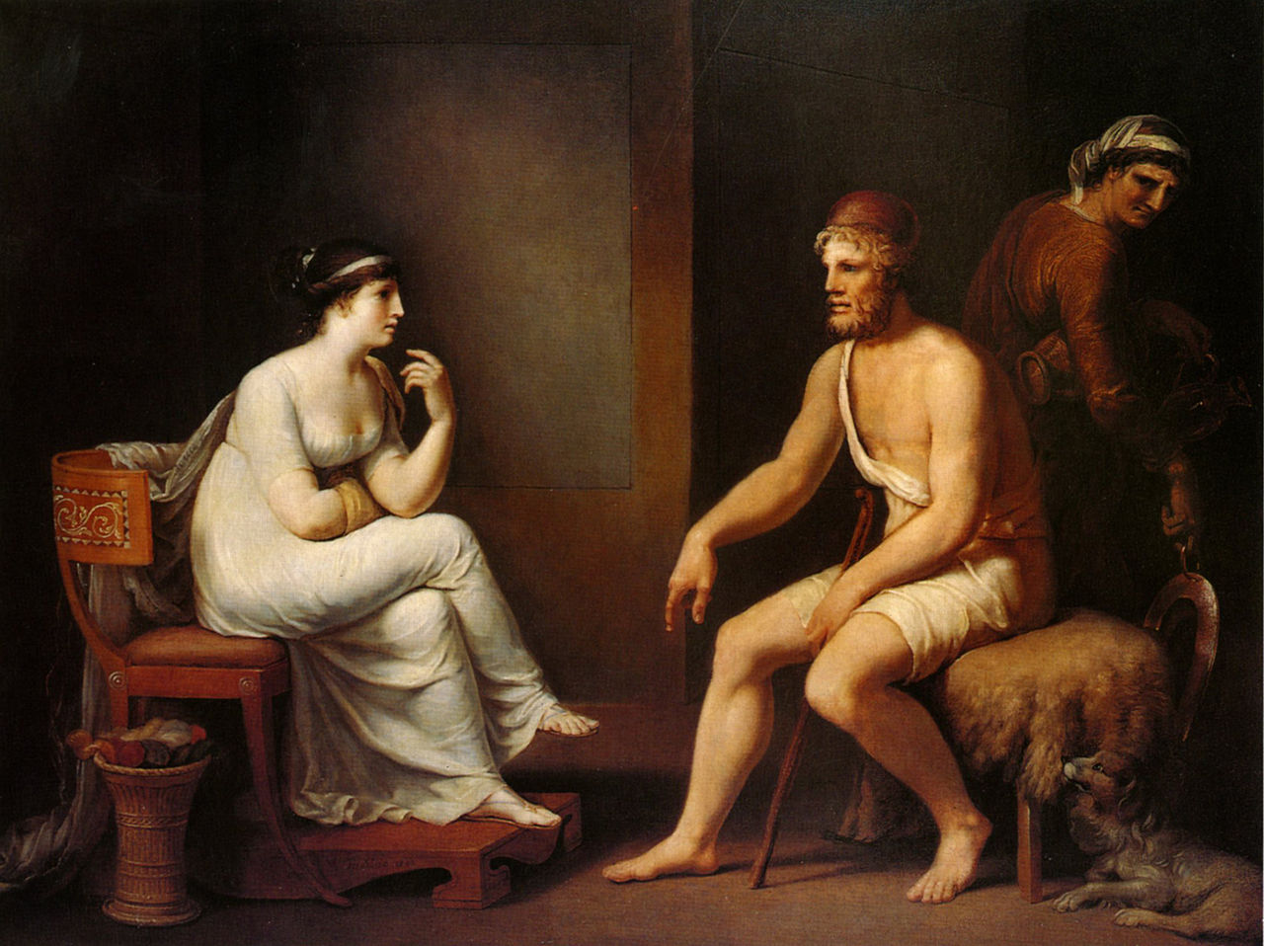How do both Odysseus and Penelope use their intelligence when conversing with one another?

Why does Homer yet again delay the response to the initial question?

**Read lines 173-307**

Create a mini family-tree for Odysseus’ invented identity.

What three things does Odysseus receive in the story?



What is the irony of this tale?

What tool does Homer use to create pathos (i.e. emotion in the audience) and irony? Support this with a quote.

What do we learn about the items Odysseus possesses?

|  |  |  |
| --- | --- | --- |
| Item | Description | Who gave it to him? |
| Cloak |  |  |
| Brooch |  |  |
| Tunic |  |  |
| Sword |  |  |
| Mantle |  |  |
| Tunic |  |  |

What is the irony of Odysseus’ luxurious garb in this account?

Find quotations that support Odysseus’ accumulation of wealth. How do we already know Penelope shares this interest?

**Read lines 308-385**

Select adjectives to describe these three characters from the word bank below. Give a quote to support each one.

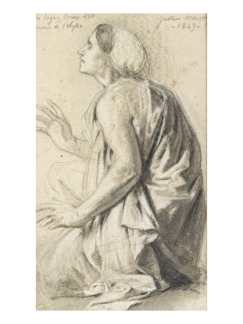

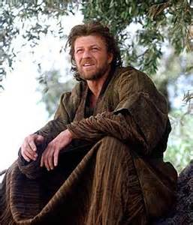

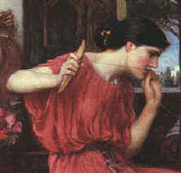

**hospitality loyal intelligent**

**hardy understanding**

How does Eurycleia’s speech add irony to the scene?

**Read lines 386-466**

Complete a mini family-tree for the real Odysseus:

What aspects of this passage preclude Odysseus’ *metis* (cunning)?



Annotate the tale of the boar hunt

There is another ring-composition with lines 393-4 and 464-6. Why has Homer used this?

**Read lines 467-507**

Use this passage to show how Odysseus and Eurycleia resume a master-servant relationship

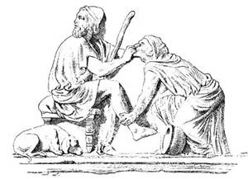

**Read lines 508-603**

Why does Penelope trust Odysseus at this point?



Why is the simile of Pandareus’ daughter (Aedon) appropriate?

Now that Telemachus has grown up, what are Penelope’s options?

What do the following represent in Penelope’s dream?

|  |  |
| --- | --- |
| The geese |  |
| The grain |  |
| The eagle |  |
| Swooping down |  |

What two interpretations are possible?

1. ivory gate =
2. horn gate =

What test does Penelope propose for the suitors?

Why does she do this?

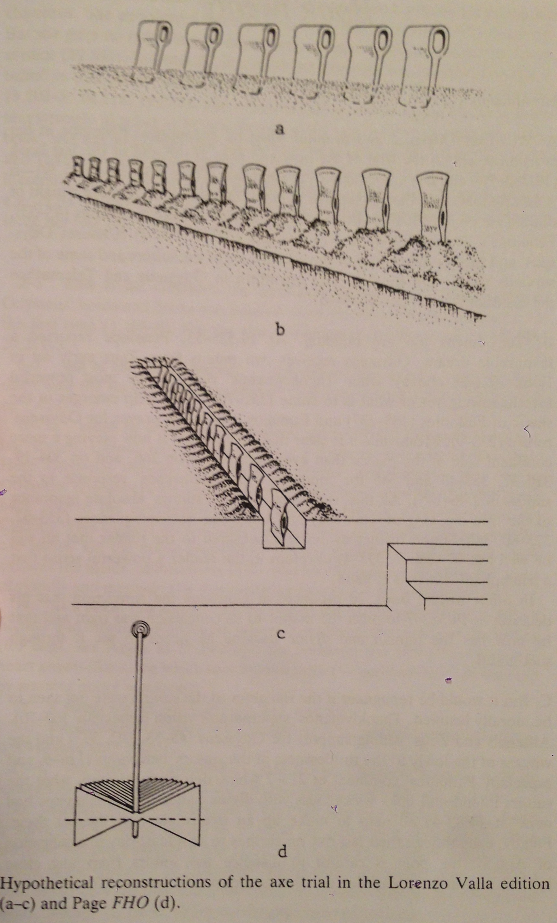**Appendix A – The Axe Trial**

**Appendix B – The Penelope-Odysseus Conspiracy**

Analysts have seen books 18 and 19 as signs of another version of the Odyssey, where Penelope is aware of Odysseus’ identity and plots with him. They claim the following make more sense in this setting:

* Penelope appears to be tricking the suitors to gain gifts (18.281-3)
* Odysseus asks to be bathed by the one woman who could recognise him! (19.344-8)
* The axe trial is set up just when there are signs Odysseus will return.

Do you think this suggests multiple authors? Or is there any reason for an oral poet leaving these aspects in?