**This is a collection of stand alone Pure Mathematics practice questions written as an additional resource for the GCE 2017 Mathematics specification.**



* There are **19 questions** in this document.
* The marks for each question are shown in brackets.
* The questions are ramped in order of difficulty.
* Mark schemes can be found in the accompanying document on the Pearson website and Emporium.

This **is not** an exam paper so there is no time allocation or a set number of total marks. Teachers can use the questions as they wish to support teaching and learning. If any of the questions are being set as a test, students should be advised to follow the standard guidance for A Level Mechanics exams:

**Instructions**

* Use black ink or ball-point pen.
* If a pencil is used for diagrams/sketches/graphs it must be dark (HB or B).
* You should show sufficient working to make your methods clear. Answers without working may not gain full credit.
* Answers should be given to three significant figures unless otherwise stated.

**Information**

* The marks for each question are shown in brackets - use this as a guide as to how much time to spend on each question.

**Advice**

* Read each question carefully before you start to answer it.
* Try to answer every question.
* Check your answers if you have time at the end.

**Answer ALL questions.**

**1.** Given that

arcsin *x* = arcos (*y* – 2)

show that

*x*2 + *y*2 – 4*y* + *k* = 0

where *k* is a constant to be found.

**(Total for Question 1 is 4 marks)**

**___________________________________________________________________________**

**2.** (i) Using algebra, prove that for all real values *x*

(*x* – 2)2 > 8*x* – 33 + 2 sin *x* cos *x*

(4)

(ii) You are given the following information:

* *x* ∈ ℤ+, *y* ∈ ℝ

* *x* + ⎪*y*⎪ = 6

Prove by exhaustion that “the product of *x* and *y* is always between 10 and –10”

(2)

**(Total for Question 2 is 6 marks)**

**___________________________________________________________________________**

**3.** (a) Prove, by counter example, that the sum of two irrational numbers is not always irrational.

(2)

(b) Prove by contradiction that the sum of a rational number and an irrational number must be irrational.

(4)

**(Total for Question 3 is 6 marks)**

**___________________________________________________________________________**

**4. In this question you must show detailed reasoning**

Given that *θ* is small and is measured in radians,

(a) use the small angle approximations to find an approximate value of



(3)

(b) Hence or otherwise, find an approximate value of



(2)

**(Total for Question 4 is 5 marks)**

**___________________________________________________________________________**

**5.** The points *P*, *Q* and *R* have coordinates (–2, 4), (2, 2) and (6, 10) respectively.

(a) Show that angle *PQR* = 90

(3)

Given that *P*, *Q* and *R* all lie on a circle *C*,

(b) find an equation for *C*.

(3)

**(Total for Question 5 is 6 marks)**

**___________________________________________________________________________**

**6.** Given that

* *x* is a rational number, *x* ≠ 0
* *y* is an irrational number

prove, by contradiction, that  is irrational.

**(Total for Question 6 is 4 marks)**

**___________________________________________________________________________**

**7.**

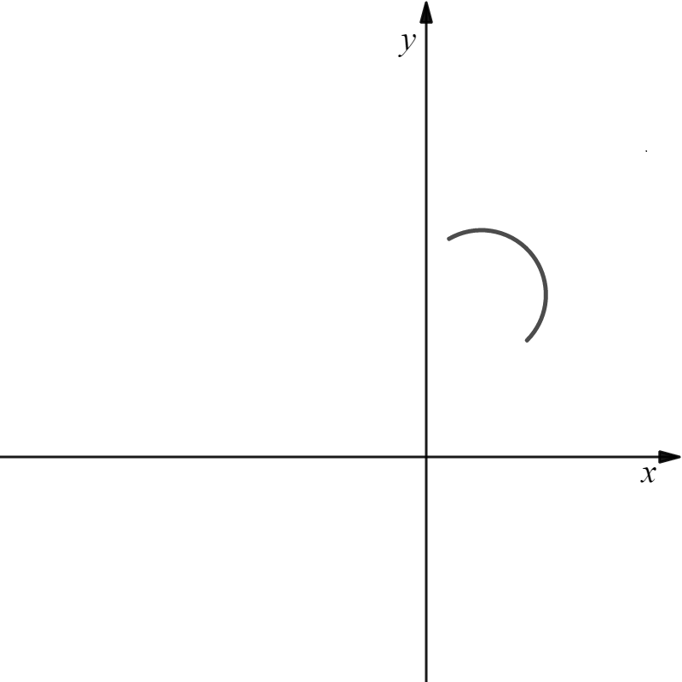

*O*

**Figure 1**

The curve *C* has parametric equations

*x* = 3 + 2√3 cos *t*, *y* = 5√3 + 2√3 sin *t*, – ≤ *t* ≤ 

A sketch of *C* is shown in Figure 1.

(a) Show that all points on *C* satisfy (*x* – 3)2 + (*y* – 5√3)2 = 12.

(2)

For curve *C*,

(b) (i) state the range of *x*,

(ii) state the range of *y*.

(2)

The point *P* lies on *C*.

Given the linewith equation *y* = *mx* + 12√3, where *m* is a constant, intersects *C* at *P*,

(c) state the range of *m*, writing your answer using set notation.

(6)

The points (0, 0), (0, 12√3) and *P* form a triangle.

(d) (i) Find the largest possible area of the triangle

(ii) Find the smallest possible area of the triangle.

(2)

**(Total for Question 7 is 12 marks)**

**___________________________________________________________________________**

**8.** Relative to a fixed origin *O*, vector 

Given that

* point *B* is such that 
* point *C* lies on the line thorough *A* and *B* such that 

(a) find the two possible coordinates of point *C.*

(3)

(b) Hence calculate the exact magnitude for the shortest possible length for vector .

(2)

**(Total for Question 8 is 5 marks)**

**___________________________________________________________________________**

**9.** Using algebra, prove that the sum of the squares of three consecutive integers is never divisible by 3.

**(Total for Question 9 is 4 marks)**

**___________________________________________________________________________**

**10.**

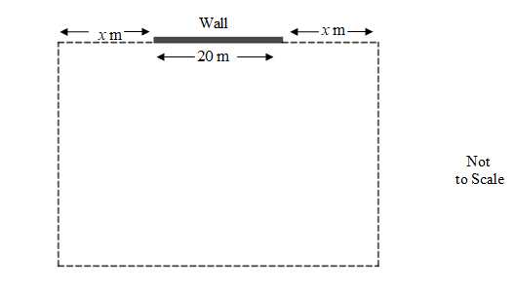

**Figure 2**

**In this question you should show detailed reasoning.**

**Solutions relying entirely on calculator technology are not acceptable.**

A farmer constructs a rectangular enclosure in which to keep lambs.

The enclosure, shown in Figure 2, consists of a wall that is 20 metres long and 200 metres of fencing.

Given that there is *x* m of the fencing on either side of the wall, shown in Figure 1, and that the farmer will use the full 200m fencing in order to make the enclosure,

(a) show that the area of the enclosure, *A* m2, is given by

*A* = 1800 + 140*x* – 4*x*2

(4)

The farmer needs a minimum area of 120m2 for each lamb.

(b) Find the maximum number of lambs he can keep in the enclosure.

(5)

(c) Prove that your answer you have found in part (b) is a maximum.

(2)

**(Total for Question 10 is 11 marks)**

**___________________________________________________________________________**

**11.** The 1st and 2nd terms of an arithmetic sequence are (*k* – 1) and (2*k* + 1) respectively, where *k* is a positive integer.

Given also that the 12th term is (14*k* + 9),

(a) use algebra to find the value of *k*,

(4)

(b) find the numerical value of sum of the first 20 terms of the series.

(3)

Given that the sum of *N* terms of the series is 8145,

(c) use algebra to find the value of *N*, making your method clear.

(3)

**(Total for Question 11 is 10 marks)**

**___________________________________________________________________________**

**12.** A researcher investigates the relationship between the percentage, *P* %, of Ultraviolet B radiation protection and the sun protection factor, *F*, for sun cream.

The researcher suggests the model

, 0 ≤ *P* < 100, 2 ≤ *F* ≤ 50

where *m*, *a*, and *b* are constants.

The researcher decides to use *m* = 100.

(a) Suggest why the researcher may have decided to use *m* = 100.

(1)

Given that

* a sun cream with *F* = 10 had 90 % Ultraviolet B radiation protection
* a sun cream with *F* = 50 had 98 % Ultraviolet B radiation protection

(b) (i) show that .

(ii) Hence, find the value of *a*. Give your answer to 3 significant figures.

(6)

It was later found that a sun cream with *F* = 2 had 50% Ultraviolet B radiation protection.

Using the model,

(c) evaluate the reliability of the model for determining *P* for sun cream with *F* = 2.

(2)

The researcher alters the coefficients of the model above to give the equation



Using this model,

(d) evaluate whether this is a better model to use for determining *P* for sun creams where 2 ≤ *F* ≤ 50, than the one found in (a) and (b).

(2)

**(Total for Question 12 is 11 marks)**

**___________________________________________________________________________**

**13.** The area of a forest covered by rhododendron is being monitored.

The number of hectares of forest covered by rhododendron, *N*, is modelled bythe equation

*N* = 150 + 8 ln (4*t* + 1) – *t*2 , *t* ≥ 0,

where *t* is the number of months after monitoring began.

**Use the equation of the model to answer parts (a) to (d).**

(a) Find the area of the forest covered by rhododendron when monitoring began.

(1)

The number of hectares of forest covered by rhododendron reaches its maximum value after *T* years.

(b) (i) Show that *T* is a solution of the equation

32*t*2 + 8*t* – 160 = 0

(ii) Hence find the maximum area of the forest covered by rhododendron.

(6)

The area of the forest covered by rhododendron is zero after *P* years.

(c) Show that *P* lies in the interval [15, 16]

(2)

The iteration formula

*tn* + 1 =  with *t*1 = 15

is used to find the value of *P*

(d) Find the value of *P* to 3 decimal places.

(2)

**(Total for Question 13 is 11 marks)**

**___________________________________________________________________________**

**14.**

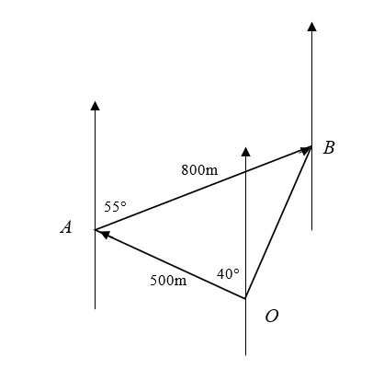

**Diagram not drawn to scale.**

**Figure 3**

The flight of a drone is modelled by the route shown in Figure 3.

The drone flies, from *O*, 500 metres on a bearing of 320° to *A*.

It then continues a further 800 metres, to *B*, on a bearing of 055°

Given that the drone flies at an average speed of 80 km per hour

(a) (i) Calculate the quickest time, to the nearest second, that it could return to *O*.

(3)

(ii) Explain why this time is unlikely to be accurate in real life.

(1)

(b) Calculate the bearing, to the nearest degree, that the drone operator should steer in order to return in a straight line to *O*.

(3)

[*Solutions based entirely on graphical or numerical methods are not acceptable.*]

**(Total for Question 14 is 7 marks)**

**___________________________________________________________________________**

**15.** Nisha has a mathematics test every week.

Over the past term she recorded, each week, the number of hours she spent revising and the mark she achieved for each test*.*

Nisha found that

* she scored 29 marks when she did no revision
* she scored 74 marks with 3 hours revision
* 74 was her maximum mark, even when she did more revision

The mark she achieved, *m*, is modelled by the equation

*m* = *p* – *q*(*t* – *r*)2

where *t* is the number of hours she revises that week and *p*, *q* and *r* are constants.

(a) Find, using all of the information given, the full equation for the model.

(3)

Next week Nisha plans to revise for 1 hour 45 minutes.

(b) Find, according to the model, the mark that Nisha should score.

(2)

(c) Give a limitation on the model.

(1)

**(Total for Question 15 is 7 marks)**

**___________________________________________________________________________**

**16.** The value of a piece of land, £ *P* is modelled by the equation

*P = Ak t*

where *A* and *k* are constants and *t* is the time in years after 1st January 1932.

Given that

* the initial value of the land was £540
* the value of the land on 1st January 1982 was £ 24 000

(a) (i) write down the value of *A*,

(ii) show that to 5 decimal places.

(3)

Using the model with the values of *A* and *k* from part (a),

(b) estimate the value of this piece of land on 1 January 2032, giving your answer to the nearest £1000.

(2)

(c) Give a limitation of the model

(1)

The value, £*P*, of a different piece of land is modelled by the equation

*P* = 450 ×1.08548*t*

Using both models,

(d) find the year in which the two pieces of land would have the same value.

(*Answers relying entirely on graphical or numerical methods are not acceptable*.)

(4)

**(Total for Question 16 is 10 marks)**

**___________________________________________________________________________**

**17.** The height *h* metres, of a water jet in a fountain is modelled by the differential equation

 = 8 sin 4*t*, 0 ≤ *t* ≤ 6*π*,

where *t* is the time in minutes after the water is turned on.

Given that initially the water jet has zero height,

(a) solve the differential equation to find *h* in terms of *t*.

(6)

(b) Find the maximum height of the water jet, giving your answer to the nearest cm.

(2)

The water jet first reaches its maximum height *T* **seconds** after the water is turned on.

(c) Find the value of *T*, giving your answer to one decimal place.

(2)

**(Total for Question 17 is 10 marks)**

**___________________________________________________________________________**

**18.** (a) Express

3 sin *θ* − cos *θ*

in the form *R* sin (*θ* – *α*) where *R* and *α* are constants, *R* > 0, .

Give the exact value of *R* and give the value of *α*, in radians, to 3 decimal places.

(3)

A causeway connects a mainland to an island.

The height of sea water above a fixed point on the causeway, metres, on a particular day, is modelled by the equation

*H* = 1.2 + 3 sin  – cos , 0 ≤ t < 240,

where *t* is the number of hours after midnight.

**Use the equation of the model to answer parts (b) to (d).**

(b) Find the maximum height of the sea water above the fixed point on the causeway.

(1)

(c) Find the second time in the day when this maximum height occurs.

Give your answer in hours and minutes to the nearest minute.

(3)

A car is only allowed to cross the causeway if the height of the sea water is 10 cm below the fixed point on the causeway.

(d) Find the first two times of the day between which it is safe to cross the causeway.

(5)

(e) Give one limitation of the model.

(1)

**(Total for Question 18 is 13 marks)**

**___________________________________________________________________________**

**19.** The speed, *v* m s­–1, of a battery-operated toy car is modelled by the formula

*v* = 0.5(1 – e–*kt*)

where *t* is the time in seconds after the toy is switched on and *k* is a constant.

Exactly 2 seconds after the toy car is switched on its speed is 0.4 ms–1

Using this information,

(a) find a complete equation for the model, writing the value of *k* to 3 significant figures.

(3)

Using the model and the value of *k* found in part (a),

(b) find the speed of the toy 4 seconds after the toy is switched on, giving your answer in m s–1 to 2 significant figures.

(2)

Given that the actual speed of the toy 4 seconds after being switched on is 0.6 m s–1,

(c) comment on the accuracy of the model.

(1)

(d) State a limitation of the model.

(1)

**(Total for Question 19 is 7 marks)**

**___________________________________________________________________________**

**TOTAL FOR THIS PAPER IS 164 MARKS**

**BLANK PAGE**