**The Aeneid – Book 12**

**Read lines 1-19**

How are the following traits of Turnus reiterated here again?

**Bravery:**

**Anger:**

**Impetuousness:**

**Read lines 20-113**

‘Latinus answered him, and his voice was calm’ How does this line create an obvious juxtaposition with Turnus?

What are the desires of Latinus, Amata and Turnus as the former two attempt to dissuade the latter from fighting?

**What does Latinus want?**

**What does Turnus want?**

**VS**

**What does Turnus want?**

**What does Amata want?**

**VS**

How is Lavinia described? What does that show about the role of her character in the *Aeneid*?

What episode in the *Iliad* does Latinus and Amata’s attempts to dissuade Turnus recall?

How has Virgil reversed the role of ‘the new Achilles’ (Turnus) and his Trojan opponent?

|  |  |
| --- | --- |
| **Equipment:** | **Description:** |
|  |  |
|  |  |
|  |  |
|  |  |
|  |  |

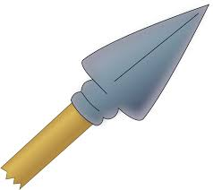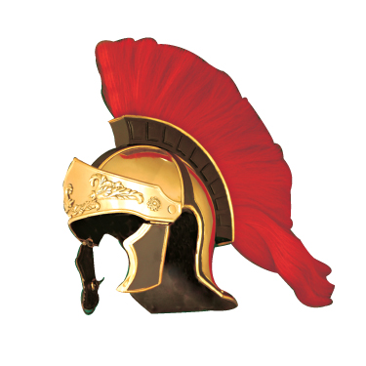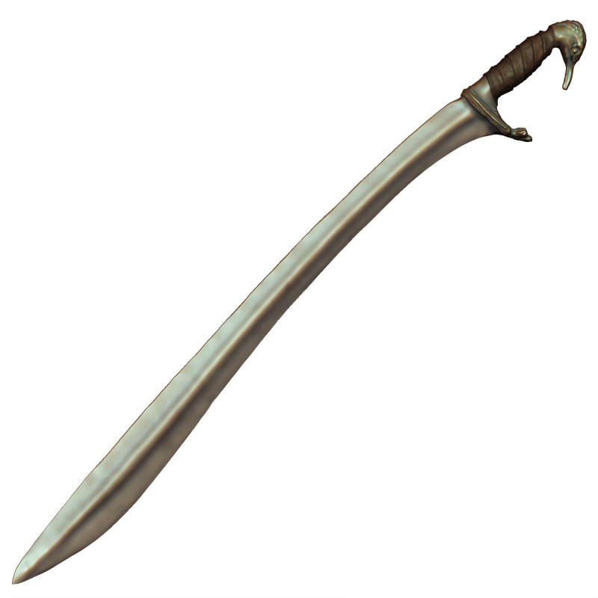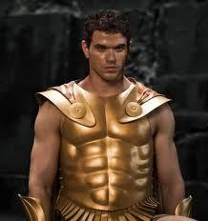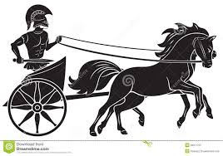How is each piece of Turnus’ equipment described in his ‘arming scene’?

What is significant about the following description?

‘The God of Fire himself had made the sword for Turnus’ father Daunus, dipping it white-hot in the waters of the Styx.’

Why do you think that Aeneas’ arming scene is much shorter?

**Read lines 114-206**

There was a temple to Juturna in Rome in Virgil’s day. Do you find this surprising based on Juno’s interaction with her?

Complete the following for the attempted truce:

***Truce***

***Parties involved:***

***All those in attendance:***

***Sacrifices offered:***

***Oath of Aeneas:***

***Oath of Latinus:***

‘Both nations shall move forward into an everlasting treaty, undefeated, and equal before the law.’ Given Rome’s long history of wars with the Latins, why would Virgil include this?

**Read lines 207-311**

How has Turnus’ mood changed? Why does Virgil do this?

Complete the following for the failure of the Truce:

|  |  |  |
| --- | --- | --- |
| **X** |  |  |
| What arguments does Juturna use to change the Rutulians’ minds? | What omen appears to also convince them to fight en masse? | How does Tolumnius violate the truce? |

Read *Iliad* 4.84-125. How does this episode mirror that of Tolumnius?

Whose death do you think is the most vividly described, Aulestes’, Ebysus’ or Podalirius’? Discuss all three’s death.

**Read lines 312-384**

Why is Aeneas unarmed?

Why do you think he is still desperate to keep the peace?

Why do you think Virgil makes the archer who wounds Aeneas anonymous?

Read the following passages in the *Iliad* and find quotes from the *Iliad* that match Turnus’ *aristeia* here:

|  |  |  |
| --- | --- | --- |
| ***Iliad*** | ***Iliad* quote** | ***Aeneid* quote** |
| 13.298-310 |  |  |
| 4.440 |  |  |
| 20.498-503 |  |  |
| 11.305-308 |  |  |

What does Virgil want to show by drawing on so many parallels to Homer here?

**Read lines 385-441**

Annotate this picture to show the story of Iapyx and Aeneas:

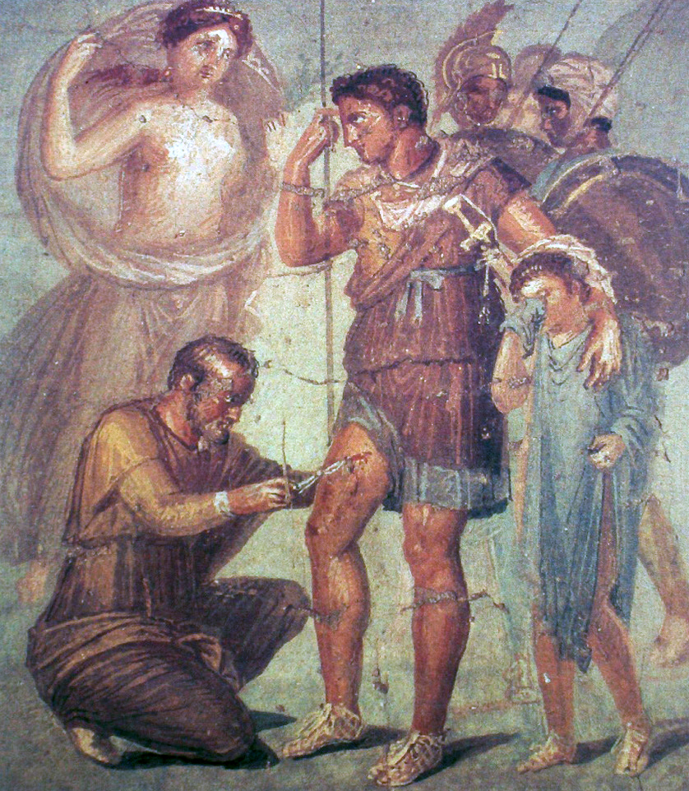

Collect quotes that show it is important that Aeneas returns to the fight as quickly as possible:

|  |
| --- |
| **Quotes** |
|  |
|  |
|  |
|  |
|  |

‘It is not my right hand that saved you, Aeneas. Some greater power, some god, is driving you and sending you back to greater deeds.’ Why does Virgil have Iapyx say this?

Why does Aeneas speak to Ascanius before returning to battle? What does this recall in the *Iliad*?

|  |  |  |
| --- | --- | --- |
| ***Iliad*** | ***Iliad* quote** | ***Aeneid* quote** |
| 4.275-279 |  |  |

**Read lines 442-499**

How does Virgil recall Homer with the ‘approaching storm’ simile?

How does Juturna help her brother?

List all the examples you can think of in Homer and Virgil of gods assisting mortals in disguise:



|  |  |  |  |
| --- | --- | --- | --- |
| **He searches only for Turnus** | **He takes shelter behind his shield** | **In frustration, he prays to Jupiter** | **He plunges into the enemy** |
|  |  |  |  |
| Justification: | Justification: | Justification: | Justification: |

Assess Aeneas’ heroism in this passage. Mark on how Roman/ Homeric you think he is in each instance:

**Hero-Meter**

**Hero-Meter**

**Hero-Meter**

**Hero-Meter**



**Roman**

**Roman**

**Roman**

**Homeric**

**Homeric**

**Homeric**

**Roman**

**Homeric**

**Read lines 500-553**

Find an example of each of the following:

**Read lines 554-612**

Find quotes that show how the new attack on Laurentum itself is a Roman style assault, with everyone working together:

|  |
| --- |
| **Quotes** |
|  |
|  |
| The Roman *testudo* (‘tortoise’) formation |
|  |
|  |

How is Amata’s death an epitome of Greek tragedy?

What does Latinus’ reaction to her death recall from the *Iliad*?

**Read lines 613-697**

Saces’ report to Turnus proves to be the turning point needed for the final combat. Complete the following:

**How does Turnus show his courage afterwards?**

**How was Turnus feeling shamed before hand?**

‘In that one heart of his seethes a bitter shame, a grief shot through with madness, love driven on by fury, and a consciousness of his own courage.’

**Read lines 698-791**

How does Virgil create excitement around the following aspects of the duel?

|  |  |  |
| --- | --- | --- |
| **Turnus and Aeneas charge one another** | **Turnus’ sword shatters** | **Aeneas pursues Turnus** |
|  |  |  |
| **Turnus appeals for his sword** | **Aeneas’ spear is stuck** | **The heroes recover their weapons** |
|  |  |  |

Virgil bases this scene heavily on *Iliad* Book 22. Find parallels for the following quotes from the *Iliad*

|  |  |
| --- | --- |
| ***Iliad* (Book 22)** | ***Aeneid* (Book 12)** |
| ‘…then the Father opened out his golden scales. In the pans he put the two fates of death’s long sorrow, one for Achilleus and one for Hektor the tamer of horses, and he took the scales in the middle and lifted them up: and Hektor’s day of doom sank down, away into Hades, and Phoibos Apollo left him.’ |  |
| ***Iliad* (Book 22)** | ***Aeneid* (Book 12)** |
| ‘As when a dog has started the fawn of a deer from its lair in the mountains and chases it on through the hollows and the glens: even if it takes to cover and crouches hidden under a bush, the dog smells out its track and runs on unerringly until it finds it. So Hektor could not throw off the swift-footed son of Peleus.’ |  |
| ‘…they ran at speed, since it was no sacrificial beast or ox-hide shield they were competing for – such as are the usual prizes that men win in the foot-race – but they were running for the life of Hektor the tamer of horses.’ |  |
| ‘He watched it come and crouched down, and the bronze spear flew over him and fixed in the earth: and unseen by Hektor, shepherd of the people, Pallas Athene pulled up the spear and gave it back to Achilleus.’ |  |

**Read lines 792-886**

In his final appearance, what does Jupiter say about Aeneas’ destiny?

As Juno concedes victory to Aeneas, what does she say about how the Trojans and Latins should be united?

What is paradoxical about Juno speaking the line ‘Let…the stock of Rome be made mighty by the manly courage of Italy’?

Find quotes that show how Virgil portrays the Dira as terrifying and forceful:

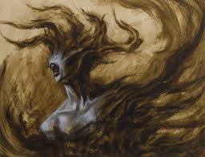

What does Juturna complain about as she leaves her brother to his fate?

**Read lines 887-951**

How is it fitting the way Turnus is brought low even before being wounded by Aeneas’ spear?

‘Just as when we are asleep…so it was with Turnus.’ How is this simile unique?

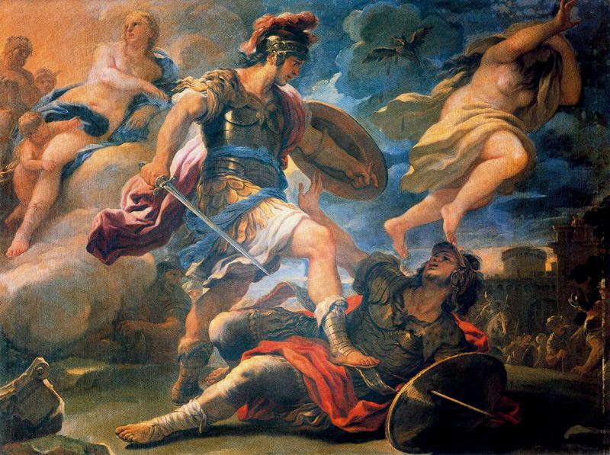What is unheroic about Turnus’ supplication?

How do the following suggest Aeneas would spare Turnus?

**Anchises concludes the pageant of Roman heroes with the line ‘These will be your arts – and to impose a settled pattern upon peace, to pardon the defeated and war down the proud.’ (Book 6)**

**Turnus supplicates himself, admitting defeat.**

**Turnus asks for Aeneas to pity his father, Daunus.**

**Turnus says ‘Do not carry your hatred any further’.**

How do the following explain why Aeneas does kill Turnus?

**Aeneas’ relationship with Pallas.**

**Evander’s response to the death of Pallas (Book 11).**

**The depiction of Pallas’ funeral (Book 11).**

After the death of Pallas, Aeneas most closely parallels Achilles. Before this, the role of Achilles had fallen to Turnus. What parallels can you find between Aeneas’ killing of Turnus and Achilles’ killing of Hector in the *Iliad*?

‘Blazing with rage, he plunged the steel into his enemy’s breast. The limbs of Turnus were dissolved in cold and his life left him with a groan, fleeing in anger down to the shades.’

The *Aeneid* ends in an act of vengeance, which Virgil does not justify or criticise explicitly. Aeneas loses control and acts in anger. The poem does not end in triumph but focuses the audience on the victim, not the victor.

In your opinion, was Virgil right to end *The Aeneid* on this note?

Complete your answer on A4 paper. Consider:

* The themes explored throughout the *Aeneid*
* The titular character’s progression
* Virgil’s own experience
* The Roman audience

**Appendix – Aeneas, the Hero of the Epic**

Throughout the *Aeneid*, we have seen Aeneas develop from a Homeric hero into a Roman one. It comes as a shock to see his final action as one of vengeance and anger. The question at the end of the epic is has Aeneas become a Roman hero, admittedly with lapses at times, or does he not quite attain this.

Homeric and Roman Heroic Codes

|  |  |  |
| --- | --- | --- |
| **Aspect** | **Homeric Hero** | **Roman Hero** |
| Emotion | Homeric heroes display emotion and are frequently driven by it. Achilles is the archetype here; he and many others are the victims of his anger. | Roman heroes are not unfeeling. Rather, the ideal is the ability to hold it in check if needed. Aeneas is forced to leave Dido, despite his love for her; he gives greater importance to the future destiny. |
| Piety | Homeric heroes, such as Odysseus, Diomedes and Achilles, frequently receive help from the gods and are always willing to acknowledge this. Yet they are able to defy the gods too. Achilles is prepared to ignore their will and Diomedes even assaults several gods. | A Roman hero’s relationship with the gods is far less self-centered. They do receive divine assistance but their piety is not diminished when they suffer at their hands. Aeneas is prepared to sacrifice to Juno after Thybris visits him. Romans typically dedicate their *spolia* (spoils) to the gods. |
| Individuality | Gaining *kleos* is at the forefront of a Homeric hero’s mind. The *aristeia* of a hero gains them individual fame and a hero like Odysseus is eager to promote the memory of his own exploits. Their *time* is manifest in that which they take in battle and receive/give in the act of *xenia*. | The Romans were careful when encouraging individual exploits as their military system required cohesion. However, their military honours show that feats of daring were still allowed. What is important is the service individual feats provide others, rather than purposefully seeking opportunities to do it alone. |
| Family and the City | Homeric heroes place weight on their family and home. In particular, family members are needed to ransom captives, bury the fallen and keep the hero’s memory alive. Hector is also prepared to put the needs of Troy first, although he is unique in this. | The Roman hero is often branded as a protector, both of the family and the community at large. In this, they are far less self-serving than the typical Homeric hero and are mindful of the future fate of everyone. |

The Development of Aeneas

|  |  |
| --- | --- |
| **Book** | **Consider the following…** |
| Book 1 | What sort of character does Virgil set out in his opening lines? How does Aeneas demonstrate leadership qualities? How does Aeneas show his piety? How is Aeneas already aware of his destiny? |
| Book 2 | How does this Book show Aeneas’ urge to fight vs the need to follow destiny? How does Aeneas show his leadership qualities? How does Aeneas demonstrate his piety and devotion to his family? |
| Book 4 | How does Virgil show a tension between Aeneas’ love for Dido and his divine mission? Why does the latter eventually win out? |
| Book 6 | Why might this Book be considered the turning point for Aeneas’ development into a hero? How does Aeneas show his piety and family devotion? How is the destiny of Aeneas and his ancestors emphasised? |
| Book 7 | What impression does Aeneas make on Latinus? How does Aeneas demonstrate his piety? |
| Book 8 | How does Aeneas respond to the prospect of war? How does Aeneas show his piety? What allows Aeneas to win over the Arcadians and Etruscans to his side? How does Aeneas view Pallas? What does his new shield reveal about Aeneas and his destiny? |
| Book 10 | How does Aeneas show his leadership qualities? How does Aeneas appear in battle? How does Aeneas respond to the deaths of Pallas, Lausus and Mezentius? |
| Book 12 | How does Aeneas act when the truce is being drawn up and when it is first violated? Why is Aeneas initially focused on Turnus? Why does Aeneas dive into the enemy ranks? How are the gods shown to be on Aeneas’ side? How does Aeneas appear in battle? How does Aeneas respond to Turnus’ appeal for mercy? |