**Cell Differentiation: Basics**

* Structural differences between different types of cells enables them to perform specific functions within the organism
* Cell differentiation is an important process by which a cell changes to become specialised
* Cells that have not differentiated are therefore unspecialised. As an organism develops, cells differentiate to form different types of cells
* Almost all of the cells in a multicellular organism will contain the same genetic information (the same genes or alleles), but depending on what role one particular cell needs to have, only some of the total sum of genes in a particular cell are used to control its development
* When a cell differentiates, it develops a structure and composition of subcellular structures which enables it to carry out a certain function
  + To form a nerve cell the cytoplasm and cell membrane of an undifferentiated cell must elongate to form connections over large distances

[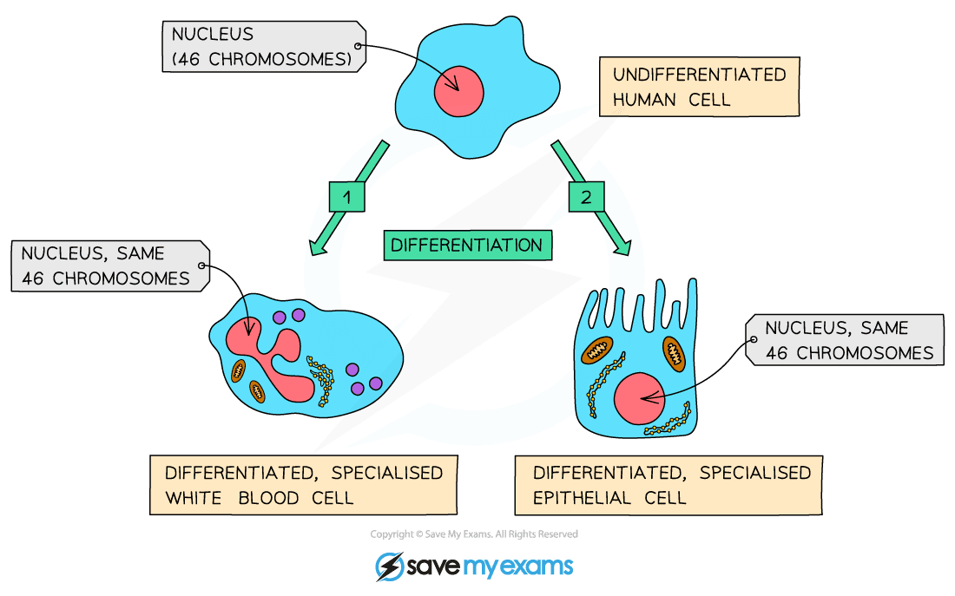](https://cdn.savemyexams.co.uk/wp-content/uploads/2020/06/1.1.4-Differentiation.png)

***Diagram showing the differentiation of a human cell***

**Differentiation & Development**

* As a multicellular organism develops, its cells differentiate to form specialised cells
* In an animal, most cells differentiate at an early stage of its development. Cell division is mainly restricted to repair and replacement in mature animals
  + Animal cells therefore lose their ability to differentiate after they have become specialised early in the life of the animal
  + Some cells in various locations throughout the body of an animal retain the ability to differentiate throughout the life of the animal. These cells are called adult stem cells and are mainly involved in replacing and repairing cells (such as blood or skin cells)
* Plants differ from animals in that many types of plant cell retain the ability to fully differentiate throughout the life of a plant, not just in the early stages of development