**The Aeneid – Book 5 Summary**

**Read lines 1-285**

Where does Aeneas arrive after leaving Carthage?

Why are games declared here?

Interview the following ships’ captains about how the race went:

|  |  |
| --- | --- |
| The Greek Age of Bronze - Shields**Gyas** | **Cloanthus** |
| Picture**Mnestheus** | Picture**Sergestus** |

What order were did the competitors come in and what did they win?



**1**



**2**



**3**



**4**

**Read lines 286-603**

Above the podiums note who wins the competitions and what they gained (if stated). Below them, note anything that happened of interest during these competitions:

**The Foot Race The Boxing Bout The Archery Contest**

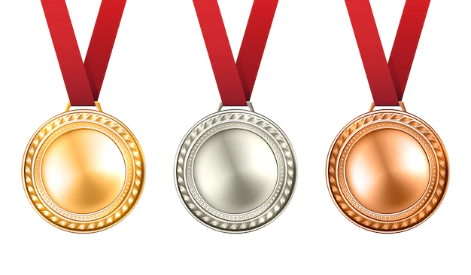



**Read lines 604-871**

How do the following gods play a role in the remaining part of this book?

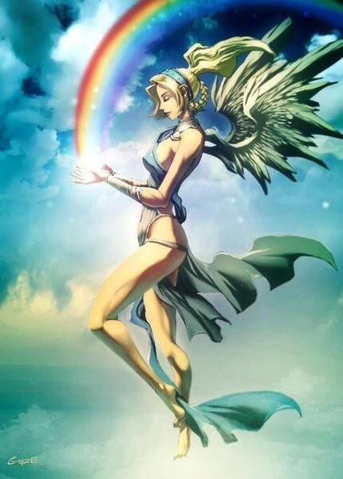

**Juno**

**Iris**

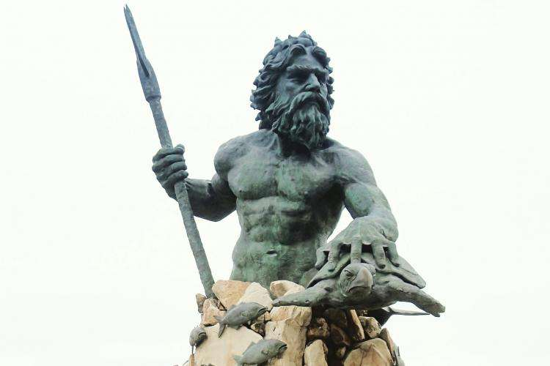

**Venus**

**Neptune**

What does the ghost of Anchises say?



Write an epithet to go on Palinurus’ tombstone:

**Epithet:**

**Palinurus**