

**Marking Scheme**

**Transformation of Graphs**

**Name --------------------------------**

**Answers**

**Question 1**

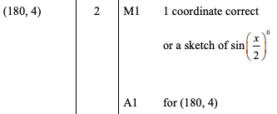

**Question 2**

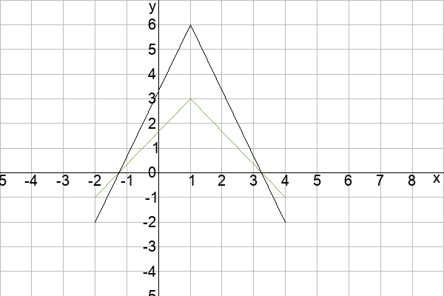

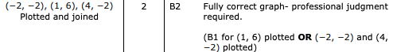

**Question 3**

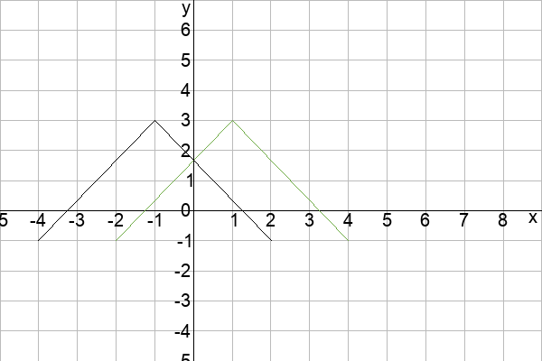

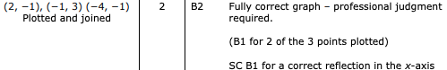

**Question 4**

../uploads/users/6190/images/img-6190-1562491269-413.png

**Question 5**

../uploads/users/6190/images/img-6190-1562491317-995.png

**Question 6**

,

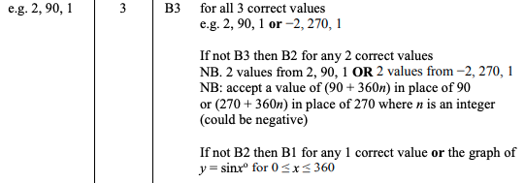

**Question 7**

../uploads/users/1379/images/img-1379-1550703766-251.png

**Question 8**

../uploads/users/84981/images/img-84981-1557063739-33.png

**Question 9**

../uploads/users/84981/images/img-84981-1557063801-183.png

**Question 10**



**Question 11**

../uploads/users/1379/images/img-1379-1556985358-370.png

**Question 12**

"-2 OR - 2 OR minus 2 OR take 2 OR take away 2 OR subtract 2" and "y"

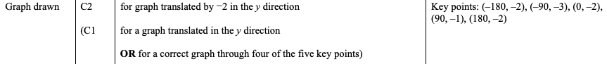

**Question 13**

../uploads/users/6190/images/img-6190-1551615079-83.png

**Question 14**

../uploads/users/6190/images/img-6190-1551615134-64.png

**Question 15**

../uploads/users/6190/images/img-6190-1551615168-754.png

**Question 16**

../uploads/users/6190/images/img-6190-1551615223-943.png

**Question 17**

../uploads/users/1379/images/img-1379-1551353222-700.png

**Question 18**

../uploads/users/1379/images/img-1379-1551353231-523.png

**Question 19**

../uploads/users/1379/images/img-1379-1551353242-864.png

**Question 20**

../uploads/users/1379/images/img-1379-1551016594-806.png

**Question 21**

../uploads/users/1379/images/img-1379-1551016602-214.png

**Question 22**

|  |  |
| --- | --- |
| Equation | Graph |
|  | **C** |
|  | **D** |
|  | **A** |
|  | **F** |
|  | **B** |
|  | **E** |

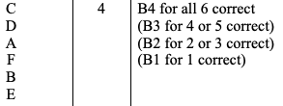

**Question 23**

../uploads/users/1379/images/img-1379-1550785284-928.png

**Question 24**

../uploads/users/1379/images/img-1379-1550785293-486.png

**Question 25**

../uploads/users/1379/images/img-1379-1550785302-483.png

**Question 26**

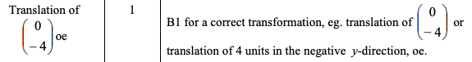

**Question 27**

../uploads/users/1379/images/img-1379-1550782990-568.png

**Question 28**

../uploads/users/1379/images/img-1379-1550783007-144.png

**Question 29**

, ,

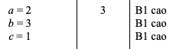

**Question 30**

../uploads/users/1379/images/img-1379-1550758962-469.png

**Question 31**

../uploads/users/1379/images/img-1379-1550758972-352.png

**Question 32**

../uploads/users/1379/images/img-1379-1550756424-158.png

**Question 33**

../uploads/users/1379/images/img-1379-1550747770-721.png

**Question 34**

../uploads/users/1379/images/img-1379-1550747780-757.png

**Question 35**

"translation"

../uploads/users/1379/images/img-1379-1550703809-2.png

**Question 36**

../uploads/users/1379/images/img-1379-1550703798-579.png

**Question 37**

../uploads/users/1379/images/img-1379-1550703786-729.png

**Question 38**

../uploads/users/1379/images/img-1379-1550703778-174.png

**Question 39**

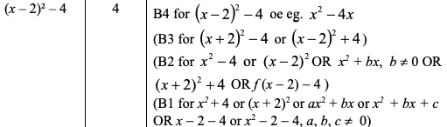

**Question 40**

../uploads/users/1379/images/img-1379-1550695670-472.png

**Question 41**

../uploads/users/1379/images/img-1379-1550695661-797.png

**Question 42**

../uploads/users/1379/images/img-1379-1550695652-421.png

**Question 43**

../uploads/users/1379/images/img-1379-1550695642-81.png

**Question 44**

../uploads/users/1379/images/img-1379-1550599964-903.png

**Question 45**

../uploads/users/1379/images/img-1379-1550339669-370.png

**Question 46**

../uploads/users/1379/images/img-1379-1550339680-865.png

**Question 47**

../uploads/users/1379/images/img-1379-1550339690-324.png

**Question 48**

120

../uploads/users/1379/images/img-1379-1550339704-13.png

**Question 49**

../uploads/users/1379/images/img-1379-1549719665-993.png

**Question 50**

../uploads/users/1379/images/img-1379-1549712397-777.png

**Question 51**

../uploads/users/1379/images/img-1379-1549712407-455.png

**Question 52**

../uploads/users/1379/images/img-1379-1549712418-207.png

**Question 53**

It crosses the -axis first at 1 and and at 2 and It crosses the -axis at 2